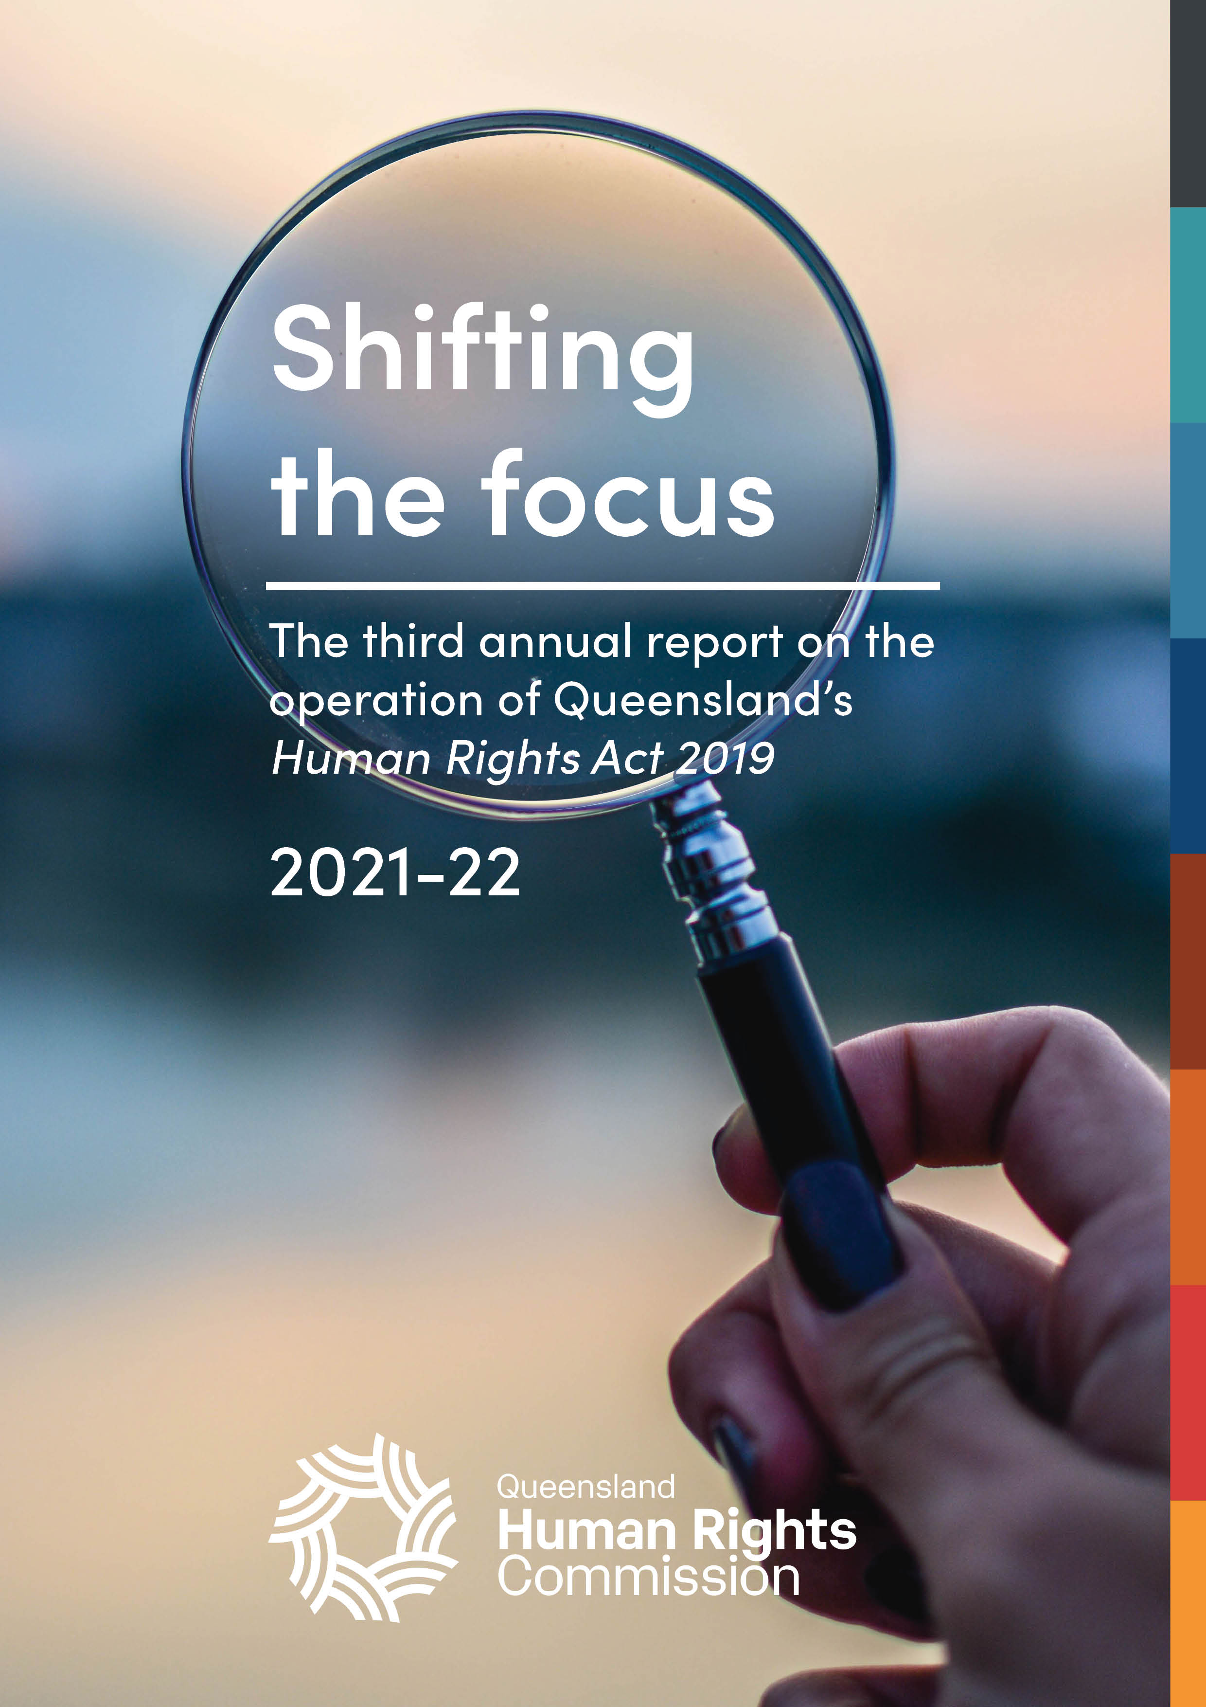

# Annual report on the operation of the *Human Rights Act 2019*

## 2021-22­­­

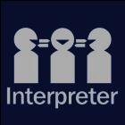The Queensland Human Rights Commission is committed to providing accessible services to Queenslanders from all culturally and linguistically diverse backgrounds. If you have difficulty in understanding the annual report, you can contact us on toll free 1300 130 670 and we will arrange an interpreter to effectively communicate the report to you.

English: If you’d like us to arrange an interpreter for this report, please call us on 1300 130 670.

Spanish: Si desea que nosotros para solicitar un intérprete de este informe, por favor llámenos en 1300 130 670

French: Si vous souhaitez organiser un interprète pour ce rapport, veuillez nous appeler au 1300 130 670

Chinese: 如果您想让我们为此报co告安排传译员，请致电我们 1300年 130 670

Arabic: إذا كنت تريد منا أن يرتب مترجما لهذا التقرير، يرجى الاتصال بنا على 1300 130 670

German: Wenn Sie uns einen Dolmetscher für diesen Bericht anordnen möchten, rufen Sie uns bitte auf 1300 130 670

Turkish: Lütfen bizi arayın 1300 130 670 bizimle bu rapor için bir tercüman istiyorsanız,

Japanese: このレポートのための通訳の手配を希望する場合は、1300年 130 670 に問い合わせください。

Dutch: Als u wij dat wilt te regelen een tolk voor dit verslag, bel ons op 1300 130 670

Korean: 우리가이 보고서에 대 한 해석자를 정렬 작업을 원하시면 전화 주시기 바랍니다에 1300 130 670

**© Queensland Human Rights Commission 2022**

**ISSN 2652-8835 (online)**

**Licence**: This annual report is licensed by Queensland Human Rights Commission under a Creative Commons Attribution

(CC BY) 4*.0 International licence*.

*Creative Commons license image: Grey and black rectangle, with 'CC' in a circle on the left and a person icon in a circle on the right. The person icon has 'BY' under the circle.*To view a copy of this licence, visit: <http://creativecommons.org/licenses/by/4.0/>

**CC BY Licence Summary Statement:** In essence, you are free to copy, communicate and adapt this annual report, as long as you attribute the work to the Queensland Human Rights Commission.

**Attribution**: Content from this annual report should be attributed as: Queensland Human Rights Commission, 2021-2022 Annual report on the operation of the *Human Rights Act 2019*.

This publication is available in electronic format on the Commission’s website at: [www.qhrc.qld.gov.au](http://www.qhrc.qld.gov.au).

# Contents

Commissioner’s foreword 5

About the Commission 7

About this report 8

Report summary 9

Report highlights 13

Human rights timeline: 2021-22 18

About the *Human Rights Act 2019* 20

Human rights and the parliament 26

The role of Queensland Parliament 27

Human rights indicators 30

Significant legislation 2022-22 36

Summary of the role of parliament in 2021-22 44

Human rights in courts and tribunals 46

The role of courts and tribunals 47

Key cases 52

Interventions 56

Summary of the role of courts and tribunals in 2021-22 58

Human rights and the public sector 60

Obligations on public entities 61

Developing a human rights culture 61

Indicators of a human rights culture 62

State public entities 63

Local government public entities 83

Human rights leadership 92

Progress towards a human rights culture in government and councils 95

*Building Belonging*: A Review of Queensland’s Anti-Discrimination Act 96

Functional public entities 98

Human rights complaints 99

About human rights complaints 100

Complaints made directly to public entities 100

Early complaint resolution 104

Complaints made to the Commission 105

Resolved complaint case studies 124

Human rights in the community 130

Community education and training 131

Appendices 134

Appendix A: Courts and tribunals 135

Appendix B: Human rights indicators 138

Appendix C: Complaints data tables 142

Appendix D: Human rights timeline 2021-22 149

# Commissioner’s foreword

Since the Human Rights Queensland Human Rights Commissioner Scott McDougall. Scott has short brown hair and is wearing a dark blue suit jacket and tie with a light blue collared shirt. A green wall is behind him. He is smiling at the camera, and the photo is in a round frame with a dark grey border.Act became fully operational on 1 January 2020, COVID-19 has been the lens through which we’ve viewed much of its impact.

Complaints about COVID-19-related issues have comprised the bulk of human rights complaints received by the Commission, and formed the biggest share of our public comment and awareness-raising about the Act. The work of many of Queensland’s public entities in developing human rights compatibility assessment tools has been sharply focussed on pandemic response measures. Courts are grappling with multiple matters which will require them to assess the human rights impact of now-lapsed public health directions, while parliament has continued to pass COVID-related legislation and extend emergency powers.

While it is no surprise that an international pandemic and its inescapable impact domestically has been the focal point for Queensland’s newly minted human rights legislation, three years into the Act’s operation, it is time to lift our eyes to the horizon and expand our understanding of how human rights protections apply to acts and decisions beyond those related to COVID.

Looking forward, it is important to welcome signs of progress while also being realistic about shortcomings or areas which need further attention.

Human rights complaints to the Commission are still heavily COVID-focussed, but advocates have reported encouraging successes in using human rights arguments in the housing and homelessness sector to secure good outcomes for their clients without the need to engage in a formal complaint process. This is the dialogue model in action and is a promising sign of what is possible to achieve outside the formal complaints process.

The work of parliamentary committees in examining human rights compatibility is becoming more sophisticated and detailed, and while this has not yet led to recommendations for proposed legislation to be amended it is nonetheless a welcome development and an area we hope to continue to see growth in over the coming years.

The ability to enforce rights is fundamental to the effectiveness of human rights protections. This year there have been important developments in Queensland’s emerging human rights jurisprudence. These include the Supreme Court’s ruling about inhumane treatment of a prisoner subjected to prolonged solitary confinement and the Land Court’s historic decision to allow evidence to be given ‘on country’ by First Nations witnesses after a consideration of their cultural rights under the Act.

Outside COVID, public entities are still in varying stages of implementing the Act, and approaches differ depending on the size and sector of the entity, as well as its location. Identifying when complaints from clients or service users are human rights-related continues to challenge most public entities. This is particularly the case where the complainant does not raise the Act themselves, or where there are inconsistencies between different divisions of the organisation in terms of complaint handling. These challenges are reflected in the complaints data from public entities contained in this report.

Councils too appear to have widely differing approaches to implementation, partly as a result of funding and resourcing issues. The lack of resourcing for smaller and more remote councils is an ongoing concern in terms of the Act’s operation, and there appears also to be a gap in including human rights considerations in local government law-making processes statewide.

As the pandemic begins to subside it is critical we all reflect on how the Act will be used to protect and promote human rights into the future, where COVID-19 issues are less likely to dominate and other challenges come to the fore.

**Scott McDougall**

**Commissioner**

**Queensland Human Rights Commission**

# About the Commission

The Queensland Human Rights Commission (the Commission) is an independent statutory body established under the *Anti-Discrimination Act 1991*. The Commission was formerly the Anti-Discrimination Commission Queensland and was renamed the Queensland Human Rights Commission on 1 July 2019 following the passage of the *Human Rights Act 2019* (the Act). The functions and powers of the Commission under section 61 of the Act are:

* to deal with human rights complaints;
* if asked by the Attorney-General, to review the effect of Acts, statutory instruments and the common law on human rights and give the Attorney-General a written report about the outcome of the review;
* to review public entities’ policies, programs, procedures, practices and services in relation to their compatibility with human rights;
* to promote an understanding and acceptance, and the public discussion, of human rights and this Act in Queensland;
* to make information about human rights available to the community;
* to provide education about human rights and this Act;
* to assist the Attorney-General in reviews of this Act under sections 95 and 96;
* to advise the Attorney-General about matters relevant to the operation of this Act; and
* another function conferred on the Commission under this Act or another Act.

# About this report

Section 91 of the Act requires that, as soon as practicable after the end of each financial year, the Commissioner must prepare an annual report about the operation of the Act during the year. The purpose of this report is to provide a resource for government, parliament, and the community on the operationalisation of the Act and the degree to which it is achieving its objectives.[1] The Act will be reviewed in 2023[2] and 2027,[3] and the content of this report will provide evidence of how the Act has operated in its early years.

# Report summary

Table 1: Required information for this report under section 91 of the Human Rights Act 2019

| Section | Required information |
| --- | --- |
| 91(2)(a) | details of any examination of the interaction between this Act and other Acts, statutory instruments and the common law  This provision relates to section 61(b) of the Act. In May 2021, Queensland’s Attorney-General asked the Commission to undertake a review of the *Anti-Discrimination Act 1991* (Qld) pursuant to section 61(b) of the Human Rights Act and section 235(k) of the *Anti-Discrimination Act 1991*. The review report, *Building Belonging – Review of Queensland’s Anti-Discrimination Act 1991*, was handed to the Attorney-General on 29 July 2022. *For more information see* *the Human rights and the public sector chapter*. |
| 91(2)(b) | details of all declarations of incompatibility made  No declarations of incompatibility were made in the 2021–22 financial year. |
| 91(2)(c) | details of all override declarations made  No Override Declarations were made in the 2021–22 financial year. |
| 91(2)(d) | details of all interventions by the Attorney-General or the commission under section 50 or 51  The Commission intervened in 10 court matters, 8 in the Supreme Court and 2 in the Coroners Court.  The Attorney-General intervened in 10 matters, 8 of which are the same matters in the Supreme Court in which the Commission intervened. Of the remaining, 1 matter is subjection to publication restrictions and 1 is ongoing. |
| 91(2)(e) | the number of human rights complaints made or referred to the commissioner  The total number of human rights complaints lodged with the Commission during the reporting period is not ascertainable, due to the large increase in complaints lodged and the impact this has had on assessment timeframes and reporting.[4]  Complete data is however available for the first two quarters of the financial year from 1 July 2021 to 31 December 2021.[5] In this 6-month period, the Commission received 251 complaints[6] identified as human rights complaints, of which:  157 were human rights only complaints.[7]  94 were piggy-back complaints.[8] |
| 91(2)(f) | the outcome of human rights complaints accepted by the commissioner for resolution by the commission, including whether or not the complaints were resolved by conciliation or otherwise  Of the 191 accepted complaints finalised in the 2021–22 financial year:  61 complaints were resolved  41 complaints were referred to the Queensland Civil and Administrative Tribunal  16 complaints were referred to the Queensland Industrial Relations Commission.  *For more information, see* *the Human rights enquiries and complaints – Outcomes of finalised complaints* and *Resolved complaint case studies* sections. |
| 91(2)(g) | the number of human rights complaints resolved by the commission  In the 2021–22 financial year, 61 complaints were resolved and finalised, comprising:  12 human rights only complaints resolved and finalised by the Commission; and  49 piggy-back complaints resolved and finalised by the Commission.  *For more information,* see *the Human rights enquiries and complaints – Human rights complaints snapshot*. |
| 91(2)(h) | the number of conciliation conferences conducted under this part  170 conciliation conferences relating to human rights were scheduled in the 2021–22 financial year. Piggy-back complaints accounted for 137, and 33 were for human rights only complaints.  *For more information, see* *the Human rights enquiries and complaints – Dispute resolution process: conciliation and early intervention section*. |
| 91(2)(i) | the number of public entities that were asked or directed to take part in a conciliation conference, and the number that failed to comply with a direction to take part  Most accepted complaints involved more than one respondent, and some public entities were directed to attend on more than one occasion. Overall, 192 discrete respondents were directed to take part, of which 138 were individual people, and 54 were public entities such as government departments or councils.  No public entities failed to comply with a direction to attend a conference in the 2021–22 financial year.  For more information, see *Human rights enquiries and complaints – finalised complaints by sector*. |
| 91(2)(j) | the number of human rights complaints received by particular public entities decided by the commissioner  This information is too detailed to reproduce in the report summary.  See the *Human rights complaints – Complaints made directly to public entities*. |
| 88(4) | details of action the commissioner considers the respondent should take to ensure its acts and decisions are compatible with human rights, following an unresolved conciliation  None were published in the financial year. |

# Report highlights

## Impact of COVID-19

This year, 43% of the human rights complaints finalised by the Queensland Human Rights Commission related to COVID-19, up from 25% the previous year. These complaints commonly raised issues about vaccination, wearing masks, border restrictions, and hotel quarantine. The high proportion of COVID-19-related complaints has influenced the complaints data presented in this report and continues to determine the agencies most complained about (e.g. health agencies and police) and the rights most often identified in complaints (e.g. freedom of movement).

More information on complaints about human rights is available under the *Human rights complaints* chapter of this report.

The Queensland Parliament has continued to extend the public health emergency period through short-term legislation. While the Commission acknowledges the need to manage the spread of COVID-19, the Commission recommends that this be achieved through long-term legislation that incorporates safeguards to protect human rights, rather than through the continued use of extraordinary powers.

More information on COVID-19-related legislation is available under the *Human rights and the parliament* chapter of this report.

Public entities have reported that they continue to consider human rights and make decisions about COVID-19 using a rights-based approach.

Queensland Corrective Services have made decisions to increase or decrease control measures in correctional environments subject to a human rights assessment.

Queensland Health has a human rights compatibility assessment as part of the decision-making process for COVID-19 exemption applications. In one instance, consideration of the human rights of affected individuals led to a ‘class exemption’ being made to ensure parents who are COVID-19 positive (or close contacts) can visit their babies in the neonatal intensive care unit after a reduced mandatory isolation period.

More information on human rights culture in the public sector is available in the *Human rights and the public sector* chapter of this report.

## Shifting the focus beyond COVID

Since the Human Rights Act became fully operational on 1 January 2020, the pandemic has largely been the focus of public discourse about human rights, as well as much of the work of those with obligations under the Act. Complaints about COVID-19-related issues have formed the bulk of complaints received at the Commission, public entities have developed tools to assist them to make decisions compatibility with human rights in relation to COVID-19, courts have considered human rights in matters about COVID-related restrictions, and parliament has passed COVID-related legislation and used emergency powers.

The Commission is now reflecting on how the Act will be used to protect and promote human rights in the next period in which COVID-19 issues are less likely to dominate.

## Human rights dialogue in housing sector

The housing sector has been proactive in implementing the Human Rights Act as demonstrated by a partnership between the Queensland Council of Social Service and the Department of Communities, Housing and Digital Economy to build the capacity of organisations working in the housing and homelessness sector in Queensland.

More information on this partnership is available in the section of this report *Human rights and the public sector – Functional public entities.*

The Commission heard from community legal advocates that human rights issues raised by public housing tenants were being resolved directly with public housing providers.

Consistent with research findings across human rights jurisdictions in Australia, while there are few reported tribunal and court decisions to indicate that the Human Rights Act is having a significant impact on the sector,[9] the Commission continues to hear that informal discussions and negotiations between advocates and housing service providers framed around the Human Rights Act is leading to early resolution of disputes. In her recent research on human rights jurisdictions in Australia (Queensland, ACT, and Victoria) Professor Tamara Walsh ran focus groups with lawyers, who told her that while many people were hesitant to raise rights-based arguments before tribunals, human rights dialogue was taking place ‘behind the scenes’ in negotiations with social housing providers.[10]

Early resolution of complaints means that parties can avoid the investment of time and resources required by formal complaints processes or proceedings in courts and tribunals. Case studies provided by community legal centres in the section *Human rights complaints – early complaint resolution* demonstrate the dialogue model working at its best.

## Human rights-based policy reform

Human rights considerations were central to the Commission’s recent review of the *Anti-Discrimination Act 1991*, conducted during the reporting period. The Terms of Reference asked the Commission to consider whether there is a need for any reform to enhance and update the Act to best protect and promote equality. In undertaking the Review, the Commission was required to have regard to compatibility of the Anti-Discrimination Act with the Human Rights Act. The Human Rights Act, including its proportionality test in section 13 of the Act, provided the framework for balancing human rights, especially when considering whether additional groups need protection under the Act, and in examining whether exemptions from discrimination should be changed or removed. The process of reviewing the Anti-Discrimination Act also presented an opportunity to learn from and integrate guidance from international human rights law.

More information is available in the section *Human rights and the public sector – Building Belonging: A Review of Queensland’s Anti-Discrimination Act.*

## Human rights and the courts

Queensland case law on the Human Rights Act from courts and tribunals is gradually emerging, and the outcomes of a number of matters in which the Commission intervened in the reporting period are still to be published.

However, this year in *Owen-D'Arcy v Chief Executive, Queensland Corrective Services* [2021] QSC 273,the Supreme Court provided important guidance on the obligations placed on public entities in the Human Rights Act.

As an indicator of the extent to which tribunals and courts are starting to consider human rights, the Commission identified 86 cases in which courts or tribunals mentioned the Act. The majority were in tribunal proceedings, including guardianship matters, discrimination, privacy, blue card reviews, and industrial matters. This is up from 59 mentions in the 2020-21 financial year, but as with the previous period, the Act was not the central focus of many cases, despite the mention.

More information is available in the section *Human rights in courts and tribunals.* Full details of the particular courts and tribunals and causes of action are contained Appendix A: Courts and Tribunals.

## Progress in the parliament

The Commission identified 36 Bills that were introduced to the Queensland Parliament during the reporting period, and 21 relevant inquiries that were completed in relation to Bills introduced. Human rights were considered in Statements of Compatibility prepared by government departments in relation to these Bills and by portfolio committees in their inquiry reports.

This report assesses the progress of the developing human rights culture in parliament against a set of indicators that the Commission introduced in our 2020-21 report. As with the previous year, the Commission has observed that it is rare for parliamentary committees to formally make recommendations or comments about human rights compatibility, such as seeking additional information, changes to a Statement of Compatibility, or legislative amendments.

In summary, while relevant human rights issues are being identified and discussed in committee reports, the Human Rights Act does not at this stage seem to be having much of an effect on the outcomes of the legislative process once a Bill is before parliament.

For the third year, no Bills passed with an Override Declaration, which is where parliament can expressly declare a new operates despite being incompatible with rights. However, in one instance the Legal Affairs and Safety Committee suggested an Override Declaration in circumstances that did not appear to be exceptional (such as war or another crisis). The Commission observes that rather than suggesting an Override Declaration, better alternatives may have been available, such as recommending amendments to the Bill, seeking further justification for rights limitations or recommending that the Bill not be passed.

More information is available in the section *Human rights and the parliament.*

# Human rights timeline: 2021-22

Below is a brief timeline of some significant events relevant to the operation of the Act in its third year.

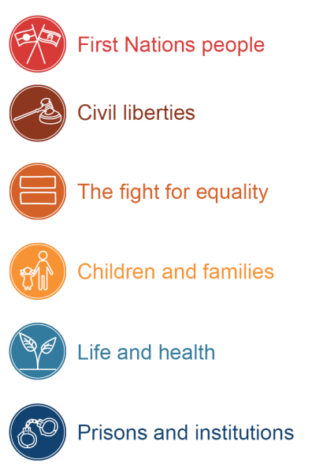

Timeline laying out significant events with human rights impacts which took place across 2021-22, including judicial decisions, parliamentary enquiries and legislation, and COVID-19 public health directions. The full text is available in Appendix D of this report. 


1. Explanatory Notes, Human Rights Bill 2018, 44
2. Section 95 of the Act requires the Attorney-General to cause an independent review of the operation of the Act up until 1 July 2023.
3. Section 96 of the Act requires the Attorney-General to cause a second independent review of the operation of the Act for the period July 2023 to July 2027.
4. The Commission has received a large volume of complaints in the last two financial years, in part due to the COVID-19 pandemic, and the wait time to assess complaints is over 6 months. Further resources have been committed to the complaints team to address this.
5. In the financial year 2020-21 the Commission received 441 human rights complaints.
6. In the same period, the Commission received 550 complaints about discrimination, sexual harassment, and other contraventions under the *Anti-Discrimination Act 1991*. Human rights complaints therefore represented nearly one-third of matters dealt with by the Commission.
7. A ‘human rights only’ complaint is one which was dealt with only under the *Human Rights Act 2019.*
8. A ‘piggy-back complaint’ is where the complaint raises issues under the *Anti-Discrimination Act 1991* and the *Human Rights Act 2019*. Under section 75 of the Human Rights Act, the Commission may decide that a human rights complaint would be more appropriately dealt with by the Commission as a complaint under the *Anti-Discrimination Act 1991*.
9. Tamara Walsh, ‘Social Housing, Homelessness and Human Rights’ (2022) 45(2) *UNSW Law Journal* 688.
10. Tamara Walsh, ‘Social Housing, Homelessness and Human Rights’ (2022) 45(2) *UNSW Law Journal* 709.