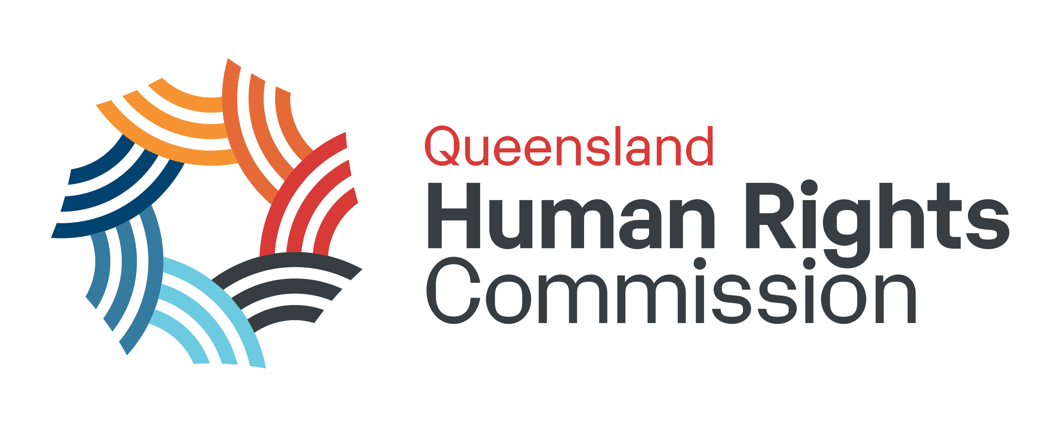

Annual Snapshot 2021-22
This document is a text summary of the information presented in the Queensland Human Rights Commission’s 2021-22 Annual Snapshot infographic.

Enquiries
6405 enquiries were received in 2021-21. This is an increase of 9% from the previous year, and over 125% in three years.
76% of enquiries came through calls to our general enquiry line. 29% of all enquiries were COVID-related.

Complaints
1870 complaints were received in 2021-22. This is an increase of 24% from 2020-21.
36% of the complaints we dealt with this year were COVID-related.
Of the complaints we were able to deal with:
- 86% included allegations of discrimination
- 35% involved alleged human rights breaches
- 11% were about sexual harassment
- 60% of discrimination complaints were about disability discrimination
- 40% of discrimination complaints and 74% of sexual harassment complaints were about work
We finalised 1568 complaints this year, up from 1145 last year. A finalised complaint is one which has been dealt with to conclusion, either through our dispute resolution process or through rejection and closure of the complaint file.
Despite the increase in finalised complaints, over 600 complaints remained awaiting assessment as at 30 June 2022. A further 300 were still in progress. As a result, many of the complaints we finalised this year were lodged in 2020-21.Of these categories, complaints awaiting assessment and those assessed but not accepted were the largest growing in 2021-22.
As at 30 June 2022, complaint outcomes in 2021-22 were:
- 203 complaints had been resolved through conciliation or early intervention.
- 148 complaints had conciliation or early intervention conducted, but the parties were not able to reach an agreement and the complaint was referred to a tribunal for a hearing.
- A further 167 were accepted but either withdrawn by the complainant before dispute resolution, or the parties were unable to reach an agreement but the complaint was not referred to tribunal.
- 1060 complaints had been assessed and either found to be something we are not able to deal with, referred elsewhere, rejected, or withdrawn.

Training
In 2021-22 we delivered 226 training sessions to 3482 participants.
By topic, the most sessions were delivered on the Human Rights Act and on workplace inclusion and diversity, followed by sexual harassment, unconscious bias, and tailored sessions. The smallest number were about the Anti-Discrimination Act, and the sessions for advocates.
There are 44,000 active users of our online learning products.
97% of training participants in 2021-22 told us they were satisfied or very satisfied with their training.

Also in 2021-22:
- We made 31 submissions to public consultations
- We appeared 13 times before parliamentary committees
- We had over 1 million views of our website
- We had 49 formal speaking engagements
- We conducted the review of Queensland’s Anti-Discrimination Act, including:
  - 120 stakeholder consultations
  - 6 roundtables
  - 4 public consultations
  - 159 submissions
  - 1100+ survey responses
- We had the equivalent of 45 full time staff across all teams and offices of the Commission as at June 2022.

