Commissioner’s foreword
This fourth annual report on the operation of Queensland’s Human Rights Act documents some impressive progress in building a human rights culture in our state’s judiciary and public service.
2022-23 saw significant growth in human rights jurisprudence, with the number of times courts considered or mentioned the Human Rights Act doubling on the previous year. Several important decisions were handed down, including a landmark decision from the Land Court recommending the refusal of a mining lease on the basis that the proposed mine would impact human rights by contributing to climate change.
Across state and local government entities there has been an increased engagement with the Act. State government departments are incorporating more human rights principles and assessments into their community consultation and their complaint handing functions, and councils can point to concrete examples where considering human rights when making decisions has led to systemic changes that have made practices or policies more compatible with human rights for everyone.
These are the kinds of impacts we look for when trying to assess the stage of development of a human rights culture in Queensland. Unfortunately, those positive developments are not mirrored across all the areas of the Act’s operation.
This reporting period we also saw the first override declarations used in state parliament, allowing significant changes to youth justice legislation to pass through parliament without the usual scrutiny given to new legislation and despite an acknowledgement that the provisions are incompatible with human rights.
Override declarations, according to the Act, are supposed to be invoked only in extreme circumstances – the examples given in the legislation are war, a state of emergency, or an exceptional crisis situation constituting a threat to public safety, health or order. In contrast, despite the clear applicability of this provision during COVID-19, the parliament showed restraint and chose not to rely on override declarations.
While I appreciate the community concern in response to high-profile and tragic events this year, the overall rate of youth offending has decreased, and removing the rights of young people in the youth justice system does not protect the rights of victims of crime or improve community safety.
Overriding the operation of the Act may have serious implications for individuals who are unable to rely on the Act’s protective mechanisms when their rights have been unreasonably limited. In the context of the importance of protecting the rights of at-risk children, the parliament’s use of the override declaration provisions is a serious setback to the realisation of the Act’s objectives of protecting and promoting human rights in Queensland.

Scott McDougall
Queensland Human Rights Commissioner

About the Commission
The Queensland Human Rights Commission (the Commission) is an independent statutory body established under the Anti-Discrimination Act 1991 (the Anti-Discrimination Act). The functions and powers of the Commission under section 61 of the Human Rights Act 2019 (Human Rights Act) are:
- to deal with human rights complaints;
- if asked by the Attorney-General, to review the effect of Acts, statutory instruments and the common law on human rights and give the Attorney-General a written report about the outcome of the review;
- to review public entities’ policies, programs, procedures, practices and services in relation to their compatibility with human rights;
- to promote an understanding and acceptance, and the public discussion, of human rights and this Act in Queensland;
- to make information about human rights available to the community;
- to provide education about human rights and this Act;
- to assist the Attorney-General in reviews of this Act under sections 95 and 96;
- to advise the Attorney-General about matters relevant to the operation of this Act; and
- another function conferred on the Commission under this Act or another Act.

About this report
Section 91 of the Human Rights Act requires that, as soon as practicable after the end of each financial year, the Commissioner must prepare an annual report about the operation of the Act during the year. The purpose of this report is to provide a resource for government, parliament, and the community on the operationalisation of the Human Rights Act and the degree to which it is achieving its objectives.
The Human Rights Act is to be independently reviewed as soon as practicable (after 1 July 2023) and in 2027. It is intended that the content of this report will provide evidence of how the Human Rights Act has operated in its early years.

Report summary
Table 1: Required information for this report under section 91 of the Human Rights Act 2019
Section | Required information
91(2)(a) | details of any examination of the interaction between this Act and other Acts, statutory instruments and the common law  For more information see Human rights and the public sector chapter.
91(2)(b) | details of all declarations of incompatibility made  No declarations of incompatibility were made in the 2022–23 financial year.
91(2)(c) | details of all override declarations made  The Strengthening Community Safety Act 2023 passed with 4 override declarations. For more information see Human rights and the parliament chapter.
91(2)(d) | details of all interventions by the Attorney-General or the Commission under section 50 or 51  The Commission intervened in 6 court matters.  The Attorney-General intervened in 12 matters.  For more information see Human Rights in courts and tribunals - Interventions section.
91(2)(e) | number of human rights complaints made or referred to the Commissioner  The Commission received 762 complaints about human rights in the financial year. The number of human rights complaints finalised in the financial year was 561. Of these, 209 were human rights only complaints and 352 were piggy-back complaints.
91(2)(f) | outcome of human rights complaints accepted by the Commissioner for resolution by the Commission, including whether or not the complaints were resolved by conciliation or otherwise  Of the 241 accepted complaints finalised in the 2022–23 financial year:  - 57 complaints were resolved  - 41 complaints were referred to the Queensland Civil and Administrative Tribunal  - 32 complaints were referred to the Queensland Industrial Relations Commission.  For more information, see Human rights complaints – Outcomes of finalised complaints and Resolved complaint case studies sections.
91(2)(g) | the number of human rights complaints resolved by the Commission  In the 2022–23 financial year, 57 complaints were resolved and finalised by the Commission, comprising 22 human rights only complaints and 35 piggy-back complaints.  For more information see Human rights complaints – Human rights complaints snapshot.
91(2)(h) | the number of conciliation conferences conducted under this part  185 conciliation conferences relating to human rights were scheduled in the 2022–23 financial year. Piggy-back complaints accounted for 137, and 48 were for human rights only complaints.
91(2)(i) | the number of public entities that were asked or directed to take part in a conciliation conference, and the number that failed to comply with a direction to take part  Most accepted complaints involved more than one respondent, and some public entities were directed to attend on more than one occasion. Overall, 392 discrete respondents were directed to take part, of which 324 were individual people, and 68 were public entities such as government departments, councils or functional public entities.  No public entities failed to comply with a direction to attend a conference in the 2022–23 financial year.  For more information, see Human rights complaints – finalised complaints by sector section.
91(2)(j) | the number of human rights complaints received by particular public entities decided by the Commissioner  This information is too detailed to reproduce in the report summary. See Human rights complaints – Complaints made directly to public entities section.
88(4) | details of action the Commissioner considers the respondent should take to ensure its acts and decisions are compatible with human rights, following an unresolved conciliation  Two reports on unresolved complaints with recommendations were made this financial year.  For more information, see Human rights complaints – Unresolved complaints with recommendations section.

Report highlights

Developing human rights case law
In 2022-23, there were significant developments in the area of human rights jurisprudence. The frequency with which courts referred to or considered the Human Rights Act more than doubled, marking a notable increase in the engagement with human rights issues among advocates, tribunals and courts. Several significant decisions offered invaluable insights to both public entities and the community on interpretation of the rights to liberty, property rights, the right to non-discrimination and the right to consent to medical treatment.
In a landmark decision, the Land Court recommended refusing a mining lease and environmental authority due to concerns about the impact on human rights, including the right to life, Aboriginal and Torres Strait Islander cultural rights, and property rights.
For more information see Human rights in courts and tribunals chapter.

Increasing influence on parliament, but Act overridden
The Queensland Parliament continued to play a crucial role in addressing human rights compatibility through the passage of primary legislation. In 2022-23, the Commission observed encouraging signs that the Human Rights Act was exerting a growing and positive influence on the parliamentary process.
Parliamentary committees assessed Bills and statements of compatibility, leading to more detailed scrutiny and some amendments being made to Bills to address human rights concerns. However, in some instances human rights issues were left unaddressed, and Bills were passed despite concerns raised by Committees.
The most concerning development was the parliament's decision to override the Human Rights Act for the first time since its introduction, in circumstances where clear justification was lacking. Under the Act, override declarations should be confined to the most exceptional circumstances such as war, a state of emergency, or an exceptional crisis situation constituting a threat to public safety, health or order. The use of override declarations effectively bypasses the usual scrutiny and assessment of human rights compatibility by committees and stakeholders. Passing override declarations undermines the accountability and transparency of the legislative process, as it prevents thorough examination of potential human rights issues, while denying affected individuals effective protection and access to remedies.
For more information see Human rights and the parliament chapter.

Growing human rights culture
In the fourth year of the operation of the Human Rights Act, state public entities have shown steady progress in cultivating a human rights culture, focusing on staff awareness and training, community engagement, and compliance in government contracts. While human rights compatibility assessments in policy development appear to be increasingly routine, there are few examples of significant policy changes based on the Act.
State government employees continue to report that they understand how the Act applies in the work, but challenges persist in identifying and reporting on human rights complaints.
The implementation of the Human Rights Act in councils initially faced challenges, leading to delays compared to state public entities, mainly due to funding and resource issues. However, there have been positive developments, including improved staff awareness through human rights training, enhanced public information dissemination, and a growing influence of human rights on local law development and complaint management within councils.
Case studies provided by state and local government entities are a positive indicator that the internal complaints process is achieving beneficial outcomes. Despite ongoing challenges, there is evidence of progress, and a commitment to converting human rights principles to practice is evident in both state and local government entities.
For more information see Human rights and the public sector chapter.

Stepping down from COVID-19 response
In November 2022, parliament passed legislation to replace the temporary COVID-19 framework with more targeted powers to manage the disease as a notifiable condition under the Public Health Act 2005 (Qld). The Commission had previously made submissions to parliament recommending changes to the temporary COVID-19 framework which granted extraordinary powers to the Chief Health Officer and emergency officers. In response to the Commission and other stakeholder’s advocacy for greater transparency and scrutiny of public health directions, including requiring a statement of compatibility with human rights, the Health Minister passed the Public Health and Other Legislation (COVID-19) Management Bill 2022. This reflects a step-down approach, acknowledging that while the COVID-19 pandemic is not over, it should be treated in line with other communicable diseases.
In the last report, the Commission expressed our hope for a shift in focus away from COVID-19, which had inevitably been the early focus for the Commission, the parliament, the government, and public discourse, during the initial years of the Human Rights Act. While the focus of the Commission’s policy and educative work has shifted away from COVID-19, the human rights complaints being dealt with by the Commission remained centred around COVID-19 related issues, representing 44% of our complaints finalised (43% last year).
However, the nature of the COVID-19 related complaints has evolved during the course of the pandemic. In previous years, the Commission’s role primarily involved aiding individuals subject to hotel quarantine, those seeking exemptions to enter Queensland during periods of border restrictions, and individuals facing challenges in adhering to mandatory mask-wearing requirements.
In the reporting period, most of the complaints the Commission was dealing with were about vaccine mandates to control the spread of COVID-19, often brought by public sector workers and sometimes in combination with other workplace issues. These disputes are often intractable and are also complicated by the fact the Supreme Court is yet to hand down several decisions currently before the court about whether vaccine mandates for public servants were compatible with human rights.

Youth justice changes
News headlines this year were dominated by changes to the government’s approach to youth justice and culminated in the parliament overriding the Human Rights Act for the first time to pass the Strengthening Community Safety Bill 2023.
Without adequate consultation, new laws were introduced in February 2023 including a new breach of bail offence for youth offenders. The Commission opposed the amendments on the basis that there was no evidence they would be effective or meet the goal of protecting the community from the small number of Queensland children engaging in harmful behaviours.
In December 2022, the numbers of children held in youth detention and police watchhouses had significantly increased, with young people spending an average of 43 nights in unsentenced detention. Throughout the reporting period, the Commission expressed escalating concerns about the practice of holding children in the watchhouse for prolonged periods because of the unacceptable risks of psychological and physical harm to young people.

Recognition and equality for LGBTQ+ Queenslanders
A significant event in the reporting period for the LGBTQ+ community was the introduction of new birth registration laws to remove unfair barriers to obtaining a change of sex on a person’s birth certificate. On 2 December 2022, the Births, Deaths and Marriages Registration Bill was introduced into parliament, and on 24 February 2023 it was recommended to be passed by a parliamentary committee.
For over a decade the Commission has advocated for updates to births registration laws, and in that period Queensland’s regime had fallen significantly behind that of most other Australian jurisdictions. The Commission welcomed the Bill which provides greater recognition of trans and gender diverse people and contemporary family and parenting structures, upholding and promoting the rights to equality, privacy, families and children.

Medical and disability support for prisoners
A theme emerging from human rights complaints this year centred around the assistance provided to prisoners with medical or disability-related support needs. In complaints brought to the Commission, prisoners sought continuity of treatment or supports they were receiving in the community through the National Disability Insurance Scheme and continued prescription of medication they were relying on.
Of the human rights only complaints made to the Commission this year, most came from corrections, representing a shift away from health and policing as the key complaint areas. Our resolved complaint case studies feature examples in which the health service operating in prison committed to addressing concerns raised by prisoners in specific instances.
On 28 June 2023, the Commission released a report as the result of an unresolved complaint on this issue. This report emphasised the pressing need for improved coordination between prison health services and Queensland Corrective Services to minimise delays in taking action to support prisoner health.

Human rights of victim-survivors
In 2022-23, the Commission observed a heightened focus on the rights of victims of crime in the media, parliamentary debate, public discourse, and inquiry recommendations. While not explicitly mentioned in the Human Rights Act, several human rights in the Act as it stands protect and promote the rights of victim-survivors, including the right to life, non-discrimination, prohibition on cruel, inhuman and degrading treatment, and the right to privacy.
The Commission considers that all people involved in proceedings in the criminal justice system should be able to participate and have their rights upheld. One helpful framing is the concept of a ‘triangulation of interests’, with the 3 rights-holders being the victim-survivor, the public, and the perpetrator.
On 1 July 2022, the Women’s Safety and Justice Taskforce’s second Hear her voice report recommended the establishment of an independent victims’ commissioner to promote and protect the victims of violent offences, with a focus on domestic and family violence, and to review both the Human Rights Act and the Victims Charter.
To mark the 2022 International Day for the Elimination of Violence against Women, the Commission presented a webinar hosted by Legal Aid Queensland about international and Queensland human rights obligations to victims of domestic and family violence. On 12 April 2023 the Commission was pleased to support a parliamentary inquiry into support provided to victims of crime and expressed our support for a dedicated victims’ commissioner as well as more explicit recognition of fair hearing rights for victims following the forthcoming review of the Human Rights Act.

Human rights timeline: 2022-23
Below is a brief timeline of some significant events relevant to the operation of the Act in its third year.
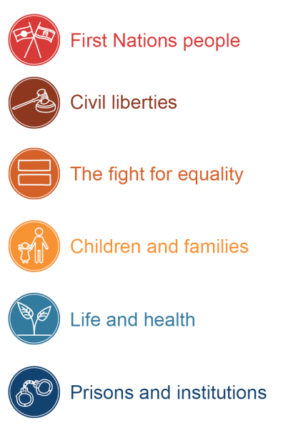

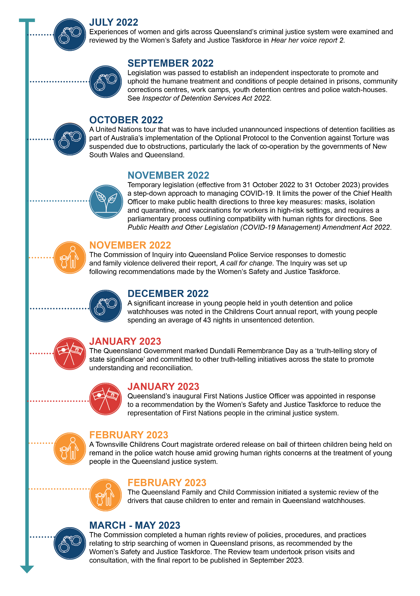
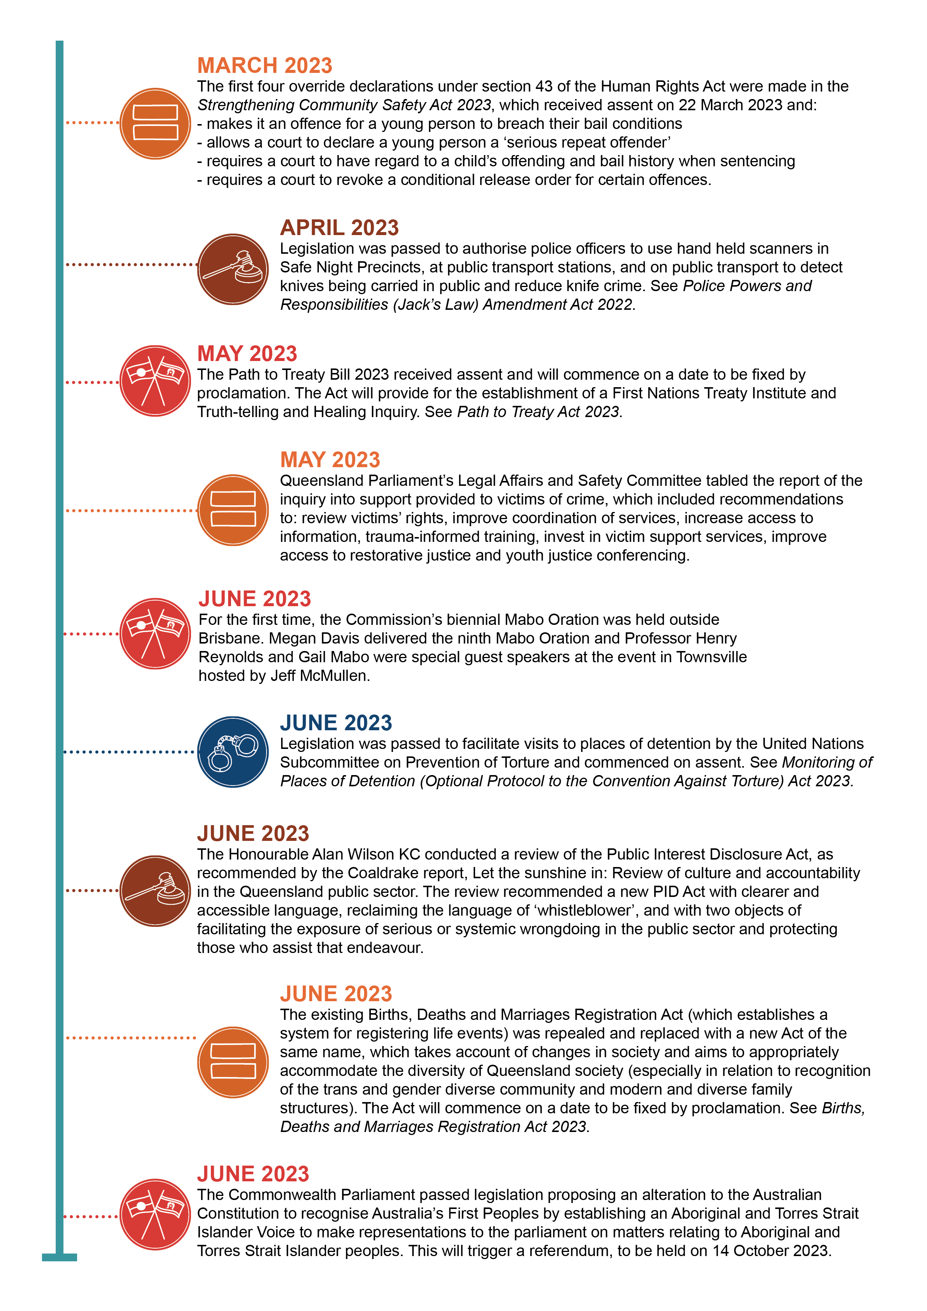

Explanatory Notes, Human Rights Bill 2018, 44.
Human Rights Act 2019 (Qld) ss 95–96.
Some matters that the Commission intervened in during previous reporting periods continued into this financial year.
Waratah Coal Pty Ltd v Youth Verdict Ltd & Ors (No 6) [2022] QLC 21.
Queensland Government, Working for Queensland survey 2022 (Highlights report – Queensland public sector, 2022) 3.
At the time of writing, this Bill has passed into law but not yet commenced.
A ‘human rights only’ complaint is a complaint about a public entity in relation to an act or decision of the public entity that is not compatible with the person’s human rights, or that proper consideration of a human right relevant to a decision was lacking, where the person is not also raising a complaint that is covered by the Anti-Discrimination Act.
The concept was initially articulated by Lord Steyn of the House of Lords in R v H [2004] 2 AC 134, 145–46.
Women’s Safety and Justice Taskforce, Hear Her Voice – Report two: Women and girls’ experiences across the criminal justice system (vol. 1, 2022) Recommendations 18–20.
Charter of Victim’s Rights is contained in schedule 1AA of the Victims of Crime Assistance Act 2009 (Qld).

