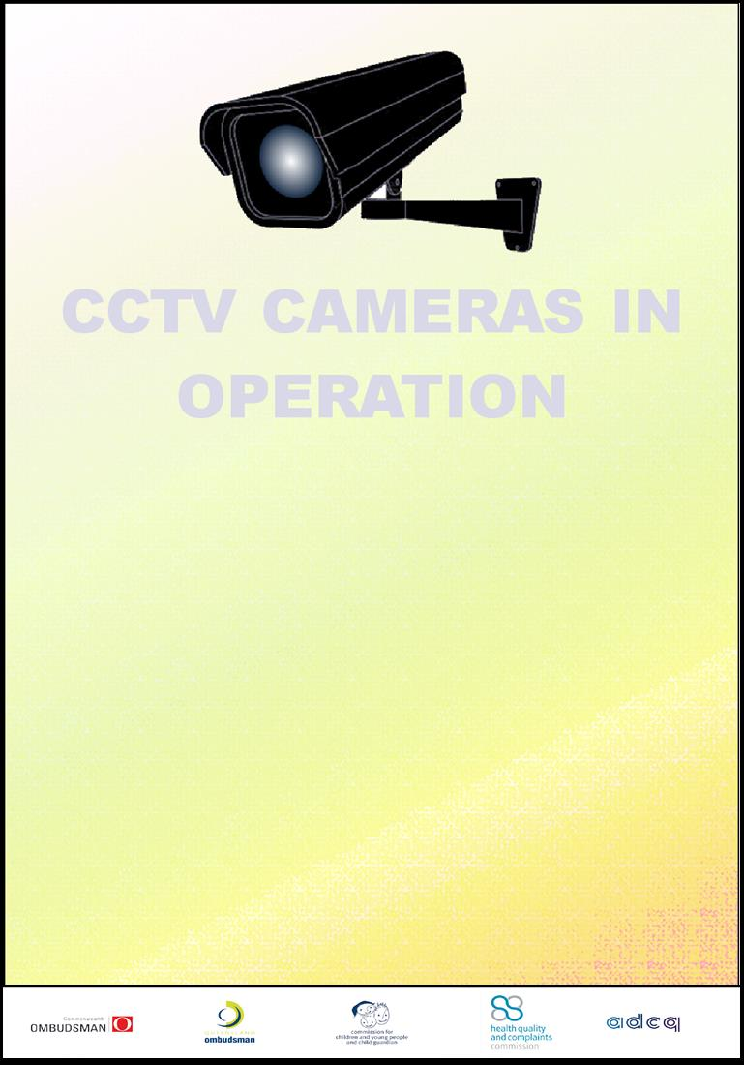

53 Albert St
Collocated Agencies
Closed Circuit Television
(CCTV) POLICY/PROTOCOL
Contents
Revision History 4
Circulated for review list 4
Approvals 4
Objective 5
Purpose – closed circuit television (CCTV) security systems 5
Scope 5
Ownership and control of the CCTV system 5
CCTV management practices 6
Performance indicators 6
Operational objectives 6
Queensland guidelines 6
Australian standards 6
Relevant legislation 6
Accountability 7
Policy/protocol for CCTV implementations 7
Implementation - closed circuit television 7
Covert images and data 7
CCTV system expansion and upgrades 8
Policy/protocol for CCTV operations 8
Access to recorded surveillance images 8
Storage and disposal of surveillance images 9
Overt surveillance images 9
Covert surveillance images 9
Public awareness and media management 10
CCTV signage 10
Public information 10
CCTV operation access controls 10
The recording of audio 10
Camera management 11
Camera selection 11
Camera risk assessments 11
Control and operation of cameras 11
Fixed cameras 11
Maintaining camera operations 11
Appendix A Definition of terms 12
Appendix B Guideline for the ethical use of the CCTV system 13
Non-compliance with the guideline 13
Ethical use of CCTV systems and recorded material 13
Confidentiality 13
Operating conditions 13
Reporting unethical use of the CCTV system 13
Appendix C: Camera Locations 14
Appendix: D List of Authorised Officers 16
Appendix E: Request for recorded CCTV footage form 18

Owner: | Di Gunton
Contact Details: | 3005 7007, dgunton@ombudsman.qld.gov.au
Division/Unit: | Queensland Ombudsman, CSU
Document Version: | V1.0
Document Status: | Final
File name: | 0000.doc

Revision History
Revision Date | Version No. | Author | Description of Change/Revision
8/8/2013 | Draft v0.2 | Gary Bryant | Initial Draft released for review
15/8/2013 | Draft v0.3 | Gary Bryant | Inclusion of review feedback
20/8/2013 | V1.0 | Gary Bryant | Final Version

Circulated for review list
Name | Title | Date | Response Y/N
Di Gunton | Manager, Corporate Services Unit, Queensland Ombudsman | 8/8/2013 | Y
Warren Edwards | Manager, Corporate Services, Anti-Discrimination Commission Queensland | 8/8/2013 | Y
Shaun Nesbitt | Manager Information Management, Health Quality Complaints Commission | 8/8/2013 | N
Amanda Carroll | Senior Advisor, Corporate Infrastructure and Procurement, Commission for Children and Young People and Child Guardian | 8/8/2013 | Y
Samantha Keenan | Commonwealth Ombudsman | 8/8/2013 | N
David McCluney | Manager (Business Services), Commission for Children and Young People and Child Guardian | 8/8/2013 | N
Dave Redmond | Senior ICT Consultant, Corporate Services Unit, Queensland Ombudsman | 8/8/2013 | N
Peter Hartmann | BSC Officer, State Government Protective Security | 8/8/2013 | N

Approvals
Name | Title | Signature | Date
Phil Clarke | Ombudsman
Di Gunton | Manager, Corporate Services Unit

Objective
This policy/protocol document sets out a framework for the application of the 53 Albert St Brisbane’s collocated agencies’ closed circuit television system (CCTV).

Purpose – closed circuit television (CCTV) security systems
The rationale for use of CCTV within the collocated agencies’ shared facilities is to provide surveillance of public or high risk areas as part of a security system. The three primary focus areas for CCTV are:
- as a deterrent to unwanted behaviour of persons
- as an aid to the detection of people, events or activities, and to assist in timely and effective response
- to gather evidentiary material.

Scope
This policy/protocol applies to all collocated agencies’ employees (permanent, temporary, casual, and contracted) and all organisations and individuals acting as its agents.
It specifically places requirements on management, other staff and/or other persons (eg. contractors) providing security services to, or on behalf of all collocated agencies.

Ownership and control of the CCTV system
The CCTV System is owned and managed in common by the collocated agencies, at 53 Albert St, Brisbane.
Under a collocation arrangement, five Queensland Government agencies are accommodated in floors 17 to 22 of 53 Albert St, Brisbane. Under agreed protocols, (see the 53 Albert St Collocation Protocols Document), the collocated agencies maintain common facilities that include:
- a security station in the ground floor foyer
- a reception area on the 17th floor
- meeting and interview rooms on the 17th floor
- training rooms on the 17th floor
- security and access control system
- duress alarms
- a 35 camera CCTV system.
The five agencies are:
Agency | Acronym
Anti-Discrimination Commission | ADCQ
Commission for Children and Young People and Child Guardian | CCYPCG
Commonwealth Ombudsman | CwO
Health Quality Complaints Commission | HQCC
Queensland Ombudsman | QO
The collocated agencies will conduct CCTV operations in accordance with this policy/protocol document and authorised officers will abide by the guideline for the ethical use of the CCTV system, (see Appendix B Guideline for the ethical use of the CCTV system).
The collocation agencies’ policy/protocol establishes the purpose and control parameters set by the collocation agencies, in order to achieve the following:
- manage CCTV operations in compliance with Australian standards 4802:2006, parts 1 – 4, and future or superseding standards
- manage CCTV operations in compliance with Queensland and Australian legislation and amendments which may affect the use of CCTV and recorded material. The relevant and primary areas of compliance are Information Privacy, Right to Information and the Public Records Acts
- operate, use and maintain CCTV operations in accordance with the guideline for the ethical use of the CCTV system
- operate, use and maintain CCTV operations to maintain effective oversight of monitoring, review, auditing and reporting.

CCTV management practices

Performance indicators
Establishing clear and concise performance indicators for CCTV operations will allow effective reporting and monitoring of system efficacy and quickly highlight trends concerning fundamental operations, which may require early intervention or closer monitoring by collocated agency management.
The collocated agencies’ CCTV operation performance indicators are to include the following:
- percentage time live monitoring was undertaken
- number of incidents detected, and a breakdown of whom they relate too
- number of incidents responded too
- number of requests/applications for recorded material
- time frame for responding to applications for recorded material
- number of requests for maintenance or system repair.

Operational objectives
The objectives established for CCTV operations should be based on measurable criteria, as follows:
- Contract performance indicators:
- maintenance undertaken within timeframes of contractual obligations
- repairs and response times undertaken within timeframes of contractual obligations

Queensland guidelines
The collocated agencies will comply with the following CCTV related guidelines:
- Queensland State Archives’ “Managing Closed Circuit Television (CCTV) Records Guideline for Queensland Public Authorities”
- Queensland’s Office of the Information Commissioner Information Privacy Act 2009 Privacy compliance and camera surveillance.

Australian standards
The collocated agencies will comply as far as practicable with Standards Australia’s CCTV standard AS 4806.1–2006:
- AS 4806.1–2006–Closed circuit television (CCTV)–Part 1: Management and operation
- AS 4806.2–2006–Closed circuit television (CCTV)–Part 2: Application guidelines
- AS 4806.3–2006–Closed circuit television (CCTV)–Part 3: PAL signal timings and levels
- AS 4806.4–2008–Closed circuit television (CCTV)–Part 4: Remote video
- AS 2201.1:2007 Security Installations
- AS/ACIF S009:2008 Cabling Provider Rules.

Relevant legislation
The collocated agencies’ CCTV operations will be conducted in accordance with State Legislative requirements, which includes:
- Public Records Act 2002
- Information Standard 40: Recordkeeping
- Information Standard 31: Retention and Disposal of Public Records
- Information Privacy Act 2009
- Right to Information Act 2009
- Crime and Misconduct Act 2001
- Security Providers Act 1993
- State Buildings Protective Security Act 1983.

Accountability
The collocated agencies will evaluate CCTV operations annually to identify whether its purposes are being complied with and whether objectives are being achieved.
Resources committed to CCTV operations will include the cost of evaluations.
Evaluation of CCTV operations will include, as a minimum:
- assessment of its meeting the purposes of the above policy/protocol statement “Purpose – Closed Circuit Television (CCTV) Security Systems”, That is:
- has the collocated agencies’ CCTV system acted as a deterrent to unwanted behaviour of persons
- where incidents have occurred, has the system effectively aided in the:
- detection of people, events or activities, and assisted in timely and effective response
- gathering of evidentiary material
- the views of the stakeholders on the operation of the CCTV system
- compliance with the guideline for the ethical use of the CCTV system, policy/protocols and operating procedures
- whether the purposes for which the CCTV operation was established still exist
- whether or not the CCTV policy/protocol and other CCTV related documentation require renewal and/or update.
The results of evaluations will be considered by the collocated agencies for future management and functioning of CCTV operations, and the collocated agencies will agree to fund resources to undertake any agreed remedial actions.

Policy/protocol for CCTV implementations

Implementation - closed circuit television
The collocated agencies will apply the following policies/protocols when implementing CCTV facilities:
- toilets, showers and change rooms shall not be subject to CCTV surveillance
- conspicuous signs (plain language and/or recognisable icons) shall be displayed where overt CCTV surveillance is being conducted
- staff responsible for surveillance shall be trained in the ethical conduct and use of CCTV surveillance systems
- monitoring of CCTV images may be conducted on or away from the facility or workplace
- installation of CCTV systems or electronic devices capable of connection to the public telecommunications network should be undertaken by an installer holding a current Australian Communications Authority (ACA) licence or registration
- CCTV images, which may be used as evidence in a court, shall meet acceptable standards. The content of images should be clear and contain a creation date, data and time stamp, proof of non-tamper and verification methodology.

Covert images and data
- In exceptional circumstances, covert surveillance may be required where there is a concern in relation to the security of an area or there is suspected criminal activity or undertaking.
- Approval in writing shall be given by authorised officers from the agency, or agencies, impacted prior to installation of covert CCTV systems on the collocated agencies’ property or within the workplace.
- When seeking written approval to undertake covert CCTV the following information shall be provided to the authorised officers from the agency, or agencies, impacted:
- the evidence based grounds for the request (e.g. specific person or persons may be involved in unlawful activities)
- details of any other managerial or investigative actions which have already been conducted
- who or what will be in view of the camera
- proposed dates and times of surveillance (not to be open ended).
- Any written approval given by the authorised officers from the agency, or agencies, impacted, will remain in force for a maximum of 30 days and shall not be used for any other purpose.

CCTV system expansion and upgrades
Where an agreement is reached to extend the CCTV system or coverage, the collocated agencies agree to take the following actions:
- at the outset, the collocated agencies will identify and agree on primary aims and associated issues that must be addressed to achieve those aims
- they will identify and plan for resource implications, including deciding the commitment levels of resourcing that will be provided by each stakeholder
- they will agree to the extent of involvement and respective responsibilities of each stakeholder
- they will establish protocols to govern the process for decision making both in establishing the system within the area and for the ongoing management of the system
- they will establish operational procedures for the management of the system and, as appropriate, implement protocols for monitoring and auditing of the system, as it affects those areas.

Policy/protocol for CCTV operations
The collocation agencies’ policy/protocol provides for the manner in which the CCTV operation will be operated, managed and reported to the collocation agencies’ Commissioners or Ombudsmen.
CCTV Management practices will ensure CCTV operations are conducted in accordance with the following policy/protocol statements:
- the CCTV System will be operated within applicable laws, and for the ethical and beneficial purposes for which it is established or which are subsequently agreed in accordance with these approved policy/protocol statements
- the CCTV System will be operated with due regard to the privacy and civil liberties of individual members of the public, and the collocated agencies
- the public interest in CCTV operations will be recognised by ensuring the security and integrity of recorded material
- all stakeholders and authorised officers will act in accordance with the CCTV operation's guideline for the ethical use of the CCTV system
- the collocated agencies will be accountable to its stakeholders for the effective management and control of CCTV operations
- CCTV operations will be monitored and evaluated to verify compliance and report annually on its performance
- the retention of, and access to any recorded material will only be for the purposes provided by CCTV policy/protocol statement “Purpose – Closed Circuit Television (CCTV) Security Systems”.

Access to recorded surveillance images
- Strict limitations shall be placed on access to and retention of recorded CCTV images. Persons wishing to view recorded images must first gain written authorisation from the authorised officers, from the agency relating to the recorded image. This should be done using the form in Appendix E: Request for recorded CCTV footage form. In determining whether authority is to be granted, the authorised officers, shall be satisfied that the reasons provided by the employee are lawful and reasonable. Consideration shall also be given to protecting the rights of other persons captured on the CCTV recording.
- Authorised persons or agencies may exercise their legislative powers and may view and obtain copies of CCTV images.
- If during the undertaking of surveillance (whether overt or covert) it is recognised or suspected that a criminal offence or official misconduct has occurred, the appropriate agency shall be advised accordingly.
- Access to overt surveillance images shall be restricted to the authorised officers from the collocated agencies and those employees authorised to monitor or operate the surveillance equipment as a normal part of their duties.
- Access to covert surveillance images shall be limited to the authorised officers, from the agency, or agencies, impacted, the security officer/operator conducting the surveillance and the person or agency authorised in writing to conduct the surveillance.
- Subject to the written approval of the authorised officers from the agency, or agencies, impacted, employees and/or their legal representatives may be permitted to view available recorded CCTV images subject to fulfilling the requirements of this Protocol.
- Where recorded images establish an employee’s involvement in misconduct or unlawful activity, the Commissioner or Ombudsman, or authorised officers, from the agency, or agencies, impacted may be required to provide the recorded images to appropriate law enforcement agencies.
- Subject to limitations of criminal investigations, where disciplinary action against an employee is proposed, the employee and their union and/or legal representatives may be entitled access to a copy of the relevant sections of the recorded CCTV images where it is to be submitted into evidence. In instances where the CCTV images relate to alleged criminal proceedings, authority and permission to view or obtain a copy of the data shall be via the lead agency or investigating authority. Where the matter relates to possible disciplinary action, permission and approval shall be obtained via the relevant agency’s Commissioner or Ombudsman, or authorised officers.

Storage and disposal of surveillance images
Note: In theory this area covers all recorded CCTV images including:
- those images held on the CCTV system’s infrastructure and regularly overwritten
- those images extracted and held by the Building Services Coordinator (BSC) and/or individual agencies.
However, in practice this section only applies to point 2 as those records held under point 1 are managed under separate mechanisms.
- The Commissioner or Ombudsman, or authorised officer, from the agency, or agencies, impacted shall be responsible for the secure storage of CCTV surveillance images.
- Each collocated agency will ensure that their record management system’s policies and procedures, and their disposal and retention schedules are adapted to incorporate the appropriate handling of primary, original and working versions of CCTV images.
- The impacted collocated agency will provide and ensure that encrypted and/or password protected portable storage media (e.g. password protected and encrypted USB), is provided to and used by the authorised officer transferring original and working versions of CCTV images off the CCTV system.

Overt surveillance images
- Overt primary surveillance images shall be stored in the 17 floor data centre, and secured from unauthorised access.
- Overt primary surveillance images shall be stored for a minimum period of 31 days, unless otherwise directed by the Commissioners or Ombudsmen from the collocated agencies.
- Collocated agencies that take possession of overt original or working images shall secure them from lose and damage and unauthorised access, as per their record management system’s policies and procedures.

Covert surveillance images
- Covert primary surveillance images shall be stored in the 17 floor data centre, and secured from unauthorised access. Access should be limited and strictly controlled and a CCTV image access register maintained. As soon as practicable, original covert surveillance images should be recorded and copied off the 17 floor data centre equipment and handed over to the relevant agency, or agencies, for safe keeping. If possible, the primary covert image should then be removed from the 17 floor data centre equipment.
- The Commissioner or Ombudsman, or authorised officer, from the agency, or agencies, impacted shall ensure the original covert surveillance images are secured in a lockable unit in an area where access can be limited and strictly controlled, and a CCTV image access register maintained.
- Original covert surveillance images not containing images of an employee’s involvement in misconduct or unlawful activity shall be destroyed within 31 days of the Commissioner or Ombudsman from the agency, or agencies impacted, written authority’s expiry date.
- Original covert surveillance images that are used as evidence in proceedings against an employee and which form a part of their disciplinary file will be retained in accordance with the impacted agencies’ disposal and retention schedules.

Public awareness and media management

CCTV signage
The collocated agencies’ installation and management of CCTV signage will be conducted in accordance with the following policy/protocol statements:
- signs will be sited to inform the public that cameras are in operation and promote easy readability, including for those who may be influenced by drugs or alcohol
- signs will identify the owner of the CCTV system, including contact details
- signs will be mounted as close as practical to an adult’s line of sight. For a standing adult this will be approximately five degrees up or down from a point 1500mm above the ground level in front of the observer (approximately 1700mm above the ground).
- care will be taken to ensure that signs are not placed close to other unrelated signs, i.e. not safety related, which may limit the ability for the information to be processed and understood. In addition, area access signage should be located to encourage the public to read and recognise the sign and therefore be placed at consistent locations, where possible, for recognition purposes
- signs will be regularly inspected for damage and effectiveness by authorised officers, and promptly replaced if compromised.

Public information
Each collocated agency will make available the following management documents on their internet, namely:
- CCTV policy/protocol statements
- CCTV guideline for the ethical use of the CCTV system
- Complaint procedures

CCTV operation access controls
Operational access to the collocated agencies’ CCTV system will be restricted to authorised officers and will be protected from unauthorised access.
The collocated agencies will implement the following:
- a requirement that authorised officers conducting live surveillance must be licensed, qualified at a suitable level on appointment and be capable of meeting in-service training requirements
- a procedure which makes plain that authorised officers risk disciplinary proceedings if they breach any of the provisions of the guideline for the ethical use of the CCTV system
- a requirement of confidentially which can be enforced during and after termination of employment
- plans of monitoring and supervision that ensure compliance with standard operating procedures
- access to the collocated agencies’ CCTV system will be limited to collocated agency authorised officers with a defined responsibility.

The recording of audio
There is no use of foreseen use of audio recording with the collocated agencies’ CCTV system. However, before audio recording is introduced, policy/protocol for its proper use must be defined.

Camera management

Camera selection
The selection criteria for each camera placement and location should be documented and the effectiveness of the installation should be measurable and reviewed annually.
The location of the cameras should be clearly apparent to the public with CCTV Signage in the reasonable and/or immediate vicinity of each camera, (see Appendix C: Camera Locations).
A replacement or upgrade program based on system value should be implemented for the proceeding three to five years.

Camera risk assessments
The collocated agencies will undertake a risk assessment when installing new CCTV cameras. For instance, it is important to recognise how the CCTV camera will influence the consequences of any particular risk event which will impact in different ways within the target area. Financial costs, personal harm (physical and psychological), legal consequences and damage to reputation may all result from a single incident.

Control and operation of cameras

Fixed cameras
Fixed cameras should be selected for defined fields of view which have a designated and defined purpose, either to detect, recognise or identify.

Control of PTZ cameras
Cameras will not be used to look into or monitor adjacent or nearby premises or buildings, unless it is explicitly for following (in real time) participants in a 'situation of concern', which originated in the public domain.
Any misuse is to be treated as a breach of the guideline for the ethical use of the CCTV system and possibly subject to disciplinary action.
Only authorised officers will have access to camera operating controls.
All authorised officers will be made aware that recordings are subject to routine audit and they will be required to justify their interest in a particular member of the public or other person.

Maintaining camera operations
The collocated agencies will provide a maintenance regime for the CCTV system that will include:
- maintenance of CCTV recording equipment in a fully functional working order
- maintenance of clear, recorded vision from each camera at all times with records of down times
- monitoring for obstructions (boxes, furniture, screens and building fit outs) and report on treatments against obstructions
- ensuring any equipment fault is recorded and attended to in the shortest possible time frame.

Appendix A Definition of terms
Term | Definition / Explanation / Details
Activities | Workplace operations, processes or functions for the safe and effective delivery of healthcare services.
Authorised Officer | A person authorised by an impacted collocation agencies’ Commissioner or Ombudsman, or their delegate, to operate the collocated CCTV system, or perform other CCTV related duties, as defined in Appendix:D List of Authorised Officers.
Closed Circuit Television (CCTV) | A television system that transmits images on a ‘closed loop’ basis, where images are only available to those directly connected to the transmission system. The transmission of closed circuit television images may involve the use of coaxial cable, fibre-optic cable, telephone lines, IP networks, infra-red and radio transmission systems.
CCTV operations | All aspects of CCTV surveillance management, use, recording, maintenance and access to recorded material.
Covert images and data | Covert surveillance is where:  - the employees have not been notified before the intended surveillance is conducted  - cameras or evidence of their existence are not clearly visible at the workplace  - there are no clearly visible signs at the entrance to the workplace to notify people that they may be under CCTV surveillance.
Operator (security) | Is the person specifically designated and authorised by the owner of a CCTV system to carry out the physical operation of controlling that system.
Owner (security) | Is the legal person or entity designated as having overall responsibility for the formulation and implementation of the policies, purpose and control of a CCTV system.
Security | The preparedness, protection and preservation of people, property and information, both tangible and intangible.
Security equipment and technologies | The physical security element of protective security.
Security incident | Any event or circumstance involving or affecting the individual or organisation that causes or is likely to cause a loss (physical or otherwise), disruption, or fear arising from the deliberate activities of other parties. Where impacts are, or could potentially be realised against people, property or information.
Technical surveillance | Refers to the use of electronic security equipment (closed circuit television or video monitoring) to monitor vulnerable areas.
Workplace | A place where work is carried out for a business or undertaking and includes any place where a worker goes, or is likely to be, while at work. The term “place” includes a vehicle, vessel, aircraft or other mobile structure.
Primary images | The first instance in which an image is recorded onto any media. The primary image is generally overwritten after a specified period of time, when the footage could be considered to have no further administrative use.
Original images | Exact binary copy of the Primary Image. There can be a number of Original Images. While the file name can be changed, the actual image data must remain exact.
Working images | A copy of the original or primary image. This may involve applying processes that change file format or Original Image data in any way (including compression, enhancement, filtering, cropping, etc.)

Appendix B Guideline for the ethical use of the CCTV system
This guideline has been developed to ensure that the highest ethical standards are maintained by all authorised officers who operate the 53 Albert St, Brisbane collocated agencies’ CCTV system.
Authorised officers are:
- staff, of the agencies, or other persons, (e.g. CCTV technical support personnel), authorised by the Commissioner or Ombudsman, or their delegate, or
- authorised by the Collocated Agencies Committee.

Non-compliance with the guideline
CCTV operations require high standards of integrity and honesty. As a consequence, unethical use of the CCTV system could result in disciplinary action as provided for in the collocated agencies’ codes of conduct.

Ethical use of CCTV systems and recorded material
The collocated agencies have the highest expectation of all authorised officers to:
- at all times, act in an honest and legal manner when operating the CCTV system
- treat all live and recorded images in an ethical manner and with the utmost of care, respect and dignity
- interact with all stakeholders in a timely, courteous and cooperative manner.

Confidentiality
The collocated agencies expect authorised officers to ensure confidentiality of information gathered by or from CCTV operations by not disclosing or discussing any events with unauthorised personnel or associates who have no direct responsibility relating to CCTV operations.
In addition, authorised officers will explicitly not identify any involved person or party with family, friends, or acquaintances and will not disclose any information to third parties, including the media without prior written approval in accordance with CCTV operation policy/protocol.

Operating conditions
Written reports documenting the recording or reporting of situations of concern, will take place as soon as practicable. Reports must be written in simple, non-offensive English that will not cause offense or embarrassment should the record be made public or subpoenaed.
In the course of carrying out duties, CCTV operations must not be used for personal benefit or invade individual or group privacy. Cameras should only be used in accordance with policy/protocol statement “Purpose – Closed Circuit Television (CCTV) Security Systems” and have priority for when there is an operational necessity or a reasonable belief that an offence has or is likely to occur.
Recorded material shall only be released when requested in writing on an approved and authorised application.
Recorded material shall not be copied or taken from the CCTV system without an approved written and authorised application.
All copies of recorded material must only be copied or be taken from the CCTV system on an encrypted and/or password protected device.
CCTV operational records (hard copy or electronic) can only be destroyed with written authorisation and in accordance with approved procedures.

Reporting unethical use of the CCTV system
Should any person become aware that an officer of the collocated agencies work behaviour is or was inappropriate, and the incident has not been dealt with through normal supervisory procedures, then the person is obliged to report the incident to their manager, Commissioner/Ombudsman, or the Collocation Agencies Committee.
I have read and understood the CCTV operation's guideline for the ethical use of the CCTV system.

NAME: ..........................................................................

SIGNATURE:............................................................................ DATE:.......................................

Appendix C: Camera Locations
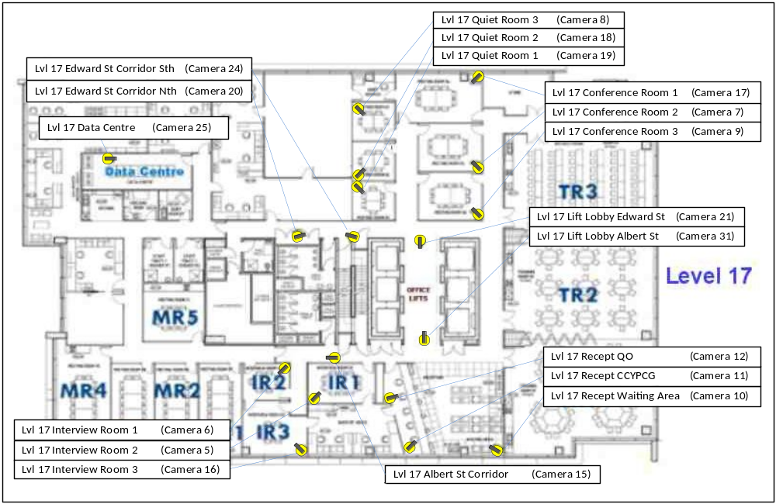

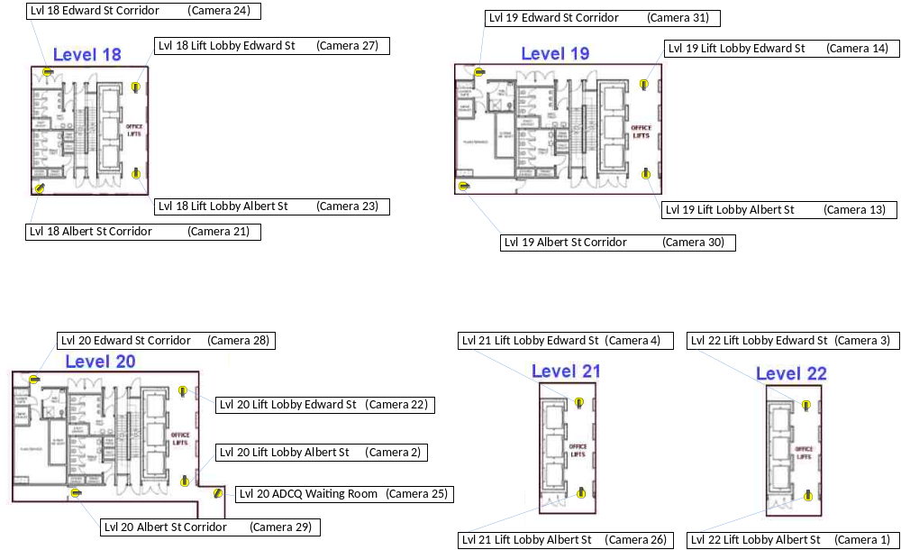

Appendix: D List of Authorised Officers
Officer | Level of authorisation
Ombudsmen and Commissioners | - Covert surveillance  - the authorisation of the undertaking covert CCTV surveillance  - the authorisation of the viewing of covert CCTV footage relevant to their agency  - the authorisation of the extraction and handing over of covert CCTV footage relevant to their agency  - the definition of covert CCTV footage’s expiry date relevant to their agency  - the viewing of covert CCTV footage relevant to their agency  - the authorisation of CCTV related policies, protocols, procedures and forms  - the authorisation of modifications, enhancements or other CCTV relate initiatives  - the authorisation of who has authorisation, and the level of that authorisation  - the authorisation of the extraction and handing over of CCTV footage relevant to their agency  - the authorisation of the viewing of CCTV footage relevant to their agency  - the viewing of CCTV footage relevant to their agency  - the viewing of live CCTV footage
Collocation committee members | - As delegates of their Ombudsman or Commissioner  - the authorisation of CCTV related policies, protocols, procedures and forms  - the authorisation of modifications, enhancements or other CCTV relate initiatives  - the authorisation of who has authorisation, and the level of that authorisation  - the authorisation of the extraction and handing over of CCTV footage relevant to their agency  - the authorisation of the viewing of CCTV footage relevant to their agency  - the viewing of CCTV footage relevant to their agency  - the viewing of live CCTV footage
Building Services Coordinator (BSC) | - the operation of the CCTV system  - the viewing of live CCTV footage  - the viewing and searching of CCTV footage  - the authorised extraction and handing over of CCTV footage  - the authorised undertaking of covert CCTV surveillance  - the authorised deletion of CCTV footage  - the authorised deletion of covert CCTV footage  - the authorised viewing of covert CCTV footage
Registration and preliminary assessment (RAPA) staff of the Office of the Queensland Ombudsman | - the viewing of live CCTV footage of a defined set of CCTV cameras
Venue co-ordinator and assistant venue co-ordinator, from the Office of the Queensland Ombudsman | - the viewing of live CCTV footage  - Inspection and maintenance of CCTV warning signs  - CCTV maintenance and support coordination
Access control system support officer (Advisor, Corporate Infrastructure and Procurement), from the Commission for Children and Young People | - the viewing of live CCTV footage  - Inspection and maintenance of CCTV warning signs
Reception staff, from the Office of the Queensland Ombudsman | - the viewing of live CCTV footage  - Inspection and maintenance of CCTV warning signs
Reception staff, from the Commission for Children and Young People | - the viewing of live CCTV footage  - Inspection and maintenance of CCTV
Info technology support staff of the collocation agencies  - Senior ICT consultant, from the Office of the Queensland Ombudsman  - Desktop support officer, from the Office of the Queensland Ombudsman  - Network Systems Engineer, from the Health Quality and Complaints Commission  - Senior Systems Support Officer, from the Health Quality and Complaints Commission | - As may be necessary in the undertaking of CCTV system support  - the operation of the CCTV system  - the viewing of live CCTV footage  - the viewing and searching of CCTV footage  - the authorised extraction and handing over of CCTV footage  - establishing the authorisation of who has authorisation, and the level of that authorisation  - maintenance, enhancement and support of the CCTV system’s technical infrastructure  - CCTV maintenance and support coordination
Trident Security technical support staff | - As may be necessary in the undertaking of CCTV system support  - the operation of the CCTV system  - the viewing of live CCTV footage  - the viewing and searching of CCTV footage  - the authorised extraction and handing over of CCTV footage  - establishing the authorisation of who has authorisation, and the level of that authorisation  - maintenance, enhancement and support of the CCTV system’s technical infrastructure
Law enforcement agencies | - the authorisation of the extraction and handing over of CCTV footage relevant to lawful investigations deriving from the Acts the law enforcement agencies operate under.

Appendix E: Request for recorded CCTV footage form
53 Albert St Collocated Agencies’
Request for Recorded CCTV Footage For
(Page 1) To be completed by the requester
Requesting Collocated Agency or Law Enforcement Agency:
To be completed by the requester
Requester’s: | Name:
Requester’s: | Position:
Requester’s: | Contact Number:
Requester’s: | eMail Address:
Date request lodged: |  | Time request lodged:

Request Details:
Reason for request:
(eg. The nature and description of incident)
Requested footage:
Date: |  |  | Start time: |  | Duration:  (in minutes)
From an RTI Request? | Yes: |  | RTI reference
Are staff from other agencies likely to be captured on the footage? | Yes:  No:  If Yes, then please tick the other agencies. |  | Anti-Discrimination Commission Queensland  Commission for Children and Young People and Child Guardian  Commonwealth Ombudsman  Health Quality Complaints Commission  Queensland Ombudsman
Please describe the incident or scenario that you are requesting footage of:
(This will assist the CCTV authorised officer recover the correct footage from the correct camera. However, it is not compulsory to provide this information)

Please tick the cameras listed below that you think cover the footage you are requesting
Collocated Agencies’ CCTV System’s Cameras:
Lvl 17 Recept Waiting Area | Lvl 17 Quiet Room 1 | Lvl 18 Lift Lobby Edward St | Lvl 20 Lift Lobby Edward St
Lvl 17 Recept CCYPCG | Lvl 17 Quiet Room 2 | Lvl 18 Lift Lobby Albert St | Lvl 20 Lift Lobby Albert St
Lvl 17 Recept QO | Lvl 17 Quiet Room 3 | Lvl 18 Edward St Corridor | Lvl 20 Edward St Corridor
 |  | Lvl 18 Albert St Corridor | Lvl 20 Albert St Corridor
Lvl 17 Interview Room 1 | Lvl 17 Data Centre |  | Lvl 20 ADCQ Waiting Room
Lvl 17 Interview Room 2 |  | Lvl 19 Lift Lobby Edward St
Lvl 17 Interview Room 3 | Lvl 17 Lift Lobby Edward St | Lvl 19 Lift Lobby Albert St | Lvl 21 Lift Lobby Edward St
 | Lvl 17 Lift Lobby Albert St | Lvl 19 Edward St Corridor | Lvl 21 Lift Lobby Albert St
Lvl 17 Conference Room 1 | Lvl 17 Edward St Corridor Nth | Lvl 19 Albert St Corridor
Lvl 17 Conference Room 2 | Lvl 17 Edward St Corridor Sth |  | Lvl 22 Lift Lobby Edward St
Lvl 17 Conference Room 3 | Lvl 17 Albert St Corridor |  | Lvl 22 Lift Lobby Albert St
Building Owner’s CCTV System’s Cameras:
Ground Floor Foyer | Goods Lift

Authoriser’s | Name: |  | Signature: (If Paper Form)
 | Position:
 | Contact Number:
 | Email Address:

53 Albert St Collocated Agencies’
Request for Recorded CCTV Footage Form
(Page 2) To be completed by the CCTV authorised officer
Request received by CCTV Authorised Officer (Name):  To be completed by the CCTV authorised officer |  | Signature of Receiving CCTV Authorised Officer: (If Paper Form)

Extracted footage:
Date: |  | Start time: |  | Duration: (in minutes)
Please tick the cameras listed below from which footage was extracted

Collocated Agencies’ CCTV System’s Cameras:
Lvl 17 Recept Waiting Area | Lvl 17 Quiet Room 1 | Lvl 18 Lift Lobby Edward St | Lvl 20 Lift Lobby Edward St
Lvl 17 Recept CCYPCG | Lvl 17 Quiet Room 2 | Lvl 18 Lift Lobby Albert St | Lvl 20 Lift Lobby Albert St
Lvl 17 Recept QO | Lvl 17 Quiet Room 3 | Lvl 18 Edward St Corridor | Lvl 20 Edward St Corridor
 |  | Lvl 18 Albert St Corridor | Lvl 20 Albert St Corridor
Lvl 17 Interview Room 1 | Lvl 17 Data Centre |  | Lvl 20 ADCQ Waiting Room
Lvl 17 Interview Room 2 |  | Lvl 19 Lift Lobby Edward St
Lvl 17 Interview Room 3 | Lvl 17 Lift Lobby Edward St | Lvl 19 Lift Lobby Albert St | Lvl 21 Lift Lobby Edward St
 | Lvl 17 Lift Lobby Albert St | Lvl 19 Edward St Corridor | Lvl 21 Lift Lobby Albert St
Lvl 17 Conference Room 1 | Lvl 17 Edward St Corridor Nth | Lvl 19 Albert St Corridor
Lvl 17 Conference Room 2 | Lvl 17 Edward St Corridor Sth |  | Lvl 22 Lift Lobby Edward St
Lvl 17 Conference Room 3 | Lvl 17 Albert St Corridor |  | Lvl 22 Lift Lobby Albert St
Building Owner’s CCTV System’s Cameras:
Ground Floor Foyer | Goods Lift

Location of extracted footage: |  | Workstation footage stored on: | Ground Floor
Location of extracted footage: |  | Workstation footage stored on: | 17th Floor
Name of extracted footage: |  | Snap shots taken?  Yes:  If Yes, list snap shots taken.
Footage extraction media | USB  DVD  CD  Other  If other; please describe: | Encrypted:  Password:  Password | Footage extraction media’s name or identifier:

Collocated Agency or Law Enforcement Agency that the extracted footage is being given to:
Extracted footage receiver’s: | Name:
Extracted footage receiver’s: | Position:
Extracted footage receiver’s: | Contact Number:
Extracted footage receiver’s: | Email Address:
Date extracted received: |  | Time extracted received:
Receiver’s Signature:
(If Paper Form)

