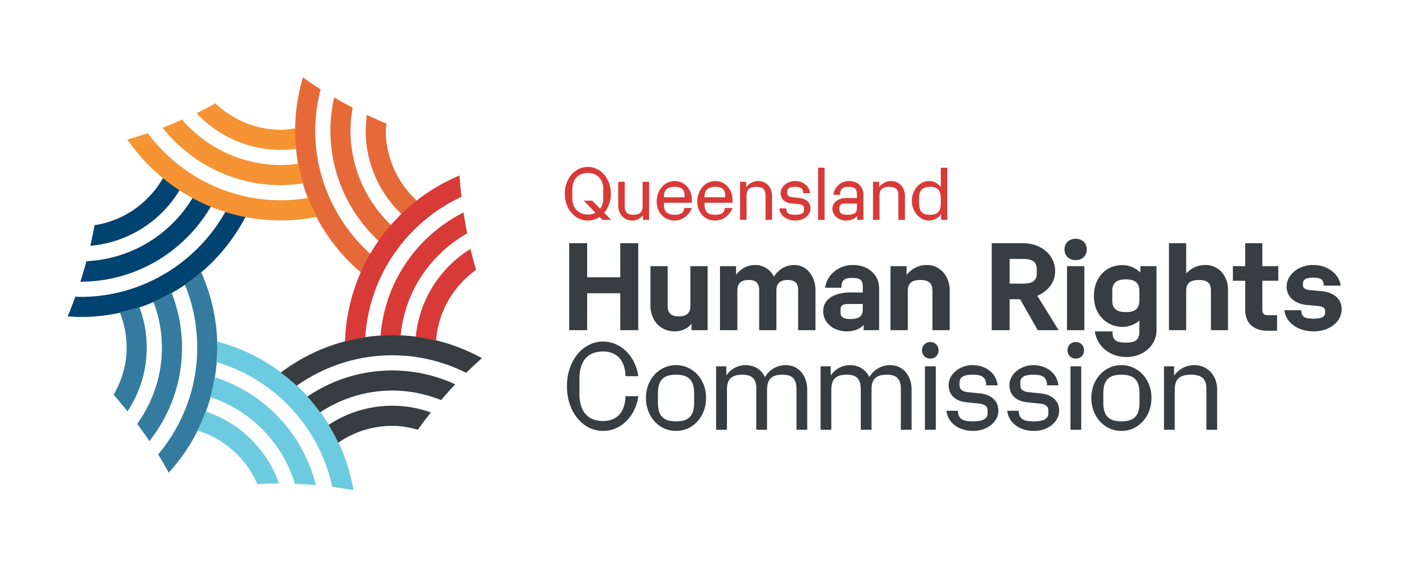

Annual Snapshot 2022-23
This document is a text summary of the information presented in the Queensland Human Rights Commission’s 2022-23 Annual Snapshot infographic.

Enquiries
3829 enquiries were received in 2022-23. This is a decrease of 40% from the previous year, back to pre-pandemic levels.
90% of enquiries came through calls to our general enquiry line. This year just 2.5% of all enquiries were COVID-related, compared with 29% the year before.

Complaints
1860 complaints were received in 2022-23, almost the same as last year’s 1870.
24% of the complaints we dealt with this year were COVID-related.
Of the complaints we were able to deal with:
- 84% included allegations of discrimination
- 39% involved alleged human rights breaches
- 8% were about sexual harassment
- 65% of discrimination complaints were about disability discrimination
- 43% of discrimination complaints and 80% of sexual harassment complaints were about work
We finalised 1653 complaints this year, up from 1568 last year. A finalised complaint is one which has been dealt with to conclusion, either through our dispute resolution process or through rejection and closure of the complaint file.
Despite the increase in finalised complaints, some complaints remained awaiting assessment as at 30 June 2022, and others were still in progress. As a result, many of the complaints we finalised this year were lodged in 2021-22.
As at 30 June 2022, outcomes of the complaints we finalised in 2021-22 were:
- 216 complaints had been resolved through conciliation or early intervention.
- 188 complaints had conciliation or early intervention conducted, but the parties were not able to reach an agreement and the complaint was referred to a tribunal for a hearing.
- A further 200 were accepted but either withdrawn by the complainant before dispute resolution, or the parties were unable to reach an agreement but the complaint was not referred to tribunal.
- 1049 complaints had been assessed and either found to be something we are not able to deal with, referred elsewhere, rejected, or withdrawn.

Training
In 2021-22 we delivered 275 training sessions to 4341 participants.
By topic, the most sessions were delivered on workplace inclusion and diversity, followed by those about the Anti-Discrimination Act, the Human Rights Act, sexual harassment, and unconscious bias. The smallest number were tailored sessions, and the sessions for advocates.
There are 60,000 active users of our online learning products.
95% of training participants in 2022-23 told us they were satisfied or very satisfied with their training.

Also in 2021-22:
- We made 22 submissions to public consultations
- We concluded our review of Queensland’s Anti-Discrimination Act and handed the final report to the Attorney-General, containing 122 recommendations to strengthen discrimination law
- We held the Mabo Oration in Townsville for over 350 attendees
- We had over 700,000 views of our website
- We attended more than 50 public and community events
- We had the equivalent of 63 full time staff across all teams and offices of the Commission as at June 2022.

