
Queensland Human Rights Commission
2025–2026
ANNUAL REPORT
Annual report 2025-26
The Queensland Human Rights Commission is committed to providing accessible services to Queenslanders from all culturally and linguistically diverse backgrounds. If you have difficulty in understanding the annual report, you can contact us toll free on 1300 130 670 and we will arrange an interpreter to effectively communicate the report to you.
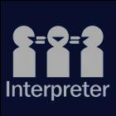
English: If you’d like us to arrange an interpreter for this report, please call us
on 1300 130 670.
Spanish: Si desea que nosotros para solicitar un intérprete de este informe, por favor llámenos en 1300 130 670.
French: Si vous souhaitez organiser un interprète pour ce rapport, veuillez nous appeler au 1300 130 670.
Chinese: 如果您想让我们为此报告安排传译员，请致电我们 1300 130 670.
Arabic: إذا كنت تريد منا أن يرتب مترجما لهذا التقرير، يرجى الاتصال بنا على 1300 130 670.
German: Wenn Sie uns einen Dolmetscher für diesen Bericht anordnen möchten, rufen Sie uns bitte auf 1300 130 670.
Turkish: Lütfen bizi arayın 1300 130 670 bizimle bu rapor için bir tercüman istiyorsanız,
Japanese: このレポートのための通訳の手配を希望する場合は、1300年 130 670 に問い合わせください。
Dutch: Als u wij dat wilt te regelen een tolk voor dit verslag, bel ons op 1300 130 670.
Korean: 우리가 이 보고서에 대 한 해석자를 정렬 작업을 원하시면 전화 주시기 바랍니다
1300 130 670.
© Queensland Human Rights Commission 2026
ISSN 1441-5747 (print) ISSN 1837-0640 (online)
Licence:

This annual report is licensed by Queensland Human Rights Commission under a Creative Commons Attribution (CC BY) 4.0 International licence. To view a copy of this licence, visit: http://creativecommons.org/licenses/by/4.0/
CC BY Licence Summary Statement: In essence, you are free to copy, communicate and adapt this annual report, as long as you attribute the work to the Queensland Human Rights Commission.
Attribution:
Content from this annual report should be attributed as:
Queensland Human Rights Commission Annual Report 2025-2026.
This publication is available in print from the Queensland Human Rights Commission’s Brisbane office, or in electronic format on the Commission’s website at: https://www.qhrc.qld.gov.au.
Contents
Letter of compliance 5
Commissioner’s foreword 6
About the Commission 9
Our vision 10
Our purpose 10
Our services 10
Organisational structure and management 11
Government’s objectives for the community 16
Significant initiatives 17
Rights Made Real podcast 17
Refreshed website 17
Office location uplift 17
New Education Hub 18
Dispute resolution services 19
Complaints we received and resolved 19
Our dispute resolution process 20
Complaints we finalised 21
Accepted complaints: discrimination 23
Accepted complaints: other breaches of the Anti-Discrimination Act 1991 27
Accepted complaints: human rights 29
Accepted complaints: outcomes 33
Finalised complaints: demographics of complainants 35
Feedback from complaint parties 36
Conciliated complaints 38
Complaints referred to the tribunal 41
Enquiries 44
Education services 46
Education services review 46
Private and public training sessions 47
eLearning 49
Policy 50
Submissions to parliamentary inquiries and other reviews and consultations 50
Legal 56
Engagement and communications 63
Yirmba First Nations Unit 63
Engagement 64
Communications 65
Corporate governance 66
Structure and management 66
Risk management and accountability 67
Human resources 70
Early retirement, redundancy, and retrenchment 71
Open data 71
Summary of financial performance 72
Financial governance 72
Financial summary 2025-26 72
Income 72
Expenditure 73
Financial position 73
Financial statements 75
Appendix A: Compliance checklist 99
Appendix B: Performance statement 101
Appendix C: Glossary 102
Appendix D: Our organisational structure 103
Appendix E: Our functions 104

Letter of compliance
28 August 2026

The Honourable Deb Frecklington MP
Attorney-General and Minister for Justice and Minister for Integrity
1 William Street
Brisbane QLD 4000

Dear Attorney-General,
I am pleased to present the Annual Report 2025-2026 and financial statements for the Queensland Human Rights Commission.
I certify that this Annual Report complies with:
- The prescribed requirements of the Financial Accountability Act 2009 and the Financial and Performance Management Standard 2019, and
- The detailed requirements set out in the annual reporting requirements for Queensland Government agencies.
A checklist outlining the annual reporting requirements can be found at Appendix A of this annual report or accessed at https://ww.qhrc.qld.gov.au.

Yours sincerely,
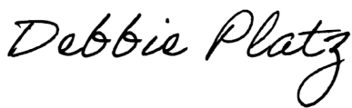
Debbie Platz
Commissioner
Queensland Human Rights Commission

Commissioner’s foreword
It is a privilege to be appointed as the second Commissioner of the Queensland Human Rights Commission and commence in the role in January 2026. I sincerely thank Scott McDougall for his stewardship as Commissioner until October 2025 and Catherine Scott who acted as Commissioner until I commenced.
As all who have held this role, I am thankful to the passionate and professional Commission staff for their ongoing dedication to preventing discrimination and strengthening human rights in Queensland.
During the first five months of my tenure in the role, I travelled to many parts of the state, listening to our stakeholders to understand their challenges, identifying collaboration opportunities and understanding the impact of Commission work on the ground, as we work to build fairer, safer and more inclusive communities.
The listening tour highlighted the importance of the Commission’s ongoing role in supporting Queenslanders progressing complaints regarding discrimination and human rights infringements, as well as continuing to build productive relationships to further amplify the work of the Commission.
While the breadth and depth of the work at the Commission and the stakeholders we collaborate with is enormous, there are many major highlights to recognise this year.
In July 2025 the Commission launched its first podcast ‘Rights Made Real’ Gathering Strength series which features the voices of First Nations community members following the Bandarran Marra’Gu Summit held in the previous financial year. The Rights Made Real podcast has had over 2,500 listens as at August 2026 and been shortlisted for the national Mumbrella Publish Awards for best podcast (series). This is notable recognition for the podcast which amplifies First Nations voices and supports the Commission’s strategic priority to support self-determination of First Nations peoples.
In an ongoing commitment to raising awareness, a refreshed website was launched in February 2026. User research informed an improved user experience and increased accessibility of the website. The updates also increase Queenslanders digital access to information about preventing discrimination and upholding human rights.
Following its foundational year, the Yirmba First Nations Unit continues to build strong relationships with First Nations peoples, communities and organisations, engaging on country to increase an understanding of rights. Yirmba works closely with teams across the Commission to build a culturally safe practice across our services and provide support to First Nations complainants.
Across the Commission staff engage with community members and stakeholders to progress awareness-raising activities. Through attendance at community events such as NAIDOC and Pride, and partnering with stakeholders including local Councils, multicultural groups and community sector organisations, we engage with community members across the state to raise awareness of rights and Commission services.
Our Education services benefited from a strategic review, leading to the development of a new strategy, reshaping the direction of delivery to focus on capability uplift of organisational leaders to uphold their obligations. Education services also commenced a significant upgrade to our digital learning platform to improve the digital learning experience across our human rights and anti-discrimination training modules. The new Education Hub will launch in the 2026-27 financial year.
The Commission’s small but mighty legal and policy team continued to monitor public policy to protect and promote human rights and contribute to building equitable communities. Participating in consultations, providing submissions to parliamentary enquiries, engaging with key stakeholders and intervening in relevant legal proceedings continues to ensure anti-discrimination and human rights considerations are prioritised and maintained.
In another demonstration of the Commission’s commitment to improve access to our services, both Brisbane and Cairns offices moved location. The new office locations provide improved access, culturally safe and accessible design and functional spaces to deliver our services to all in Queensland.
Significantly, complaints to the Commission increased by 60% compared to the previous financial year. While we have seen a consistent increase in complaints over the past years, this increase is a significant jump. The committed Enquiries & Dispute Resolution team is dealing efficiently with this substantial increase having received over 2,439 complaints (47 per week) and over 5,148 enquiries (over 99 per week). The team finalised 1,849 complaints throughout the year, another significant increase from the 1,628 complaints finalised in 2024-25.
The Commission remains committed to strengthening the systems and processes that support complaint management. A key achievement was the successful implementation of an updated customer relationship management platform, enhancing complaint recording, monitoring and reporting. This investment provides a strong foundation for ongoing service improvements for staff and the people of Queensland.
This year’s complaints data provides insight into the rapidly changing environment in which the Commission operates. The increase in complaints may be attributed to the fast uptake of AI-supported complaints along with ongoing awareness-raising activities delivered by our engagement, communication and education teams.
As I present the 2025-26 Annual Report, I am reminded that the Commission's achievements are built on the dedication and hard work of our staff and the strength of our partnerships with communities across Queensland. I extend my heartfelt thanks to all who have contributed to this important work. Together, we have made significant progress, and I look forward to continuing our collective efforts to prevent discrimination and uphold and strengthen human rights for current and future generations of all those who live in and visit Queensland.

Debbie Platz
Commissioner
Queensland Human Rights Commission

About the Commission
The Commission is an independent statutory body established under the
Anti-Discrimination Act 1991. We are accountable to Parliament through the Attorney-General and Minister for Justice.
The Commission is led by the Human Rights Commissioner, who is appointed under section 238 of the Anti-Discrimination Act 1991 by the Governor in Council.
We have functions under the Anti-Discrimination Act 1991 and the Human Rights Act 2019, which include:
- Dealing with complaints of discrimination, sexual harassment, vilification, reprisal (under the Public Interest Disclosure Act 2010), and contraventions of the Human Rights Act 2019
- Reviewing public entities’ policies, programs, procedures, practices and services in relation to their compatibility with human rights
- Promoting an understanding, acceptance and public discussion of human rights and the Human Rights Act 2019 in Queensland
- Providing education about discrimination, human rights and the Human Rights Act 2019.
Our operational objectives are directly aligned to the objectives of our governing legislation. Our four strategic objectives are:
- Promoting self-determination for First Nations peoples
- Promoting equitable communities
- Preventing and responding to harm
- Optimising our capacity
Through our work, we contribute to the Government's objectives for the community by working to provide ‘safety where you live’ and ‘a better lifestyle through a stronger economy.’ The Commission does this by fostering safety in Queensland communities, including creating environments where individuals – regardless of who they are– can live, work, and participate in society free from harm, prejudice, and exclusion; and by addressing discrimination and human rights complaints where they occur.

Our vision
A Queensland where human rights are real for everyone.

Our purpose
To protect and promote freedom, respect, equality and dignity.

Our services
Our services include:
- providing an expert dispute resolution service for discrimination and human rights complaints
- helping people understand their rights and responsibilities through our statewide enquiry service
- training for businesses, government and the community
- supporting the development of policy and legislation to better protect rights
- increasing public understanding and discussion of human rights and responsibilities through our community engagement, education programs and communications.
More detail about the nature and range of our services is contained in the next 4 sections of this report: Dispute resolution and enquiries; Education services; Policy and Legal; Engagement and communications.
A table showing effectiveness and efficiency measures against our service standards can be found in Appendix B.
Further comments on significant initiatives and policy changes have been made in the Commissioner’s foreword and on pages 17-18 of this report.

Organisational structure and management

Organisational structure
A chart showing the Commission’s organisational structure during the
FY25-26 period is available in Appendix D of this report.

Executive management
Accountability for our operations under the Financial Accountability Act 2009 resides with the Commissioner as the Accountable Officer.
The Commissioner is appointed under section 238 of the Anti-Discrimination Act 1991 for a term of no longer than seven years. Commissioner Scott McDougall concluded his seven-year term as Queensland's Human Rights Commissioner on 7 October 2025. Following his departure, Catherine Scott served as the acting Human Rights Commissioner until 30 January 2026. The current Commissioner, Debbie Platz, was appointed as the new Human Rights Commissioner for a five-year term commencing 30 January 2026.
The Commissioner leads the executive management committee (EMC). The EMC is responsible for the development of the strategic plan and contributing to setting the overall strategic direction for the organisation. It is accountable for achieving the Commission’s long-term objectives, providing leadership and direction that upholds the Commission’s values, and delivering services, relevant regulatory requirements and the overall functions of the Commission.
The EMC is governed by the following key objectives:
- to position the Commission as an effective, independent authority, delivering on all its statutory functions
- to set the culture of the Commission, including to ensure a cohesive and high performing workforce that is diverse and inclusive
- to demonstrate and embed agreed risk management principles
- to ensure the Commission has the workforce capacity and capability required to deliver high quality, appropriately prioritised services and projects
- to ensure sound financial management and decision-making
- to monitor the Commission’s performance in delivering the strategic and operating plans
- to engage effectively with the Department of Justice and secure funding that allows the exercise of statutory independence.

The members of the EMC as at 30 June 2026 are Debbie Platz, Jane Vasey, Clair Perkins, Alison Bock and Anh Bui. The Manager, Yirmba First Nations Unit, Luke Wenitong, reports to the Director, Engagement and Communications and attends EMC meetings as an advisory member.
Debbie Platz, Queensland Human Rights Commissioner
(from 30 January 2026)
Debbie Platz commenced as the Queensland Human Rights Commissioner on 30 January 2026. She is the second Commissioner to be appointed to this role in Queensland.
Debbie has extensive public sector leadership experience, including as the New South Wales State Emergency Service (SES), Deputy Commissioner Operations, where she was responsible for safeguarding communities from natural disasters and demonstrated a deep commitment to representing vulnerable people.
Debbie holds a Masters of Studies (Applied Criminology) from the University of Cambridge, United Kingdom; Masters of Business Administration from the University of the Sunshine Coast; Graduate Diploma in Education (Secondary/VET) from the University of the Sunshine Coast; and is Adjunct Professor with the University of Queensland.

Catherine Scott, Acting Queensland Human Rights Commissioner
(from 8 October 2025 to 30 January 2026)
Catherine has a wealth of experience in public administration and law, having worked in the public service for over twenty years occupying a variety of senior leadership roles at the Queensland Crown Solicitor’s Office, Metro South Hospital and Health Service, Queensland Health and the Department of Justice. Since 2024, Catherine has been General Counsel of the Department of Justice.
She holds a Bachelor of Business/Bachelor of Laws from the Queensland University of Technology and a Masters of Applied Law from the College of Law.

Scott McDougall, Queensland Human Rights Commissioner
(from 8 October 2018 to 7 October 2025)
On 8 October 2018 Scott commenced his appointment as the Queensland Anti-Discrimination Commissioner. Prior to this appointment he was the Director and Principal Solicitor at Caxton Legal Centre Inc. in Brisbane.
As Queensland’s inaugural Human Rights Commissioner, Scott has led the introduction of the Human Rights Act 2019, including implementation of Australia’s first human rights complaints scheme. Through the exercise of his statutory functions, he has also conducted major reviews of discrimination laws, workplace equality in the Queensland Police Service and intervened in legal proceedings to guide Queensland’s human rights jurisprudence.
He holds a Bachelor of Laws from the Queensland University of Technology.

Brenna Booth-Marxson, Acting Deputy Commissioner, Public Policy and Prevention
Since joining the public sector in 2012, Brenna has worked across policy, legislative and advisory roles in criminal justice, human rights, anti-discrimination, and other social policy areas at both State and Federal government levels. Following her secondment to the Commission, Brenna returned to her role as the Director of the Human Rights Unit in the Department of Justice, leading whole-of-government initiatives to embed the Human Rights Act 2019 into public sector practice. Brenna has been closely involved in the development and implementation of the Act since its inception and has published on the impact of human rights on the ethical duties of public servants.

Jane Vasey, Deputy Commissioner, Public Policy and Prevention
Jane is the Deputy Commissioner, currently overseeing the Commission’s legal, policy and education functions.
Jane has a depth of experience within independent statutory agencies and public inquiries. She has led and delivered a number of major reviews and reports, where her work has addressed systemic issues at the intersection of human rights and discrimination within a range of contexts.
She has worked in various senior roles including at the Royal Commission into Violence, Abuse, Neglect and Exploitation of People with Disability, the Queensland Ombudsman and the Royal Commission into Institutional Responses into Child Sexual Abuse. Prior to her work in systemic reform, Jane practised as a social justice lawyer in Victoria.
Jane holds qualifications in law and psychology, attaining a Bachelor of Law / Bachelor of Arts, and later a Graduate Diploma in Psychology from the University of Melbourne, and Honours in Psychology from the Queensland University of Technology.

Clair Perkins, Director, Enquiries and Dispute Resolution
Beginning her career in private legal practice, Clair has over 15 years’ experience in statutory complaint handling agencies, including over 10 years at the UK Financial Ombudsman Service, in roles spanning complaints, stakeholder engagement, education and insight roles.
Clair holds a Bachelor of Arts, Bachelor of Laws, Graduate Diploma in Legal Practice and is admitted as a solicitor of the Supreme Court of Queensland.

Alison Bock, Director, Engagement and Communications
With an extensive engagement, communications and marketing career, Alison has held executive roles in Queensland Government and has experience working in public, private and not-for-profit sectors.
Alison has a background in behaviour change marketing and communications and prior to joining the Commission she led strategic communication and engagement activities for significant public health and policy initiatives including COVID-19 vaccination, social housing and tobacco cessation.
Alison has worked closely with Queensland communities including Aboriginal and Torres Strait Islander peoples, people with disability and multicultural communities to co-design effective programs and initiatives.
Alison holds a Bachelor of Arts in Communication, a Graduate Diploma in Public Relations and a Masters in Public Health, along with professional qualifications in engagement and marketing.

Anh Bui, Director, Corporate Services
As Director, Corporate Services and Chief Finance Officer (CFO), Anh leads the Performance and People directorate encompassing information and communications technology (ICT), finance, people & culture, corporate governance, procurement and facilities.
Anh holds a Bachelor of Business Administration, Bachelor of Laws, Executive Master in Public Administration, Graduate Diploma in Legal Practice and is admitted in the Supreme Court of Queensland. She is a fellow of the Governance Institute of Australia and member of CPA Australia.

Luke Wenitong, Manager, Yirmba First Nations Unit
Luke Wenitong is Manager of the Yirmba First Nations Unit at the Queensland Human Rights Commission, a role he has held since March 2024.
Luke has worked across Australia in the areas of community development, human rights, anti-discrimination, digital literacy, and cultural knowledge. Luke has worked with First Nations communities and organisations, with not-for-profits, and in local, state and federal government roles. Prior to his work at the Commission, Luke worked with Registered Native Title Bodies Corporate across Australia in a regulatory role with the Office of the Registrar of Indigenous Corporations (ORIC).

Directorate responsibilities
All directorates report to the Office of the Commissioner and carry out the duties described below.
- Led by the Deputy Commissioner, the Public Policy and Prevention directorate brings together the Commission's legal and policy, education and research functions to undertake proactive, strategic work that maximises the Commission’s impact and drives systemic change.
- Led by the Director, Enquiries and Dispute Resolution, the Enquiries and Dispute Resolution directorate responds to enquiries and provides complaints management and dispute resolution services.
- Led by the Director, Engagement and Communications, the Engagement and Communications directorate raises awareness, promotes public discussion and engages communities. This directorate includes the Yirmba First Nations Unit that engages and partners with First Nations communities and organisations.
- Led by the Director, Corporate Services, the Performance & People directorate delivers corporate support functions, including ICT, finance, people and culture, and corporate governance.

Government’s objectives for the community
Our business direction and service delivery contribute to the Government’s objectives for the community.
- Safety where you live: We contribute to stronger laws by providing expert human rights advice to inquiries, Parliamentary Committees and other consultative mechanisms. We foster safety in Queensland communities by creating environments where individuals – regardless of their background, circumstances, or vulnerabilities – can live, work, and participate in society free from harm, prejudice, and exclusion.
We give victims of discrimination or human rights breaches an easily accessible dispute resolution process and call out serious human rights issues in Queensland.

- Health services when you need them: By preventing and responding to discrimination and promoting human rights, we help remove barriers that limit access to health care, contributing to more equitable outcomes.

- A better lifestyle through a stronger economy: We engage and strengthen Queensland communities on rights and responsibilities and lead public dialogue on human rights in Queensland, both of which allow Queenslanders to participate to a greater extent in civil society.

- A plan for Queensland’s future: We contribute to preparing young Queenslanders for the future by making human rights protections and education more accessible to all people in Queensland.

Significant initiatives

Rights Made Real podcast
In July 2025 the Commission launched its first podcast ‘Rights Made Real’. The Gathering Strength series features voices of First Nations community members and leaders from across Queensland.
The Rights Made Real podcast provides a platform to discuss freedom, respect, equality and dignity - and how this can be achieved for all Queenslanders.

Refreshed website
In February 2026, the Commission launched a new website to improve digital access to information about preventing discrimination and upholding human rights.
The website was informed by user research with key audience groups to ensure an improved user journey and increased accessibility and inclusion. The extensive website improvements significantly support the Commission’s work to prevent discrimination and strengthen human rights in Queensland through improved access to information about how the Commission helps to build a fairer, safer and more inclusive community.
All website content was reviewed and updated in line with best practice content management principles to enhance understanding. The new website is accessible for people from culturally and linguistically diverse communities with over 20 language translations available via an easy toggle function located on every page.
The website improves information delivery for diverse learners through engaging colours, imagery and storytelling. Improved case study content and search functionality delivers practical insights on complex information.

Office location uplift
The Commission has physical offices in 3 locations across Queensland including Brisbane, Rockhampton and Cairns.
The Brisbane and Cairns offices completed moves in 2025-26 to new, more accessible and culturally safe premises to support improved service delivery.

New Education Hub
During the reporting period, the Commission prepared to launch a new Education Hub, working to configure a new learning management system for this purpose. With plans to launch in the 2026-27 financial year, the Education Hub will:
- provide a one stop shop for smooth learner and client onboarding across our entire Education Services program
- enable easy navigation, including mobile responsive display, and meet accessibility standards
- provide high-quality, engaging, interactive eLearning course content aligned with adult learning principles and evidence-based best practices
- enable learning engagement in live workshops
- support data-driven assessment capabilities and comprehensive multi-level reporting on individual and client learning outputs, outcomes, and impact.

Dispute resolution services
Our functions under the Anti-Discrimination Act 1991 and the
Human Rights Act 2019 include impartial dispute resolution of complaints.

Complaints we received and resolved
This year we received 2,439 complaints, a nearly 60 per cent increase on the 1,529 complaints received in 2024-25.
The Commission finalised 1,849 complaints, which was significantly more than the previous year where we finalised 1,628 complaints.

Figure 1: Total complaints received and finalised 2020-21 to 2025-26

Note: Complaints are not always finalised in the year they are lodged with the Commission.

Complaints increased by nearly 60% this year, which may be attributed to an increase in generative artificial intelligence (AI)
supported complaints and
an increase in awareness raising activities.

Complaints we deal with
We deal with complaints about:
- discrimination, sexual harassment, victimisation, vilification, and other contraventions of the Anti-Discrimination Act 1991;
- unreasonable limitations of human rights by public entities under the Human Rights Act 2019; and
- reprisal under the Public Interest Disclosure Act 2010, enabling people to resolve their complaints through the Commission’s process as an alternative to pursuing court proceedings.

Our dispute resolution process
A dispute resolution officer assesses each complaint lodged. This involves a thorough examination of the allegations contained in the complaint to determine whether, if proven, they would amount to conduct covered by the legislation.
We accept complaints that meet the criteria and definitions under the relevant legislation for dispute resolution. We cannot or may not be able to deal with complaints for reasons including the allegations not being covered by the legislation, complaints being made outside the legislated time limits, or the complainant having made a previous complaint about the same allegations.
We are not a court or tribunal and do not have the power to determine whether a breach of the Act/s has occurred. Our role is to help the parties involved in the complaint resolve their dispute.
We attempt to resolve complaints accepted under the Anti-Discrimination Act 1991 through conciliation processes, including early resolution, shuttle negotiations and conciliation conferences. We provide flexibility in our dispute resolution services, so they reflect modern expectations and are fit for purpose for the people using our service.
We use early resolution in complaints where the Commission can facilitate efficient and productive discussions with the parties to resolve complaints.
The Human Rights Act 2019 allows us to attempt to resolve human rights complaints by taking appropriate reasonable action, which can include conducting preliminary investigations, requesting submissions from public entities, and conducting early negotiations and conciliation conferences.
Dispute resolution processes are managed by a Commission dispute resolution officer. Our dispute resolution officers are impartial third parties and do not take sides or advocate for either party, but ensure the process is fair, safe and consistent with the relevant Act, and assist the parties to come to resolution. Dispute resolution officers have specialist knowledge about human rights and discrimination under the Acts. They help the parties understand their rights and responsibilities under the Acts, which may include explaining the law, point out the strengths and weaknesses of the complaint and the response, tell the parties about previous cases and the range of possible outcomes if the complaint does not resolve at conciliation, and make suggestions or give options for resolving the complaint.
For Anti-Discrimination Act 1991 complaints unable to reach resolution, the complainant can choose to proceed to the Queensland Industrial Relations Commission for work-related matters, and the Queensland Civil and Administrative Tribunal for all other matters.
If a Human Rights Act 2019 complaint against a public entity does not resolve, the Commissioner may report on actions the entity should take to ensure its acts and decisions are compatible with human rights. Unresolved complaints accepted under the Human Rights Act 2019 are unable to proceed to a tribunal.
It is possible for complaints to be covered by both the Human Rights and Anti-Discrimination Acts. In most of these cases, the complaint is dealt with under the Anti-Discrimination Act 1991, even though it also contains allegations relating to human rights breaches. In this report we refer to complaints by which Act they are dealt with under.

“The conciliator has gone out of their way to support me and read through everything and completely understand my case.
I can't thank them enough.” – Complainant

Complaints we finalised
We finalised 1,849 complaints this year, a significant increase compared to 1,628 last year.
A finalised complaint is one which has been dealt with to conclusion, either through our dispute resolution process or through rejection or closure of the complaint for another reason.
The continuing high numbers of complaints being lodged with the Commission, including a record number this year, means extended delays have continued in assessing complaints after lodgement. As a result, many
of the complaints dealt with this financial year were lodged the previous year.

Figure 2: Outcomes of complaints finalised in 2025-26
1,849 complaints finalised
612 accepted
216 resolved
- apology
- damages
- training
- change in policy
- service and/or accessibility improvements
- explanation accepted
- other (including private agreements and reversal of original decision)
285 unresolved
- referred to Queensland Civil & Administrative Tribunal
- referred to Queensland Industrial Relations Commission
- unresolved but not referred
- unresolved human rights complaint
- unresolved human rights complaint with recommendations
111 others
(including withdrawn before conciliation, lost contact)
- complaints dealt with under Anti-Discrimination Act
- complaints dealt with under Human Rights Act
1,237 not accepted
- not covered by our legislation
- Human Rights Act complaints where no internal complaint had been made to public entity
- frivolous, vexatious, misconceived or lacking in substance
- other (including withdrawn, uncontactable and those dealt with elsewhere)

Accepted complaints: discrimination
Discrimination complaints under the Anti-Discrimination Act 1991 involve allegations of less favourable treatment based on a protected attribute occurring in an area of public life covered by the Act.

Attributes
We can only accept a discrimination complaint if the discrimination is based on one of the attributes protected under the Act.
The breakdown of accepted discrimination complaints by attribute is shown in Table 1 below.
Impairment (disability) discrimination continues to be the most commonly accepted complaint, with 269 accepted complaints this year, compared to 305 accepted in 2024-25. Due to the increased complaint numbers received this year, the overall percentage of impairment discrimination complaints decreased from 63 per cent of the total accepted and finalised complaints to 50 per cent. This year 95 complaints of impairment discrimination were in the area of work.
Complaints about discrimination on the basis of sex, religious belief or activity, pregnancy, sexuality and most other attributes remained relatively steady compared to 2024-25.
The exception was the percentage of accepted and finalised complaints about race discrimination, which increased significantly from 11 per cent of accepted and finalised complaints in 2024-25 (56 complaints) to 25 per cent in 2025-26 (133 complaints).
Themes that we have identified from the increased race discrimination complaints include:
- An increase in race discrimination across several areas of public life, including at work, accessing goods and services, in the administration of state laws and programs, and education.
- Complaints from Aboriginal people and Torres Strait Islander people about poor, discriminatory and less favourable treatment compared to people who are not First Nations including:
  - excessive scrutiny of work performance
  - negative stereotypes and assumptions
  - aggressive and abusive behaviour
  - insufficient consideration given to remaining close to family members and/or community when in correctional centres or under the care of child safety
  - denial of service in hospitality and retail environments
- Complaints from people where stereotypes or assumptions have been made about them, their work ability or performance, or behaviour on the basis of their race, including ethnicity, colour or national origin.
“The process was flexible with my child's disability
and with my role as their advocate.”
– Parent advocate for child complainant

Areas
Under the Act, for discrimination to be unlawful it must take place in one of 9 prescribed areas of public life. The number of complaints we accepted about discrimination are broken down by area in Table 1.
The continued high number and proportion of work-related complaints show workplace fairness continues to be the most significant area of people’s lives in relation to conduct covered by the Anti-Discrimination Act 1991.

This year 52% of accepted discrimination complaints arose in the workplace or when seeking work, up from 42% last year.

Goods and services, state laws and programs, and education were the next most common areas, as was the case last year, with similar numbers of complaints to 2024-25.

Table 1: Accepted and finalised discrimination complaints by attribute and area 2025-26
Attribute | Work | Goods & services | State laws & programs | Education | Accommo-dation | Club member-ship & affairs
Impairment | 95 | 77 | 41 | 29 | 24 | 3
Sex | 55 | 7 | 6 | 3 | 3 | 2
Race | 51 | 31 | 34 | 12 | 5 | 0
Religion | 17 | 4 | 10 | 0 | 0 | 0
Age | 10 | 6 | 5 | 1 | 11 | 0
Family responsibility | 23 | 4 | 5 | 0 | 2 | 0
Pregnancy | 13 | 0 | 1 | 0 | 0 | 0
Sexuality | 6 | 5 | 2 | 1 | 0 | 0
Trade union activity | 1 | 0 | 0 | 0 | 0 | 0
Gender identity | 2 | 5 | 2 | 1 | 0 | 1
Political belief/activity | 0 | 2 | 0 | 0 | 0 | 0
Parental status | 6 | 0 | 0 | 0 | 0 | 0
Relationship status | 2 | 1 | 1 | 0 | 0 | 0
Breastfeeding | 0 | 0 | 0 | 0 | 0 | 0
Sex work activity | 1 | 2 | 0 | 0 | 3 | 0
Sex characteristics | 0 | 3 | 2 | 1 | 0 | 1
Association with, or relationship to, someone who has any of these characteristics | 1 | 0 | 1 | 1 | 0 | 0
Note: Each complaint can identify more than one attribute.
Note: No complaints about superannuation, insurance, disposition of land or the local government area were accepted and finalised in 2025-26.

Table 2: Accepted and finalised discrimination complaints by attribute in percentage terms 2025-26 and 2024-25
Attribute | % of accepted discrimination complaints alleging this breach 2025-2026 | % of accepted discrimination complaints alleging this breach 2024-2025
Impairment | 50 | 63
Race | 25 | 11
Sex | 14 | 15
Religion | 6 | 7
Age | 6 | 7
Family responsibility | 6 | 6
Pregnancy | 3 | 3
Sexuality | 3 | 3
Gender identity | 2 | 1
Trade union activity | <1 | 1
Political belief/activity | <1 | 1
Parental status | 1 | <1
Relationship status | 1 | <1
Breastfeeding | 0 | <1
Sex work activity | 1 | <1
Sex characteristics | 1 | 0
Association with, or relationship to, someone  who has any of these characteristics | 1 | 0
Note: Each complaint can identify more than one breach; percentages in this table have been rounded to the nearest whole number.

Table 3: Accepted and finalised discrimination complaints by area in percentage terms 2025-26 and 2024-25
Area | % of accepted discrimination complaints alleging  this breach 2025-2026 | % of accepted discrimination complaints alleging  this breach 2024-2025
Work | 52 | 42
Goods & services | 27 | 25
State laws & programs | 20 | 20
Education | 9 | 11
Accommodation | 9 | 8
Club membership & affairs | 1 | <1
Super & insurance | 0 | 1
Note: Each complaint can identify more than one breach; percentages in this table have been rounded to the nearest whole number.

Accepted complaints: other breaches of the Anti-Discrimination Act 1991
As well as discrimination, the Anti-Discrimination Act 1991 makes other kinds of discriminatory conduct unlawful. Complaints about these breaches are dealt with in the same way as other Anti-Discrimination Act complaints.

Sexual harassment
We accepted 77 complaints about
sexual harassment this year,
comparable to 81 in 2024-25.

Sexual harassment is unwelcome sexual behaviour such as comments about a person’s body and/or sex life, telling lewd jokes to or about a person, requests for sex, sending sexualised emails and texts, showing pornographic pictures and/or videos, sexual assault and rape.
Unlike discrimination or human rights complaints, sexual harassment complaints can be made about harassment that happens anywhere, not just in prescribed areas. Most sexual harassment complaints we receive are about the workplace, accounting for 61 per cent of sexual harassment complaints we dealt with this year.
This year 22 per cent of sexual harassment complaints did not indicate the harassment occurred in any prescribed area, an increase compared to 16 per cent in 2024-25, which was already a significant increase from previous years. This may include sexual harassment that occurs in public or in the context of personal relationships.

Vilification
There were 38 accepted complaints of vilification in 2025-26,
compared with 22 last year.

Public vilification is a public act that urges hate, severe ridicule or severe contempt for a person or group of people on the basis of their race, religion, sexuality, sex characteristics or gender identity.
The increase of race vilification complaints was linked to the comparable increase in complaints about race discrimination. A complaint of both race discrimination and racial vilification may arise from the same circumstances.

Table 4: Number of accepted vilification complaints by attribute 2025-26 and 2024-25
Attribute | Number of accepted complaints 2025-26 | Number of accepted complaints 2024-25
Race | 23 | 13
Sexuality | 7 | 3
Religious belief or activity | 5 | 3
Gender identity | 3 | 4
Sex characteristics | 0 | 1
Total | 38 | 24
Note: One complaint may allege vilification based on multiple attributes.

Victimisation
Victimisation complaints arise where a complainant or witness feels they have been poorly treated for making or being involved in a complaint under the Anti-Discrimination Act 1991.
We accepted and finalised 89 victimisation complaints this year, comparable to 93 in 2024-25.
Most accepted victimisation complaints were in relation to the workplace. The continuing relationship between employer and employee means there is more opportunity for victimisation complaints to arise after a person makes an initial complaint at work, compared to other areas. Fear of victimisation is also a reason why complainants are sometimes reluctant to lodge complaints until after they leave the workplace, or at all.

Unnecessary questions
Asking for information, which can be used to discriminate against a person, is unlawful, unless it is genuinely required for a non-discriminatory reason. Complaints about this conduct generally arise in relation to seeking employment – for example, applicants being asked in application forms or interviews for information such as their age or gender when it is irrelevant to their capacity to perform in the role.
We dealt with 42 complaints about unnecessary requests for information in 2025-26, a decrease from 55 last year.

Reprisal for public interest disclosure
Complainants alleging they have experienced a detriment because of making a public interest disclosure under the Public Interest Disclosure Act 2010 are able to make a complaint to the Commission to be dealt with under the Anti-Discrimination Act 1991. Complaints about this remained steady at 4 complaints this year compared to 5 last year.

“I am a member of the respondent's board of directors.
I was very satisfied with the process and outcome”
– Respondent’s advocate

Accepted complaints: human rights
Complaints about human rights can be made about unreasonable limitations on human rights by public entities.
The complaint must be in relation to one of the 23 rights protected by the Human Rights Act 2019 and can only be made in relation to public entities. Under the Act, a public entity is one providing services to and for Queenslanders, including state and local governments, emergency services, public schools and public hospitals, NDIS providers, and organisations providing services on behalf of the state. Federal government departments and agencies are not covered by the Act, nor are private businesses (unless they are providing services on behalf of the state).
Table 5 shows the number of human rights complaints that were accepted and finalised this year, by right. This includes complaints dealt with under the Anti-Discrimination Act 1991, which also contain allegations covered by the Human Rights Act 2019. These are referred to as ‘piggy-back’ complaints. Due to the different options available for complainants under the Anti-Discrimination Act 1991 – for example, being able to refer an unresolved complaint to a tribunal for a binding decision – many complainants with allegations covered by both Acts elect to have their issue dealt with under the Anti-Discrimination Act 1991.
Most complaints dealt with under the Human Rights Act 2019 are therefore solely about human rights and do not have a discrimination component.

“The opportunity to put forward human rights complaints was much appreciated, given that my previous employer had
themselves admitted human rights violations.”
– Complainant in our process
As in previous years, the highest number of human rights complaints accepted this year were about the right to recognition and equality before the law. This right is about fair treatment and non-discrimination.
Many discrimination complaints made about public entities will also be a complaint about the right to recognition and equality before the law, which explains the relatively high number of human rights complaints which engage this right.
The Commission accepted and finalised increased numbers of complaints about several human rights this year, including:
- Privacy and reputation – 95 compared to 66 last year
- Freedom of expression – 45 compared to 29 last year
- Protection of families and children – 44 compared to 31 last year
- Right to take part in public life – 36 compared to 24 last year
- Cultural rights – Aboriginal peoples and Torres Strait Islander peoples – 22 complaints compared to 7 last year
These included complaints about:
- Facilities, cleanliness and access to communication with family while in hospital and mental health facilities
- Level of service provided by public housing associations including for vulnerable residents
- Domestic and family violence survivors not being provided with timely access to safe accommodation
- Access to medical treatment at correctional centres
- Access to visitors and communication restrictions at correctional centres
- Allegations children had been discriminated against at school based on their race
“The conciliator was absolutely amazing.
I have severe anxiety and the conciliator was extremely accommodating
and attentive to ways that I could work around it.
They gave me multiple options at any time and made sure
I knew I was safe and able to take as many breaks as I need.”
– Complainant in our process

Table 5: Accepted and finalised human rights complaints by right 2025-26
Right | % of accepted and finalised human rights complaints | Total number of accepted and finalised complaints alleging a breach of this right | Dealt with under Human Rights Act 2019 | Dealt with under Anti-Discrimination Act 1991
Recognition and equality before the law | 76% | 204 | 12 | 192
Privacy and reputation | 35% | 95 | 37 | 58
Protection from torture & cruel, inhuman or degrading treatment | 25% | 67 | 14 | 53
Freedom of expression | 17% | 45 | 16 | 29
Protection of families and children | 16% | 44 | 23 | 21
Taking part in public life | 13% | 36 | 0 | 36
Right to education | 12% | 33 | 4 | 29
Humane treatment when deprived of liberty | 10% | 27 | 14 | 13
Cultural rights – Aboriginal peoples & Torres Strait Islander peoples | 8% | 22 | 8 | 14
Freedom of thought, conscience, religion and belief | 6% | 15 | 0 | 15
Right to liberty and security of person | 6% | 16 | 7 | 9
Property rights | 5% | 14 | 7 | 7
Freedom of movement | 3% | 9 | 4 | 5
Cultural rights – general | 3% | 8 | 2 | 6
Right to health services | 2% | 6 | 2 | 4
Right to life | 1% | 2 | 0 | 2
Fair hearing | 1% | 4 | 3 | 1
Rights in criminal proceedings | 1% | 4 | 2 | 2
Protection of children in the criminal process | 1% | 2 | 0 | 2
Peaceful assembly and freedom of association | 0% | 0 | 0 | 0
Right not to be tried or punished more than once | 0% | 0 | 0 | 0
Protection from retrospective criminal laws | 0% | 0 | 0 | 0
Freedom from forced work | 0% | 0 | 0 | 0
Note: Each complaint can identify more than one protected right; percentages in this table have been rounded to the nearest whole number.
Table 6: Accepted and finalised human rights complaints by sector 2025-26 and 2024-25
Sector | Total number of accepted and finalised complaints alleging a human rights breach 2025-26 | Total number of accepted and finalised complaints alleging a human rights breach 2024-25
Work | 79 | 62
Other | 42 | 38
Education | 40 | 35
Police | 28 | 23
Corrections | 25 | 32
Accommodation/housing | 14 | 10
Health | 13 | 16
Child Safety | 13 | 5
Councils | 11 | 13
Disability services | 3 | 6
Transport | 1 | 11
Court services | 1 | 1
Total | 270 | 252

Accepted complaints: outcomes
Dispute resolution officers at the Commission assist parties to resolve complaints under the Anti-Discrimination Act 1991 through conciliation. Complaints under the Human Rights Act 2019 have a more flexible resolution process and fewer legislated timeframes. The Commission may help the parties resolve a human rights complaint through conciliation as well as other steps.
“Culturally appropriate response by the conciliator.
The conciliator was very professional and helpful in explaining the process.”
– Complainant in our process

A conciliation conference allows the parties to explore each other’s perspective on the issues, identifying what they may have in common, and discuss options for settling the complaint. Our early resolution processes are suitable for complaints where the complaint material and/or the allegation appears straightforward, and the parties are focused on outcomes and coming to a mutually satisfactory agreement to resolve the complaint quickly.

35% of accepted and finalised complaints were resolved through our dispute resolution process in 2025-26.

Resolution rates differ depending on the type of complaint.

Table 7: Resolution rates for ADA, HRA and combined complaints
2025-26 and 2024-25
Type of complaint | Conciliated percentage  2025-26 | Conciliated percentage  2024-25
Anti-Discrimination Act 1991 | 44% | 54%
Combined Anti-Discrimination Act 1991 and Human Rights Act 2019 (“piggyback”) | 25% | 24%
Human Rights Act 2019 | 23% | 34%
Note: Percentages in this table have been rounded to the nearest whole number.

Some of the factors that may have contributed to the reduced percentage of conciliated complaints include:
- Reduced capacity in the early resolution team due to new staff joining the Commission and undergoing training
- Overall timeliness and complaint queues impacting on likelihood of complaints to resolve
- Increased reliance by complainants on AI tools in navigating the dispute resolution process and contributing to hardening of parties’ positions
- AI-generated information providing unrealistic expectations of outcomes
Complaints alleging discrimination or other breaches of the Anti-Discrimination Act 1991 against public entities (dealt with as “piggyback” complaints) continued to be less likely to resolve than complaints against private entities.
Factors which may impact the difference in resolution rates for complaints involving human rights include complainants being more likely to be self-represented in human rights matters, and Anti-Discrimination Act 1991 complaints against state government entities, which are more likely to include human rights allegations, being historically less likely to resolve than those against private enterprises.

Resolved complaints
A complaint is resolved when the parties have reached an agreement on how to settle the complaint. This can be through an apology (87 complaints this year), payment of damages or other financial compensation (84), a policy change (40), training (44), or other measures to resolve the complaint (59). Multiple outcomes to resolve the same complaint can be agreed upon during the resolution process.
Most complaints were resolved through conciliation (156) with an increased number of complaints resolved through early resolution (60) this year compared to last year.

“I feel strongly the handling of the matter
through the process was very clear and supported.”
– Respondent in our process

Unresolved complaints
Anti-Discrimination Act 1991 complaints (including “piggy-back” complaints), which are unresolved after conciliation, may be referred to a tribunal at the complainant’s request. Work-related complaints are referred to the Queensland Industrial Relations Commission (60 complaints this year). All other complaints are referred to the Queensland Civil and Administrative Tribunal (98 complaints). There were 87 unresolved Anti-Discrimination Act 1991 complaints not referred to tribunal this year.
Unresolved complaints accepted under the Human Rights Act 2019 are unable to proceed to a tribunal. There were 40 unresolved Human Rights Act 2019 complaints.
When a human rights complaint to the Commission is not resolved, the Commission must prepare an unresolved complaint report. This report may include details of actions the Commissioner considers the public entity respondent should take to ensure its acts and decisions are compatible with human rights. Reports can shine a light on systemic issues, help public entities meet their human rights obligations and build a broader culture of human rights in Queensland.
This year, the Commission made five unresolved complaint reports with recommendations. These related to:
- a public entity blocking a person from their Facebook page
- unauthorised disclosure of personal information in relation to a Workcover claim
- a visitor suspended from visiting their partner in prison
- contact between a husband and wife held in different prisons limited to written contact only
- detention of a person in the Forensic Disability Service.
Examples of recommendations made included that the public entity:
- consider particular rights in making a decision of that nature
- record decisions and provide the complainant with reasons, including an assessment of compatibility with human rights
- review policies and practices to embed human rights obligations
- ensure relevant staff have adequate training on understanding human and public entity obligations.

Finalised complaints: demographics of complainants
Demographics are requested from every person who makes a complaint; however, the provision of this information is voluntary. Of the finalised complaints where demographic data about the complainant was provided:
- The most common age bracket for complainants was 35-44, accounting for 28 per cent of finalised complaints where the complainant’s age was recorded. 34 complaints from or on behalf of children or teenagers were finalised this year, comparable to last year.
- Men and women were equally likely to make complaints this year, at just under 50 per cent each. We received 6 complaints from non-binary people and 5 where people described their gender in another way.
- 139 complainants (16 per cent of those who provided this information) identified as First Nations people. This is a significant increase from the previous year (11.5 per cent) The dispute resolution team consults with the Commission’s Yirmba First Nations Unit, who provides advice and cultural support to the team and to complaint parties. Promoting self-determination for First Nations peoples and providing a culturally appropriate and safe experience is a strategic priority for the Commission. Yirmba First Nations Unit directly supports this objective through providing advice and cultural support internally and to complaint parties. Yirmba has a proactive engagement schedule with First Nations communities across the State to raise awareness about the Commission and build culturally safe and accessible access to dispute resolution services.
- Around 1 in 4 complainants (27 per cent) who provided their country of birth were born overseas, and almost 99 speak a primary language other than English.

“Everything was fine. I was mostly just nervous. This wasn't…about money. The conciliator was lovely and kept me updated on everything. They were very understanding and helped me through the process”
– Complainant in our process

Feedback from complaint parties
Of those people who completed an evaluation form in 2025-26, 46 per cent were satisfied or very satisfied with the overall complaint handling process compared with 62 per cent last year.
The customer satisfaction rate decreased this year after showing an increase last year.
Feedback provided by the parties that affected the satisfaction rate included:
- Ongoing extended wait times due to high demand for our services continues to impact overall satisfaction with our complaint handling service.
- Respondents considered the complaints process did not allow for their response to be tested or their perspectives to be included before the Commission accepts a complaint; and
- Complainants considered some respondents did not engage satisfactorily in the complaint process.
Once complaints were allocated to a dispute resolution officer, complaint parties identified the Commission’s clear and supportive communication, commitment to efficiency, independence, understanding and facilitating a safe environment for dispute resolution as key positives.
Complainants were more likely to be satisfied with the complaint handling service, compared to respondents. Commission staff are aware that being party to a complaint can be an unwelcome experience, and we continue to focus on respectful and honest communication with parties and, after a complaint has been allocated to a dispute resolution officer, providing a professional, fair and timely service that meets the needs of our clients.

“My experience with the QLD Human Rights Commission has been very positive. My conciliator educated and informed me on all the steps involved and clearly explained what role the Commission plays. My conciliator was an absolute pleasure to deal with.”
– Complainant

“Thank you for the adjustments that you have already made for my client and for your approach to this complaint, which has been both compassionate and professional.”
– Complainant’s advocate

Conciliated complaints
University student denied a placement due to her vaccination status
The complainant was enrolled in a degree that required her to attend practical placements. The university had a policy that required students to be vaccinated against COVID-19, and despite the student electing not to receive the vaccination, she was permitted to complete her first placement. However, the university relied on the policy when deciding the student could not commence her second placement, which hindered the progress of her degree. The student made a human rights complaint to the Commission. The respondent acknowledged that its policy had not been updated since the vaccine mandate for health workers was removed. It agreed to update its policy to reflect the change and to incorporate human rights considerations. It also agreed to contribute $7,500 towards the complainant’s tuition fees.

Airline refused to allow passenger in the aircraft cabin with
assistance dog
The complainant lives with disability and has an assistance dog. An airline refused the complainant’s request for her to travel with the assistance dog in the cabin with her, which meant she couldn’t fly. The complainant made a complaint of impairment discrimination when accessing goods and services. In response to the complaint, the airline proposed changes to its assistance dog policy, including recognising assistance animals that are not accredited under international assistance dog assessment standards. The airline incorporated the complainant’s suggested changes to the policy before it was implemented. The complainant’s assistance dog was accepted for in-cabin travel, and the complainant received a goodwill payment of $5,000.

Sexual harassment following a work Christmas party
The complainant lodged a sexual harassment complaint that her manager sexually assaulted her following a work event and then disclosed the incident to other male staff members. The complainant’s employer later threatened defamation proceedings if the complainant talked about the matter to anyone else, including her lawyer or worker’s compensation officer. The employer did not agree that the incident had any relation to work and said it had not received a complaint from the woman. The Commission facilitated shuttle conciliation and the resolution of the complaint included a financial settlement of $80,000, and a meeting facilitated by the Commission where the complainant read an impact statement to her manager and a representative of the employer.

Job candidate humiliated and asked unnecessary questions
during interview
A sole parent, who also cared for other family members, attended a job interview. The interviewer made derogatory and mocking remarks about a gap in her work history due to severe illness, her apparent lack of career ambition as a single mother, and her response, when asked, that family was more important than work. The interviewer also asked unnecessary questions about her disability and suggested it would prevent her from working in the role. The parent lodged a complaint of family responsibilities and sex discrimination in the pre-employment area. The Commission facilitated early resolution discussions between the parties. As a resolution to the complaint, the respondent agreed to complete Anti-Discrimination Act training and provided a statement of regret for the woman’s experience.

Employee terminated after reporting sexual harassment
An employee made a complaint to their employer, alleging that another staff member had sexually harassed them by making sexually explicit comments in person and via text message. The complainant’s employment was subsequently terminated, which the complainant said was because they made a complaint. The complainant lodged a complaint of sexual harassment and victimisation. The employer denied the allegation of victimisation and maintained that the termination was based on legitimate performance concerns but agreed to pay the complainant $55,000 in resolution of the complaint.
Body Corporate locked accessible swimming pool gate
The owner of a unit in an apartment complex had a mobility disability. The shared swimming pool in the apartment complex had two access gates, but the body corporate had arranged for one of them to be permanently locked, to prevent unauthorised access. The remaining gate had stairs leading to it which the complainant was unable to use, so she was unable to enjoy the pool with her family. The complaint lodged a complaint of impairment (disability) discrimination in the accommodation area. The representatives of the body corporate committee explained that a motion had been passed at the general meeting to permanently lock the gate, and that they had been unable to source a lock which would both prevent unauthorised access and meet pool certification requirements. The complaint resolved on the basis that the complainant would source a suitable lock and submit a motion at the body corporate general meeting to have it installed, which the committee would support.

Applicant for public housing removed from the waitlist
An applicant on the waitlist for public housing had complex psychosocial and physical needs. While on the waitlist, she lost her existing accommodation so went interstate to stay with a friend, then later obtained some temporary supported accommodation. She wished to return to Queensland, but when it was discovered she was living interstate she was removed from the waitlist. While she was eventually placed back on the waitlist, she went to “the back of the queue”. The complainant lodged a complaint of impairment discrimination in accommodation. The Commission had pre-conference discussions with the respondent that were co-operative, respectful and solutions focused. As a result, by the time of the conciliation conference the respondent had already taken steps to prioritise the application.
At conference, the respondent agreed to backdate the application and consider the complainant’s specific housing requirements, and the complaint resolved by agreement between the parties.

Student dissatisfied with support provided by school
The mother of a 13-year-old boy with ADHD made a complaint of impairment discrimination in the education area on his behalf. The private school he attended had agreed to an individual support plan, however the mother alleged that the school failed to make reasonable adjustments for the complainant, such as giving him movement breaks and not sitting at the back of the classroom. The complainant faced disciplinary action, including suspension, for behaviours linked with his ADHD, and was later unenrolled. The school said the boy was unenrolled for other breaches of school policy, not because of behaviours associated with his ADHD. As a resolution to the complaint, the school agreed to review its behaviour management policy and create a new position to oversee it. It also agreed to an external review of other school policies and to provide discrimination training to its staff, as well as giving the complainant a written apology and $7,500 compensation.

Complaints referred to the tribunal
Complaints accepted under the Anti-Discrimination Act 1991 that are not resolved through conciliation in the Commission may be referred to the relevant tribunal for hearing and determination. For work-related complaints, the tribunal is the Queensland Industrial Relations Commission (QIRC) and for all other matters the tribunal is the Queensland Civil and Administrative Tribunal (QCAT).
A complainant may ask for a complaint to be referred after a conciliation conference, or after the Commissioner provides a written notice that the complaint cannot be resolved through conciliation.
A respondent or a complainant may ask for a complaint to be referred if it has not been finalised within 6 months of acceptance.
The following is a small selection of decisions showing how the tribunals deal with referred complaints.

Climate change activists can book council facilities0F
A ban by a local council that prevented Extinction Rebellion from holding meetings in council libraries was unlawful political activity discrimination.
A political belief or activity is one that bears on the form, role, structure, feature, purpose, obligations, duties, or some other aspect of a government. As a global movement with the purpose of encouraging governments to take action to prevent climate breakdown, the tribunal considered it a political movement. Holding meetings in council libraries to discuss, give presentations, and plan protest marches to put pressure on governments to do something about climate change was political activity.
The tribunal did not accept the council’s argument that Extinction Rebellion engaged in large scale coordinated and premeditated unlawful activities. The right to peaceful protest may include disrupting traffic and causing inconvenience.
The tribunal dealt with the complaint as a class complaint and declared that the council had unlawfully discriminated against the individual who brought the complaint and the members of the class of people who shared the political belief or activity. The council was ordered to stop enforcing the decision not to allow Extinction Rebellion from booking council meeting facilities, and to notify the class members through various Facebook pages/groups.

Sexual harassment training was inadequate1F
Unwanted touching and sexual comments by a male floor manager to a female croupier was sexual harassment in the workplace. Other incidents where the man touched the woman after a birthday party that they both attended happened at a private event unrelated to work.
The employer, the casino, was held vicariously liable for the workplace conduct because it did not take reasonable steps to prevent the sexual harassment. Face-to-face sexual harassment training had been replaced with online learning that staff undertook while carrying out their duties and that led to ‘skipping’ through the course. The tribunal was critical of the way the employer delivered its sexual harassment training and said that training requires focus on the content. In circumstances where the man had been on a final warning for sexual harassment, the standard biennial online training was insufficient, and the tribunal suggested additional training should have been mandatory for the man.
The sexual harassment had a significant effect on the woman, including psychological injury. The woman was awarded general damages and damages for past and future economic loss. Aggravated damages were also awarded because the man had said to the woman ‘I am not at work … I can do what I want’ when she told him to stop.
The tribunal awarded a total of $126,863.21 to be paid to the woman, with the employer and the man being jointly responsible for payment of $49,427.60, and the man responsible for an additional amount of $77,435.61.

Evidence of guilty plea allowed2F
Shortly after the hearing of a complaint of sexual harassment and victimisation against a man, the man pleaded guilty to a charge of common assault of the female complainant. In the criminal proceeding, the man admitted to facts that were similar to the alleged victimisation, that is, entering her home, yelling about police reports and dropping the court case, threats to harm the woman’s family, and pushing her in the chest and face.
The tribunal had not made a decision on the complaint of sexual harassment and victimisation. Because the new evidence was so material, the tribunal allowed the complaint to be reopened to include the transcript of the criminal charge as evidence.

Minister joined to class complaint 3F
The tribunal has ordered that a complaint about a direction to restrict hormone treatment for children diagnosed with gender dysphoria is to be dealt with as representing the class of children diagnosed with gender dysphoria who had not commenced receiving the specified hormone therapy.
As the direction was made by the Minister of Health and Ambulance Services to all hospital and health services, it was appropriate to join the Minister as a respondent to the complaint.

Enquiries
We provide a free, accessible and personal information service to help people understand their rights and responsibilities under Queensland’s anti-discrimination and human rights legislation.
Enquiries are taken primarily via telephone, email and post. People can also make enquiries in person at our offices in Brisbane, Cairns or Rockhampton.
This year we responded to 5,148 enquiries, a comparable number to last year’s figure of 5,563, as we continue to experience high demand for our enquiries service.

Figure 3: Enquiries received by year, 2019-20 to 2025-26

Most enquirers were potential complainants – that is, people with questions about whether conduct they had experienced could be covered by the Human Rights or Anti-Discrimination Acts. Other types of enquiries were from people calling for general information or with questions about their obligations under anti-discrimination or human rights law.
We ask enquirers to provide demographics on a voluntary basis. Where the gender of the enquirer was recorded, similar to last year, women made a larger number of enquiries (59 per cent) compared to men (41 per cent), with just under one per cent of enquiries from non-binary people and other genders. Of enquiries where the age was recorded, those between 35 and 54 made 45 per cent of enquiries, compared to people under 25 who made 3 per cent. This broadly reflects the age of people who go on to make a complaint.
Those 55 years and above made around 36 per cent of enquiries.
Consistent with last year, around 80 per cent of enquiries were dealt with by phone. Other methods of contact included email, letter, and in-person enquiries.
In addition to our general statewide enquiries line, we also provide dedicated points of contact for prisoners, LGBTQIA+ people, and Aboriginal and Torres Strait Islander peoples.
During specified hours two days per week, our enquiry team is available to prisoners via the Prison Telephone System in correction centres. In 2025-26 we received 714 enquiries through this service, a significant increase from last year’s 301.

Education services
We deliver education across Queensland to private, community and government sectors to increase understanding of rights and responsibilities under the Anti-Discrimination Act 1991 and Human Rights Act 2019.
We offer education through:
- online eLearning via self-paced modules.
- workshops delivered in person, virtually or a hybrid of both, including both private and public education sessions.

Education services review
During the relevant period, we completed a comprehensive review of our education services. As part of the review, we analysed our client base and evaluation feedback, considered best practices through a literature review and, in consultation with other commissions and experts, critically examined our operational processes and systems to identify opportunities to offer improved service delivery.
The education services review was finalised in November 2025. Based on the review’s findings, the Commission drafted a new Education Strategy for the period July 2026 – December 2030. The new strategy re-orientates our education programming to move beyond a legal knowledge model towards increasing the capability of key organisational influencers and leaders to uphold their obligations.

Education Hub
The Commission is continuing to implement improvements to our education systems and processes. During the reporting period, the Commission prepared to launch a new Education Hub, as a one stop shop for:
- booking and enquiring about our education services
- undertaking a learning journey for all our education services, including eLearning and live workshops
- assessment capabilities and comprehensive multi-level reporting on individual and client learning outcomes.
It is anticipated the Education Hub will be launched in the 2026-27 financial year.

Private and public training sessions
In 2025-26, private training was delivered directly to workplaces, as well as open sessions offered to the general public, both in-person, virtually and in a hybrid delivery format. Training was provided on a fee-for-service basis, with reduced rates available for small community organisations and groups that demonstrated limited capacity to pay.
To focus our resources on the review of our education services, from January 2025 we reduced the number of public sessions on offer along with travel to regional Queensland and tailored training. These adjustments reflect the reduced private and public training sessions delivered in 2025-26. During this period, we delivered 98 live workshops to 1,334 people across Queensland.

“Specific scenarios were related to our work; I liked that it was challenging enough to be interesting and insightful.”
– Training participant

The public sector continues to be our largest client, by both number of sessions delivered and by absolute number of people in attendance, with 748 public servants attending our workshops (in 44 sessions). This is followed by 395 participants from the private sector (in 28 sessions) and 146 participants from the community sector (in 9 sessions).

Table 8: Delivery of private and public training sessions by sector 2025-26 and 2024-25
 | Number of sessions  2025-26 | Number of sessions  2024-25
Private sessions - private sector | 28 | 18
Private sessions - public sector | 44 | 124
Private sessions - community sector | 9 | 14
Public sessions | 17 | 18
Total | 98 | 174

The Queensland Human Rights Act 2019 workshop is our most popular, with 24 sessions delivered in 2025-26, and 434 participants. This is followed by the Contact officer and Sexual harassment courses.

Table 9: Public and private training sessions delivered by topic 2025-26 and 2024-25
Course | Number of sessions 2025-26 | Number of sessions 2024-25
Queensland’s Human Rights Act 2019 | 24 | 28
Contact officer | 23 | 25
Sexual harassment | 19 | 63
Queensland’s Anti-Discrimination Act 1991 | 13 | 29
Anti-Discrimination Act 1991 for managers | 7 | 7
Tailored training | 5 | 5
Contact officer - refresher | 5 | 3
Human Rights Act 2019 for legal advocates | 0 | 1
Gender identity and discrimination | 1 | 1
Using the Human Rights Act 2019 | 1 | 10
Total | 98 | 174

Our participant satisfaction rate for our ‘live’ training sessions was 93.5 per cent in 2025-26. Satisfaction rate is measured using a Likert scale of 1 to 5, with the majority of participants selecting that they ‘strongly agree’ that they were satisfied with the training delivered. The percentage of clients who reported their understanding of rights and responsibilities under anti-discrimination and/or human rights law increased following training was 98.5 per cent.
“I liked that it was so interactive and [the trainer] delivered the training in a way that was engaging and comprehensive"
– Training participant

eLearning
We offer standalone eLearning courses focused on increasing understanding of the Human Rights Act 2019 and Anti-Discrimination Act 1991, and preventing sexual harassment, as well as a package of 6 individual modules called Diversity Awareness.
In 2025-26 we began to phase out the Learning Management System that hosted our eLearning, closing the storefront for sales in December 2025. Learners who had purchased prior to store closure had access to complete eLearning until 30 June 2026. We still made group subscriptions possible, for organisations who had already embedded the modules on their own learning management systems.
In 2025-26 we received over 20,000 new enrolments to undertake our online training modules.
In the 2026-27 financial year, we will launch new eLearning courses on our new Education Hub with high-quality, engaging, interactive course content aligned with adult learning principles and evidence-based best practices.

Policy
In line with our statutory function to promote an understanding and acceptance, and the public discussion, of human rights and the Human Rights Act 2019 in Queensland, our policy work considers the impact of proposed legislative or policy change on human rights and makes recommendations for amendments to better protect human rights.
The purpose of our policy work is to:
- Influence public policy to protect and promote human rights, equal opportunity, and equitable outcomes.
- Promote public discussion and understanding of discrimination and human rights, including through public comment, guidance material, reports and research.

Our submissions to parliamentary inquiries support the scrutiny of proposed legislation by members of parliament, who are required to consider the compatibility of proposed legislation with human rights.
If we have made a submission to a parliamentary inquiry, we may also appear before the relevant parliamentary committee. Our appearance before a parliamentary committee gives members of parliament the opportunity to ask questions of the Commission about human rights impacts and builds understanding of the intersection between the Human Rights Act 2019 and other legislation.

Submissions to parliamentary inquiries and other reviews and consultations
In 2025-26 the Commission responded to 15 consultations and made 2 submissions to parliamentary inquiries.
Our submissions and responses are usually published on our website unless they are confidential.
In 2025-26, some of the systemic issues we addressed included:
- supporting people with disabilities
- protecting children and young people
- improving child safety systems and responses to child sexual abuse
- reforming criminal justice and community safety frameworks
- promoting equitable access to healthcare services
- strengthening emergency management and disaster response arrangements.

Examples of submissions – criminal justice
The following are summaries of selected submissions on criminal justice issues.

Fighting Antisemitism and Keeping Guns out of the Hands of Terrorists and Criminals Amendment Bill 2026
This Bill was introduced on 10 February 2026 and proposed a range of amendments aimed at preventing hateful conduct and the misuse of firearms. Measures included new offences relating to prohibited expressions and acts done in preparation for serious violence, protections for people attending places of worship, expanding the prohibited symbols framework, and expanded police powers for controlled operations and surveillance.
The Commission submitted that while it supports objectives to reduce targeted hatred and violence, legislation must appropriately balance these objectives with human rights. The Commission’s submission recommended:
- Applying a higher threshold before an expression can be prescribed as prohibited.
- Requiring consultation with affected communities before prohibiting an expression.
- Adopting the same processes for prescribing expressions as exists for prescribing terrorist symbols and organisations as under section 52C of the Criminal Code Act 1899, namely that the Minister be satisfied the symbol is widely known by the public or a relevant group as solely or substantially representative of an ideology of extreme prejudice.
- Providing clearer definitions for the proposed offence of preparing or planning serious violence and considering aligning the offence to its counterpart in the Criminal Code Act 1995 (Cth).4F
- That an exceptional circumstances statement be tabled alongside any expansion of the offences for which children will be sentenced as adults (‘adult crime, adult time’), to provide appropriate justification for the further override of the Human Rights Act.5F
- Clarifying the offence relating to conduct near places of worship to ensure people are not criminalised for unintentional conduct.
- Retaining a higher threshold for the use of controlled operations and surveillance powers or limiting those powers to specific offences.

The Commission subsequently provided a response to a question taken on notice regarding the proposed framework for prohibiting expressions and the likelihood of unintentional offending.
The Commission reiterated its written submission that ‘consultation with community prior to the prescription of expressions may assist to identify if the expression has any multiple or contested meanings, reducing unintended impacts’.6F
The Commission provided its submission on 17 February 2026 and the Bill passed on 5 March 2026. The recommendations made by the Commission were not adopted. However, the Bill was later amended such that expressions may only be proscribed via further amendment to the Criminal Code Act 1899 (Qld).7F

Community Protection and Public Child Sex Offender Register (Daniel's Law) Bill 2025
This Bill was introduced on 27 August 2025 and proposed establishing a public child sex offender register in Queensland. The Bill included an override declaration as a ‘precautionary measure’ even though the Minister did not consider the Bill incompatible with human rights.
The Commission's submission focused on the lack of evidence supporting public child sex offender registers, and the Bill’s incompatibility with human rights.
The Commission’s primary concerns with the Bill as set out in the submission were as follows:
- There is insufficient evidence that exceptional circumstances exist which justify overriding the Human Rights Act. Overriding the Human Rights Act is only lawful in ‘exceptional circumstances’ such as where there is a war, state of emergency, or an exceptional crisis.
- There is no evidence available which demonstrates that public child sex offender registers reduce sexual offending against children, with some research suggesting such schemes may increase reoffending and disrupt rehabilitation efforts.
- Existing legislative mechanisms already allow information about reportable offenders to be disclosed where necessary to protect children.
- Publication of offenders' information could lead to the identification and re-traumatisation of victims of child sexual abuse, particularly where offenders and victims are known to each other or live in smaller communities.
- Family members and others associated with identified offenders could be exposed to harassment, intimidation, stigma and other negative consequences as a result of publication through the register.
The Commission recommended that the bill not be passed. Instead the funding provided to establish the register should be reallocated to support evidence-based strategies that have been shown to prevent child sexual abuse. The Commission provided 9 alternative recommendations in the event that its primary recommendation was not taken up.
The Commission provided its submission on 10 September 2025 and the Bill passed on 30 October 2025. The recommendations made by the Commission were not adopted.

Examples of consultation response – social policy
The following are summaries of selected consultation responses that relate to social policy issues.

Review of the Disability Discrimination Act 1992 (Cth)
The Attorney-General's Department commenced a review of the Disability Discrimination Act 1992 (Cth) in late 2024 to examine whether the Act remains effective in protecting people with disability from discrimination and to consider reforms arising from the Royal Commission into Violence, Abuse, Neglect and Exploitation of People with Disability. The review sought feedback on modernising the Act, improving access to justice, strengthening protections against discrimination, and promoting greater inclusion of people with disability in employment, education and other areas of public life.
The Commission's submission focused on strengthening the Act to better prevent discrimination and promote substantive equality for people with disability. A core recommendation of the submission was that the Act should be amended to incorporate a positive duty for duty holders to take reasonable and proportionate steps to eliminate discrimination on the basis of disability. The Commission submitted that positive duties are an emerging feature of modern discrimination law and represent an important shift towards a preventative approach to discrimination.
The submission additionally included commentary and recommendations to improve the Act, including by:
- modernising the definition of disability
- including protections against intersectional discrimination
- simplifying definitions of direct and indirect discrimination
- improving access to employment and education
- introducing protections against offensive behaviour (vilification).
The Commission submitted its submission to the review on 14 November 2025. At the time of writing, the review was not yet finalised. No amendments to the Disability Discrimination Act 1992 (Cth) have been announced or enacted in response to the review.

Independent review of Stage 1 and Stage 2 hormone therapies in Queensland’s public paediatrics gender services
On 28 January 2025, the Queensland Government announced a review to consider the evidence and ethical considerations and provide policy advice to the Queensland Government regarding the use of puberty suppression
(Stage 1) and gender affirming (Stage 2) hormones for children and adolescents with gender dysphoria in Queensland's public hospital system.
The Commission's submission focused on the importance of ensuring that any review of gender-affirming healthcare is evidence-based and compatible with human rights. The submission emphasised that decisions about treatment should remain guided by existing, well-established clinical standards, informed consent processes, and the human rights of children, including their right to protection in their best interests.
The submission:
- Highlighted the substantial body of evidence which supports the safety and effectiveness of Stage 1 and Stage 2 hormone treatments for children and young people experiencing gender dysphoria.
- Noted the findings of the recent independent evaluation of the Queensland Children's Gender Service, which found the service was operating consistently with national and international clinical guidelines and had appropriate assessment, consent and governance processes.
- Emphasised that, as with all medical care, hormone therapies come with risks. However, these risks are suitably managed under current regulations and codes of practice applicable to all medical practitioners and clinical care guidance specific to gender affirming care for children experiencing gender dysphoria.
- Raised concerns about reliance on the Cass Review, noting criticisms of its methodology and conclusions by academics.
- Argued that a blanket restriction on access to hormone treatments limits a range of human rights, including the rights to life, protection from cruel treatment, privacy, equality, protection of families, protection of children and access to healthcare. If imposed, these limitations must be justified, including having regard to the evidence-base supporting the need for the restriction, and whether there are less restrictive, reasonably available ways to achieve that purpose.
The submission was provided to the Independent Panel on 29 July 2025, and the report was released on 19 December 2025.

Child Safety Commission of Inquiry
The Child Safety Commission of Inquiry was established to examine Queensland's child safety system and identify reforms to better protect children and young people.
The Commission submitted that the Commission of Inquiry:
- Place the human rights of children at the centre of its inquiry and properly consider human rights and make decisions compatibly with human rights when making recommendations.
- Prioritise the investigation and development of recommendations to address the overrepresentation of Aboriginal and Torres Strait Islander children in our child safety system.
- Engage with affected groups including, in particular, Aboriginal and Torres Strait Islander children and communities, to ensure their voices inform the Inquiry.
- Consider and make recommendations in relation to the effectiveness of existing intervention and prevention measures to support family-based care and prevent children from entering the child safety system.
- Include, as a part of its inquiry, an examination of the links between child protection and youth justice, including how disconnection from family, culture and community, experiences in out-of-home care, and interactions with the criminal justice system contribute to children's criminalisation and offending, supported by case studies of children involved in both systems.
The submission was provided to the Commission of Inquiry on 30 July 2025 and the Commission of Inquiry report was submitted to the Queensland Government on 22 May 2026.

Legal
Our legal work includes a range of statutory functions of the Commission, as well as providing internal legal advice.
The purpose of our legal work is to:
- Inform the development of human rights jurisprudence in Queensland by providing an expert independent perspective to cases raising discrimination and human rights issues.
- Build legal literacy and capacity on discrimination and human rights issues.
- Provide legal expertise to support the functions of the Commission.

Intervention in court and tribunal proceedings
The Commission may intervene in proceedings that involve human rights issues.8F
Under the Human Rights Act 2019, we may intervene in a court or tribunal proceeding where a question of law about the application of the Human Rights Act 2019 arises, or a question in relation to the interpretation of a statutory provision in accordance with the Human Rights Act 2019 arises. Where either of these questions arise in a proceeding in the Supreme Court, District Court, Land Court, or Land Appeal Court, a party to the proceeding is required to give notice to the Commission of the relevant question (section 52 of the Human Rights Act 2019). We are sometimes notified of proceedings in other ways.
Under the Anti-Discrimination Act 1991 we may intervene in a proceeding that involves human rights issues with the permission of the court or tribunal. There were no interventions under the Anti-Discrimination Act 1991 during the period.
A guideline outlines how we decide whether to intervene in proceedings under the Human Rights Act 2019 and is published on our website. The guideline was updated during the reporting period. We intervene as an independent, expert advocate for the Human Rights Act 2019 and the Anti-Discrimination Act 1991 and assist the court or tribunal by identifying and explaining human rights and the law, and potentially recommending outcomes compatible with human rights. We intervene only in a small number of matters. Broadly speaking, we may intervene in matters that are likely to:
- develop the body of Queensland judicial decisions on human rights
- foster discussion of the meaning and scope of rights
- address serious human rights issues.
In 2025-26, we received 29 notifications or requests to intervene under the Human Rights Act 2019, and we intervened in one matter in the Supreme Court and 2 matters in the Court of Appeal.
Additionally, the Commission is a respondent to an application for leave to appeal to the High Court from a decision of the Court of Appeal about the interpretation of a statutory provision that prevents prisoners from accessing assisted reproductive technology. This is because the Commission intervened in the Court of Appeal proceeding.
These are the matters in which the Commission intervened during this period.

Eviction of homeless people from public land
This was a challenge to decisions of a council to evict people who had been living in a council park and destroy some of their belongings. The people had been living in the park lawfully until the council changed its local laws. The council gave very little notice to leave the property and moved in with police and bulldozers and impounded or destroyed some of the people’s property.
The Court said that enforcing local laws needs to be proportionate and justified, taking into account the circumstances of the people affected. In the case of homelessness, this includes assisting them to organise alternate accommodation before evicting them.
In this case, the Court found the council had unjustifiably limited the rights of individuals to protection from degrading treatment, protection of privacy and home, protection of families, and the right to own and not be arbitrarily deprived of property.9F

Decision that prevents applying for parole
This was an appeal from a decision of the Supreme Court on an application for judicial review in which the Commission had intervened. The Parole Board had declared that a 70-year-old prisoner with serious medical conditions could not apply for parole for a further 8.5 years. In May 2025 the Supreme Court found the prisoner’s human rights had not been properly considered and ordered that the declaration was invalid.10F
The appeal to the Court of Appeal was heard on 4 November 2025 and a decision is yet to be delivered.

Cultural rights and mining activities
Cultural Custodians of land in Central Queensland had applied to the Department of Environment, Science and Innovation to take action to prevent mining activities in the Galilee Basin from harming sacred springs of cultural significance to Aboriginal peoples. The Department did not take any action and the Cultural Custodians applied to the Supreme Court for judicial review of the decision. The Court said the decision wasn’t one that could be judicially reviewed but ordered that the Cultural Custodians could continue with an application for a declaration that the Department’s decision was unlawful.
Both parties appealed different parts of the Court’s decision. The Court of Appeal held that the application for judicial review should not have been dismissed because various rights recognised in the Human Rights Act 2019 were affected by the decision of the Department. Also, it was not appropriate to dismiss the application for a declaration because there was an obligation on the Department to properly consider human rights.11F
The two original applications have been sent back to the Supreme Court to be heard and decided.
Details about submissions made by the Commission on interventions are published on the Commission’s website.

Applications to the tribunal for review
Under section 169 of the Anti-Discrimination Act 1991 a complainant may apply to the tribunal for review of a decision lapsing a complaint because the Commissioner has formed the opinion that the complainant had lost interest in continuing with the complaint. The tribunal’s role is to consider afresh the complainant’s interest in pursuing the complaint
There was one application to a tribunal for review of a decision under section 169 in the period. The complainant demonstrated a genuine interest in continuing with the complaint, and in the circumstances of this case, the Commissioner agreed to the tribunal setting aside the decision.

Judicial review of administrative decisions
Administrative decisions made under the Anti-Discrimination Act 1991 or the Human Rights Act 1991 may be judicially reviewed on application to the Queensland Supreme Court under the Judicial Review Act 1991.
In the current period 3 applications for judicial review were made, and one application made in July 2024 was finalised.
The application made in the previous period was discontinued after the complaint parties availed themselves of the Commission’s dispute resolution processes and agreed on a resolution. An application was made in respect of the delay in deciding whether to accept a complaint that had been made outside the statutory time limit. The complaint was accepted after the parties addressed issues about the time limit, and the application was resolved by agreement. A complainant has made an application that has not been served on the Commission, and the Court has adjourned it indefinitely. An application for review of a decision not to accept part of a complaint made outside the time limit was made but not yet heard or finalised.
The Commission’s website includes a table of all published court decisions on applications for judicial review of decisions of the Commission. It is arranged according to the provision of the Act under which the Commission’s decision was made and includes a short description.

Tribunal exemptions
Under section 113 of the Anti-Discrimination Act 1991, the tribunal is required to consult the Commission before deciding an application for an exemption from the operation of a specified provision of the Act. For work-related applications the tribunal is the Queensland Industrial Relations Commission (QIRC) and for all other applications the tribunal is the Queensland Civil and Administrative Tribunal (QCAT).
During the period there were 7 exemption applications, 5 to the QIRC and 2 to the QCAT. We made submissions on 4 applications to the QIRC and 2 applications to the QCAT, and we assisted in consultations ordered by the QIRC.
During the period, 3 decisions of the QIRC were published, one of which was a joint decision on separate applications made by 2 related companies, and 4 decisions of the QCAT were published.
Exemptions were granted for the following:
- For 2 related companies that provide defence services and equipment to the Australian Government. Technology associated with the equipment is regulated by United States laws that prohibit people who are nationals of certain countries from accessing the technologies. In line with previous decisions of the tribunal, the QIRC considered the exemptions were necessary for the companies to perform critical work that is in the community interest, and that the limitation of the right to protection of the law without and against discrimination is reasonable and justified.12F
- For a retail provider in remote Aboriginal communities to restrict the sale of no and low alcohol beverage products to persons aged over 18 years.13F
- For an organisation that provides community and social services to vulnerable Aboriginal and Torres Strait Islander children, young people, and families to recruit workers based on sex to respect cultural practices relating to men’s business and women’s business.14F
- For the operators and franchisees of health and fitness clubs to open, promote, and operate the clubs so that they are run exclusively by and for women.15F
- For a residential community title complex to restrict accommodation, goods and services, and interests in land to people aged over 50 years.16F
Exemptions were refused for the following:
- To recruit a manager with lived experience of disability in an organisation that provides supports to people with disability. An exemption was not necessary because not having an impairment is not a protected attribute.17F
- For a not-for-profit incorporated association to restrict eligibility to the management committee so that a percentage is held by women. An exemption was not necessary because the organisation is not a club and managing the affairs of the association is not ‘work’ within the meaning of the Anti-Discrimination Act 1991.18F
A table of all published decisions of the QCAT and the QIRC on exemption applications is published on the Commission’s website.

Tribunal decisions
Under the Anti-Discrimination Act 1991, the tribunals (the QCAT and the QIRC) have the functions of:
- hearing and determining complaints referred by the Commissioner19F
- hearing and determining applications for exemptions20F
- hearing and determining applications for interim orders before referral of a complaint21F
- considering applications for review of a decision that a complainant has lost interest22F and
- providing opinions about the application of the Act.23F
For examples of tribunal decisions on complaints referred from the Commission, see pages 41-43 of this report.
There were 52 decisions of the tribunals published or notified for the period, made up as shown in Table 11 (totalling 54 decisions as a decision can involve more than one issue).

Table 10: Tribunal decisions 2025-2026
 | QIRC | QCAT | Total
Final hearings | 5 | 8 | 13
Dismiss/strike out | 8 | 2 | 10
Join parties | 2 | 1 | 3
Produce/disclose documents | 0 | 1 | 1
Legal representation | 4 | 0 | 4
Interim orders before referral (s144) | 1 | 0 | 1
Non-publication/anonymity | 2 | 0 | 2
Amend complaint | 1 | 2 | 3
Representative complaint | 0 | 1 | 1
Time limit for making complaint | 3 | 0 | 3
Costs | 1 | 1 | 2
Miscellaneous process/Other | 4 | 0 | 4
Exemption applications | 3 | 4 | 7
Total | 34 | 20 | 54

Appeals
A party to proceedings in the QCAT may appeal a decision on a question of law and apply for leave to appeal a decision on questions of fact, or questions of mixed fact and law. Appeals are decided by the Queensland Civil and Administrative Appeals Tribunal (QCAT Appeal Tribunal). In the period, 3 decisions of the QCAT Appeal Tribunal were published. The outcomes were:
- The jurisdiction of the tribunal to deal with complaints against foreign entities was confirmed.24F
- A tenant in a community housing facility who had racially vilified another tenant was required to vacate the tenancy. Protecting the safety and human rights of the other tenant justified limiting the right to choose where to live.25F
- A Muslim prisoner was not discriminated against because of his religion when he was not provided with a dedicated toaster.26F
A party to proceedings in the QIRC may appeal a decision to the Industrial Court of Queensland (Industrial Court). In the period, decisions of the Industrial Court in 2 appeals were published. The outcomes were:
- The refusal of an Industrial Commissioner to recuse himself was confirmed.27F In a separate decision The Industrial Court considered costs of the appeal and ordered no order as to costs.28F
- There was no error in a decision that a complainant had failed to establish that alleged treatment in work was unlawful discrimination or victimisation.29F
The Industrial Court ordered a complainant to pay the costs of the respondents in an appeal that was dismissed in the previous period.30F

Court of Appeal
A party to a decision of the QCAT Appeal Tribunal or the Industrial Court may appeal the decision to the Court of Appeal (a division of the Supreme Court of Queensland). Also, where a judicial member decides a case in the QCAT, an appeal goes to the Court of Appeal rather than the QCAT Appeal Tribunal.
There was one decision of the Court of Appeal published in the period, which was an appeal from a decision of a judicial member. The Court confirmed that it was not unreasonable to require a prisoner who has various impairments (post-traumatic stress disorder, personality disorders, and physical effects from an injury) to share a cell, and that the prisoner had not demonstrated that he could not comply with the requirement. The prison had properly considered human rights and the decision to house the prisoner in a shared cell was justified.31F

Engagement and communications
The Commission has a legislative role under the Human Rights Act 2019 to raise awareness of and promote public discussion of human rights. Through targeted activities, we proactively contribute to achieving the Commission’s strategic priorities including promoting self-determination for First Nations peoples and promoting equitable communities.

Yirmba First Nations Unit
Building on the strong foundations established in its first full year, the Yirmba First Nations Unit has moved into active, sustained engagement across Queensland. This year, the small but dedicated team delivered over 130 engagement activities across metropolitan, regional, and remote First Nations communities. This significant reach reflects the team's commitment to meeting communities where they are, leading to a better understanding of rights, as well as hearing stories on Country, rather than expecting communities to come to the Commission.
A defining feature of this year's work has been the deepening of relationships built on trust, cultural safety, and genuine reciprocity. Rather than one off consultations, the Unit has prioritised sustained presence in communities, returning to build on earlier conversations and demonstrating the Commission's ongoing commitment beyond initial introductions. These relationships have become the backbone of the Unit's ability to support culturally responsive, community led human rights work. This is a testament to what a small team grounded in cultural knowledge can achieve.
Alongside community engagement, the Unit has played a critical role within the Commission's complaints process, providing cultural support in more than 25 instances involving First Nations complainants. This support has ensured that First Nations people navigating the complaints process are met with cultural understanding at every stage, improving accessibility and confidence in the Commission's services. The consistent demand for this support underscores both the need for embedded cultural expertise and the trust the team has earned across the state.
As the Unit matures, this year's achievements reflect a growing capacity to work in true partnership with First Nations peoples, strengthening the Commission's ability to deliver culturally safe, rights-based outcomes for communities across Queensland.

Engagement
By fostering partnerships, amplifying community voices, and delivering tailored information, the Commission’s engagement activities extend our reach, deepen stakeholder trust, and inform evidence-based policy development.
During 2025-26, engagement efforts focused on responding to communities’ immediate needs and building organisational and institutional awareness of rights and obligations to help prevent harm before it occurs.
Engagement activities took place across the State including in Cairns, Townsville, Rockhampton and Toowoomba as well as Brisbane. The Commission had presence at a range of community events to support raising awareness of human rights and discrimination protections and the commission’s services and processes, increasing the Commission’s visibility while ensuring information is accessible to diverse communities across Queensland.
We hosted and participated in workshops, training sessions, forums and in-person panels aimed at building a stronger culture of human rights, discussing human rights and anti-discrimination law with those working across emergency service, corrections, health and education and sharing accessible information with people most vulnerable to discrimination and human rights breaches.
Some highlights of engagement activities in 2025-26 included:
- Partnering with Refugee and Immigrant Legal Service and Queensland African Community Council to launch resources and videos addressing vilification and racism.
- Partnering with Multicultural Families Organisation to develop a video resource and social media campaign during the International Day of Elimination of Race Discrimination.
- Partnering with Open Doors Community Services to organise “Wear it Purple celebration and community forum” in Parliament House. This event brought together a panel of young people from LGBTQIA+SB community, organisations supporting communities, allies and supporting MPs.
- Supporting the Queensland Museum's "Making a Scene: Queer identity and Club culture 1990's exhibition", raising awareness of human rights and discrimination protections for members of the LGBTQIA+SB community in Queensland.
- Working with partners to deliver capacity building activities including:
  - In partnership with Centacare Cairns, community education workshops focusing on human rights in emergencies and in schools
  - In partnership with Toowoomba Regional Council and the Cultural Diversity Network, awareness raising presentations
  - In partnership with Multicultural Australia, delivering Worker’s Rights information sessions in Logan, Cairns and Toowoomba

Communications
Our communications activities have focused on establishing a proactive approach to achieving the Commission’s strategic objectives, in particular promoting self-determination for First Nations peoples, and equitable communities.
The Commission launched a new website in February 2026 to improve digital access to information about preventing discrimination and upholding human rights. The website was informed by user research with key audience groups to ensure an improved user journey and increased accessibility and inclusion. New accessibility features were included in the website design, including over 20 language translations via an easy toggle function.
Communication support was provided to the education services new eLearning system for Pillar 1, which included marketing and communication plans, multimedia content, brand creation and designs, animation, writing style and pilot testing for usability.
Proactive, targeted communication plans were developed and implemented for key events, including the Rights Made Real podcast launch in July (the Commission’s first podcast); former Commissioner Scott McDougall’s Parliamentary Address at the conclusion of his term; Commissioner’s attendance at key events; report releases; the national Human Rights Seminar co-hosted with the Australian Human Rights Commission in Brisbane, and Human Rights Week.
The Commission’s first podcast, Rights Made Real – Gathering Strength series, was launched in 2025 with participation from First Nations community members and leaders. A promotional plan was developed to launch the podcast across several channels during NAIDOC Week. The podcast was shortlisted as a finalist for best podcast (series) in the Mumbrella Publish Awards, with the winner to be announced in September 2026. Public engagement in human rights has been supported through media and social media activities, which have continued to increase engagement with new and current audiences through creative, measurable campaigns and content.
Communications activities continue to build our owned audience and raise awareness and promote public discussion of human rights and anti-discrimination with tailored messaging across social channels and through the refreshed QHRC newsletter. Reach and engagement measurements are used to inform future activity and continue to grow our audiences.

Corporate governance

Structure and management
Information about the Commission’s organisational structure and management can be found earlier in this report on page 11.

Public sector ethics
The Code of Conduct for the Queensland Public Service applies to our staff as a public service agency under the Public Sector Ethics Regulation 2010.
In accordance with section 23 of the Public Sector Ethics Act 1994, all new starters are provided training on the Code of Conduct as part of their induction activities and can access the code on an ongoing basis through the Commission’s intranet.
All staff are required to complete annual refresher training on the Code of Conduct which is monitored through the performance and development management process and recorded in staff training records. In developing and updating policies and procedures, the Commission has regard to the ethics, principles and values in the Code of Conduct.

Human rights
At the Commission, a core part of our business is to further the objectives of the Human Rights Act 2019. Promoting understanding, acceptance and public discussion of human rights is central to the delivery of our frontline services.
In relation to the obligations of public entities under the Human Rights Act 2019, we undertook the following activities during 2025-26:
- Delivered face-to-face training sessions and webinars on the Human Rights Act 2019
- Required all new staff to complete the online training module ‘Public entities and the Queensland Human Rights Act 2019’.

Of the complaints we received about our service delivery in 2025-26, 4 were human rights complaints.
The Commission continues to develop and implement guidance on human rights decision-making to help employees make decisions and behave in a way that is compatible with the Human Rights Act 2019.
The Commission promotes understanding and acceptance of human rights through our enquiries and dispute resolution services. Our enquiries team provides information about the rights protected under the Human Rights Act 2019 and how to make complaints, first to the public entity involved, and if not resolved, to the Commission. Our dispute resolution team discuss the purpose and application of the Human Rights Act 2019 during early resolution and conciliation conferences. The team has guidance on how to give proper consideration to human rights when making administrative decisions under the Anti-Discrimination Act 1991 and Human Rights Act 2019.
In addition, we carried out assessments of compatibility with human rights across a suite of internal policies and procedures to ensure compatibility with human rights as part of our review process.

Queensland public service values
The ways in which we deliver services, develop and support staff, and engage with the community also reflect the Queensland public service values of putting customers first, translating ideas into action, unleashing potential, being courageous, and empowering people.

Charter of Victims’ Rights complaints
No Charter of Victims’ Rights complaints were received in 2025-2026.

Risk management and accountability

Risk management
The Commission is committed to good corporate governance and continues to ensure a culture of effectively managing risk and encouraging continuous improvement. The Commission adopts a 3 lines of defence model with an audit and risk committee, internal audit program and uplifting the frameworks, policies and procedures that form part of the internal control environment.
Reinforcing a strong commitment to integrity and transparency, it is anticipated that the risk framework and the policies, procedures, and activities it encompasses, will continue to mature - strengthening the Commission’s ability to identify, manage and respond to material risks.

Audit and risk committee
The audit and risk committee (ARC) was established in April 2025 and comprised of 2 independent members as of 30 June 2026. The ARC is governed by the ARC charter and is directly accountable to the Commissioner. In discharging its responsibilities, the ARC has the authority to:
- conduct or authorise investigations into matters within its scope of responsibility
- access information, records, and personnel of the Commission as necessary for such investigations
- request the attendance of any employee, including the Commissioner, at meetings
- consult with internal and external auditors, and
- seek advice from external parties, as necessary.

The role of the ARC is to provide independent assurance and assistance to the Commissioner on:
- financial and performance reporting processes
- risk, control, and compliance frameworks
- external accountability responsibilities as prescribed in relevant legislation and standards.

The ARC does not replace or replicate established management responsibilities and delegations within the Commission or the reporting lines and responsibilities of either internal audit or external audit functions.
Name | Committee role | Independent | Appointment date | Remuneration
David Heley | Chair | Yes | 6 March 2025 | $4,000
Michael Dobbie-Bridges | Member | Yes | 6 March 2025 | $1,000
Eliana Lozano | Member | Yes | 21 July 2025 | $4,000
Members of the ARC are remunerated and appointed for a term of 3 years. The ARC membership was fully independent in 2025-26. The members of the ARC for 2025-26 are:
Note: Dollar amounts are inclusive of GST where applicable.
Michael Dobbie-Bridges resigned from his role as ARC member on 18 May 2026 due to the commencement of a new role with the Queensland public sector.
The ARC has an annual work plan and meeting schedule. The ARC meet at least quarterly, and in 2025-26 the following meetings were held:
Meeting date | David Heley | Michael Dobbie-Bridges | Eliana Lozano
15 August 2025 | In attendance | In attendance | In attendance
19 November 2025 | In attendance | Not in attendance | In attendance
4 March 2026 | In attendance | Not in attendance | In attendance
3 June 2026 | In attendance | n/a | In attendance

Internal audit
Internal audit is a key component of the Commission’s corporate governance as the third line of defence and is provided by an external service provider (‘the internal audit team”). The internal audit team is independent of the activities it reviews, and of the Commission’s management team, external auditors, and the Queensland Audit Office (QAO). It provides independent assurance to the ARC and management that the Commission’s policies, systems and procedures meet appropriate standards.
The internal audit team provides a range of assurance, advisory and support activities in line with the Internal Audit Plan developed and endorsed by the ARC and approved by the Commissioner. A risk-based approach was taken in planning and implementing the internal audit program of work.
Coordination with the governance and finance functions and the external auditor is designed to ensure efficient and appropriate coverage of risks and controls across the Commission.
During 2025-26 the following internal audits were completed:
- Employee life cycle with a focus on talent acquisition, onboarding, training, retention and offboarding.
- Financial processes including accounts payable, payroll and accounts receivable.
The progress of management actions is monitored by the internal audit team and reported to the ARC.

External audit
The Queensland Audit Office (QAO) is the independent auditor of the public sector and provides external audit services to the Commission, ensuring the financial statements are a true and fair account of past financial performance and current financial position.

Information systems and record keeping
QHRC recognises its information as a critical asset that enables the Commission to deliver its services effectively and consistently.
To ensure we maintain complete and reliable public records and their safe keeping, we:
- ensure accurate documentation of activities and decision-making including any matters that inform those decisions or actions
- safeguard our corporate knowledge and history
- maintain documents and electronic records in accordance with internal protocols, and
- take steps to mitigate our information security risk.
The Public Records Act 2023 and guidance issued by Queensland State Archives informs the Commission’s approach to records management. Records are retained and disposed of in line with the appropriate legislation and retention and disposal requirements.
The Commission maintains paper-based records and electronic records to help manage and secure its administrative and core business records. As part of its information technology roadmap, the Commission is working towards all records being maintained in digital form (unless regulatory exceptions apply). Continuing the program of migration to modern applications, use of automation and ICT governance will provide enhanced security, systems performance and improved user experience.
During the financial year, the QHRC provided ongoing information management, security and privacy training to employees, reiterating the importance of privacy and security obligations at the Commission. This training is provided to new employees on commencement of employment, and on an annual basis.
During the financial year:
- the Commission did not identify, or take action on, any significant issues relating to the reliability, sustainability or security of recordkeeping systems
- the Commission did not transfer any records to Queensland State Archives, to another public authority; or lose or damage any records due to a disaster or other reasons.

Human resources

Strategic workforce planning and performance
The Commission maintains offices in Brisbane, Cairns, and Rockhampton.
As at 30 June 2026, we had 77 paid permanent and temporary staff, equating to 71 full-time equivalent (FTE) staff.
We are committed to maintaining a diverse and inclusive workplace where the contributions of all staff are valued. Strategies implemented to promote diversity and inclusion include:
- active promotion of flexible work, including compressed hours, part-time and working from home arrangements
- provision of accessible office spaces where possible
- appointment of Contact Officers
- introduction of positive performance management principles
- professional development of all staff on a continuing basis.

Table 11: Workforce profile data, 2025-26
Gender | Number (headcount) | Percentage of total workforce
Woman | 57 | 74%
Man | 20 | 26%
Non-binary | 0 | 0%
Diversity groups | Number (headcount) | Percentage of total workforce
Women | 57 | 74%
Aboriginal peoples and Torres Strait Islander peoples* | <5 | Headcount is <5
People with disability | 9 | 12%
Culturally and linguistically diverse – speak a language at home other than English (including Aboriginal and Torres Strait Islander languages or Australian South Sea Islander languages) | 8 | 10%
Role classification | Women (headcount) | Percentage of total leadership cohort
Senior Officers^ | 4 | 100%
Senior Executive Service and Chief Executives^ | 2 | 100%
Source: Minimum Obligatory Human Resource Information (MOHRI) data collection June 2026; percentages have been rounded to the nearest whole number.
* To ensure privacy, where there are less than 5 respondents in a category, specific numbers are replaced by <5.
^ Women in leadership are defined as those in classified roles or on s122 or s155 contracts.

Early retirement, redundancy, and retrenchment
In 2025-26, no employees received redundancy packages.

Open data
The Commission publishes annual data on consultancies, overseas travel, interpreter services and Charter of Victims’ Rights complaints at https://data.qld.gov.au.

Summary of financial performance

Financial governance
The Commission is managed in accordance with the requirements of the Financial Accountability Act 2009 (FAA), the Financial and Performance Management Standard 2019 (FPMS), the Statutory Bodies Financial Arrangements Act 1982 (SBFAA), the Anti-Discrimination Act 1991 and the Human Rights Act 2019.
All dollar figures in this section of the report are rounded to the nearest thousand.

Financial summary 2025-26
This summary provides an overview of the Commission’s financial performance for 2025-26 and a comparison with 2024-25. A detailed view of the financial performance for 2025-26 is provided in the audited financial statements in this report.
The Commission’s operating result for 2025-26 was a surplus of $215,000, reflecting an overall financial position that was largely in line with budget expectations.

Income
The Commission derives most of its income from the Queensland Government through a grant paid by the Department of Justice. The Commission also provides some services on a fee for service basis, including education services. Interest income is received on cash balances held by the Commission’s financial institution.
Education revenue in 2025-26 decreased by $111,000 (45 per cent decrease) on prior year due to a reduced number of training sessions delivered. From January 2025, resources were redirected to support the delivery of a comprehensive review of the Commission’s education and training services. No professional services were delivered in 2025-26.
Interest and other revenue decreased by $53,000 (12 per cent decrease) due to interest received on a lower cash balance. The cash balance reflects the accumulation of prior year operating surpluses.

Table 12: Statement of comprehensive income
 | 2025-26  $’000 | 2024-25  $’000
Education sessions | 136 | 247
Professional services | - | 380
Grants and other contributions | 15,953 | 14,589
Interest and other revenue | 388 | 441
Total income from continuing operations | 16,477 | 15,657
Employee expenditure | 10,504 | 9,542
Supplies and services | 5,550 | 4,774
Grants and subsidies | - | -
Depreciation and amortisation | 143 | 177
Other expenses | 65 | 62
Total expenditure from continuing operations | 16,262 | 14,555
Operating result for the year | 215 | 1,102

Expenditure
Employee expense represented 65 per cent of total expenditure in 2025-26, with this cost category increasing by $962,000 (10 per cent increase) on prior year. This increase was due to the recruitment of the temporary queue reduction team to reduce complaint wait times, along with the appointment of relief staff for core operational functions. The Commission’s paid FTE increased from 62 as at 30 June 2025, to 71 as at 30 June 2026.
The second largest expense category, supplies and services, represented 34 per cent of total expenditure in 2025-26. This expense category increased by $776,000 (16 per cent increase) on prior year because of the implementation of key initiatives. These initiatives include the new Commission website, complaints management system upgrade and Brisbane and Cairns office moves to promote a more accessible and culturally safe environment.

Financial position
Table 13 sets out the Commission’s net assets (being assets minus liabilities) and equity. On 30 June 2026, the Commission’s net assets were $5.948 million, an increase of $215,000 (4 per cent increase) due to the current year operating surplus.
This year, the Commission’s total assets increased to $7.361 million, up $204,000 (3 per cent increase) from 2024-25.
The Commission’s current liabilities decreased by $11,000 (0.8 per cent decrease) to $1.413 million since 2024-25. This total comprises employee leave entitlements of $1.102 million (78 per cent of total liabilities) and payables of $311,000 (22 per cent of total liabilities).

Table 13: Statement of financial position
 | 2025-26  $’000 | 2024-25  $’000
Current assets | 6,330 | 7,023
Non-current assets | 1,031 | 134
Total assets | 7,361 | 7,157
Current liabilities | 1,413 | 1,424
Total liabilities | 1,413 | 1,424
Net assets | 5,948 | 5,733
Total equity | 5,948 | 5,733

Comparison to budget 32F
Budget and actual performance for 2025-26, together with explanatory notes on major variances are provided in detail in note E1 of the audited financial statements provided with this report.

Certification of financial statements
The certification of financial statements accompanies the annual report or can be viewed at https://www.qhrc.qld.gov.au.

Independent auditor’s report
The independent auditor’s report accompanies the annual report or can be viewed at https://www.qhrc.qld.gov.au.

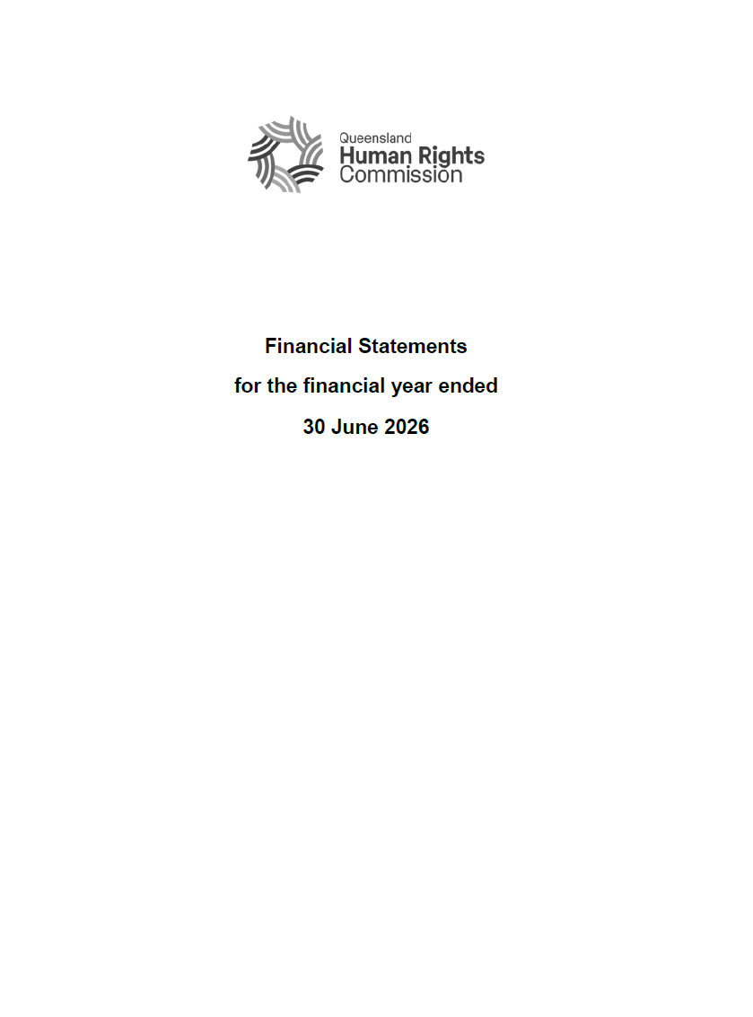
Financial Statements
For the financial year ended
30 June 2026

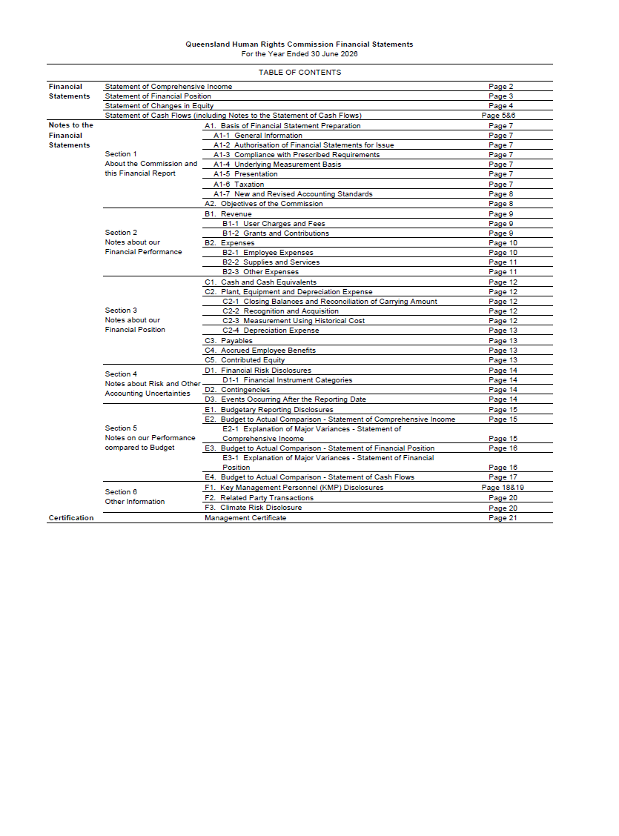
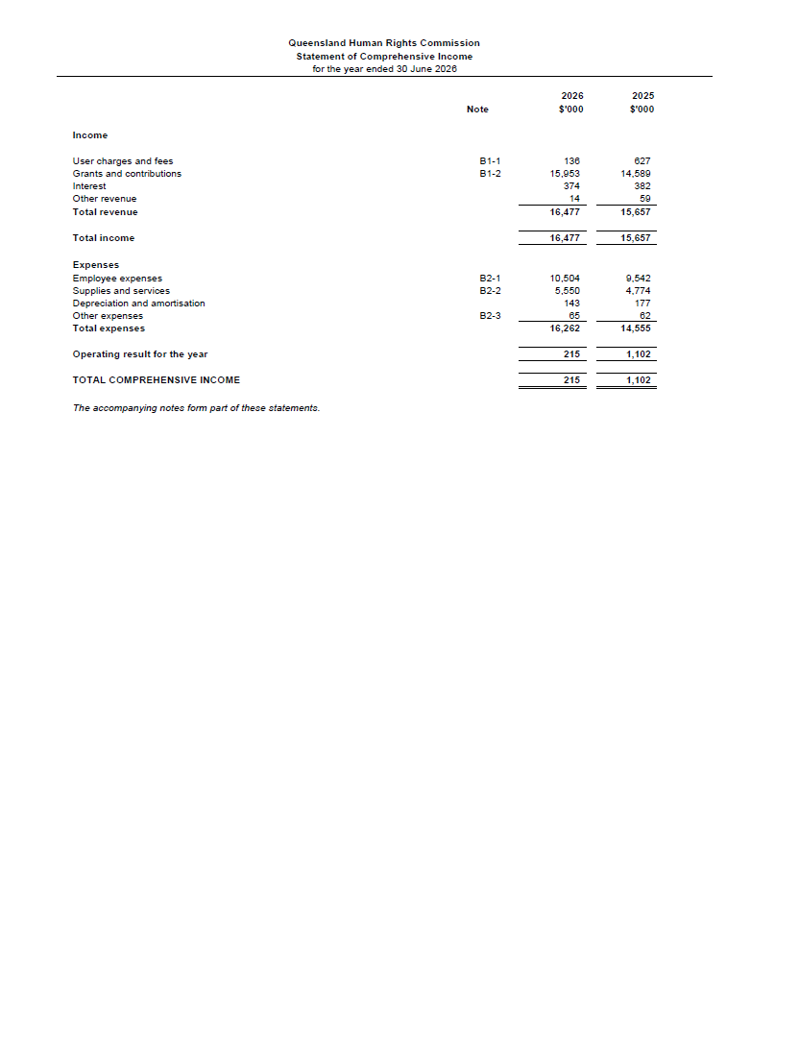
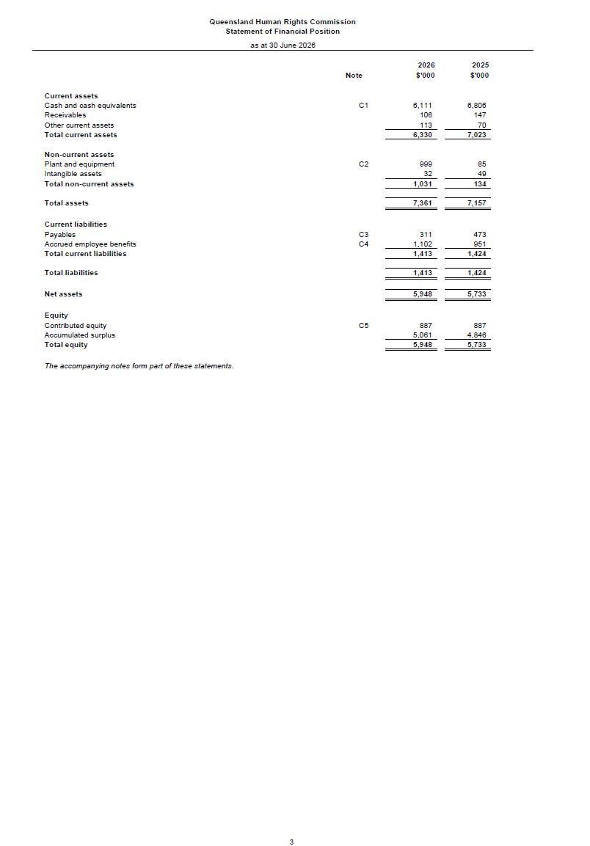
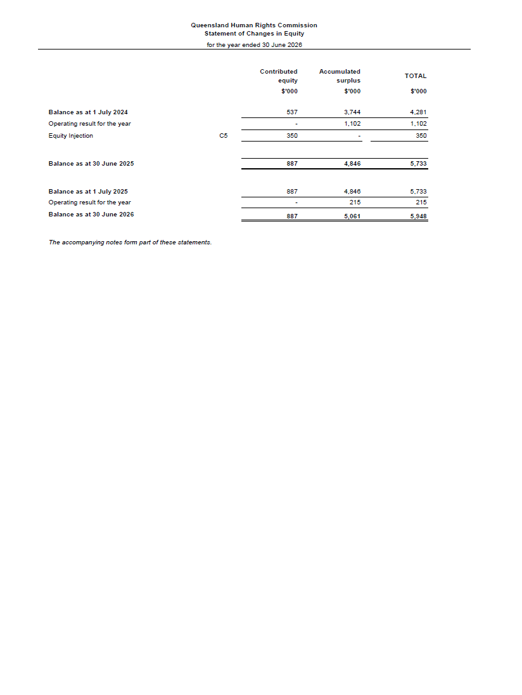
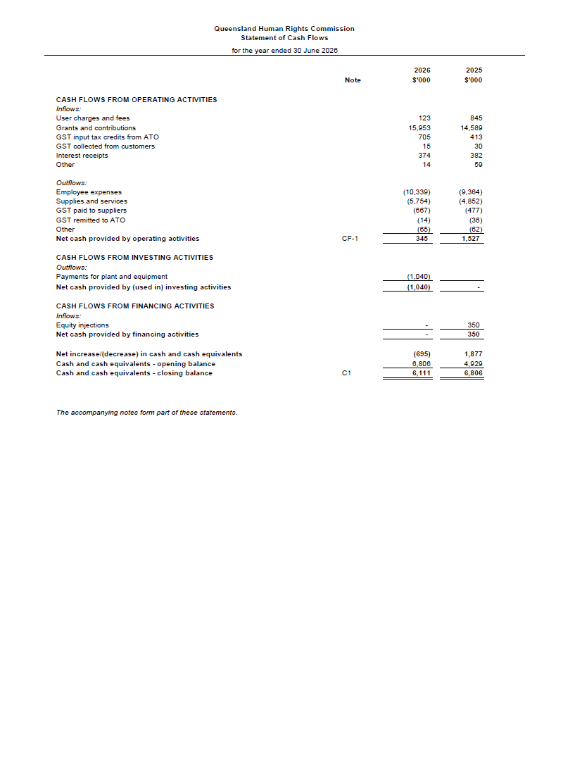
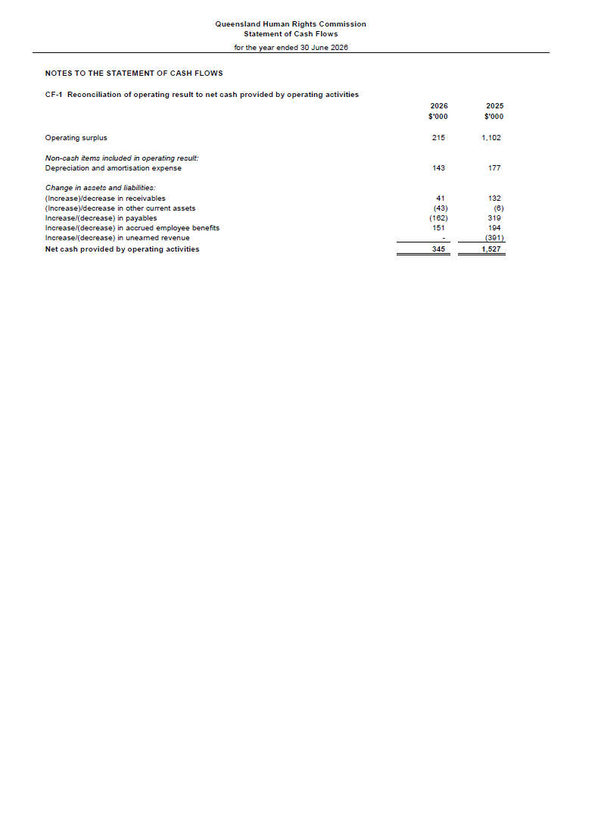
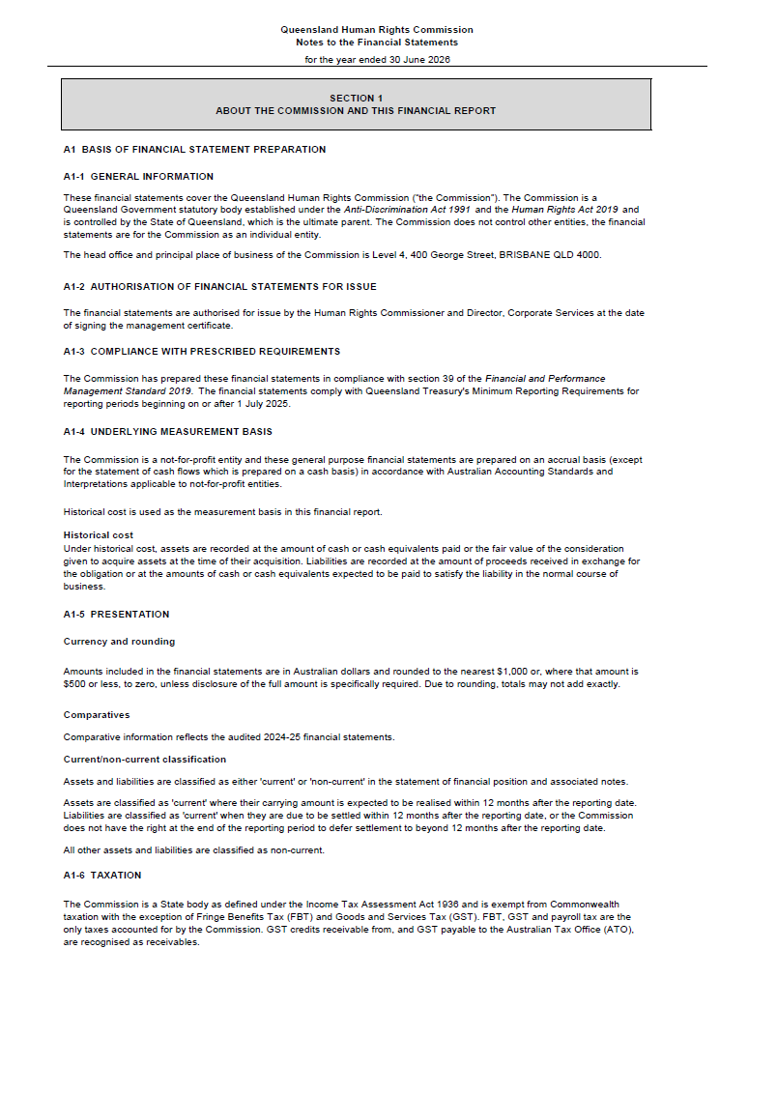
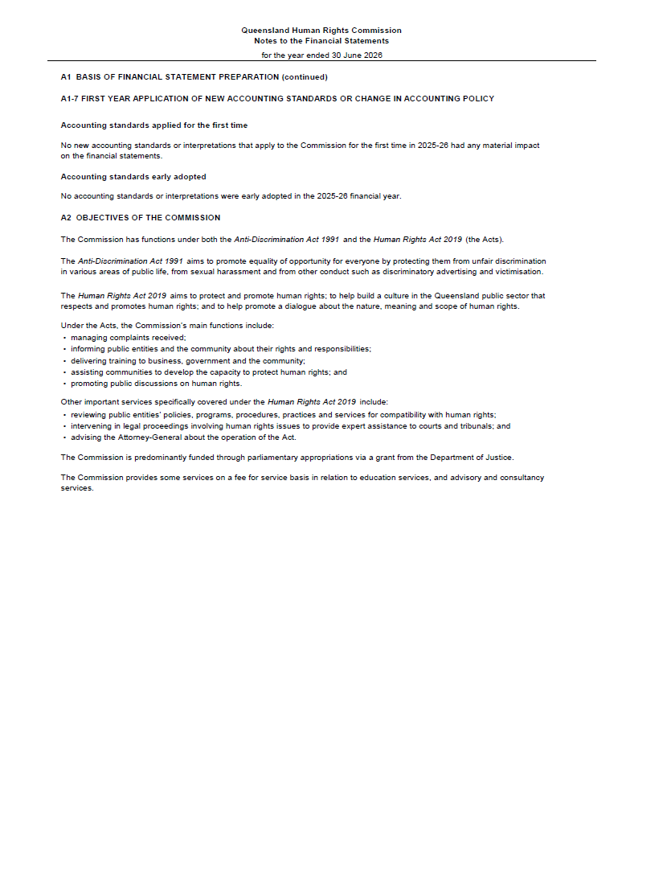
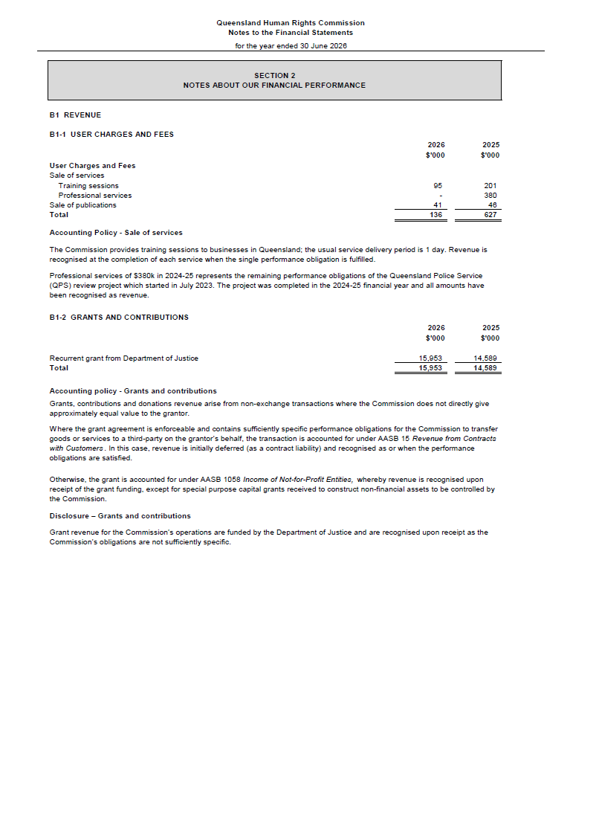
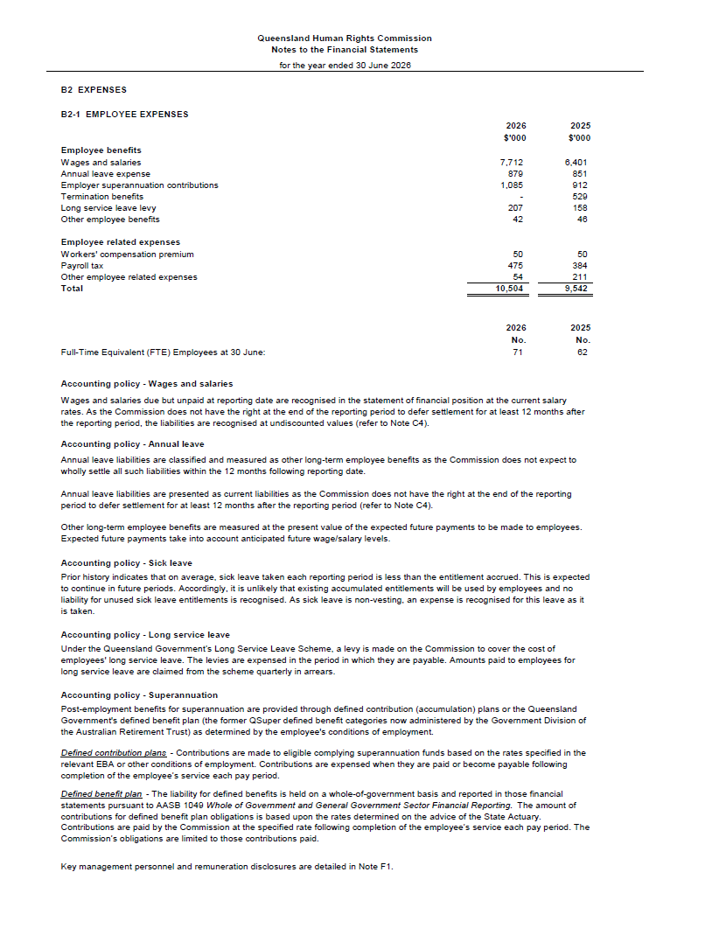
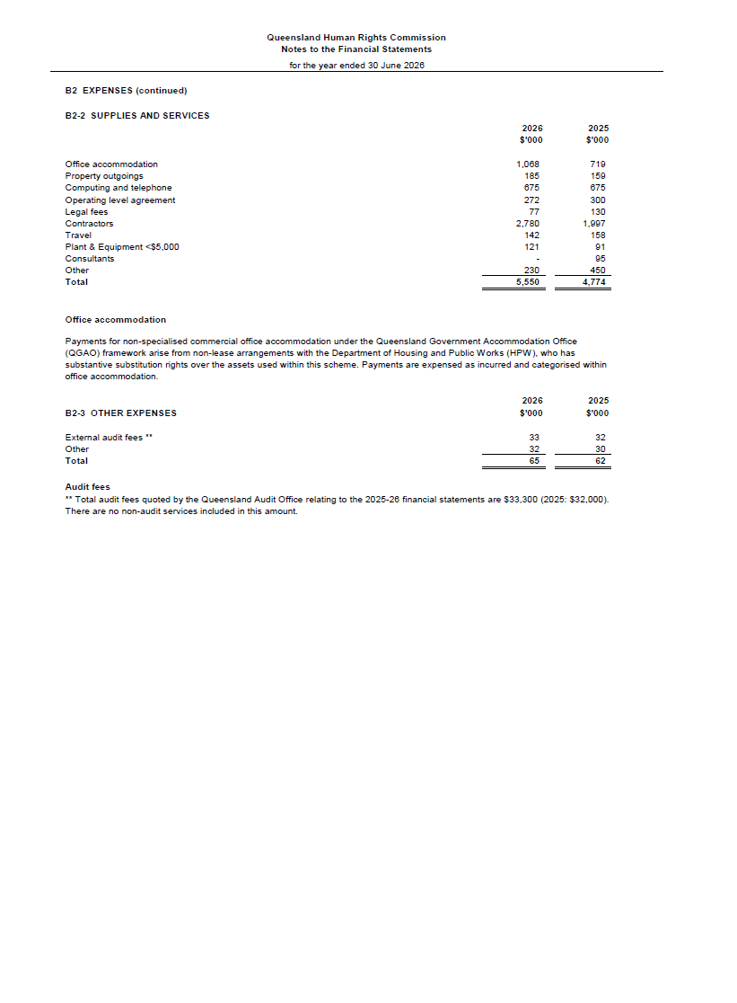
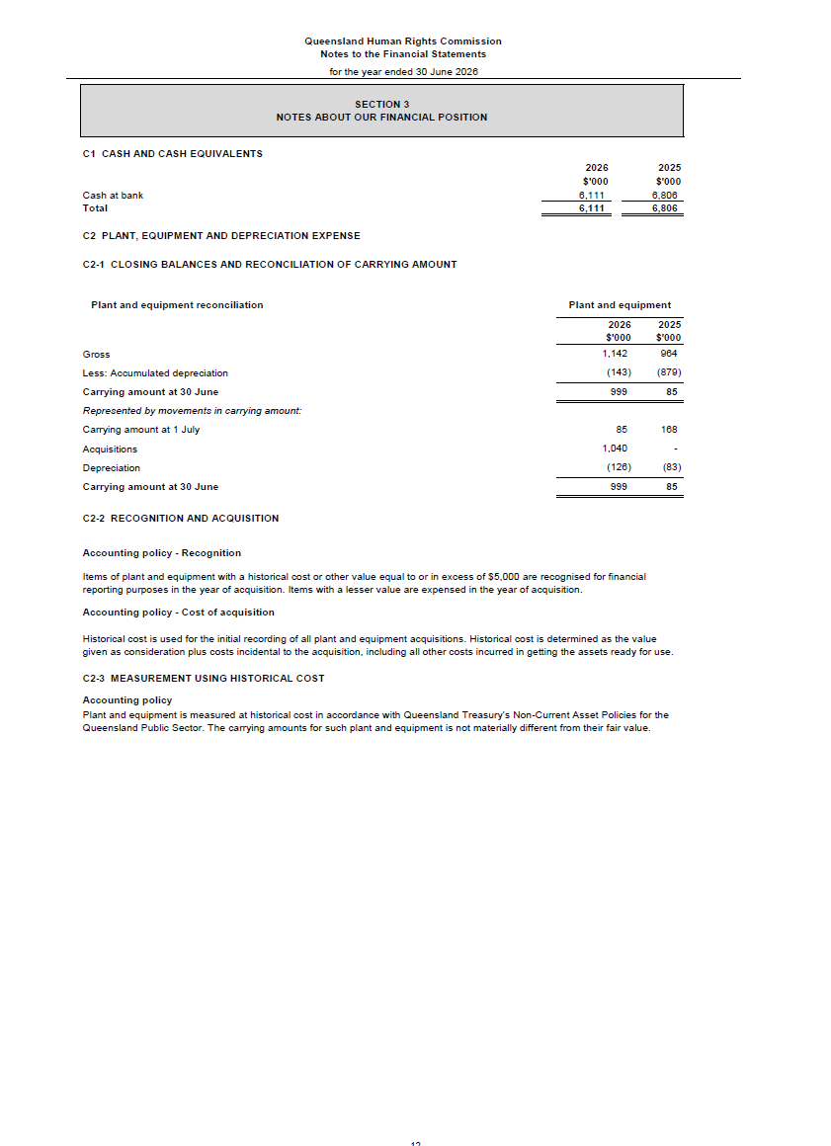
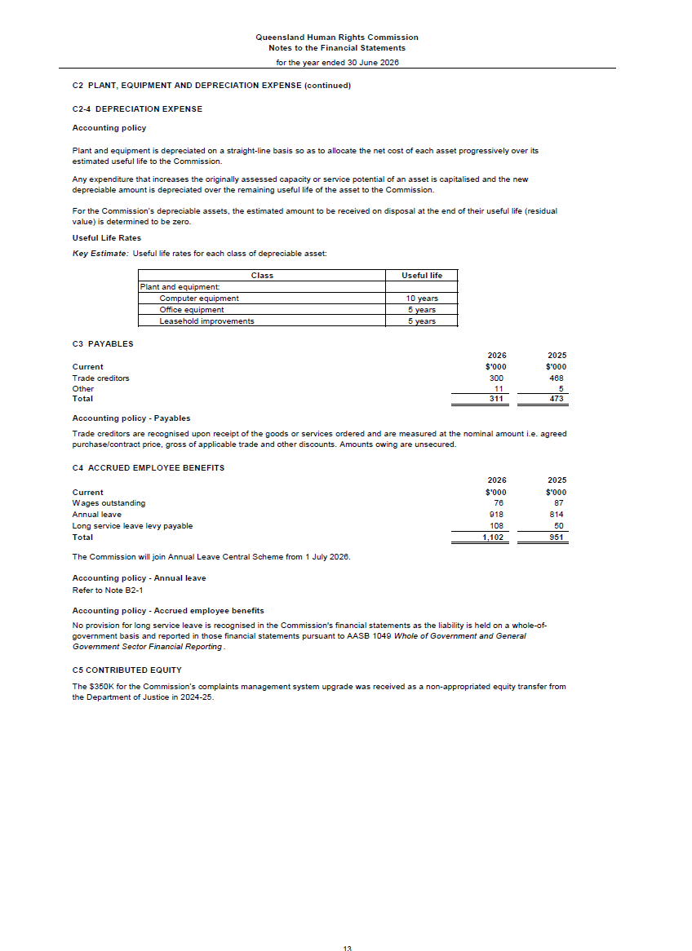

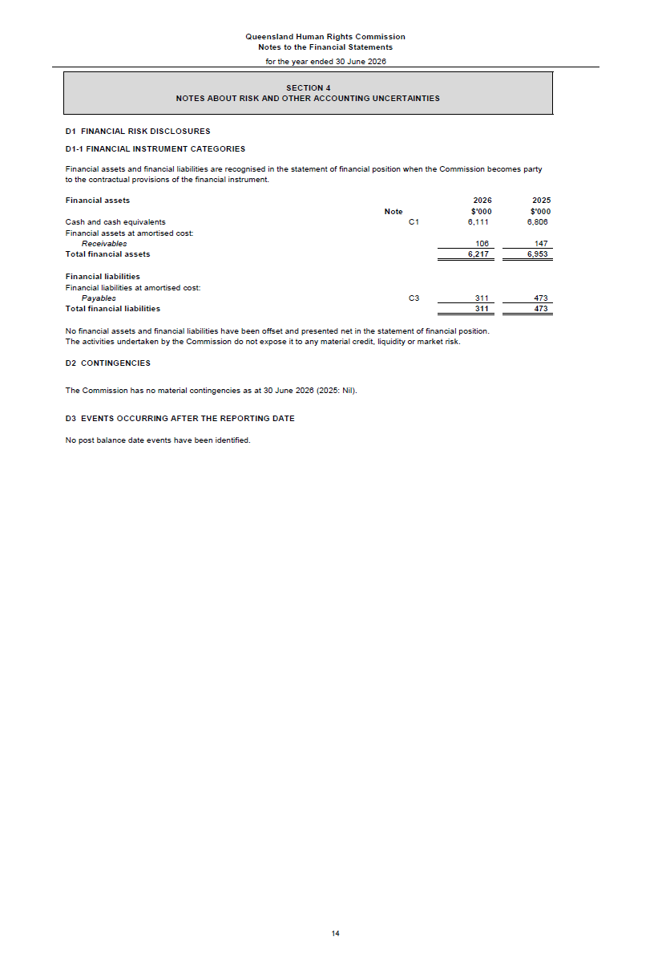
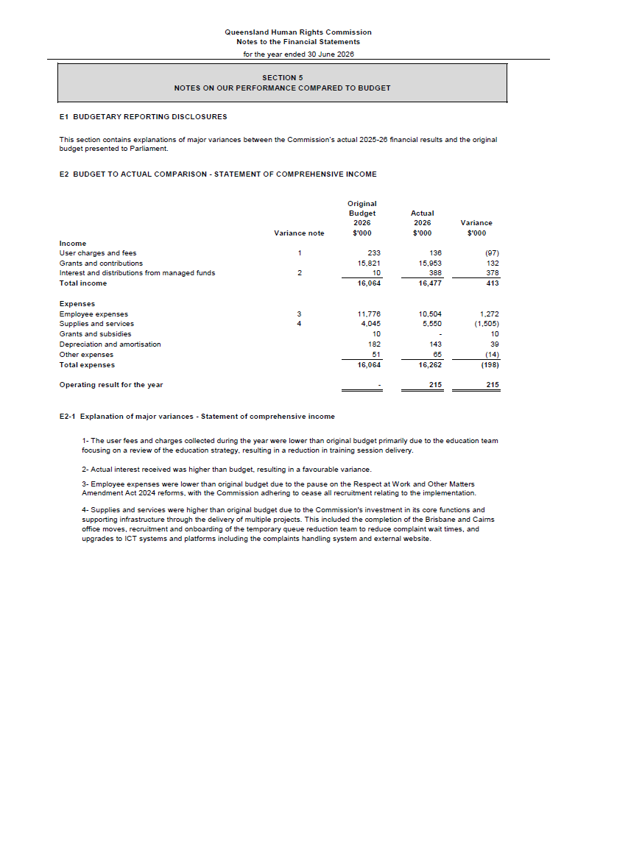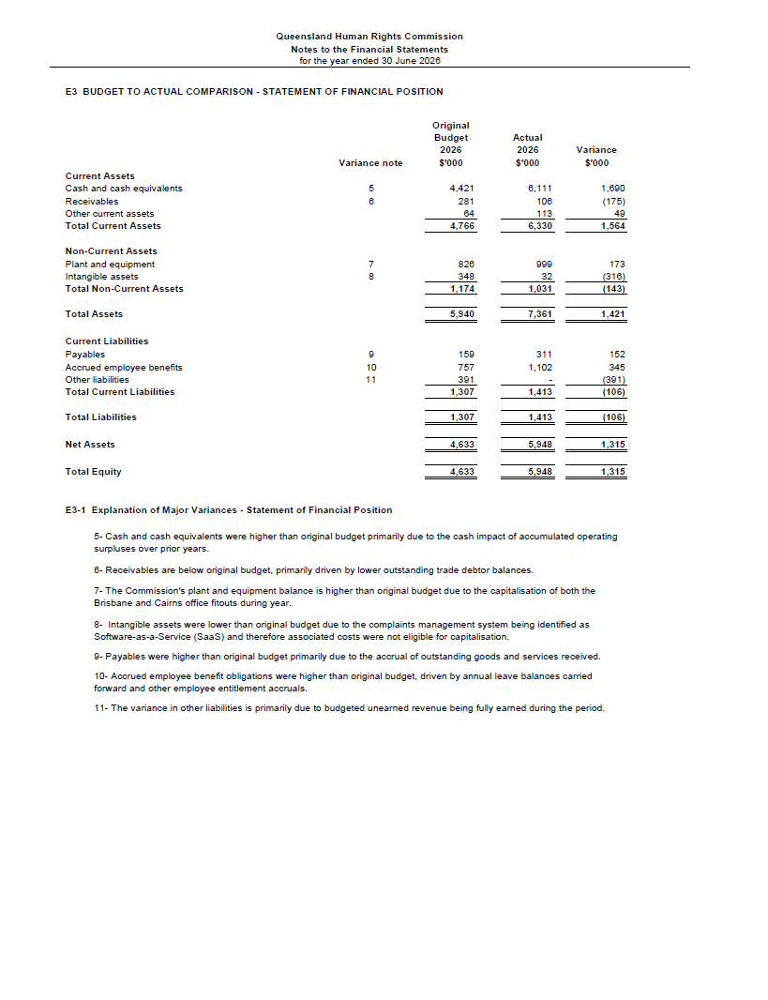
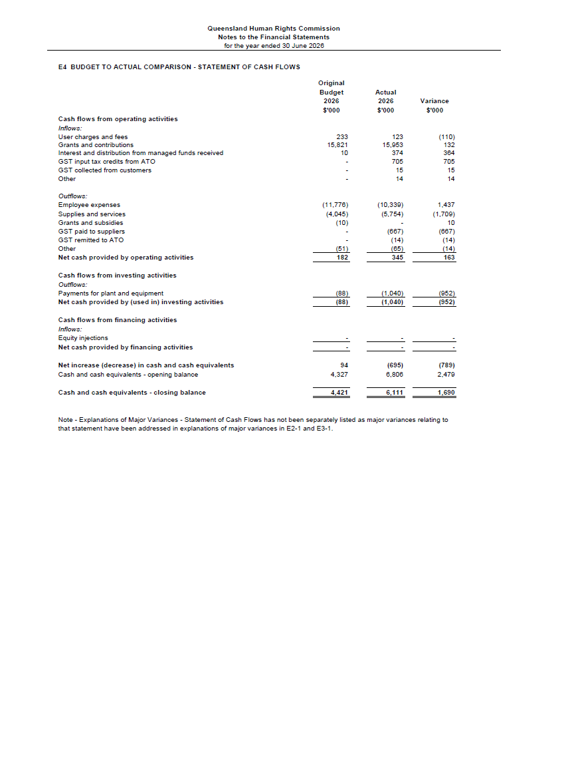
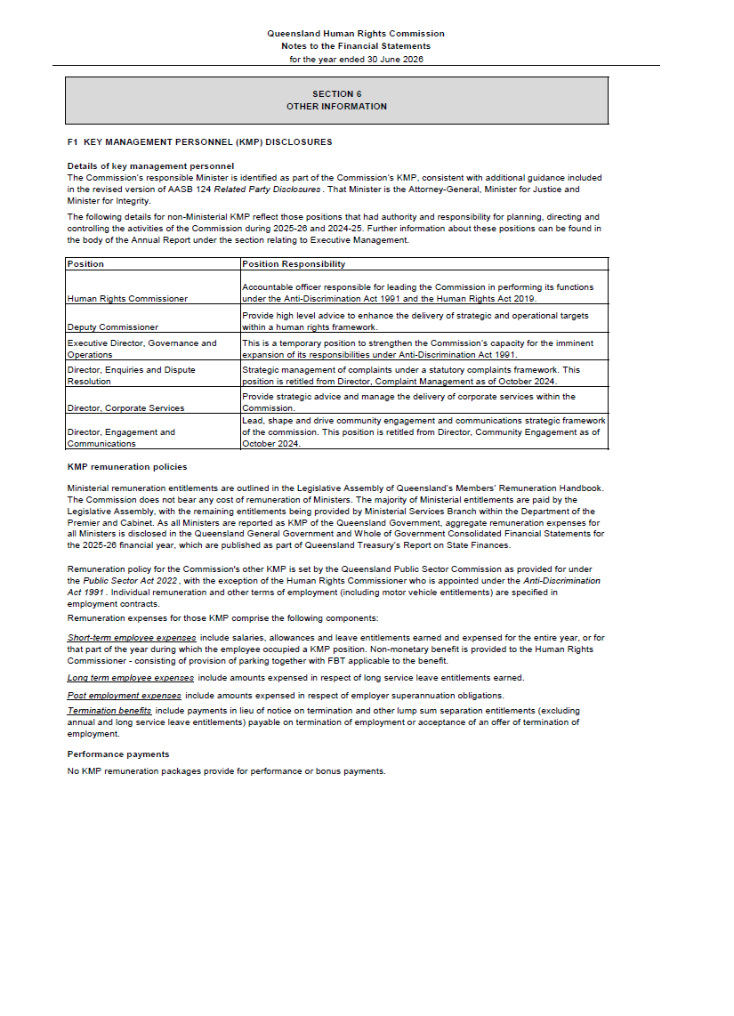
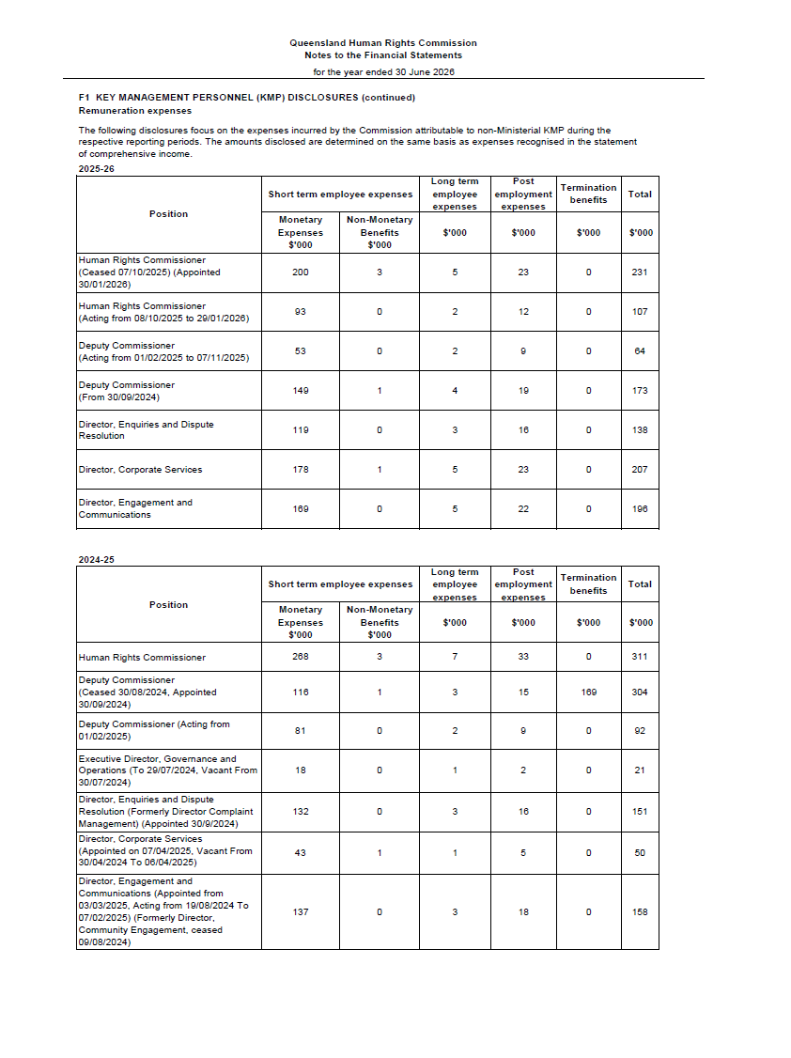
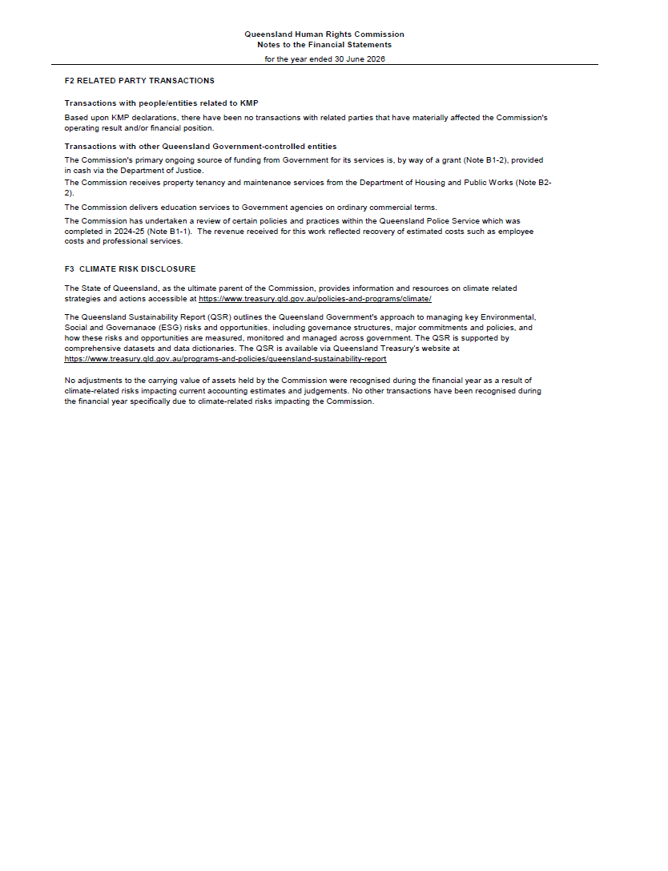
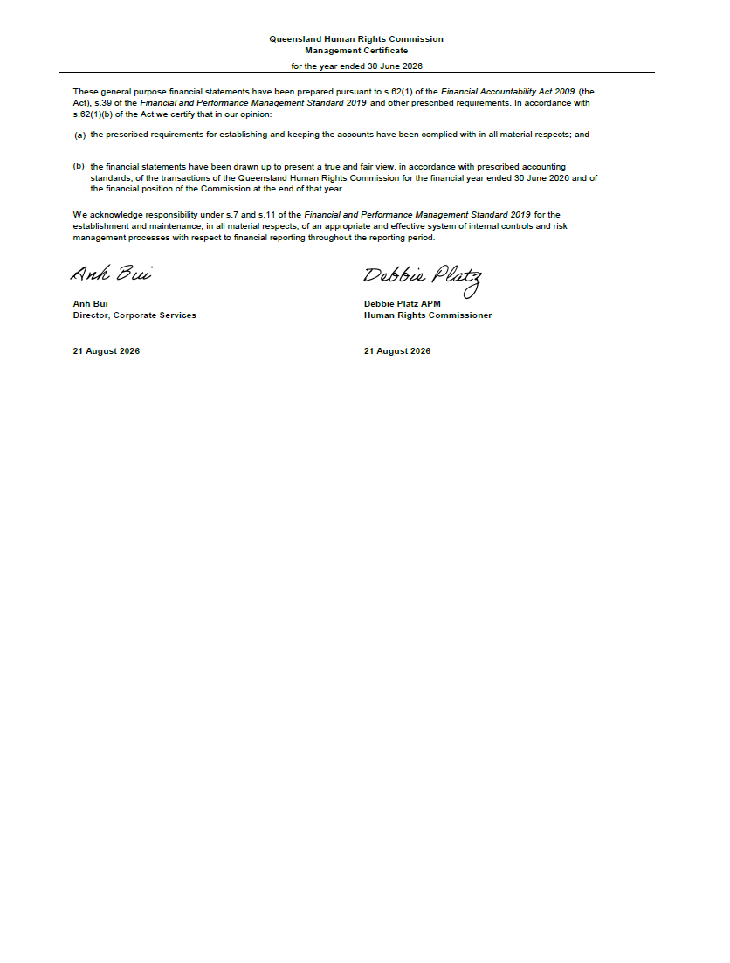
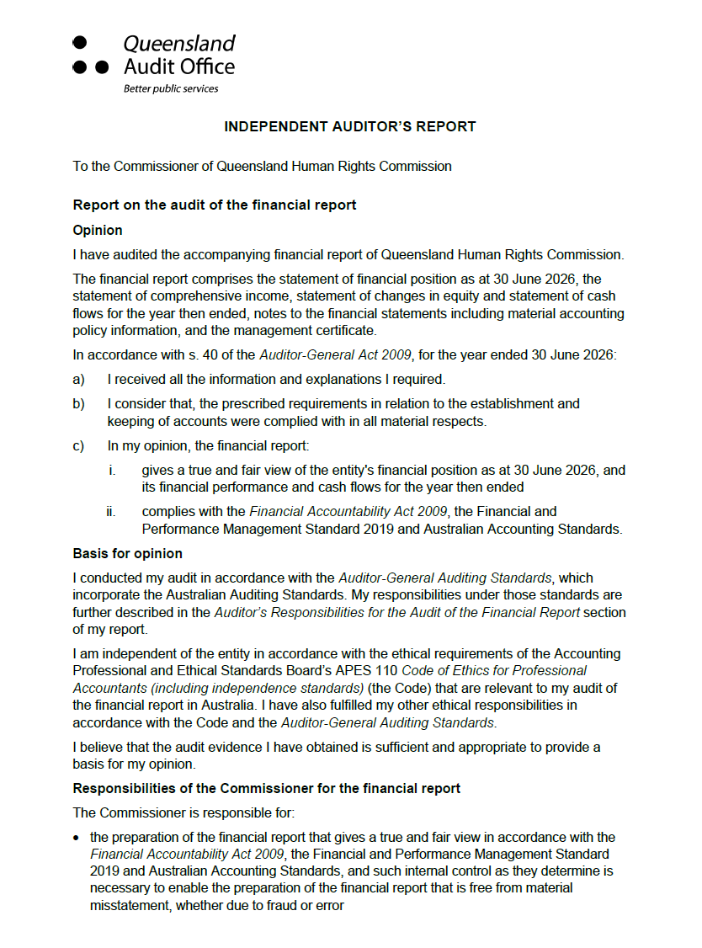
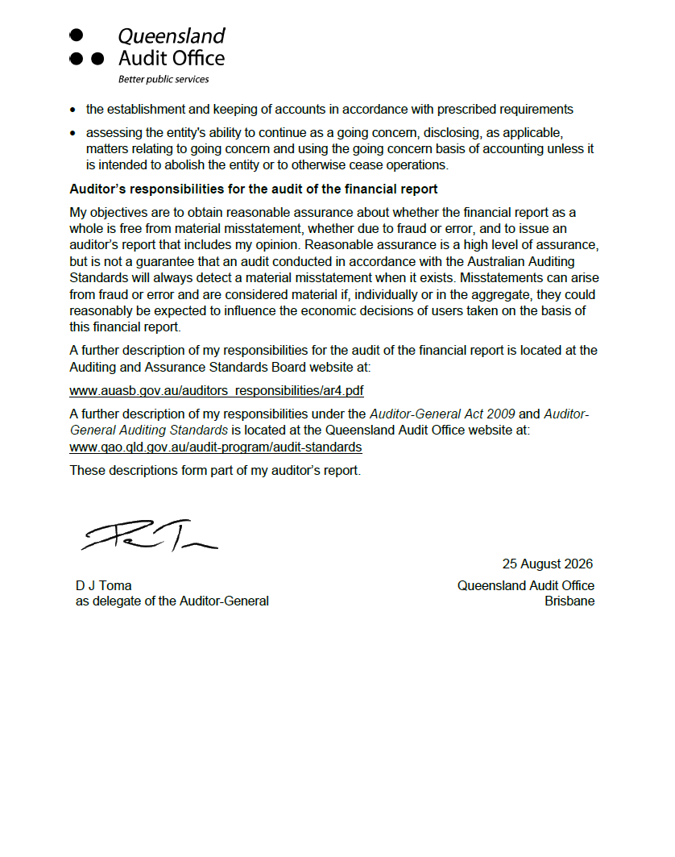

Appendix A: Compliance checklist
Summary of requirement |  | Basis for requirement | Annual report reference
Letter of compliance | - A letter of compliance from the accountable officer or statutory body to the relevant Minister/s | ARRs – section 7 | Page 5
Accessibility | - Table of contents  - Glossary | ARRs – section 9.1 | Pages 3, 102
Accessibility | - Public availability | ARRs – section 9.2 | Page 2
Accessibility | - Interpreter service statement | Queensland Government Language Services Policy  ARRs – section 9.3 | Page 2
Accessibility | - Copyright notice | Copyright Act 1968  ARRs – section 9.4 | Page 2
Accessibility | - Information Licensing | QGEA – Information Licensing  ARRs – section 9.5 | Page 2
General information | - Introductory Information | ARRs – section 10 | Page 9
Non-financial performance | - Government’s objectives for the community and whole-of-government plans/specific initiatives | ARRs – section 11.1 | Page 16
Non-financial performance | - Agency objectives and performance indicators | ARRs – section 11.2 | Appendix B
Non-financial performance | - Agency service areas and service standards | ARRs – section 11.3 | Appendix B
Financial performance | - Summary of financial performance | ARRs – section 12.1 | Page 72
Governance – management and structure | - Organisational structure | ARRs – section 13.1 | Pages 11-15  Appendix D
Governance – management and structure | - Executive management | ARRs – section 13.2 | Pages 11-15
Governance – management and structure | - Government bodies (statutory bodies and other entities) | ARRs – section 13.3 | Not applicable
Governance – management and structure | - Public Sector Ethics | Public Sector Ethics Act 1994  ARRs – section 13.4 | Page 66
Governance – management and structure | - Human Rights | Human Rights Act 2019  ARRs – section 13.5 | Page 66
Governance – management and structure | - Queensland public service values | ARRs – section 13.6 | Page 67
Governance – risk management and accountability | - Risk management | ARRs – section 14.1 | Page 67
Governance – risk management and accountability | - Audit committee | ARRs – section 14.2 | Page 67
Governance – risk management and accountability | - Internal audit | ARRs – section 14.3 | Page 69
Governance – risk management and accountability | - External scrutiny | ARRs – section 14.4 | Page 69
Governance – risk management and accountability | - Information systems and recordkeeping | ARRs – section 14.5 | Page 69
Governance – risk management and accountability | - Information Security attestation | ARRs – section 14.6 | Not applicable
Governance – human resources | - Strategic workforce planning and performance | ARRs – section 15.1 | Pages 71
Governance – human resources | - Early retirement, redundancy and retrenchment | Directive No.04/18 Early Retirement, Redundancy and Retrenchment  ARRs – section 15.2 | Page 71
Open Data | - Statement advising publication of information | ARRs – section 16 | Pages 2, 71
Open Data | - Consultancies | ARRs – section 31.1 | https://data.qld.gov.au
Open Data | - Overseas travel | ARRs – section 31.2 | https://data.qld.gov.au
Open Data | - Queensland Language Services Policy | ARRs – section 31.3 | https://data.qld.gov.au
Open Data | - Charter of Victims’ Rights | VCSVRB Act 2024  ARRs – section 31.4 | https://data.qld.gov.au
Financial statements | - Certification of financial statements | FAA – section 62  FPMS – sections 38, 39 and 46  ARRs – section 17.1 | Pages 96-98
Financial statements | - Independent Auditor’s Report | FAA – section 62  FPMS – section 46  ARRs – section 17.2 | Pages 97-98

Appendix B: Performance statement
Human rights and anti-discrimination
Objective
Strengthen the understanding, promotion and protection of human rights in Queensland.
Description
Promotion and protection of human rights and building a culture within the Queensland public sector of respect for human rights.
Service standards | 2025-26 Target/ Estimate | 2025-26 Actual | 2026-27 Target/ Estimate
Effectiveness measures
Percentage of accepted Anti-Discrimination Act 1991 (ADA) complaints resolved by conciliation | 50% | 35% | 50%
Percentage of accepted ADA complaints not referred to a tribunal and finalised within the Commission | 70% | 71% | 70%
Percentage of accepted Human Rights Act 2019 (HRA) complaints resolved by conciliation | 30% | 23% | 30%
Clients’ overall satisfaction with complaint handling service¹ | 85% | 46% | 85%
Clients’ overall satisfaction with training sessions | 95% | 93% | 95%
Percentage of clients whose understanding of rights and responsibilities under anti-discrimination and/or human rights law increased following training | 85% | 98% | 85%
Efficiency measure
Clearance rate for accepted complaints dealt with under the ADA and the HRA² | 100% | 76% | 100%
Notes:
- The variance between the 2025-26 Target/Estimate and the 2025-26 Actual is due to increasing complaint volumes impacting wait times and overall customer satisfaction.
- The variance between the 2025-26 Target/Estimate and the 2025-26 Actual is largely driven by the higher complaint numbers the QHRC has received in 2025-26.

Appendix C: Glossary
Term | Description
ADA, AD Act | Anti-Discrimination Act 1991 (Qld)
ARC | QHRC’s audit and risk committee
ARR, ARRs | Annual report requirements for Queensland Government agencies
Commission | Queensland Human Rights Commission (formerly Anti-Discrimination Commission Queensland)
E&C | QHRC’s engagement and communications directorate
EDR | QHRC’s enquiries and dispute resolution directorate
EMC | QHRC’s executive management committee
FAA | Financial Accountability Act 2009 (Qld)
FPMS | Financial and Performance Management Standard 2019
FTE | Full time equivalent, the ratio of an individual’s working hours to the relevant award full-time standard hours for the work being performed.
HRA, HR Act | Human Rights Act 2019 (Qld)
ICT | Information and communications technology
IP Act | Information Privacy Act 2009 (Qld)
LGBTIQA+ | Lesbian, gay, bisexual, transgender, queer, intersex, asexual and/or aromantic, with the + representing other identities that don’t quite fit other labels, or identities that we don’t quite have the language to describe yet
MOHRI | Minimum Obligatory Human Resource Information, the data Queensland Government agencies must provide for the Queensland public sector workforce profile report
P&P | QHRC’s performance and people directorate
PPP | QHRC’s public policy and prevention directorate
ORIC | Office of the Registrar of Indigenous Corporations
QAO | Queensland Audit Office
QCAT | Queensland Civil and Administrative Tribunal
QHRC | Queensland Human Rights Commission (formerly Anti-Discrimination Commission Queensland)
QGEA | Queensland Government Enterprise Architecture
QIRC | Queensland Industrial Relations Commission
SBFAA | Statutory Bodies Financial Arrangements Act 1982 (Qld)
VCSVRB | Victims’ Commissioner and Sexual Violence Review Board Act 2024

Appendix D: Our organisational structure

Office of the Commissioner

Public policy and prevention |  | Enquiries and dispute resolution |  | Performance and people |  | Engagement and communications
This directorate includes the legal and policy, education and prevention focused teams |  | This directorate responds to enquiries and provides complaints management and dispute resolution services |  | This directorate delivers corporate support functions including ICT, finance, people & culture and corporate governance |  | This directorate delivers engagement & communication services and includes Yirmba  First Nations Unit

Appendix E: Our functions
We have legislated functions under the Anti-Discrimination Act 1991 and Human Rights Act 2019. Our primary functions under each Act are as follows.
Anti-Discrimination Act 1991 | Human Rights Act 2019
Inquire into complaints and, where possible, to effect conciliation and carry out investigations relating to contraventions of the Act. (section 235(a) and (b)) | Deal with human rights complaints. (section 61(a))
Undertake research and educational programs to promote the purposes of the Act, and to coordinate programs undertaken by other people or authorities on behalf of the State. (section 235(d)) | Provide education about human rights and this Act. (section 61(f))  Make information about human rights available to the community. (section 61(e))
Consult with various organisations to ascertain means of improving services and conditions affecting groups that are subjected to contraventions of the Act. (section 235(e)) | Review public entities’ policies, programs, procedures, practices and services in relation to their compatibility with human rights. (section 61(c))
Examine Acts and, when requested by the Minister, proposed Acts, to determine whether they are, or would be, inconsistent with the purposes of the Act, and to report to the Minister the results of the examination. (section 235(c)) | If asked by the Attorney-General, to review the effect of Acts, statutory instruments and the common law on human rights and give the Attorney-General a written report about the outcome of the review. (section 61(b))
When requested by the Minister, to research and develop additional grounds of discrimination and to make recommendations for the inclusion of such grounds in the Act. (section 235(f)) | Assist the Attorney-General in reviews of this Act under sections 95 and 96. (section 61(g))
If the commission considers it appropriate to do so—to intervene in a proceeding that involves human rights issues with the leave of the court hearing the proceeding and subject to any conditions imposed by the court. (section 235(j)) | Advise the Attorney-General about matters relevant to the operation of this Act. (section 61(h))  Intervene in and be joined as a party to a proceeding before a court or tribunal in which a question of law arises that relates to the application of this Act; or a question arises in relation to the interpretation of a statutory provision in accordance with this act. (section 51)
Promote an understanding and acceptance, and the public discussion, of human rights in Queensland. (Anti-Discrimination Act 1991 section 235(i); Human Rights Act 2019 section 61(d))

Le Roy v Brisbane City Council [2025] QCAT 314.
Loquias v The Star Entertainment Group and John Dwyer [2026] QIRC 23.
Pariyar v Basnet & Ors [2026] QIRC 214.
SP by PY v State of Queensland [2026] QCAT 245.
Criminal Code Act 1995 (Cth) s 101.6
Human Rights Act 2019 (Qld) ss 44, 45.
https://www.qhrc.qld.gov.au/_media/documents/submissions-by-the-commission/2026/2026.02.20-QHRC-response-to-question-on-notice.pdf
Criminal Code Act 1899 (Qld) s 52DA.
See Human Rights Act 2019 section 51 and Anti-Discrimination Act 1991 section 235(j).
Bobeldyk & Anor v Moreton Bay City Council; Eichin & Ors v Moreton Bay City Council [2026] QSC 27.
Anderson v President of the Parole Board Queensland [2025] QSC 123.
Chief Executive, Department of Environment, Science and Innovation v Nagana Yarrbayn Wangan and Jagalingou Cultural Custodians Ltd [2026] QCA 7.
Re: Proximity Advisory Services Pty Ltd and Systems Planning and Analysis Australia Pty Ltd [2026] QIRC 48.
Community Enterprise Queensland [2025] QCAT 325.
Re: Kalwun Development Corporation Limited [2026] QIRC 89.
Fernwood Women’s Clubs (Australia) Pty Ltd [2026] QCAT 271.
Miami Recreational Facilities Pty Ltd [2026] QCAT 99.
ARC Disability Ltd [2026] QIRC 134.
Women Vision Together Inc [2026] QCAT 17.
Anti-Discrimination Act 1991 section 175.
Anti-Discrimination Act 1991 section 113.
Anti-Discrimination Act 1991 section 144.
Anti-Discrimination Act 1991 section 169.
Anti-Discrimination Act 1991 section 228.
Twitter Australia Holdings Pty Ltd v Australian Muslim Advocacy Network Ltd [2026] QCATA 27.
Hoban v Zhang [2025] QCATA 103.
State of Queensland v Ali [2025] QCATA 76.
Benjamin v Sharp & Ors [2026] ICQ 5.
Benjamin v Sharp & Ors No. 2 [2026] ICQ 6.
Medwell-Everett v Daltug Pty Ltd & Ors [2025] ICQ 33.
Michalakellis v LMM Holdings Pty Ltd & Ors (No. 2) [2025] ICQ 31.
Mizner v State of Queensland (Corrective Services) [2025] QCA 169.
2025-26 Queensland State Budget – Service Delivery Statements – Queensland Human Rights Commission

