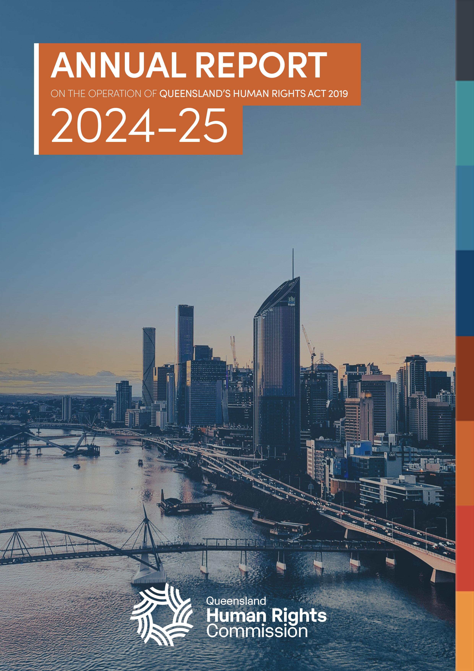
FRONT COVER
ANNUAL REPORT ON THE OPERATION OF QUEENSLAND’S HUMAN RIGHTS ACT 2019 2024-25

Logo: Queensland Human Rights Commission

Annual report on the operation of the Human Rights Act 2019

2024-25
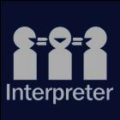
The Queensland Human Rights Commission is committed to providing accessible services to Queenslanders from all culturally and linguistically diverse backgrounds. If you have difficulty in understanding the annual report, you can contact us on toll free 1300 130 670 and we will arrange an interpreter to effectively communicate the report to you.
English: If you’d like us to arrange an interpreter for this report, please call us on 1300 130 670.
Spanish: Si desea que nosotros para solicitar un intérprete de este informe, por favor llámenos en 1300 130 670
French: Si vous souhaitez organiser un interprète pour ce rapport, veuillez nous appeler au 1300 130 670
Chinese: 如果您想让我们为此报co告安排传译员，请致电我们 1300年 130 670
Arabic: إذا كنت تريد منا أن يرتب مترجما لهذا التقرير، يرجى الاتصال بنا على 1300 130 670
German: Wenn Sie uns einen Dolmetscher für diesen Bericht anordnen möchten, rufen Sie uns bitte auf 1300 130 670
Turkish: Lütfen bizi arayın 1300 130 670 bizimle bu rapor için bir tercüman istiyorsanız,
Japanese: このレポートのための通訳の手配を希望する場合は、1300年 130 670 に問い合わせください。
Dutch: Als u wij dat wilt te regelen een tolk voor dit verslag, bel ons op 1300 130 670
Korean: 우리가이 보고서에 대 한 해석자를 정렬 작업을 원하시면 전화 주시기 바랍니다에 1300 130 670
© Queensland Human Rights Commission 2026
ISSN 2652-8835 (online)
Licence: This annual report is licensed by Queensland Human Rights Commission under a Creative Commons Attribution
(CC BY) 4.0 International licence.
To view a copy of this licence, visit: <https://creativecommons.org/licenses/by/4.0/>.
CC BY Licence Summary Statement: In essence, you are free to copy, communicate and adapt this annual report, as long as you attribute the work to the Queensland Human Rights Commission.
Attribution: Content from this annual report should be attributed as: Queensland Human Rights Commission, 2024-2025 Annual report on the operation of the Human Rights Act 2019.

This publication is available in electronic format on the Commission’s website at: <www.qhrc.qld.gov.au.>

Contents
Commissioner’s foreword 5
Report summary 7
About the Commission 10
About the Human Rights Act 12
Objects of the Human Rights Act 12
Protected human rights 12
Government obligations 13
Public entities 13
The dialogue model 14
Human rights timeline 2024-25 16
Human rights and parliament 20
Reflections on 2024-25 20
Submissions by the Commission 22
Override declarations 22
Human rights and the courts 26
Reflections on 2024-25 26
Interventions 28
Commission notifications 28
Commission interventions 28
Attorney-General interventions 29
Human rights and the public sector 31
Reflections on 2024-25 31
State public entity progress 32
Progress in councils 33
Complaints made directly to public entities 34
Complaints to the Commission 40
Unresolved complaint reports 42
Appendix A: Published submissions made by the Commission 46
Appendix B: Cases that substantively considered human rights 47
Appendix C: Questions sent to public entities 49
Appendix D: Human rights timeline 2024-25 53


BREAK PAGE
Logo
Queensland Human Rights Commission

Commissioner’s foreword
On behalf of the Queensland Human Rights Commission (the Commission), I am pleased to present the 2024-25 report on the operation of the Human Rights Act 2019 (Qld) (Human Rights Act).
I am privileged to have recently joined the Commission as the Queensland Human Rights Commissioner.
My public sector leadership experience has taken me into some of the most challenging environments in our state. These experiences, while at times confronting, have strengthened my commitment to preventing discrimination and upholding the human rights of every person.
As I step into this role, I do so with appreciation for the foundations established by Scott McDougall, who served as Anti-Discrimination Commissioner from October 2018, and subsequently as Queensland’s first Human Rights Commissioner from July 2019 to Oct 2025. His sustained commitment has been instrumental in strengthening the protection of the rights and freedoms owed to every person in Queensland. The results outlined in this report occurred during Scott’s tenure, and I acknowledge his leadership and contribution to the Commission during that time.

Purpose of report
Section 91 of the Human Rights Act requires that, as soon as practicable after the end of each financial year, the Commissioner must prepare a report about the operation of the Act during the year.
The purpose of this report is to provide a resource for government, parliament, and the community to better understand how the Human Rights Act has been operationalised and the degree to which it is achieving its objectives.
This year, we are publishing a report which supplements the Commission’s corporate annual report for the 2024-25 financial year. The information in these reports captures the extent to which the Human Rights Act achieved its objectives during this period.

Reflecting on 2024-25
During the 2024-25 reporting year, the Commission observed significant progress in developing a human rights culture. Local councils, for instance, showed substantial progress compared with previous years. They reported improved community engagement, strengthened human rights-compatible policies and procedures, growing use of tailored training, and several examples of embedded human rights decision-making.
Court and tribunal decisions this year demonstrated how applying the Human Rights Act, including through interpreting legislation consistently with human rights, can produce positive outcomes for the community.
The Commission continues to finalise more human rights complaints each year, demonstrating the much-valued work of our Enquiries and Dispute Resolution team. This trend also indicates that Queenslanders are becoming increasingly aware of and willing to take action in relation to their human rights, and signals that the state’s human rights culture is continuing to develop.
In 2024-25 the Commission adapted and responded to new challenges, building on the initial momentum created by the commencement of the Act, to support the continued development of a more integrated and mature human rights culture in Queensland.
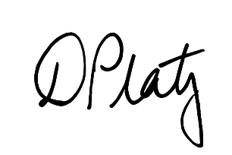

Debbie Platz APM
Queensland Human Rights Commissioner

Report summary
Table 1: Information required for this report under section 91 of the Human Rights Act
Section | Required information
91(2)(a) | details of any examination of the interaction between this Act and other Acts, statutory instruments and the common law  This provision refers to section 61(b) of the Act. The Commission was not asked to perform this function in the 2024-25 financial year.
91(2)(b) | details of all declarations of incompatibility made  The Supreme Court made no declarations of incompatibility in the 2024-25 financial year.
91(2)(c) | details of all override declarations made  Two override declarations were made by parliament in relation to amendments to the Youth Justice Act 1992 (Qld) (Youth Justice Act). Human rights were overridden a third time in relation to further amendments to the Youth Justice Act. However, those amendments were deemed to be subject to one of the existing override declarations.  For more information see Human rights and parliament - Override declarations.
91(2)(d) | details of all interventions by the Attorney-General or the Commission under section 50 or 51  The Commission intervened in 5 new matters.  The Attorney-General intervened in 4 new matters.  For more information see Human rights and the courts -Interventions.
91(2)(e) | number of human rights complaints made or referred to the Commissioner  The Commission received 491 complaints about human rights in the financial year.  For more information on complaints see the Queensland Human Rights Commission 2024-25 Annual Report, available from our website at <https://www.qhrc.qld.gov.au/about-us/annual-reports>.
91(2)(f) | outcome of human rights complaints accepted by the Commissioner for resolution by the Commission, including whether or not the complaints were resolved by conciliation or otherwise  The number of human rights complaints finalised in the financial year was 751 (up from 469, reflecting a 60% increase from 2023-24). Of these, 279 were human rights only complaints and 472 were piggy-back complaints.  Of the 234 complaints which were accepted and finalised in the 2024-25 financial year:  - 59 complaints were resolved (12 human rights only complaints, 47 piggy-back complaints)  - 59 complaints were referred to the Queensland Civil and Administrative Tribunal (all piggy-back complaints)  - 23 complaints were referred to the Queensland Industrial Relations Commission (all piggy-back complaints).  - For more information on complaints see the Queensland Human Rights Commission 2024-25 Annual Report, available from our website at <https://www.qhrc.qld.gov.au/about-us/annual-reports>.
91(2)(g) | the number of human rights complaints resolved by the Commission  In the 2024-25 financial year, 59 complaints were resolved by the Commission, comprising 12 human rights only complaints and 47 piggy-back complaints.  For more information on complaints see the Queensland Human Rights Commission 2024-25 Annual Report, available from our website at <https://www.qhrc.qld.gov.au/about-us/annual-reports>.
91(2)(h) | the number of conciliation conferences conducted under this part  134 conciliation conferences relating to human rights were conducted in the 2024-25 financial year.  For more information on complaints see the Queensland Human Rights Commission 2024-25 Annual Report, available from our website at <https://www.qhrc.qld.gov.au/about-us/annual-reports>.
91(2)(i) | the number of public entities that were asked or directed to take part in a conciliation conference, and the number that failed to comply with a direction to take part  Most accepted complaints involved more than one respondent, and some public entities were directed to attend on more than one occasion. Overall, 147 discrete respondents were directed to take part in a conciliation conference, of which 106 were individual people, and 41 were public entities such as government departments, councils or functional public entities.  No public entities failed to comply with a direction to attend a conference in the 2024-25 financial year.
91(2)(j) | the number of human rights complaints received by particular public entities decided by the Commissioner  This information is too detailed to reproduce in the report summary.  See Human rights and the public sector – Complaints made directly to public entities
88(4) | details of action the Commissioner considers the respondent should take to ensure its acts and decisions are compatible with human rights, following an unresolved conciliation  Two reports on unresolved complaints containing recommendations by the Commissioner were made this financial year.  For more information, see Unresolved complaint reports

About the Commission
The Queensland Human Rights Commission is an independent statutory body established under the Anti-Discrimination Act 1991 (Anti-Discrimination Act) with functions under that Act and the Human Rights Act 2019.
The Commission’s functions under section 61 of the Human Rights Act are:
- to deal with human rights complaints;
- if asked by the Attorney-General, to review the effect of Acts, statutory instruments and the common law on human rights and give the Attorney-General a written report about the outcome of the review;
- to review public entities’ policies, programs, procedures, practices and services in relation to their compatibility with human rights;
- to promote an understanding and acceptance, and the public discussion, of human rights and this Act in Queensland;
- to make information about human rights available to the community;
- to provide education about human rights and this Act;
- to assist the Attorney-General in reviews of this Act under sections 95 and 96;
- to advise the Attorney-General about matters relevant to the operation of this Act; and
- another function conferred on the Commission under this Act or another Act.

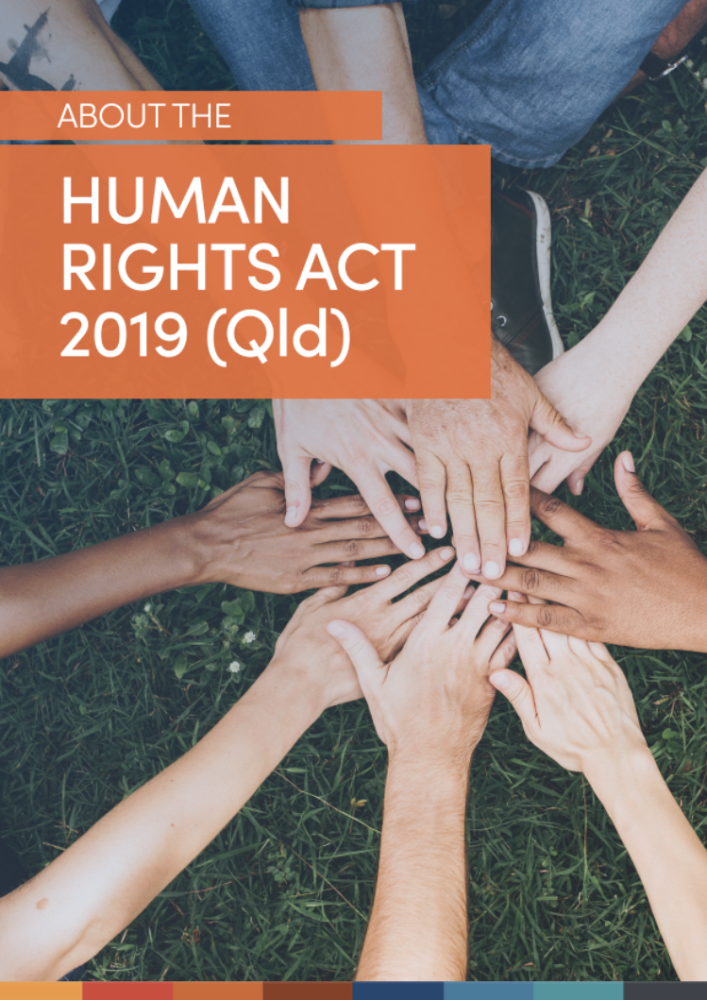
TITLE PAGE
ABOUT THE HUMAN RIGHTS ACT 2019 (Qld)

About the Human Rights Act
The Human Rights Act consolidates and establishes statutory protections for certain rights including, primarily, civil and political rights drawn from the International Covenant on Civil and Political Rights (ICCPR).
It also protects 2 rights drawn from the International Covenant on Economic, Social and Cultural Rights (ICESCR) – the right to access education and the right to access health services – and one right drawn from the Universal Declaration of Human Rights (property rights).
The Act also explicitly protects the cultural rights of Aboriginal peoples and Torres Strait Islander peoples in line with the United Nations Declaration on the Rights of Indigenous Peoples.

Objects of the Human Rights Act
The main objects of the Human Rights Act are:
- to protect and promote human rights; and
- to help build a culture in the Queensland public sector that respects and promotes human rights; and
- to help promote a dialogue about the nature, meaning and scope of human rights.

Protected human rights
The following human rights are protected under the Human Rights Act:
- Recognition and equality before the law (section 15)
- Right to life (section 16)
- Protection from torture and cruel, inhuman or degrading treatment (section 17)
- Freedom from forced work (section 18)
- Freedom of movement (section 19)
- Freedom of thought, conscience, religion and belief (section 20)
- Freedom of expression (section 21)
- Peaceful assembly and freedom of association (section 22)
- Taking part in public life (section 23)
- Property rights (section 24)
- Privacy and reputation (section 25)
- Protection of families and children (section 26)
- Cultural rights – generally (section 27)
- Cultural rights – Aboriginal peoples and Torres Strait Islander peoples (section 28)
- Right to liberty and security of person (section 29)
- Humane treatment when deprived of liberty (section 30)
- Fair hearing (section 31)
- Rights in criminal proceedings (section 32)
- Children in the criminal process (section 33)
- Right not to be tried or punished more than once (section 34)
- Retrospective criminal laws (section 35)
- Right to education (section 36)
- Right to health services (section 37)

Government obligations
The Human Rights Act places obligations on all 3 arms of government: the legislature, the judiciary, and the executive. They include:
- Parliament (the legislature) must consider human rights when proposing and scrutinising new laws.
- Courts and tribunals (the judiciary) must interpret legislation in a way that is compatible with human rights (so far as is possible).
- Public entities (the executive) – such as state government departments, local councils, state schools, the police, and non-government organisations and businesses performing a public function – must consider human rights when making decisions and must act compatibly with human rights.
The Human Rights Act makes it clear that rights can be limited, but only where it is reasonable and justifiable to do so.

Public entities
Public entities have obligations to give proper consideration to human rights when making decisions and to make decisions and act compatibly with human rights.
A public entity is an organisation or body performing a public function in and for Queensland. There are 2 types of public entities: core and functional.
Core public entities are government entities, including:
- government agencies and departments
- public service employees
- the Queensland Police Service and other emergency services
- state government ministers
- public schools
- public health services, including hospitals
- local government, councillors, and council employees.
Functional public entities are only considered public entities when they are performing a function of a public nature on behalf of the state. Organisations funded by the government to provide public services fall under this category. Functional public entities could be non-government organisations (NGOs), private companies, or Government Owned Corporations. For example, a private company funded to run a prison, or an NGO providing a public housing service.

The dialogue model
Figure 1: Diagram of the dialogue model
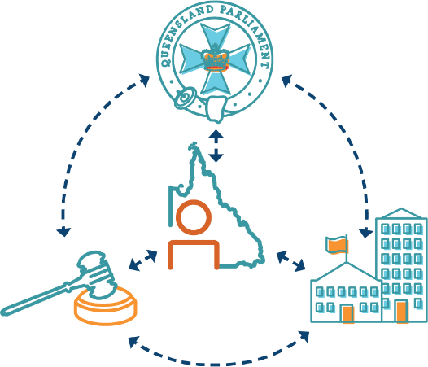
The Human Rights Act is underpinned by a dialogue model of human rights protection. The dialogue model aims to encourage discussion of human rights (as opposed to litigation) and in doing so, create a culture in which human rights are respected and protected. The model preserves the sovereignty of parliament.
The Human Rights Act contains a series of mechanisms to encourage dialogue about human rights between the 3 arms of government. For example, the Act requires members of parliament when introducing a Bill to table a statement of compatibility that details whether, in the member’s opinion, the Bill is compatible with human rights. It also requires parliamentary committees responsible for examining Bills to report to parliament about the statement of compatibility and whether the Bill is not compatible. This encourages dialogue between members of parliament about the human rights’ impacts of new legislation.
A further mechanism permits complaints to be made to the Commission about human rights (provided the complaint has first been made to the public entity). This encourages public entities to consider human rights when making decisions. The Commission takes a dispute resolution approach to resolving complaints which encourages resolution through dialogue between the complainant and the relevant public entity.
Where a complaint cannot be resolved, section 88 of the Human Rights Act requires the Commissioner to prepare a report about the complaint which may include recommendations of actions to be taken by the public entity to ensure its acts and decisions are compatible with human rights.


TITLE PAGE
HUMAN RIGHTS TIMELINE

Human rights timeline 2024-25
Below is a brief timeline of some significant events relevant to the operation of the Act in 2024-25.
See Appendix D for a text version of this timeline.
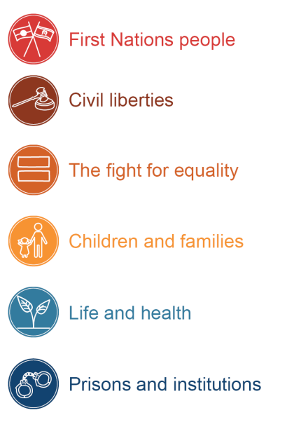

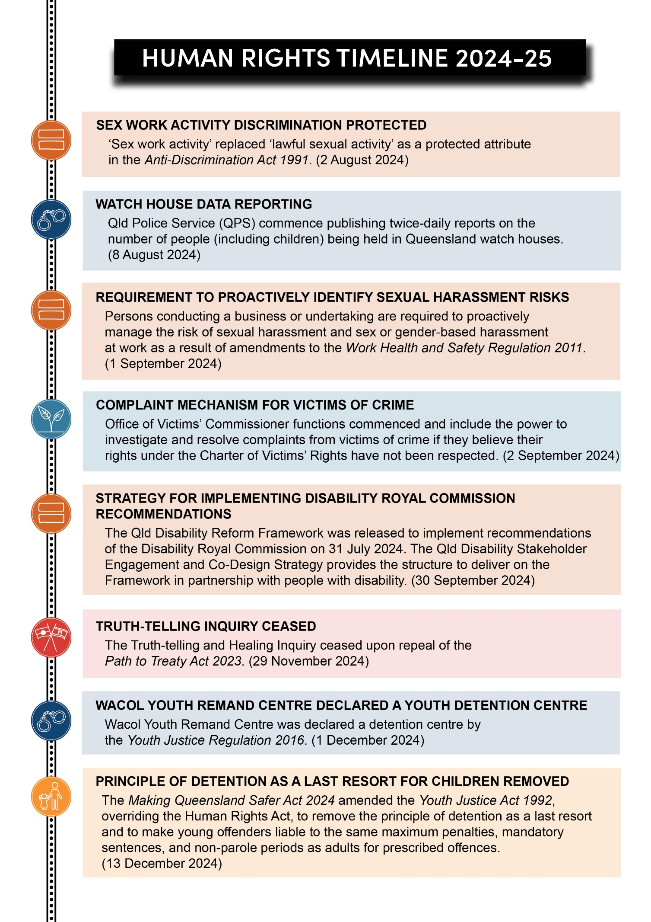
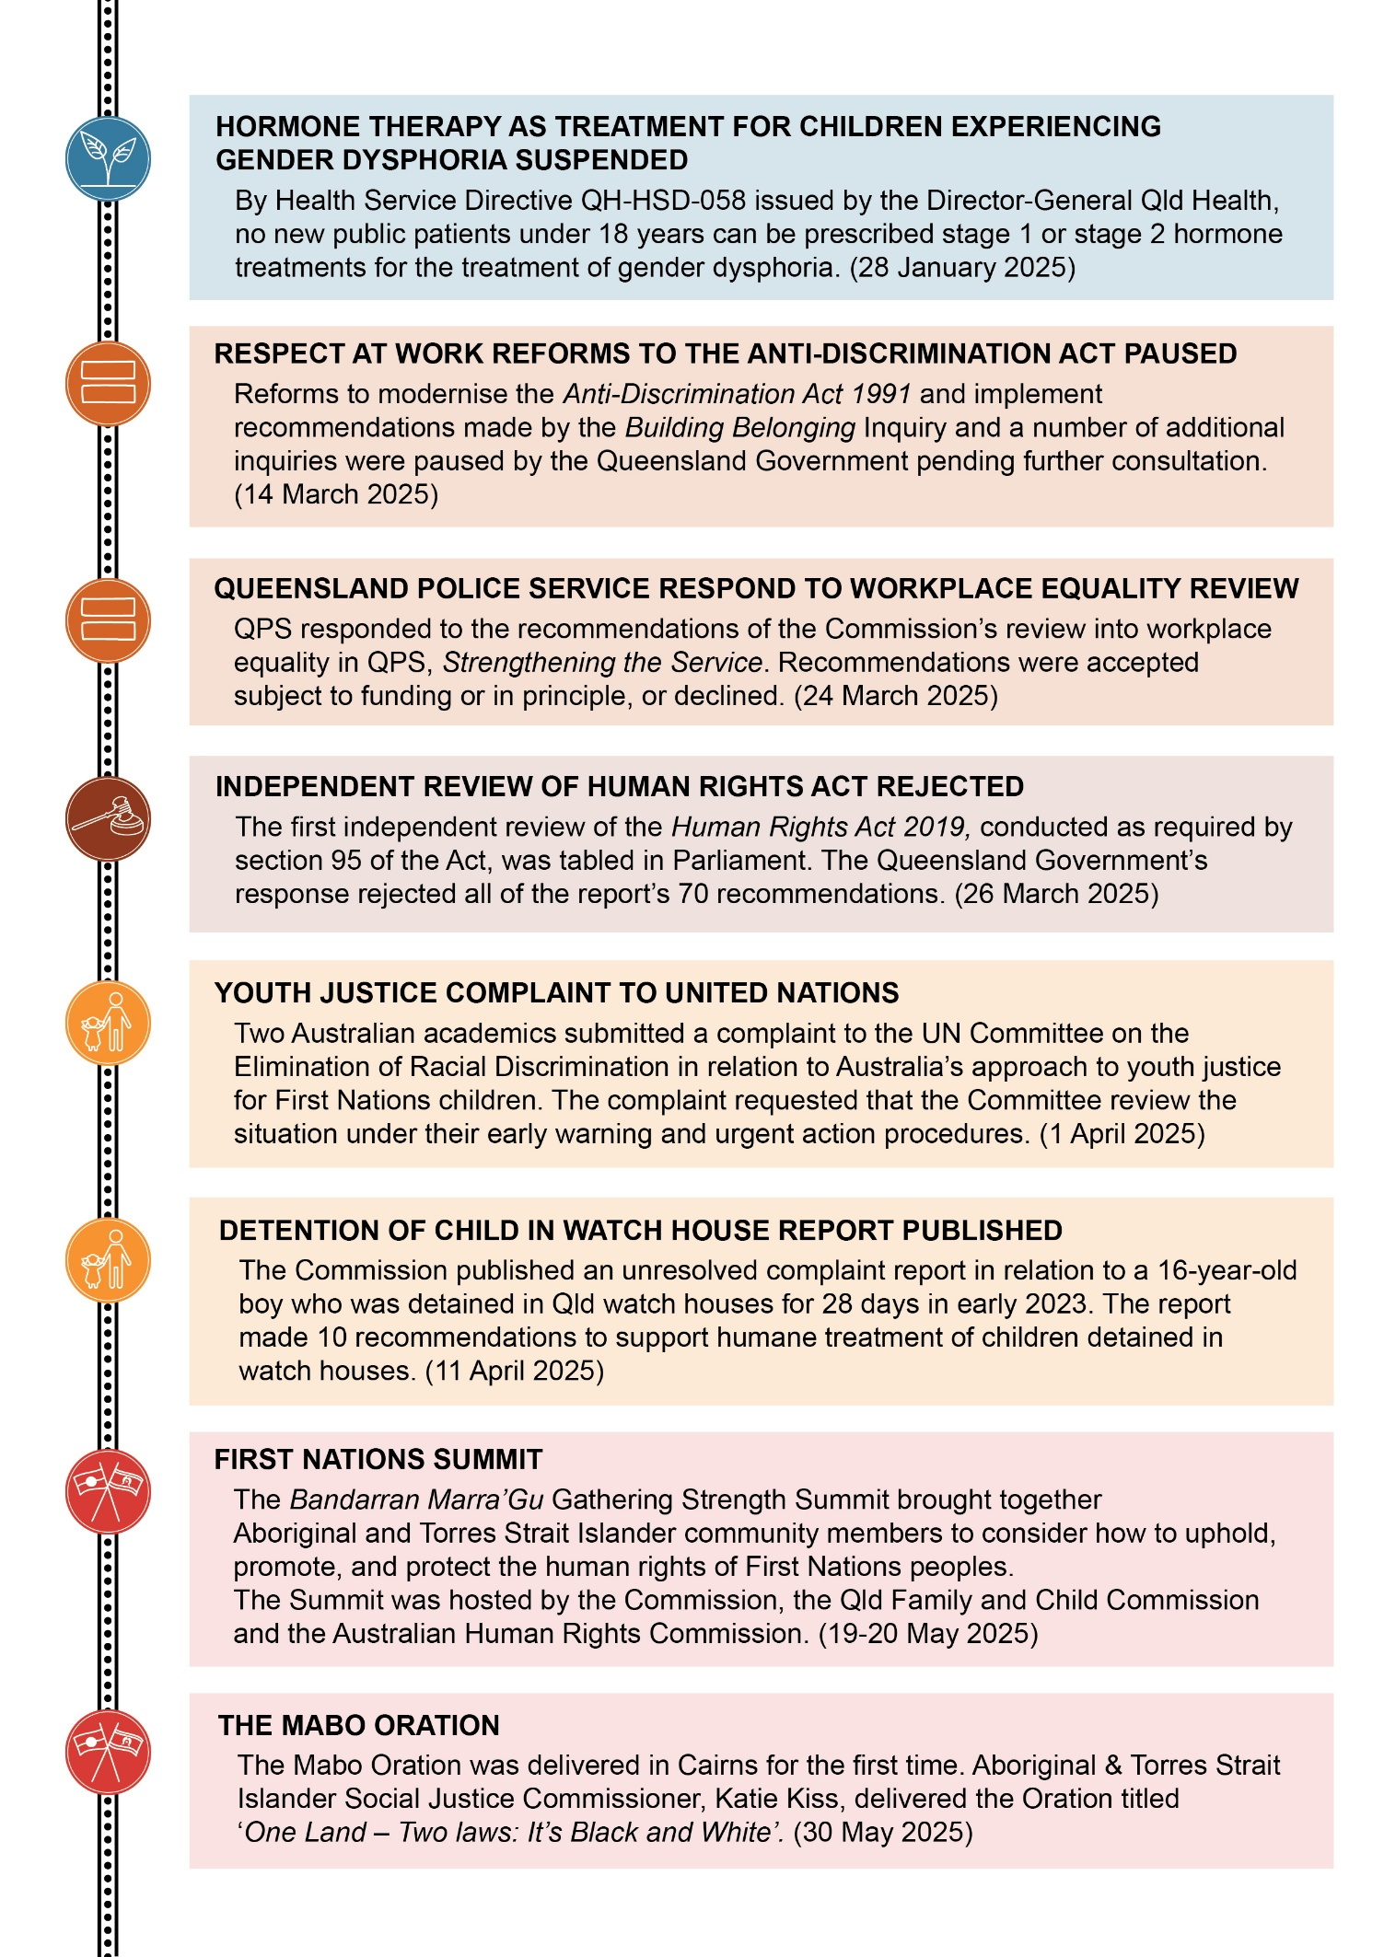
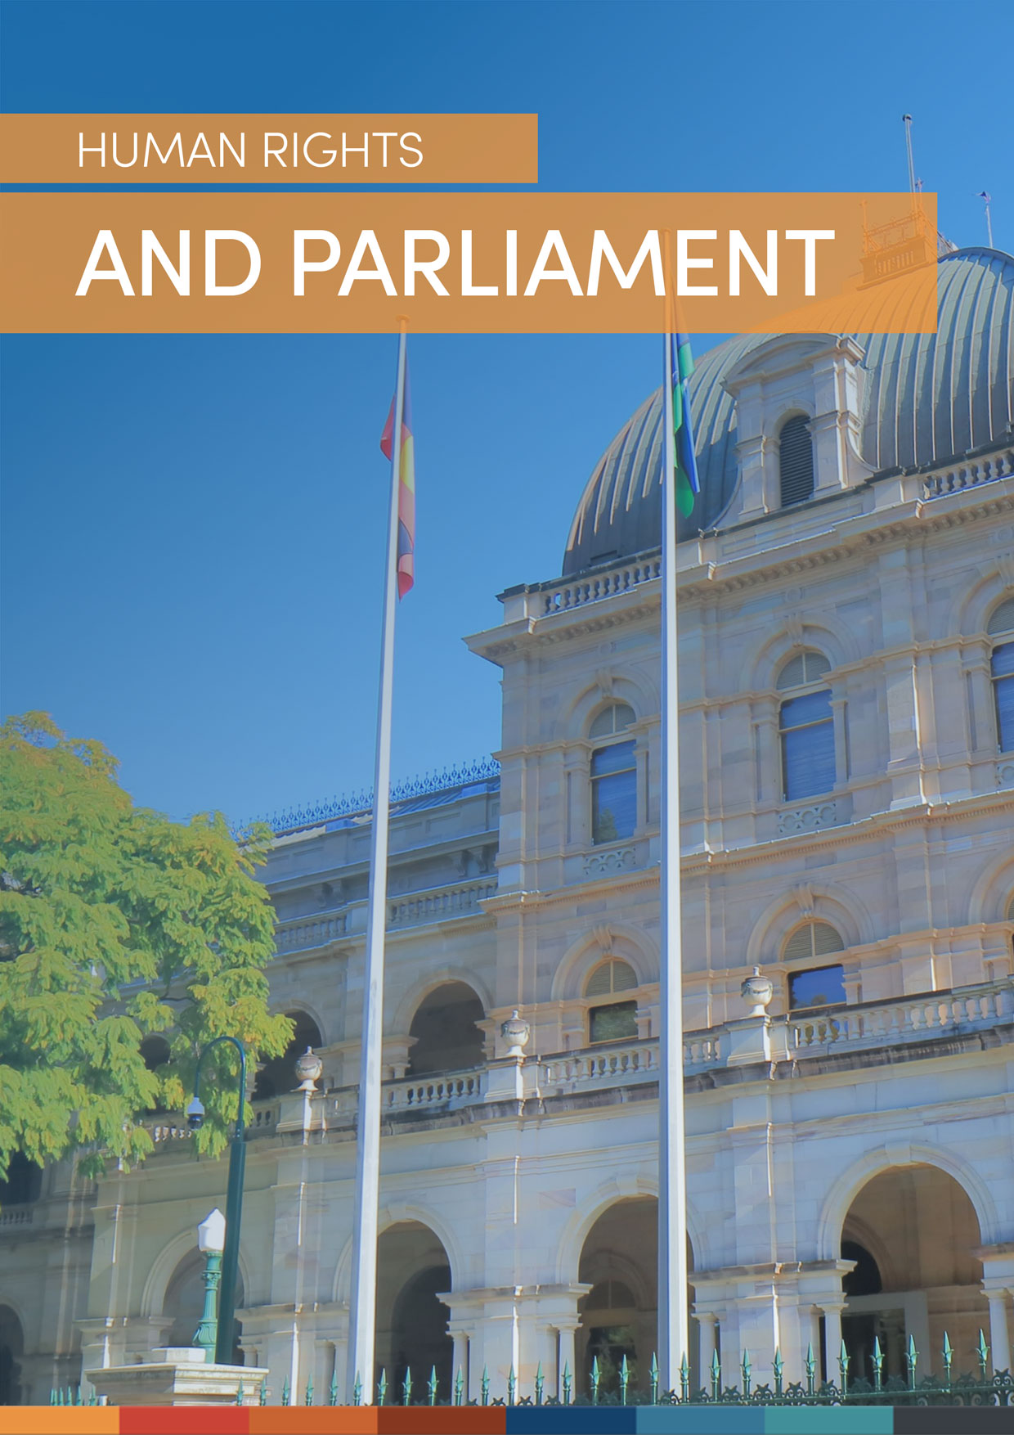
TITLE PAGE
HUMAN RIGHTS AND PARLIAMENT

Human rights and parliament

Reflections on 2024-25

Purpose of this section
The Human Rights Act requires proposed legislation (Bills) be accompanied by a statement of compatibility that outlines whether the Bill is compatible with human rights. The parliamentary portfolio committee responsible for examining a Bill, must report to parliament about the Bill and the statement. This is intended to inform debate on the Bill, ensuring human rights implications are discussed when considering whether or not to pass a Bill.
This section reflects on the extent to which members of parliament have fulfilled these obligations in the reporting year. These reflections are intended to provide insight into the extent to which the Human Rights Act has been operationalised and is achieving its objectives to promote dialogue about human rights and establish a culture in the public sector which promotes and respects human rights. In doing so, this section assists to fulfill the purpose of this report, to ‘provide a resource for government, parliament, and the community to better understand how the Human Rights Act has been operationalised and the degree to which it is achieving its objectives’.

The 2024-25 financial year demonstrated both the strengths and limitations of Queensland’s Human Rights Act and the dialogue model. As in previous years, the Human Rights Act was instrumental in shaping the scrutiny of legislation by members of parliament and the community.
Human rights dialogue occurred in parliamentary committees and in parliament, and human rights were raised in many submissions made by organisations and individuals. Human rights were most often raised in relation to youth justice legislation and increases in police powers.
While not commonplace, some portfolio committee reports to parliament did raise questions about the adequacy of statements of compatibility. For example, committee reports identified concerns about limitations placed on rights in a Bill and instances in which discussion of less restrictive alternatives was inadequate. On a few occasions, committees made recommendations for amendments in relation to human rights issues, and on 3 occasions Bills were subsequently amended to address concerns relevant to human rights.
However, on a number of occasions, despite committees identifying flaws in statements of compatibility (for example, where the statement of compatibility failed to discuss less restrictive alternatives), they nevertheless concluded that information included in the statement of compatibility was sufficient.
While committees often took an active role in identifying limits on human rights, a number of committee reports did not engage in a detailed assessment of whether those limits were compatible with human rights. Additionally, on many occasions, despite committees identifying well-evidenced concerns raised by stakeholders that called the compatibility of a Bill into question, they concluded that limits on human rights were reasonable and justified.
Over the reporting period, 2 override declarations were made to suspend the application of the Human Rights Act in relation to the sentencing of children to detention. On a third occasion, legislation was introduced and passed which was identified to be incompatible with human rights but which was deemed to fall within an existing override provision. As such a third override declaration was not made, and the government did not table a separate exceptional circumstances statement.
The Commission notes the continued and more frequent use of ‘urgent Bills’. Typically, a Bill must be referred to a committee for a period of no less than six weeks. Where a Bill is declared urgent, it may be provided for a shorter period. This restricts the period in which the parliamentary committee must complete its examination and limits their capacity to conduct a thorough examination, including community consultation on the impacts of proposed legislation, in relation to human rights. In relation to 3 youth justice Bills, and the Police Powers and Responsibilities (Making Jack’s Law Permanent) and Other Legislation Amendment Bill 2025, the community was provided with an average of 7.5 business days to make submissions.
The Commission encourages members of parliament to reflect on the value of the decision-making framework set out in the Human Rights Act, which assists to ensure legislation is evidence-based, balanced, and will create no more harm than is necessary to achieve the relevant objective.

Submissions by the Commission
The Commission makes submissions to parliamentary committees to support their consideration of the statement of compatibility, and the compatibility of the Bill with human rights. Our intention is to assist members of parliament to fulfill their obligations under the Human Rights Act.
In the financial year ending 30 June 2025, the Commission made 8 submissions to parliamentary committees about human rights issues raised by legislation.
For more information, including summaries of major submissions, see the Queensland Human Rights Commission 2024-25 Annual Report, available from our website at <https://www.qhrc.qld.gov.au/about-us/annual-reports>.
See Appendix A for a list of submissions the Commission made to parliamentary committees in 2024-25. All submissions (including those made to other bodies) can be viewed on our website at: <https://www.qhrc.qld.gov.au/our-work/submissions-by-the-commission>.

Override declarations

Purpose of this section
Parliament may expressly declare an Act or a provision of an Act has effect despite being incompatible with one or more human rights. Overriding human rights is only lawful in ‘exceptional circumstances’ such as ‘a war, a state of emergency, an exceptional crisis situation constituting a threat to public safety, health or order’. A member who introduces a Bill containing an override must make a statement to the Legislative Assembly explaining the exceptional circumstances that justify the override declaration.
This section has been included to meet the requirements in section 91(2)(c) of the Human Rights Act, which requires that this report include the details of all override declarations made in the reporting period.
In 2024-25, 2 override declarations were made. A third Bill containing provisions declared to be incompatible were deemed to fall within an existing override declaration.

The first Making Queensland Safer Act
The Making Queensland Safer Act 2024 (Qld) (the first Making Queensland Safer Act), which received assent on 13 December 2024, inserted:
- new section 175A into the Youth Justice Act to establish that for 13 offences, children are to be subject to the same maximum, mandatory, and minimum penalties as adults
- new section 150(1) of the Youth Justice Act 1992 (Qld) (Youth Justice Act), which provides that, in sentencing a child for an offence, a court must not have regard to: (a) any principle that a detention order should only be imposed as a last resort; or (b) any principle that a sentence that allows the child to stay in the community is preferable.

The statement of compatibility for the Bill acknowledges these amendments are incompatible with human rights, including because they will lead to sentences for children that are ‘more punitive than necessary to achieve the purpose of enhancing community safety’.
Noting this, 2 override declarations were made in respect of the above provisions, so that they have effect despite being incompatible with human rights and despite anything else in the Human Rights Act.
The exceptional circumstances statement tabled in respect of the first Making Queensland Safer Act provides the overrides were justified because: ‘In the Government’s view, the current situation with respect to youth crime in Queensland presents an exceptional crisis situation constituting a threat to public safety such that amendments being made to amended section 150 of the Youth Justice Act 1992 and new section 175A of the Youth Justice Act 1992 must contain override declarations.’

The second Making Queensland Safer Act
The Making Queensland Safer (Adult Crime, Adult Time) Act 2025 (the second Making Queensland Safer Act) received assent on 23 May 2025. The Act amended section 175A of the Youth Justice Act to add 20 more offences for which children will be subject to the same maximum, minimum, and mandatory sentences as adults (expanding the sentencing regime to a total of 33 offences).
The statement of compatibility for the Bill states the relevant amendments are incompatible with human rights because:
- the amendments may lead to sentences for children that are more punitive than necessary to achieve community safety;
- the negative impact on the rights of children likely outweighs the legitimate aims of punishment and denunciation;
- there may be less restrictive options available to achieve the stated purpose of improving community safety;
- the amendments may impose further strain on youth detention centres in Queensland possibly resulting in increased numbers of children in watch houses limiting the right to protection from cruel, inhumane or degrading treatment; and
- the amendments are likely to have a more significant impact on Aboriginal and Torres Strait Islander children.

The statement of compatibility concludes the Human Rights Act will be overridden by these amendments. However, the statement indicates no new override declaration will be made because the provisions are subject to the existing override declaration in section 175A(10) of the Youth Justice Act (inserted by the first Making Queensland Safe Act). On this basis, the government did not make a further exceptional circumstances statement providing a justification for the override of human rights.
For further discussion of the override declarations made in relation to the Making Queensland Safer Act and the second Making Queensland Safer Act, see the Commission’s submissions to the Justice, Integrity and Community Safety Committee available at the Commission’s website <https://www.qhrc.qld.gov.au/our-work/submissions-by-the-commission>.


TITLE PAGE
HUMAN RIGHTS AND THE COURTS

Human rights and the courts

Reflections on 2024-25

Purpose of this section
Courts and tribunals consider human rights when interpreting legislation, acting in an administrative capacity, carrying out functions where human rights have direct application, and dealing with matters in which human rights grounds have been ‘piggy-backed’ onto an existing cause of action.
This section discusses the extent to which courts and tribunals have fulfilled these obligations in the reporting year and provides insight into the extent to which the Human Rights Act has been operationalised and is achieving its objectives to promote dialogue about human rights and protect and promote human rights. In doing so, this section assists to fulfill the purpose of this report, to ‘provide a resource for government, parliament, and the community to better understand how the Human Rights Act has been operationalised and the degree to which it is achieving its objectives’.

In 2024–25, Queensland courts and tribunals continued to develop and refine the application of the Human Rights Act across a broad range of proceedings. Judgments in these matters demonstrate that consideration of human rights supports robust decision-making that takes individual circumstances into account, and ensures limitations on human rights are kept to a minimum and are capable of being justified.
Decisions this year showed how direct application of the Human Rights Act, including through interpreting legislation consistently with human rights pursuant to section 48, can provide further structure to the exercise of judicial discretion. Some of these cases reaffirmed that section 48 operates together with other rules of statutory construction and does not permit rewriting legislation to achieve compatibility.
Judgments this year also provided practical guidance on the scope and limits of specific rights. For example:
- The right to freedom of religion was explored in the context of vaccine mandates.
- Limits to equality rights were considered justified in an application for exemption under the Anti-Discrimination Act 1991 (Qld).
- The right to life was addressed in inquests and mining lease objection hearings.
- Property rights were considered in decisions involving dangerous dogs, licences, and professional registration.
- Courts assessed whether police requests for passcodes or orders requiring tree removal from private land were arbitrary or unlawful interferences with privacy.
The number of cases referencing the Human Rights Act continues to grow steadily, with more matters reaching appellate courts. Several key decisions from 2024–25 have been appealed. These include Huang v Body Corporate for the Dorchester CTS 10749 [2024] QCATA 64, Anderson v President, Parole Board of Queensland [2025] QSC 123, Nagana Yarrbayn Wangan and Jagalingou Cultural Custodians Ltd v Chief Executive Department of Environment, Science and Innovation [2025] QSC 132, and Smith v Chief Executive, Queensland Corrective Services [2024] QSC 288.
These appeals are expected to provide further guidance on statutory interpretation and the interaction of the piggy-back provision with other operative provisions of the Human Rights Act. They may also further elaborate on the scope of rights including cultural rights, humane treatment in detention, and access to health services without discrimination.
Overall, the 2024–25 reporting period reflects a maturing body of jurisprudence under the Human Rights Act. Courts, tribunals, legal practitioners, and parties continue to engage with the Act’s mechanisms. Forthcoming appellate decisions will provide further clarity to decision-makers about its practical application and strengthen the Act’s role in protecting the human rights of people in Queensland.

Queensland cases that have engaged the Human Rights Act
In 2024-25, Queensland courts and tribunals referred to the Human Rights Act in 196 judgments, a steady increase on previous years in a wide range of jurisdictions.
See Appendix B for a list of cases that substantively considered human rights during 2024-25.
Table 2: Number of matters where Queensland courts and tribunals considered or mentioned the Human Rights Act.
Court | 2022-23 | 2023-24 | 2024-25
Court of Appeal Queensland | 3 | 2 | 5
Supreme Court of Queensland | 14 | 9 | 18
Industrial Court Queensland | 1 | 1 | 2
District Court of Queensland | 3 | 6 | 5
Land Court of Queensland | 4 | 2 | 6
Mental Health Court Queensland | 1 | 1 | 0
Children’s Court | - | - | 1
Coroners Court Queensland | 2 | 0 | 1
Magistrates Court of Queensland | 2 | 1 | 2
Queensland Civil and Administrative Tribunal, Appeals | 4 | 12 | 5
Queensland Civil and Administrative Tribunal | 77 | 94 | 105
Queensland Industrial Relations Commission | 50 | 49 | 46
Total | 161 | 177 | 196

Interventions

Purpose of this section
The Attorney-General and the Commission may intervene in proceedings before a court or tribunal in which a question of law arises about the application of the Human Rights Act, or a question arises about how legislation is to be interpreted in accordance with the Human Rights Act.
Section 91(2)(d) of the Human Rights Act requires that this report include the details of all interventions by the Attorney-General or the Commission.

Commission notifications
In 2024-25, the Commission received 27 notifications or requests to intervene under the Human Rights Act, of which 18 were formal notices required by section 52 of the Human Rights Act.

Commission interventions

New interventions for 2024-25
In the reporting period, the Commission intervened in 5 new matters: 2 in the Court of Appeal, and 3 in the Coroners Court.
The Commission is currently awaiting a decision in the appeal against Huang v Body Corporate for the Dorchester CTS 10749 [2024] QCATA 64. In that decision, QCAT’s Appeal Tribunal held that the obligations under section 58(1) of the Human Rights Act did not apply to a decision of the adjudicator of the Office of the Commissioner for Body Corporate and Community Management because it was a decision of a ‘private nature’, enlivening the exception in section 58(4).
The Commission is also awaiting a decision in the appeal of Smith v Chief Executive, Queensland Corrective Services [2024] QSC 288, which turns on the meaning of ‘assisted reproductive technology’ under section 22(1) of the Corrective Services Act 2006 (Qld). The appeal involves questions about the effect of section 48 of the Human Rights Act on interpretation of the provision in light of the right to humane treatment when deprived of liberty and the right to access health services without discrimination.
The Commission intervened in the Inquest into the passing of Nundawalyn Goodman, an Aboriginal child with a history of trauma, sexual abuse, and self-harm who died while in the care of the Department of Child Safety.
The Commission has intervened by way of written submission only in 2 further inquests. The Inquest into the passing of Wayne Thomas Kerle which concerns a death in custody of a 68-year-old man during transport to a police station following arrest for possession of cannabis. The Inquest into the passing of Bradley Smith relates to a 14-year-old boy in residential care who died while a passenger in a stolen car.

Previous interventions in which decisions were published
The decision in Anderson v President, Parole Board of Queensland [2025] QSC 123 was handed down in this reporting period and was a matter in which the Commission had intervened.
In this case, a 70-year-old prisoner with serious health issues challenged a Restricted Prisoner Declaration made under the Corrective Services Act 2006 (Qld) that blocked his ability to apply for parole for 8 years and 6 months. Under the Act, in deciding the length of the declaration, the decision-maker must be satisfied the term is in the ‘public interest’.
Justice Treston found that the statutory context required the applicant’s right to dignity while deprived of liberty, and in particular his special medical needs, to be considered in determining the public interest on the ordinary principles of statutory construction. This interpretation was also consistent with section 48 of the Human Rights Act. Justice Treston further found that the length of the declaration was unlawful for failure to give proper consideration to human rights under section 58(1) of the Human Rights Act.
This judgment is currently under appeal.

Attorney-General interventions
During 2024-25, the Attorney-General intervened in 4 proceedings under section 50 of the Human Rights Act:
- R v Dignan Supreme Court of Queensland proceeding no. 171/2024 [2024] QSCPR 23
- Re I'Lache Supreme Court of Queensland proceeding no. 16153/2024
- Huang v Body Corporate for the Dorchester CTS 10749 Queensland Court of Appeal proceeding no. 9056/2024 [2024] QCATA 64; and
- Smith v Chief Executive, Queensland Corrective Services Queensland Court of Appeal proceeding nos. 1657/2024 and 1332/2025 [2024] QSC 288.

An issue in R v Dignan [2024] QSCPR 23 was whether the provision of the applicant’s mobile phone passcode to police had been an unlawful contravention of his right to privacy. The court’s decision was that there had been no unlawful conduct. Judgments in the Court of Appeal matters have been reserved. A decision in Re I’Lache has not been published.

TITLE PAGE
HUMAN RIGHTS AND THE PUBLIC SECTOR

Human rights and the public sector

Reflections on 2024-25

Purpose of this section
The Human Rights Act requires that public entities (including government departments and local councils) properly consider human rights when making decisions and requires them to act and make decisions in a way that is compatible with human rights.
This section looks at the extent to which a cross-section of public entities has fulfilled these obligations in the reporting year. It provides insight into the extent to which the Human Rights Act has been operationalised and is achieving its objectives to promote dialogue about human rights and to establish a culture in the Queensland public sector which respects and promotes human rights. In doing so, this section assists to fulfill the purpose of this report, to ‘provide a resource for government, parliament, and the community to better understand how the Human Rights Act has been operationalised and the degree to which it is achieving its objectives’.

In 2024-25 the Commission asked state government departments and local councils to respond to a series of indicator questions to help us understand how successful the Human Rights Act has been in establishing a culture of human rights in the Queensland public sector.
The state government departments were:
- Department of Education
- Department of Environment, Tourism, Science and Innovation
- Department of Families, Seniors, Disability Services and Child Safety
- Department of Housing and Public Works
- Department of Justice
- Department of Natural Resources and Mines, Manufacturing and Regional and Rural Development
- Department of Youth Justice and Victim Support
- Queensland Corrective Services (QCS)
- Queensland Fire Department
- Queensland Health
- Queensland Police Service (QPS).

These departments were selected for the impact their work has on the human rights of people living in Queensland. For example, agencies that progressed legislation in the reporting period which had significant impacts on human rights were included in this list.

Due to machinery of government changes following the State General Election on 26 October 2024, the make-up of several departments changed, making it difficult to compare progress with the previous year. The Commission acknowledges that as some departments have only recently been formed, various work units will need time to consistently identify and record information required to respond to the indicators.

Responses to questions about the indicators were provided by the following 10 councils:
- Brisbane City Council
- City of Moreton Bay
- Douglas Shire Council
- Flinders Shire Council
- Gold Coast City Council
- Ipswich City Council
- Logan City Council
- Mount Isa Council
- Northern Peninsula Area Regional Council
- Sunshine Coast Council.
These councils were selected because they represent a cross-section of metropolitan, regional, and remote areas. Councils that undertook actions during the reporting period with a significant impact on human rights were also included in the list.

A list of the questions posed to state government departments and local councils is included in Appendix C.

The following sections summarise the responses received.

State public entity progress
After more than 5 years of operation of the Act, state public entities have made progress in achieving a human rights culture, with many demonstrating involvement in human rights activities. A smaller number made enhanced efforts to embed human rights principles at the core of what they do.
The Commission was encouraged by case studies received from some state entities showing what is possible when human rights are placed at the forefront of decision-making. For example, the Department of Housing and Public Works reported on their Rent-to-Buy scheme, which aims to increase home ownership opportunities for First Nations people by allowing residents to purchase the social housing property they currently rent.
While training on human rights compatible decision-making remains an area requiring improvement for some, compared to the last reporting period, more state public entities reported that they are delivering effective, in-person training on human rights tailored to the specific nature of their employees’ work. Some entities also gave examples where they have gone beyond surface-level training initiatives and targeted areas of the organisation that have shown low levels of human rights awareness (based on the Working for Queensland survey results).
Most state public entities reported having some form of human rights compatibility assessment embedded in their work. In addition, some departments provided coaching and support to assist decision-making, which, when done well, ensures that compatibility assessments are meaningful and identify human impacts or less restrictive alternatives that would otherwise have been missed.
State public entities also strengthened human rights awareness among contractors through contractual clauses, mandatory training, and induction processes. Some, such as the Department of Justice, reported that they require suppliers of higher value procurements to comply with the Human Rights Act and will not proceed if they cannot confirm compliance.
State entities reported engaging in a variety of community engagement initiatives with a particular focus on engagement with First Nations and culturally diverse communities. These initiatives included housing schemes, workforce strategies, legislative consultations, and targeted actions on hate crime prevention and policy reform.
Positive examples were given of how state public entities’ consideration of human rights improved the development of their portfolio legislation. However, a number of entities progressed legislation that significantly limits human rights or is incompatible with human rights.
Finally, state public entities continued to report barriers to identifying human rights complaints when the limitations on human rights are not identified by the complainant. This situation emphasises the need to ensure staff are trained to identify relevant rights and consider the impact on them. We observed that processes for recording and reporting on human rights complaints continues to vary between agencies and does not follow a consistent methodology. This limits entities’ ability to compare or to demonstrate improvement.

Progress in councils
The Commission noted a marked increase in engagement with human rights by councils in this reporting period. Many councils’ responses indicated they recognised the benefits of a human rights-based approach and are using the Human Rights Act to improve outcomes for people and systems. However, progress was uneven across the councils surveyed, and a lack of resourcing for smaller and more remote councils continues to be a barrier to the establishment of a human rights culture.
Consistent with previous years, councils promoted human rights awareness through intranet resources, online training, and themed events such as Human Rights Week and NAIDOC Week. Community consultation and engagement about human rights improved significantly, and many councils actively engaged with diverse groups, while others focused on engagement initiatives to improve respect for human rights of people experiencing homelessness.
Councils also strengthened the human rights compatibility of their policies and procedures. Some councils provided promising examples of human rights decision-making guidance. For example, Logan City Council’s ‘PLAN approach to Human Rights’ guideline provides employees with a set of guidelines to assess their work against the expectations set out in the Human Rights Act.
Training uptake varied widely. In some councils, training completion rates reached 100%, whereas in others minimal participation occurred. The Commission also observed a marked increase in the number of councils conducting specific and tailored training based on the context of their work. However, in others, human rights training was limited to a one-off session following introduction of the Human Rights Act.
Councils continue to report difficulty with the volume of complaints received and limited capacity of decision-makers to assess if human rights have been limited. However, this reporting period featured a significant number of examples where councils improved their services following human rights complaints, demonstrating the benefits of this process for the community.
Finally, one council, Logan City Council, provided practical examples that demonstrated thoughtful consideration of human rights is occurring at the executive leadership level.
Overall, the progress made by councils in 2024-25 demonstrates a maturing human rights culture that has largely shifted from surface-level training and awareness to human rights embedded decision-making as part of the business model.

Complaints made directly to public entities

Purpose of this section
This section has been included to meet the requirements in Section 91(2)(j) of the Human Rights Act, which requires that this report include the number of human rights complaints received by ‘particular public entities decided by the Commissioner’.
The Commissioner has elected to report on the same state government departments discussed above.
The Human Rights Act requires that any public entity required to prepare an annual report under the Financial Accountability Act 2009 (Qld) must include in their report the number and outcomes of human rights complaints made to the entity during the financial year. The information in this section has been drawn from the relevant annual reports.
Table 3 provides the number of complaints reported by selected public entities in their annual reports for 2024-25 and for the previous year. The Commission has included details, where provided, of the outcomes of human rights complaints. Given that public entities approach reporting on this data differently, the information presented should be interpreted with caution.
Table 3: Internal human rights complaints made to public entities, 2024-25
Public entity | Number of complaints in 2024-25 | Outcomes
Department of Education | 1,880 (1,902 in 2023-24) | 41 complaints were assessed as upheld/substantiated (either in full, or in part) and incompatible with human rights.  Actions taken for substantiated complaints included giving an apology, changing a practice or process, or referring the issue for further investigation or system improvement.
Department of Environment, Tourism, Science and Innovation | 11 (10 in 2023-24) | One complaint was found to have limited a human right where the limitations were not reasonable nor demonstrably justifiable.  10 complaints were considered not to have limited a human right.  One additional complaint related to a private entity as a result of jurisdictional misunderstanding. The assessment found the relevant decision was not compatible with the Human Rights Act and the matter was referred to the Commission.
Department of Families, Seniors, Disability Services and Child Safety | 16 (80 in 2023-24) | 16 complaints contained 22 allegations related to human rights.  20 allegations related to Child Safety and 2 related to Seniors and Disability Services.  Of those allegations, 22 were substantiated (rights were limited and assessed as not justified or reasonable).  All 22 allegations were finalised.  The Department also reported that during the reporting period, 8 complaints were made to the Commission about the Department, 4 of which were finalised.
Department of Housing and Public Works | 176 (78 in 2023-24) | 176 complaints were received, of those:  - 113 complaints were made by customers and dealt with under Customer Complaint Management Policy and Procedure  - 27 complaints were made and dealt with under other departmental policies, such as the Corrupt Conduct Prevention Policy and the Public Interest Disclosure Policy  - 36 complaints were made by the department’s employees.  The outcome of the complaints were:  - 64 complaints resulted in no further action  - 66 complaints resulted in further action  - 46 complaints remained open at the time of reporting.
Department of Justice | 39 (42 in 2023-24) | 39 complaints were assessed as having human rights components, with outcomes as follows:  - 25 complaints were finalised with no further action required  - 4 complaints were finalised with further action taken  - 10 complaints remain in progress.
Department of Natural Resources and Mines, Manufacturing and Regional and Rural Development | 1 (2 in 2023-24) | No details about the outcome of the complaint were provided.
Department of Youth Justice and Victim Support | 117 (93 in 2023-24) | 117 complaints were assessed as having human rights components, with the outcomes as follows:  - 44 complaints resulted in no further action  - 19 complaints resulted in further action  - 54 complaints remained open at the time of reporting.
Queensland Corrective Services | 111 (139 in 2023-24) | 111 complaints raised a human rights issue. Of those:  - 76 were located in Custodial Operations,  - 32 in Operational Support (Custodial & Community),  - 2 in High-Risk Offender Management Unit, and  - 1 in Community Corrections.  The outcomes were as follows:  - 77 complaints were unsubstantiated  - 6 complaints were partially substantiated  - 5 complaints contained insufficient information  - 1 complainant was unable to be contacted  - 1 complaint was withdrawn  - 17 complaints remained open at the time of reporting  - 4 complaint outcomes were documented as ‘other’.
Queensland Fire Department | 2 (2 in 2023-24) | One complaint was finalised with no further action required and the other complaint was determined as suitable for management action.
Department of Health | 332 (1,516 in 2023-24) | 332 complaints were received with outcomes as follows:  - 33 complaints required further action  - 233 complaints required no further action  - 66 complaints remained open at the time of reporting.  The Department reported that actions taken in response to complaints include providing an explanation, offering an apology, making changes to practices or processes, conciliation, further staff straining and local management.
Queensland Police Service | 2,399 complaints  (2,698 in 2022-23) | 2,399 complaints were received which raised 3,511 individual human rights limitations (one complaint can include more than one human rights limitation).  There were 659 instances in which it was deemed there were no human rights limitations.  There were 36 instances where human rights were unreasonably limited, resulting in:  - 5 apologies  - 3 managerial resolutions  - 9 explanations  - 19 disciplinary actions  1,621 (of the 2,399) complaints were finalised as at 30 June 2025 and 778 remain open.  Of the 2,399 distinct complaints received, in most cases there was no further action taken as the Queensland Police Service assessed that there were no human rights limitations, or an explanation was provided to the complainant as the officers’ actions were identified as being proportionate, lawful and reasonable, accountable and necessary.


TITLE PAGE
COMPLAINTS TO THE COMMISSION

Complaints to the Commission

Purpose of this section
Under the Human Rights Act 2019 (Qld) (Human Rights Act), people who believe their rights have been unjustifiably limited by a public entity can make a complaint to the Queensland Human Rights Commission (the Commission). However, complaints may only be made to the Commission after they have first been made to the relevant public entity. If after 45 days the complainant has not received a response from the public entity, or the response they have received is unsatisfactory, a complaint can be lodged with the Commission. This is in keeping with the dialogue model of human rights protection which encourages local, informal resolution.

This section has been included to meet the requirements in Section 91(2)(e)-(i) of the Human Rights Act, which requires that this report include the number of human rights complaints received by ‘particular public entities decided by the Commissioner’.

The Commission’s role in resolving a complaint is as an impartial third party. Our role is not to decide whether a limitation of human rights has occurred. Instead, we help people reach agreement on a resolution.
The Commission aims to support the resolution of complaints by:
- ensuring all parties can put forward their point of view, are listened to, and feel safe
- assisting parties to reach agreement about how to resolve the complaint
- ensuring the process is fair.

Some human rights complaints also raise issues under the Anti-Discrimination Act 1991 (Anti-Discrimination Act). The Anti-Discrimination Act provides additional avenues for resolution of a complaint. For example, if a complaint cannot be resolved, the complainant may request that the Commission refer the complaint to a tribunal for a binding decision.
Under the Human Rights Act, if the Commissioner considers that a human rights complaint would be more appropriately dealt with as an alleged contravention of the Anti-Discrimination Act, the Commission may deal with the complaint under that Act, with the consent of the complainant. These complaints are referred to as ‘piggy-back’ complaints, because the human rights aspects of the complaint are ‘piggy-backed’ onto the discrimination complaint.
Because there are additional avenues for resolution available under the Anti-Discrimination Act, many complainants whose complaint raises issues under both Acts consent to have their complaint dealt with under the Anti-Discrimination Act.
In 2024-25:
751 human rights complaints were finalised, including 279 human rights only complaints and 472 piggy-back complaints (reflecting a 60% increase from 2023-24).
234 of those complaints were accepted, of which 34 were dealt with under the Human Rights Act and 200 were piggy-back complaints.
59 complaints were resolved, of which 12 were human rights only complaints and 47 were piggy-back complaints.
134 conciliation conferences relating to human rights were conducted.
Most accepted complaints involved more than one respondent, and some public entities were directed to attend on more than one occasion. Overall, 147 discrete respondents were directed to take part in a conciliation conference, of which 106 were individual people, and 41 were public entities such as government departments, councils or functional public entities.
No public entities failed to comply with a direction to attend a conference in the 2024-25 financial year.
More information about complaints to the Commission this year can be found in our 2024-25 Annual Report, available from our website at <https://www.qhrc.qld.gov.au/about-us/annual-reports>.

Unresolved complaint reports

Purpose of this section
Under section 88 of the Human Rights Act, the Commissioner must prepare a report about all unresolved complaints. The report must include the substance of the complaint and actions taken to try and resolve the complaint. The report may include details of actions the Commissioner considers the public entity respondent should take (recommendations) to ensure its acts and decisions are compatible with human rights.
Section 91(3) of the Human Rights Act provides the annual report on the operation of the Human Rights Act ‘may include other information the commissioner considers appropriate, including, for example, the names of public entities and details of action, mentioned in section 88(4), relating to human rights complaints that have not been resolved’.

An unresolved complaint report containing recommendations does not determine disputes of fact and does not mean that human rights have been unlawfully limited. Rather, their purpose is to assist public entities to comply with their obligations, build a culture in the Queensland public sector that respects and promotes human rights, and promotes a dialogue about the nature, meaning, and scope of human rights. The report is not admissible in a proceeding unless the parties otherwise agree.
This financial year the Commission published 2 reports on unresolved complaints that included recommendations. The Commission’s published unresolved complaint reports can be accessed online from: <https://www.qhrc.qld.gov.au/legal/unresolved-human-rights-complaints>.
The published unresolved complaint reports for 2024-25 were:
- Detention of a child in a watch house
- Ban from health service

Detention of a child in watch houses
Complaint lodged against | Department of Families, Seniors, Disability Services and Child Safety, Queensland Police Service
Human Rights Act sections | 17 (Protection from cruel, inhuman or degrading treatment), 25 (Privacy and reputation), 26(2) (Protection of children), 29 (Right to liberty and security of person), 30 (Humane treatment when deprived of liberty)
Date report published | 11 April 2025
Summary
A complaint was made by a 16-year-old boy who was detained in Beenleigh and then Southport watch house for 28 days in early 2023 pending release by the court, or transfer to a youth detention centre.
This report concludes that the allegations indicate a limitation of the complainant’s rights to protection as a child, privacy, and humane treatment when deprived of liberty, among others, and discusses factors relevant to assessing whether the limitations were reasonable and justified. The allegations demonstrate that watch houses do not meet the standards necessary to safely and humanely accommodate children for extended periods of time.
While maintaining the position that children should not be held in watch houses for longer than 24 hours, the Commission made 10 recommendations within the power of the Queensland Police Service and the Department of Families, Seniors, Disability Services and Child Safety that support the humane treatment of children detained in watch houses.

Ban from health service
Complaint lodged against | Health organisation
Human Rights Act sections | 15 (Recognition and equality before the law), 37 (Right to health services)
Date report published | 17 March 2025
Summary
The complainant had been a patient of an Aboriginal community-controlled health organisation for many years. Due to the patient’s alleged behaviour and refusal to follow medical advice, his primary treating doctor decided to stop seeing the patient, effectively banning him from accessing the health organisation.
The report discusses the health organisation’s responsibilities to the patient under the right to recognition and equality before the law, and the right to health services. It recommends that where a decision is proposed that would ban a person from accessing its health services, the health organisation’s policies or procedures should ensure that:
- the decision-maker considers alternative, less restrictive strategies that specifically target the risks the ban is meant to address
- the health service takes reasonable steps to refer the person to an alternative health organisation required by the person, subject to the person’s consent
- the decision is made, or is reviewed, by the CEO of the health organisation
- the final decision is subject to review after one year, or another appropriate time period, if requested.


TITLE PAGE
APPENDIXES

Appendix A: Published submissions made by the Commission
In the financial year ended 30 June 2025, the Commission made 8 submissions to parliamentary committees about human rights issues raised by legislation.
Table 4: Commission submissions made to parliamentary committees, 2024-25
Date | Submission | Made to
10 June 2025 | Domestic and Family Violence Protection and Other Legislation Amendment Bill 2025 | Education, Arts and Communities Committee
16 April 2025 | Making Queensland Safer (Adult Crime, Adult Time) Amendment Bill 2025 | Justice, Integrity and Community Safety Committee
15 April 2025 | Police Powers and Responsibilities (Making Jack's Law Permanent) and Other Legislation Amendment Bill 2025 | Justice, Integrity and Community Safety Committee
3 March 2025 | Youth Justice (Monitoring Devices) Amendment Bill 2025 | Justice, Integrity and Community Safety Committee
4 December 2024 | Making Queensland Safer Bill | Justice, Integrity and Community Safety Committee
10 July 2024 | Working with Children and Other Legislation Amendment Bill 2024 | Education, Employment, Training and Skills Committee
8 July 2024 | Respect at Work and Other Matters Amendment Bill 2024 | Community Safety and Legal Affairs Committee
5 July 2024 | Disability Services (Restrictive Practices) and Other Legislation Amendment Bill 2024 | Community Support and Services Committee

Appendix B: Cases that substantively considered human rights
Table 5: A selection of cases that substantively considered the Human Rights Act 2019 (Qld) in 2024-25.
Human Rights Act reference considered | Case (cases may appear twice in relation to different sections)
Section 5(2)(a) (direct application of rights by the courts) | - Attorney-General v HGD (No 2) [2025] QSC 153 (application under the Dangerous Prisoners (Sexual Offenders) Act 2003)  - Darling Downs Hospital & Health Service v J [2024] QSC 330 (termination of pregnancy)
Section 15 (Recognition and equality before the law) | - Re Team Blake Pty Ltd [2024] QIRC 163 (Exemption application under the Anti-Discrimination Act 1991)
Section 16 (Right to life) | - Inquest into the death of Damon Paul William Savage (Findings of Inquest, Coroners Court of Queensland, State Coroner Ryan, 4 November 2024) (police action)  - Re Sungela Pty Ltd & Anor [2025] QLC 5 (mining lease objection)
Section 20 (Freedom of thought, conscience, religion and belief) | - Drage v Gold Coast Hospital and Health Service [2025] QSC 22 (employment directive requiring mandatory vaccination)
Section 21 (Freedom of expression) | - Deemal-Hall v Office of the Director of Prosecutions [2024] QCATA 131 (access to information)
Section 24 (Property rights) | - Elze v Brisbane City Council [2025] QCAT 195 (declaration of dangerous dog)  - Hassid v Department of Transport and Main Roads [2024] QCAT 286 (suspension of authorisation to drive a taxi)  - Queensland College of Teachers v Teacher MXQ [2025] QCAT 60 (disciplinary proceedings)  - Yan v Queensland Police Service – Weapons Licensing [2024] QCAT 295 (revocation of weapons licence)
Section 25(a) (Right to privacy) | - R v Dignan [2024] QSCPR 23 (police access to phone passcode)  - Ross v Callinicos [2024] QCAT 455 (tree dispute)
Section 26(2) (Protection of the child) | - Darling Downs Hospital & Health Service v J [2024] QSC 330 (termination of pregnancy)
Section 48 (Statutory interpretation) | - Anderson v President of the Parole Board [2025] QSC 123 (under appeal) (restricted prisoner declaration)  - Greenall v Amaca Pty Ltd [2024] QCA 132 (workers compensation)  - Ross v Callinicos [2024] QCAT 455 (tree dispute)  - Smith v Chief Executive, Queensland Corrective Services [2024] QSC 288 (under appeal) (access to medical procedure of prisoner)  - Smith v State of Queensland (Queensland Health) & Anor (No 4) [2024] QIRC 198 (disclosure rules)
Section 59 (piggy-back provision) | - Anderson v President of the Parole Board [2025] QSC 123 (under appeal) (restricted prisoner declaration)  - Chilcott v Townsville Hospital and Health Service [2025] QIRC 32 (discrimination)  - Nagana Yarrbayn Wangan and Jagalingou Cultural Custodians Ltd v Chief Executive, Department of Environment, Science and Innovation [2025] QSC 132 (under appeal) (judicial review of decision of department not to take action)

Appendix C: Questions sent to public entities

Indicators of a developing human rights culture: State government departments

Indicator 1: Staff awareness, education, and development
- How has staff awareness been raised about the Act?
- What education and training on the Act has been provided?
- Does the training include examples specifically tailored to the organisation to illustrate how to put human rights into practice?
- Approximately what percentage of staff have received training?
- Which work groups or areas of the agency have received training? What training has been provided to senior leadership? What was the mode of delivery of the training? For example, online, face-to-face, both online and face-to-face, or other? Has the training been delivered by internal staff, or external providers?
- What has been the impact of increased working from home arrangements on the design and delivery of training?
- Have human rights been included in induction training (onboarding of new staff)? Does ongoing professional development/training for staff include human rights? If so, what is the mode of the delivery of the training?
- What feedback do you collect about education and training? How is it used to design future training and/or resources?

Indicator 2: Community consultation and engagement about human rights
- Have you conducted any community consultation and engagement, such as with stakeholders, clients, or consumers about human rights?
- What information have you provided to the community about human rights?
- Have you consulted relevant sectors of the community about proposed changes to, or development of, legislation, regulations, policies, procedures, services etc. which may impact human rights?
- Please provide details, including how did the community consultation and engagement impact on any decision-making/policy formulation, or other?

Indicator 3: Awareness raising and support for related entities (including functional public entities engaged by the entity i.e. contractors)
- Have you raised awareness of human rights with contractors/providers engaged by your agency? If so, provide details. For example, have human rights been embedded into formal contracts?
- What support in ensuring compatibility with the Act have you provided to providers engaged by your agency? If any, provide details.

Indicator 4: Reviews and development of legislation or subordinate legislation
- Please point to legislation or subordinate legislation that has been introduced in the financial year 2024-25 that:
  - has a significant impact on human rights
  - works to respect, protect, or promote human rights.
- Please provide any examples of good practice in ensuring the proper consideration of human rights is part of legislation development.

Indicator 5: Review of policies and procedures
- Has your agency reviewed policies and procedures for compatibility with human rights?
- Please provide an example of the way in which the review of policies and procedures has resulted in positive change?
- In particular, have you developed any new guides or other tools to assist staff to act and make decisions that are compatible with human rights, and to properly consider human rights when making decisions?
- Has any review of policies and procedures resulted in a change to service delivery? If so, please provide examples.

Indicator 6: Internal complaint management for human rights complaints
- How successful has your agency been in integrating human rights complaints into internal complaints processes? If possible, provide examples of what has been achieved.
- Does your agency face any barriers in successfully identifying, considering, and responding to human rights complaints? If so, what are they?
- Please provide examples of where a complaint has been resolved through the internal complaints process and/or has resulted in policy/procedure/practice review, service improvements or change for the agency.

Indicator 7: Future plans
- What future plans does your agency have to achieve the objects of the Act in:
  - protecting and promoting human rights
  - building a culture in the Queensland public sector that respects and promotes human rights; and
  - helping promote a dialogue about the nature, meaning, and scope of human rights?

Additional question:
How has senior leadership demonstrated a commitment to embedding human rights generally, and in particular with respect to the indicators 1 – 6 noted above?

Indicators of a developing human rights culture: Local councils

Indicator 1: Staff awareness, education and development
- How has staff awareness been raised about the Act?
- What education and training on the Act has been provided?
- Does the training include examples specifically tailored to the council to illustrate how to put human rights into practice?
- Approximately what percentage of staff have received training?
- Which work groups or areas of the council have received training? What training has been provided to senior leadership? What was the mode of delivery of the training? For example, online, face to face, both online and face to face, or other? Has the training been delivered by internal staff, or external providers?
- What has been the impact of increased working from home arrangements on the design and delivery of training?
- Has human rights been included in induction training (onboarding of new staff)? Does ongoing professional development/training for staff include human rights? If so, what is the mode of the delivery of the training?
- What feedback do you collect about education and training? How is it used to design future training and/or resources?

Indicator 2: Community consultation and engagement about human rights
- Have you conducted any community consultation and engagement, such as with stakeholders, clients, or consumers about human rights?
- What information have you provided to the community about human rights?
- Have you consulted relevant sectors of the community about proposed changes to, or development of, legislation, regulations, policies, procedures, services etc. which may impact human rights?
- Please provide details, including how did the community consultation and engagement impact on any decision-making/policy formulation, or other?

Indicator 3: Awareness raising and support for related entities (including functional public entities engaged by the council i.e. contractors)
- Have you raised awareness of human rights with contractors/providers engaged by the council? If so, provide details. For example, has human rights been embedded into formal contracts?
- What support in ensuring compatibility with the Act have you provided to providers engaged by the council? If any, provide details.

Indicator 4: Reviews and development of local laws and subordinate local laws
- Please point to a local law or subordinate local law that has been introduced in the financial year 2024-25 and that:
  - has a significant impact on human rights;
  - works to respect, protect, or promote human rights
- Please provide any examples of good practice in ensuring the proper consideration of human rights is part of local law development.

Indicator 5: Review of policies and procedures
- Has the council reviewed policies and procedures for compatibility with human rights?
- Please provide an example of the way in which the review of policies and procedures has resulted in positive change?
- In particular, have you developed any new guides or other tools to assist staff to act and make decisions that are compatible with human rights, and to properly consider human rights when making decisions?
- Has any review of policies and procedures resulted in a change to service delivery? If so, please provide examples.

Indicator 6: Internal complaint management for human rights complaints
- How successful has the council been in integrating human rights complaints into internal complaints processes? If possible, provide examples of what has been achieved.
- Does the council face any barriers in successfully identifying, considering, and responding to human rights complaints? If so, what are they?
- Please provide examples of where a complaint has been resolved through the internal complaints process and/or has resulted in policy/procedure/practice review, service improvements or change for the council.

Indicator 7: Future plans
What future plans does the council have to achieve the objects of the Act in:
- protecting and promoting human rights;
- building a culture in the Queensland public sector that respects and promotes human rights; and
- helping promote a dialogue about the nature, meaning, and scope of human rights.

Additional question:
How has senior leadership demonstrated a commitment to embedding human rights generally, and in particular with respect to the Indicators 1 – 6 noted above?

Appendix D: Human rights timeline
2024-25
This information is represented in the timeline on pages 17 to 18 of this report and is a summary of some significant events relevant to the operation of the Act for this year.

August 2024
Sex work activity discrimination protected
‘Sex work activity’ replaced ‘lawful sexual activity’ as a protected attribute in the Anti-Discrimination Act 1991. (2 August 2024)
Watch house data reporting
Qld Police Service (QPS) commence publishing twice-daily reports on the number of people (including children) being held in Queensland watch houses. (8 August 2024)

September 2024
Requirement to proactively identify sexual harassment risks
Persons conducting a business or undertaking are required to proactively manage the risk of sexual harassment and sex or gender-based harassment at work as a result of amendments to the Work Health and Safety Regulation 2011. (1 September 2024)
Complaint mechanism for victims of crime
Office of Victims’ Commissioner functions commenced and include the power to
investigate and resolve complaints from victims of crime if they believe their
rights under the Charter of Victims’ Rights have not been respected.
(2 September 2024)
Strategy for implementing Disability Royal Commission recommendations
The Qld Disability Reform Framework was released to implement recommendations
of the Disability Royal Commission on 31 July 2024. The Qld Disability Stakeholder
Engagement and Co-Design Strategy provides the structure to deliver on the
Framework in partnership with people with disability. (30 September 2024)

November 2024
Truth-telling Inquiry ceased
The Truth-telling and Healing Inquiry ceased upon repeal of the Path to Treaty Act 2023.
(29 November 2024)

December 2024
Wacol Youth Remand Centre declared a youth detention centre
Wacol Youth Remand Centre was declared a detention centre by the Youth Justice Regulation 2016. (1 December 2024)
Principle of detention as a last resort for children removed
The Making Queensland Safer Act 2024 amended the Youth Justice Act 1992,
overriding the Human Rights Act, to remove the principle of detention as a last resort
and to make young offenders liable to the same maximum penalties, mandatory
sentences, and non-parole periods as adults for prescribed offences.
(13 December 2024)

January 2025
Hormone therapy as treatment for children experiencing gender dysphoria suspended
By Health Service Directive QH-HSD-058 issued by the Director-General Qld Health,
no new public patients under 18 years can be prescribed stage 1 or stage 2 hormone
treatments for the treatment of gender dysphoria. (28 January 2025)

March 2025
Respect at Work reforms to the Anti-Discrimination Act paused
Reforms to modernise the Anti-Discrimination Act 1991 and implement
recommendations made by the Building Belonging Inquiry and a number of additional
inquiries were paused by the Queensland Government pending further consultation.
(14 March 2025)
Queensland Police Service respond to workplace quality review
QPS responded to the recommendations of the Commission’s review into workplace equality in QPS, Strengthening the Service. Recommendations were accepted subject to funding or in principle or declined. (24 March 2025)
Independent review of Human Rights Act rejected
The first independent review of the Human Rights Act 2019, conducted as required by
section 95 of the Act, was tabled in Parliament. The Queensland Government’s
response rejected all of the report’s 70 recommendations. (26 March 2025)

April 2025
Youth justice complaint to United Nations
Two Australian academics submitted a complaint to the UN Committee on the
Elimination of Racial Discrimination in relation to Australia’s approach to youth justice
for First Nations children. The complaint requested that the Committee review the
situation under their early warning and urgent action procedures. (1 April 2025)
Detention of child in watch house report published
The Commission published an unresolved complaint report in relation to a 16-year-old
boy who was detained in Qld watch houses for 28 days in early 2023. The report
made 10 recommendations to support humane treatment of children detained in
watch houses. (11 April 2025)

May 2025
First Nations Summit
The Bandarran Marra’Gu Gathering Strength Summit brought together
Aboriginal and Torres Strait Islander community members to consider how to uphold,
promote, and protect the human rights of First Nations peoples. The Summit was hosted by the Commission, the Qld Family and Child Commission and the Australian Human Rights Commission. (19-20 May 2025)
The Mabo Oration
The Mabo Oration was delivered in Cairns for the first time. Aboriginal & Torres Strait
Islander Social Justice Commissioner, Katie Kiss, delivered the Oration titled
‘One Land – Two laws: It’s Black and White’. (30 May 2025)

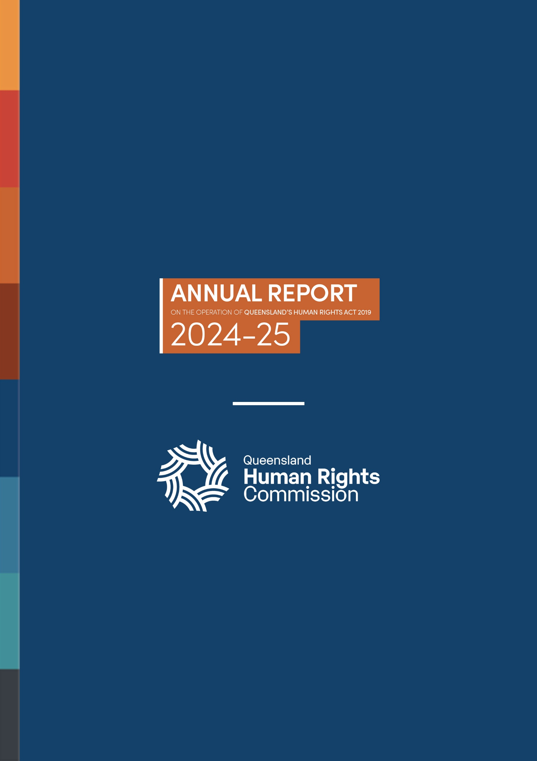
BACK COVER

ANNUAL REPORT ON THE OPERATION OF QUEENSLAND’S HUMAN RIGHTS ACT 2019
2024-25

Logo: Queensland Human Rights Commission

Explanatory Notes, Human Rights Bill 2018 (Qld) 44.
Queensland Human Rights Commission, Annual Report 2024–25 (Annual Report, Queensland Human Rights Commission, 2025).
Queensland Human Rights Commission, 'Annual Reports', Queensland Human Rights Commission (Web Page, 15 April 2026)
Note: complaints received are initially triaged for whether they fall under the Anti-Discrimination Act 1991 and/or the Human Rights Act 2019, however this initial categorisation may change once complaints are assessed. Due to a large number of complaints awaiting assessment at the time of reporting, this figure cannot be accurately reported on and is likely to change.
A complaint is ‘finalised’ if it is dealt with to conclusion, either through our dispute resolution process or through rejection or closure of the complaint file for another reason.
A complaint is ‘accepted’ if it meets the criteria and definitions under the relevant legislation for dispute resolution.
A complaint is ‘finalised’ if it is dealt with to conclusion, either through our dispute resolution process or through rejection or closure of the complaint file for another reason.
A complaint is ‘resolved’ when the parties have reached an agreement on how to settle the complaint. This can be through an apology, payment of damages or other financial compensation, a policy change, training, or other measures.
A complaint is ‘resolved’ when the parties have reached an agreement on how to settle the complaint. This can be through an apology, payment of damages or other financial compensation, a policy change, training, or other measures.
Human Rights Act 2019 (Qld) s 3.
Human Rights Act 2019 (Qld) s 48.
Human Rights Act 2019 (Qld) s 38.
Human Rights Act 2019 (Qld) s 39.
Human Rights Act 2019 (Qld) s 65(1).
Human Rights Act 2019 (Qld) s 80.
Human Rights Act 2019 (Qld) s 88(4).
Human Rights Act 2019 (Qld) ss 38.
In Queensland, parliamentary portfolio committees (committees), which are made up of government and non-government members, are responsible for examining Bills and subordinate legislation in their portfolio areas.
Human Rights Act 2019 (Qld) ss 39.
Human Rights Act 2019 (Qld) s 3.
Explanatory Notes, Human Rights Bill 2018, 44.
See for example: Transport and Resources Committee, Queensland Parliament, Land Valuation Amendment Bill 2023 (Report No 44, 57th Parliament, November 2023) 3; Health, Environment and Agriculture Committee, Queensland Parliament, Tobacco and Other Smoking Products (Vaping) and Other Legislation Amendment Bill 2024 (Report No 10, August 2024) 5; Justice, Integrity and Community Safety Committee, Queensland Parliament, Making Queensland Safer (Adult Crime, Adult Time) Amendment Bill 2025 (Report No 9, May 2025) 26.
Transport and Resources Committee, Queensland Parliament, Land Valuation Amendment Bill 2023 (Report No 44, 57th Parliament, November 2023) 3.
Transport and Resource Committee, Queensland Parliament, Land Valuation Amendment Bill 2023 (Report No 44, 57th Parliament, November 2023) iv, Recommendations 5 and 6; Education, Employment, Training and Skills Committee, Queensland Parliament, Working with Children (Risk Management and Screening) and Other Legislation Amendment Bill 2024 (Report No 8, 57th Parliament, July 2024) 15.
See for example: Justice, Integrity and Community Safety Committee, Queensland Parliament, Making Queensland Safer (Adult Crime, Adult Time) Amendment Bill 2025 (Report No 9, May 2025) 26; Justice, Integrity and Community Safety Committee, Queensland Parliament, Youth Justice (Monitoring Devices) Amendment Bill 2025 (Report No 6, 58th Parliament, March 2025) 20; Justice, Integrity and Community Safety Committee, Queensland Parliament, Youth Justice (Monitoring Devices) Amendment Bill 2025 (Report No 6, 58th Parliament, March 2025) 4; Justice, Integrity and Community Safety Committee, Queensland Parliament, Police Powers and Responsibilities (Making Jack's Law Permanent) and Other Legislation Amendment Bill 2025 (Report No 10, 58th Parliament, May 2025) 20; Education, Arts and Communities Committee, Queensland Parliament, Domestic and Family Violence Protection and Other Legislation Amendment Bill 2025 (Report No 5, 58th Parliament, June 2025) vi.
See for example: Justice, Integrity and Community Safety Committee, Queensland Parliament, Making Queensland Safer (Adult Crime, Adult Time) Amendment Bill 2025 (Report No 9, May 2025) 26; Justice, Integrity and Community Safety Committee, Queensland Parliament, Youth Justice (Monitoring Devices) Amendment Bill 2025 (Report No 6, 58th Parliament, March 2025) 20; Justice, Integrity and Community Safety Committee, Queensland Parliament, Youth Justice (Monitoring Devices) Amendment Bill 2025 (Report No 6, 58th Parliament, March 2025) 4; Justice, Integrity and Community Safety Committee, Queensland Parliament, Police Powers and Responsibilities (Making Jack's Law Permanent) and Other Legislation Amendment Bill 2025 (Report No 10, 58th Parliament, May 2025) 20; Education, Arts and Communities Committee, Queensland Parliament, Domestic and Family Violence Protection and Other Legislation Amendment Bill 2025 (Report No 5, 58th Parliament, June 2025) vi.
Making Queensland Safer Act 2024 cl. 15 and 19.
Making Queensland Safer (Adult Crime, Adult Time) Act 2025.
Per section 26B (2) of the Constitution of Queensland Act 2001 (Qld), when a Bill is referred to a parliamentary committee for examination, the period of the referral must be at least 6 weeks. However, the House may declare a Bill ‘urgent’, by ordinary majority. Where a Bill is declared ‘urgent’ the House may shorten the referral period.
Making Queensland Safer Bill 2024, Making Queensland Safer (Adult Crime, Adult Time Amendment Bill 2025, and Youth Justice (Monitoring Devices) Amendment Bill 2025.
Making Queensland Safer Bill 2024, Making Queensland Safer (Adult Crime, Adult Time Amendment Bill 2025, Youth Justice (Monitoring Devices) Amendment Bill 2025, and Police Powers and Responsibilities (Making Jack’s Law Permanent) and Other Legislation Amendment Bill 2025.
Human Rights Act 2019 (Qld) s 43.
Human Rights Act 2019 (Qld) s 43(4).
Human Rights Act 2019 (Qld) s 44.
Making Queensland Safer Act 2024 (Qld) s 19.
Making Queensland Safer Act 2024 (Qld) s 15.
Statement of Compatibility, Making Queensland Safer (Adult Crime, Adult Time) Amendment Bill 2025 (Qld), 4.
Youth Justice Act 1992 (Qld) ss 150(10), 175A(12).
Statement about exceptional circumstances tabled with the Statement of Compatibility, Making Queensland Safer Bill 2024 (Qld) 1.
Statement of Compatibility, Making Queensland Safer (Adult Crime, Adult Time) Amendment Bill 2025 (Qld) 1-5.
Statement of Compatibility, Making Queensland Safer (Adult Crime, Adult Time) Amendment Bill 2025 (Qld) 1-5.
Statement of Compatibility, Making Queensland Safer (Adult Crime, Adult Time) Amendment Bill 2025 (Qld) 1.
Queensland Human Rights Commission, Submission No 176 to Justice, Integrity and Community Safety Committee, Queensland Parliament, Making Queensland Safer Bill 2024 (4 December 2024); Queensland Human Rights Commission, Submission No 36 to Justice, Integrity and Community Safety Committee, Queensland Parliament, Making Queensland Safer (Adult Crime, Adult Time) Amendment Bill 2025 (16 April 2025).
Human Rights Act 2019 (Qld) s 48.
Human Rights Act 2019 (Qld) s 9(4)(b), s 58.
Human Rights Act 2019 (Qld) s 5(2)(a).
Human Rights Act 2019 (Qld) s 59.
Human Rights Act 2019 (Qld) s 3.
Explanatory Notes, Human Rights Bill 2018, 44.
Anderson v President of the Parole Board [2025] QSC 123 (under appeal); Attorney-General v HGD (No 2) [2025] QSC 153; Darling Downs Hospital & Health Service v J [2024] QSC 330
Eg, Smith v Chief Executive, Queensland Corrective Services [2024] QSC 288 [114], [117] (under appeal); Greenall v Amaca Pty Ltd [2024] QCA 132 [58].
Drage v Gold Coast Hospital and Health Service [2025] QSC 22.
Re Team Blake Pty Ltd [2024] QIRC 163
Inquest into the death of Damon Paul William Savage (Findings of Inquest, Coroners Court of Queensland, State Coroner Ryan, 4 November 2024); Re Sungela Pty Ltd & Anor [2025] QLC 5
Elze v Brisbane City Council [2025] QCAT 195; Hassid v Department of Transport and Main Roads [2024] QCAT 286; Queensland College of Teachers v Teacher MXQ [2025] QCAT 60.
R v Dignan [2024] QSCPR 23; Ross v Callinicos [2024] QCAT 455
Human Rights Act 2019 (Qld) ss 50-51.
Human Rights Act 2019 (Qld) s 58.
Human Rights Act 2019 (Qld) s 3.
Explanatory Notes, Human Rights Bill 2018, 44.
Human Rights Act 2019 (Qld) s 3(b).
Of the 70,000 public sector employees who completed the 2024 Working for Queensland Survey, over 79% reported that they understand how the Human Rights Act applied to their work. The figure for the previous 2 reporting periods was 77%.
For more information on the development of a human rights culture in the Queensland Parliament see the Human rights and the parliament chapter of this report.
For more information see the Human rights complaints chapter of this report.
Human Rights Act 2019 (Qld) s 97; Financial Accountability Act 2009 (Qld) s 63.
Department of Education (Qld), Annual Report 2024–2025 (Report, September 2025).
Department of the Environment, Tourism, Science and Innovation (Qld), Annual Report 2024–2025 (Report, September 2025).
Department of Families, Seniors, Disability Services and Child Safety (Qld), Annual Report 2024–2025 (Report, September 2025).
Department of Housing and Public Works (Qld), Annual Report 2024–2025 (Report, September 2025).
Department of Justice (Qld), Annual Report 2024–2025 (Report, September 2025).
Department of Natural Resources and Mines, Manufacturing and Regional and Rural Development (Qld), Annual Report 2024–2025 (Report, September 2025).
Department of Youth Justice and Victim Support (Qld), Annual Report 2024–2025 (Report, September 2025)
Queensland Corrective Services, Annual Report 2024–2025 (Report, September 2025).
Queensland Fire Department, Annual Report 2024–2025 (Report, September 2025).
Department of Health, Annual Report 2024–2025 (Report, September 2025).
Queensland Police Service, Annual Report 2024–2025 (Report, September 2025).
The Queensland Police Service annual report indicates that the increase in individual human rights limitations is largely attributable to enhanced data collection and reporting mechanisms, coupled with a heightened awareness and understanding of the scope and nature of these limitations.
Anti-Discrimination 1991 (Qld) s 164A, 166 and 167.
A complaint is ‘finalised’ if it is dealt with to conclusion, either through our dispute resolution process or through rejection or closure of the complaint file for another reason.
This represents an increase of 60% compared to the 2023-24 reporting period, during which 469 complaints were finalised.
A complaint is ‘accepted’ if it meets the criteria and definitions under the relevant legislation for dispute resolution.
A complaint is ‘resolved’ when the parties have reached an agreement on how to settle the complaint. This can be through an apology, payment of damages or other financial compensation, a policy change, training, or other measures.

