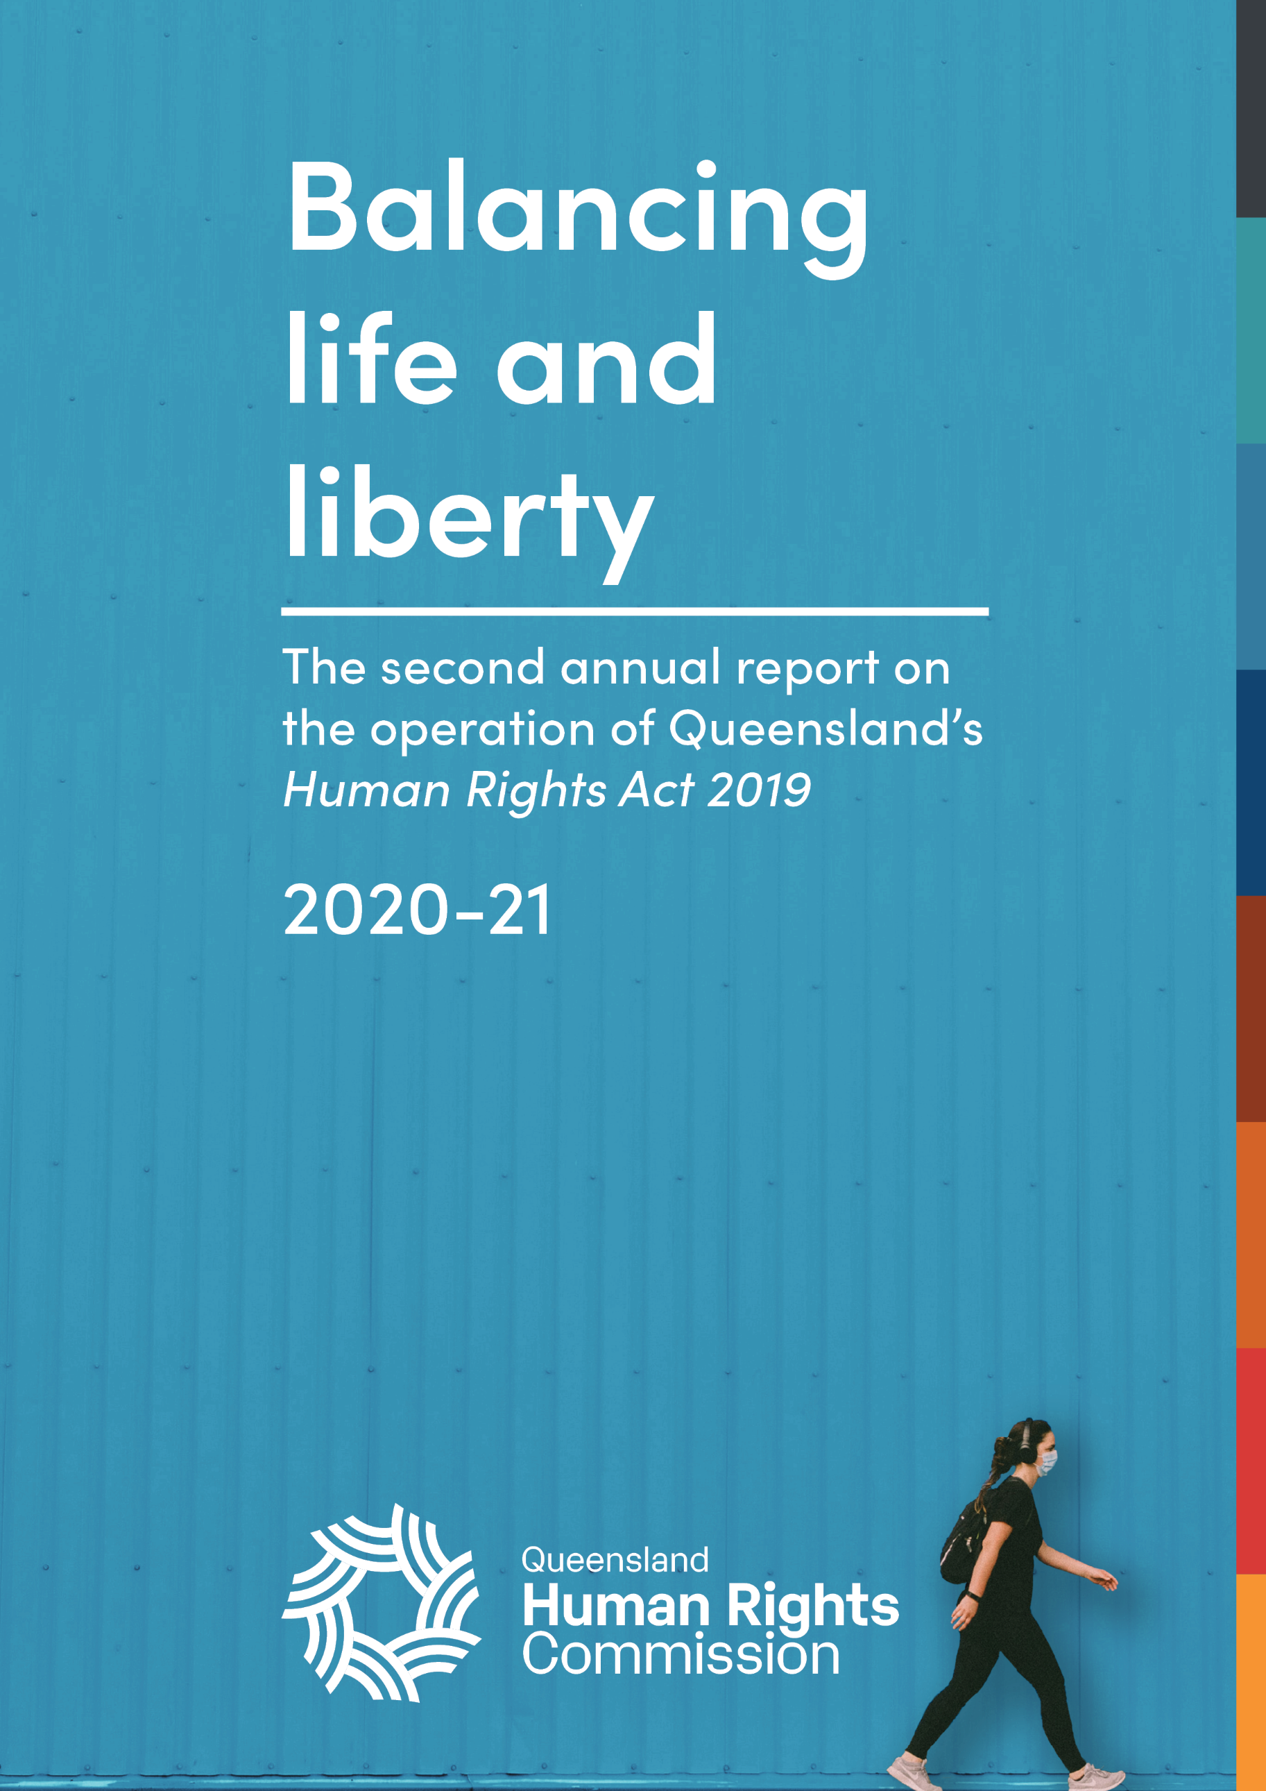

Annual report on the operation of the Human Rights Act 2019

2020-21
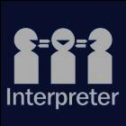
The Queensland Human Rights Commission is committed to providing accessible services to Queenslanders from all culturally and linguistically diverse backgrounds. If you have difficulty in understanding the annual report, you can contact us on toll free 1300 130 670 and we will arrange an interpreter to effectively communicate the report to you.
English: If you’d like us to arrange an interpreter for this report, please call us on 1300 130 670.
Spanish: Si desea que nosotros para solicitar un intérprete de este informe, por favor llámenos en 1300 130 670
French: Si vous souhaitez organiser un interprète pour ce rapport, veuillez nous appeler au 1300 130 670
Chinese: 如果您想让我们为此报co告安排传译员，请致电我们 1300年 130 670
Arabic: إذا كنت تريد منا أن يرتب مترجما لهذا التقرير، يرجى الاتصال بنا على 1300 130 670
German: Wenn Sie uns einen Dolmetscher für diesen Bericht anordnen möchten, rufen Sie uns bitte auf 1300 130 670
Turkish: Lütfen bizi arayın 1300 130 670 bizimle bu rapor için bir tercüman istiyorsanız,
Japanese: このレポートのための通訳の手配を希望する場合は、1300年 130 670 に問い合わせください。
Dutch: Als u wij dat wilt te regelen een tolk voor dit verslag, bel ons op 1300 130 670
Korean: 우리가이 보고서에 대 한 해석자를 정렬 작업을 원하시면 전화 주시기 바랍니다에 1300 130 670

© Queensland Human Rights Commission 2021
ISSN 2652-8835 (online)

Licence: This annual report is licensed by Queensland Human Rights Commission under a Creative Commons Attribution
(CC BY) 4.0 International licence.
To view a copy of this licence, visit: http://creativecommons.org/licenses/by/4.0/
CC BY Licence Summary Statement: In essence, you are free to copy, communicate and adapt this annual report, as long as you attribute the work to the Queensland Human Rights Commission.

Attribution: Content from this annual report should be attributed as: Queensland Human Rights Commission, 2020-2021 Annual report on the operation of the Human Rights Act 2019.

This publication is available in electronic format on the Commission’s website at: www.qhrc.qld.gov.au.

Contents
Commissioner’s foreword 5
About the Commission 7
About this report 8
Executive summary 9
Human Rights Act snapshot of 2020-21: A timeline 12
Report summary 14
About the Human Rights Act 2019 19
Human rights and the Parliament 25
The role of parliament 26
Assessing Parliament's role in promoting a human rights culture 30
Indicators of a human rights culture 34
Significant legislation 2020-21 38
Summary of the role of Parliament in 2020-21 56
Human rights in courts and tribunals 58
The role of courts and tribunals 59
Key cases 64
Interventions 68
Summary of the role of courts and tribunals in 2020-21 71
Human rights and the public sector 72
Indicators of a human rights culture 76
State public entities 78
Local government public entities 102
Progress towards a human rights culture in government and councils 110
Human rights in vocational and tertiary institutions 114
Functional public entities 117
A human rights approach to housing and homelessness services 117
Human rights enquiries and complaints 122
Internal complaints made to public entities 124
Early complaint resolution 128
Enquiries to the Commission 130
Complaints to the Commission 134
Resolved complaint case studies 156
Human rights in the community 166
Measuring human rights attitudes 167
Community education 169
Appendix A: Courts and tribunals 173
Appendix B: Human rights indicators 183
Indicators of a developing human rights culture: State government 183
Indicators of a developing human rights culture: Councils 185
Appendix C: Complaints and enquiries data tables 188


Commissioner’s foreword
In my foreword to last year’s report – the first on the operation of Queensland’s Human Rights Act 2019 – I reflected that there was possibly no greater test of new human rights legislation than a global pandemic.
COVID-19 and the ensuing restrictions swept the world less than three months after the operational provisions of Queensland’s new Human Rights Act (the Act) had come into effect, and its impact on human rights culture and understanding, both at a community and political level, has been immense.
Here at the Commission we saw dramatic increases in complaint and enquiry numbers throughout 2020-21, as well as sharp surges in enquiries and complaints as a result of lockdowns and other pandemic response measures.
Across the public sector, agencies have grappled with the human rights implications of wide-scale restrictions on their service delivery and what that means for the communities they serve, while Queenslanders both inside our borders and out – many of whom may never have considered the need for their own rights to be protected – were faced with constantly changing and sometimes confusing public health directions.
However, while the challenges have been myriad, so too have the gains when it comes to Queensland’s developing human rights culture.
Hotel quarantine, mask requirements, vaccines, lockdowns and border closures have occupied much space in media coverage and public discourse over the past year, and along with that has come an accelerated understanding of the need to balance people’s human rights against the rights of others, both individually and collectively.
Public entities have largely shown themselves willing to engage in human rights dialogue when issues were raised, and consider less restrictive alternatives to rights limitations. Advocates have also reported positive outcomes by raising human rights arguments in their dealings with public entities.
In a case in which the Commission intervened during the reporting period, the Supreme Court has since made an instructive decision about how public entities must apply the Act to ensure their actions and decisions are compatible with human rights.
However, there remain some areas where a human rights culture is still emerging. Parliamentary utilisation of the Act is arguably not as developed, particularly when it comes to scrutiny of legislation through a human rights lens. This year, the Commission has been invited to appear regularly before parliamentary committees to offer expert guidance on the potential human rights impacts of legislation across multiple portfolios. Parliamentary committees have expressed concerns about human rights compatibility, particularly laws relating to emergency powers in the ongoing pandemic, and youth justice. However, this has not translated to meaningful change through the legislative process.
Strong and sustained leadership which keeps human rights at the centre of decision-making will be essential for a human rights culture to continue to grow at every level - in public entities, the courts and in the parliament.

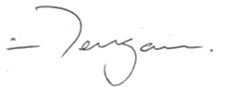
Scott McDougall
Commissioner
Queensland Human Rights Commission

About the Commission
The Queensland Human Rights Commission (the Commission) is an independent statutory body established under the Anti-Discrimination Act 1991. The Commission was formerly the Anti-Discrimination Commission Queensland and was renamed the Queensland Human Rights Commission on 1 July 2019 following the passage of the Human Rights Act 2019 (the Act). The functions and powers of the Commission under section 61 of the Act are:
- to deal with human rights complaints;
- if asked by the Attorney-General, to review the effect of Acts, statutory instruments and the common law on human rights and give the Attorney-General a written report about the outcome of the review;
- to review public entities’ policies, programs, procedures, practices and services in relation to their compatibility with human rights;
- to promote an understanding and acceptance, and the public discussion, of human rights and this Act in Queensland;
- to make information about human rights available to the community;
- to provide education about human rights and this Act;
- to assist the Attorney-General in reviews of this Act under sections 95 and 96;
- to advise the Attorney-General about matters relevant to the operation of this Act; and
- another function conferred on the Commission under this Act or another Act.

About this report
Section 91 of the Act requires that, as soon as practicable after the end of each financial year, the Commissioner must prepare an annual report about the operation of the Act during the year. The purpose of this report is to provide a resource for government, parliament, and the community on the operationalisation of the Act and the degree to which it is achieving its objectives. The Act will be reviewed in 2023 and 2027, and the content of this report will provide evidence of how the Act has operated in its early years.

Executive summary

Balancing life and liberty
The right to life is a supreme right which recognises that human life is ‘precious for its own sake’. COVID-19 has required us to give up some of our liberties to preserve the lives of others around us. Finding the right balance between protecting life and preserving liberty is an ongoing challenge for our society.
Last year the Commission reflected on how COVID-19 had presented a significant and unforeseen test of the Act in its earliest stages. COVID-19 was declared a pandemic in the first months of the Act’s operation, just as the complaints process had commenced. The Commission expressed last year that the Act provides an important framework for assessing the impact on rights of the unprecedented measures taken to protect life.
Complaints made internally to Queensland Health, and through the Commission’s complaint process, demonstrate the critical importance of the framework of assessing compatibility with human rights in order to achieve the right balance.
In the reporting period, lockdowns, border closures, and quarantine requirements imposed by the Queensland Government placed numerous limitations on human rights, especially the right to freedom of movement, in order to protect the community from COVID-19. Queensland Parliament passed legislation that granted the Chief Health Officer substantial powers. Under the Act, the Parliament was required to consider whether the limitations on human rights were reasonable and justifiable in the current situation of a pandemic.
COVID-19 was the subject matter of 1 in 4 human rights complaints and 1 in 6 enquiries to the Commission in 2020-21. Around 80% of complaints about health services were related to COVID-19. This focus is reflected in the rights most frequently identified in complaints finalised in the reporting period:
- Recognition and equality before the law
- Humane treatment when deprived of liberty
- Freedom of movement
Without the passage of the Human Rights Act 2019, hundreds of people would not have had the option of complaining to an external body equipped to deal with their complaint through a human rights lens. The complaints process ensured that people who were most disadvantaged – such as children, families, and people with disabilities – were able to negotiate fair and reasonable outcomes in challenging circumstances. The flexible processes allowed by the Act made it possible for the swift resolution of issues to the benefit of individuals and public entities and led to service improvements at a systemic level [refer to Human rights enquires and complaints – Resolved complaints case studies on page 155].
One requirement under the Act is for public entities to consider whether there are any less restrictive and reasonably available ways to achieve a legitimate purpose. Two reports issued with recommendations following unresolved complaints about COVID-19 suggested alternative options that could have been considered while still meeting the legitimate purpose of protecting life [refer to Human rights enquiries and complaints - Unresolved complaints with recommendations on page 152].
To continue to provide a legal basis for public health restrictions, Queensland Parliament passed further legislation in the reporting period. Unfortunately, in some instances such laws were passed on an urgent basis, which bypassed proper parliamentary scrutiny with respect to human rights [refer to Human rights and the Parliament – COVID-19 related legislation on page 41].
Overall, community attitudes reflect support for the actions of government with respect to the pandemic in protecting and promoting human rights [refer to Human rights in the community – measuring human rights attitudes on page 166].

Human rights leadership in the public sector
In the first year of the Act, the Commission created indicators of a developing human rights culture and asked a number of state public entities and councils about progress made against the indicators towards building a culture where rights are protected and promoted.
Again this year the Commission has asked key government agencies and a small sample of councils to respond against these indicators. It is hoped that this exercise will identify strengths and areas for improvement on an ongoing basis.
The Commission observed that in the second year, teams tasked with implementing the Act had mostly completed their initial work of reviewing policies, procedures and legislation, and a high proportion of staff had already received training on the Act. Practical examples were provided of how positive changes had been implemented either in response to a policy review, or in response to a complaint or a series of complaints. This shows the value in the Act in achieving improved service delivery.
While the pandemic has created a particularly challenging environment for cultural change, it is important that the public sector does not become complacent. The Commission will continue to monitor how the Act is operating in the hope that this culture will continue to grow. It will take sustained effort and strong leadership for human rights to be embedded in every public entity in Queensland.
That’s why this year, the Commission has focussed on the question of human rights leadership and what role it has to play in ensuring sustained cultural change [refer to Human rights in the public sector – Developing a human rights culture on page 74].

Cultural rights upheld
2020-21 has been a significant year for Aboriginal and Torres Strait Islander peoples’ cultural rights, which are protected under section 28 of the Act. Firstly, 2021 saw the passage of landmark legislation to legally recognise traditional Torres Strait Islander adoption practices.
Of the complaints received about human rights, one in 10 were made by Aboriginal or Torres Strait Islander people.
Section 28 of the Act upholds the distinct cultural rights of Aboriginal and Torres Strait Islander people, ensuring that they are free to practice their cultures. As demonstrated by a complaint resolved by the Commission, cultural rights may apply even when native title has been extinguished.
Traditional Wangan and Jagalingou custodians relied on the Act to protect their cultural rights to perform ceremonies on land granted to Adani’s Carmichael coal mine. Community leader Adrian Burragubba brought a complaint to the Commission after police asked a group of traditional custodians to stop conducting ceremonies and leave the site. The complaint was resolved through the conciliation process, and the Queensland Police Service issued a public apology.
The outcome indicates a strong commitment by the Queensland Police Service to uphold the cultural rights of Aboriginal peoples and Torres Strait Islander peoples and demonstrates the value of the Act for Queensland’s First Nations peoples.

Human Rights Act snapshot of 2020-21: A timeline
Below is a brief timeline of some of the key events relevant to the operation of the Act in its second year.

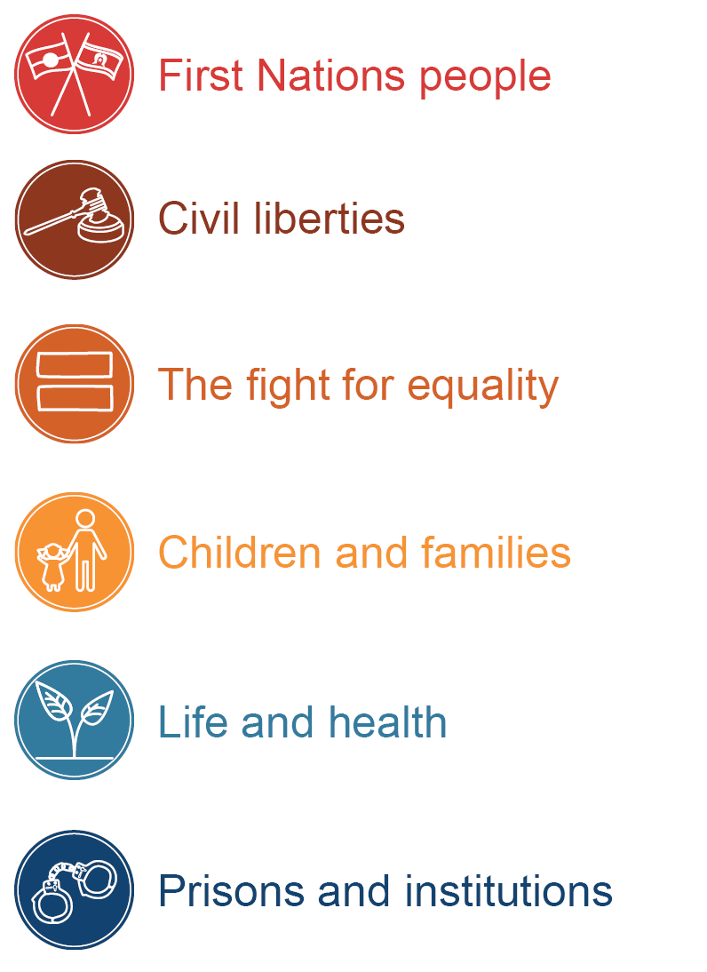

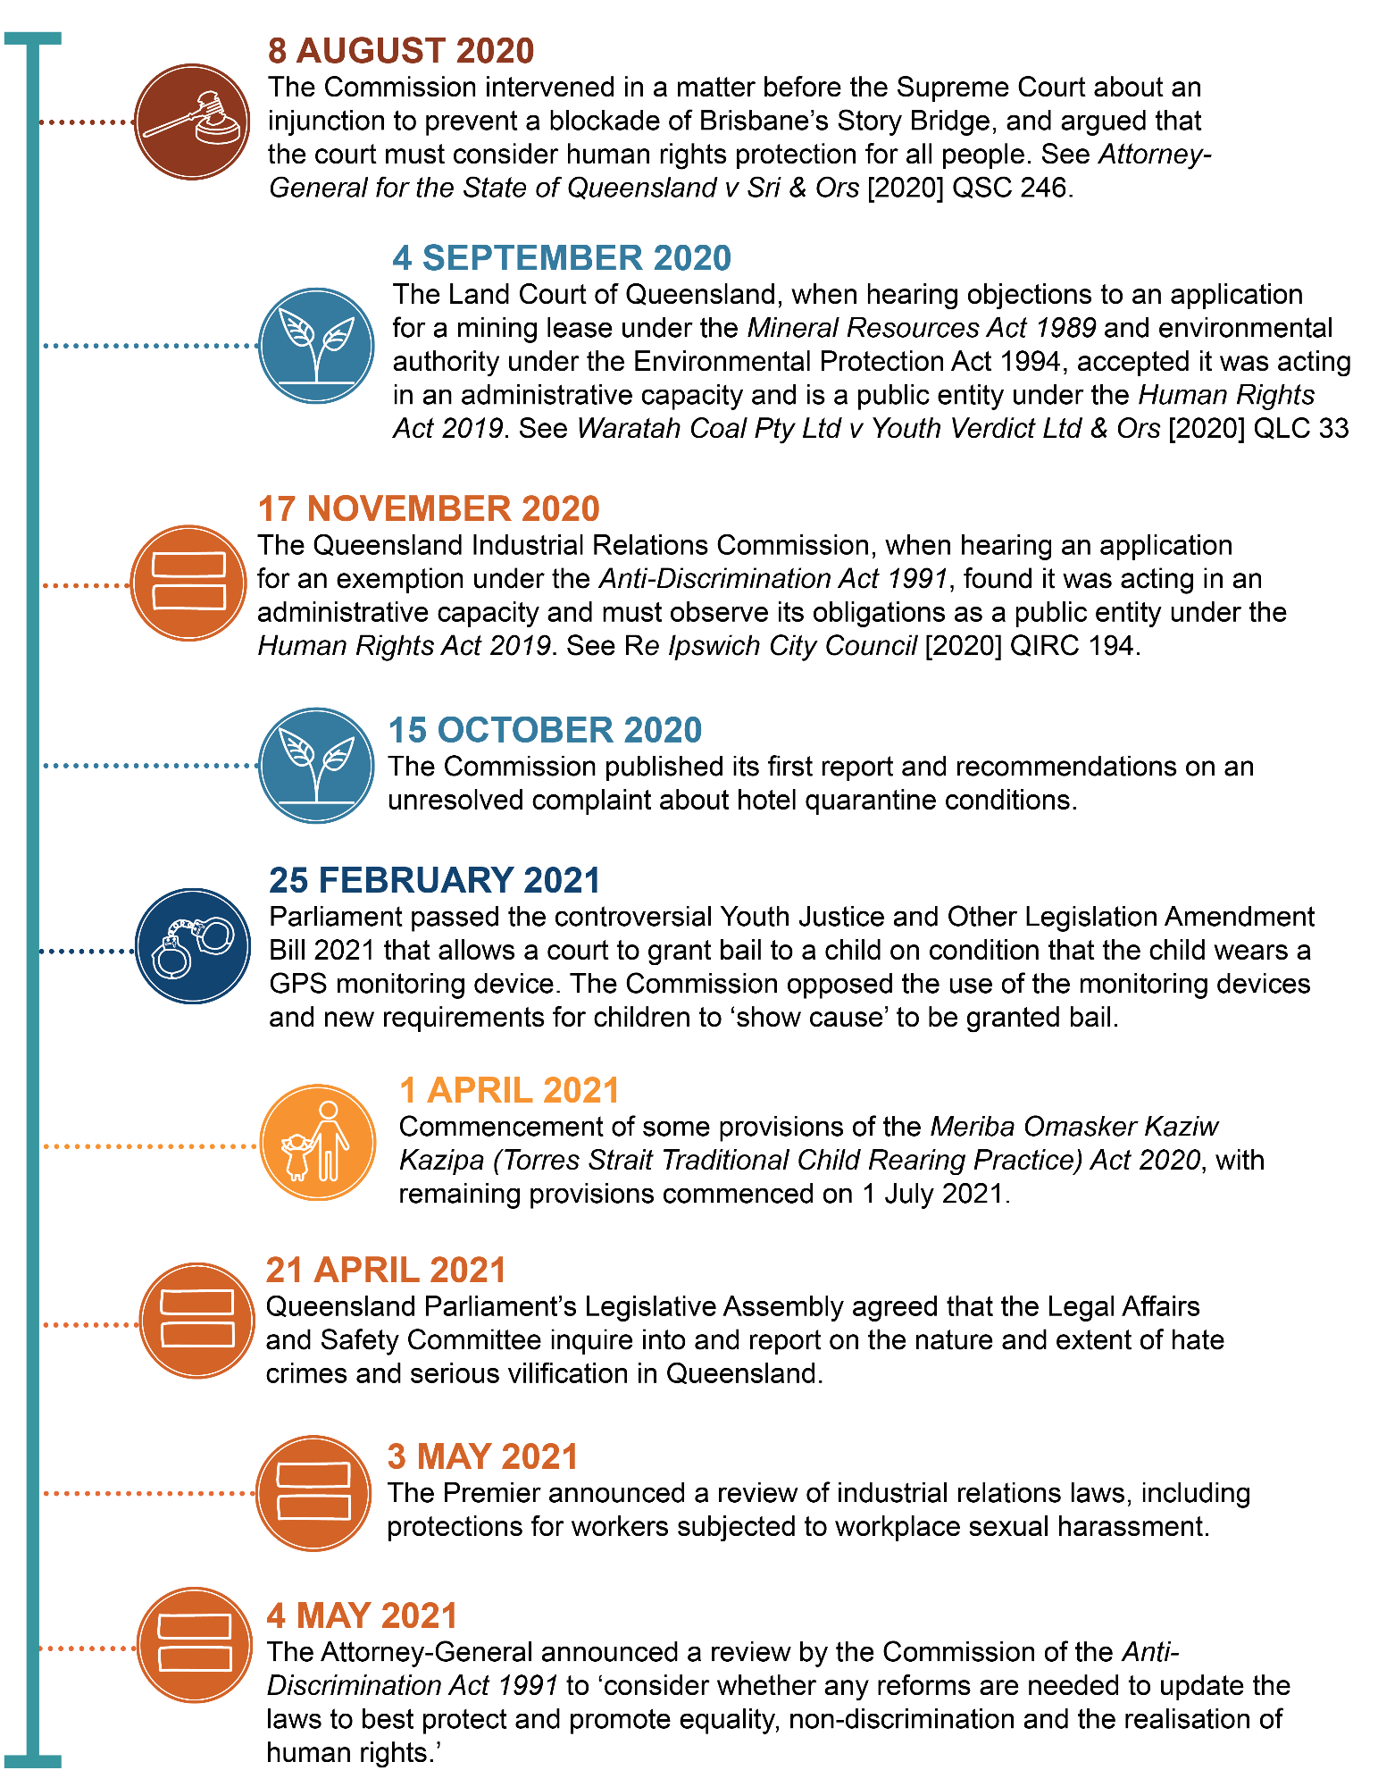

Report summary
The Act requires under s91 that this report contain particular information. This information has been summarised below, along with the location of more detailed commentary in this report.
Table 1: Required information for this report under s91 of the Human Rights Act 2019
Section | Required information
91(2)(a) | details of the examination of the interaction between this Act and other Acts, statutory instruments and the common law  This provision refers to section 61(b) of the Act. The Commission has not been asked to perform this function in the 2020-21 financial year.
91(2)(b) | details of all declarations of incompatibility made  No declarations of incompatibility were made in the 2020-21 financial year.
91(2)(c) | details of all override declarations made  No Override Declarations were made in the 2020-21 financial year.
91(2)(d) | details of all interventions by the Attorney-General or the commission under section 50 or 51  The Commission intervened in 3 matters before the Supreme Court and 2 matters before the Mental Health Court during 2020-21.  For more information, see Human rights in courts and tribunals – Interventions from page 68.
91(2)(e) | the number of human rights complaints made or referred to the commissioner  In the reporting period, the Commission received 369 complaints that have been identified as human rights complaints. Of those complaints:  - 237 were human rights only complaints  - 132 were piggy-back complaints  For more information, see Human rights enquiries and complaints – Human rights complaints snapshot on page 138.
91(2)(f) | the outcome of human rights complaints accepted by the commissioner for resolution by the commission, including whether or not the complaints were resolved by conciliation or otherwise  Of the 151 accepted complaints that were finalised in the 2020-21 financial year:  - 47 complaints were resolved.  - 14 complaints were referred to Queensland Civil and Administrative Tribunal.  - 12 complaints were referred to Queensland Industrial Relations Commission.  For more information, see Human rights enquiries and complaints – Outcomes of finalised complaints on page 140 and Resolved complaint case studies, from page 155.
91(2)(g) | the number of human rights complaints resolved by the commission  In the 2020-21 financial year:  47 complaints were resolved and finalised, comprising:  - 19 human rights only complaints resolved and finalised by the Commission; and  - 28 piggy-back complaints resolved and finalised by the Commission.  For more information, see Human rights enquiries and complaints – Human rights complaints snapshot on page 137.
91(2)(h) | the number of conciliation conferences conducted under this part  120 conciliation conferences relating to human rights were conducted in the 2020-21 financial year. 100 were for piggy-back complaints and 20 were for human rights only complaints.  For more information, see Human rights enquiries and complaints – Dispute resolution process: conciliation and early intervention on page 152.
91(2)(i) | the number of public entities that were asked or directed to take part in a conciliation conference, and the number that failed to comply with a direction to take part  While 453 notifications were sent out for public entities to participate in dispute resolution, some public entities were required multiple times. Overall, 246 discrete public entities participated.  No public entities failed to comply with a direction to attend a conference in the 2020-21 financial year.  For more information, see Human rights enquiries and complaints – finalised complaints by sector on page 146.
91(2)(j) | the number of human rights complaints received by particular public entities decided by the commissioner  This information is too detailed to reproduce in the report summary.  See Human rights enquiries and complaints - Internal complaints made to public entities from page 124.
88(4) | The names of public entities and details of actions recommended by the Commissioner following an unresolved conciliation  The Commissioner made recommendations in relation to two complaints, one about hotel quarantine and another about prisoner quarantine during COVID-19.  See further details under the heading Human rights enquiries and complaints – Recommendations made by Commissioner from page 152.

About the Human Rights Act 2019

What are human rights?
Human rights are rights inherent to all human beings.
By promoting respect for human rights, we recognise the dignity and worth of all people.
Human rights should only be limited in a way that can be justified in a free and democratic society based on human dignity, equality, freedom, and the rule of law.

Modern human rights law
The modern idea of human rights derives from the Universal Declaration of Human Rights which was adopted by the United Nations General Assembly in 1948. Australia has shown its commitment to human rights by ratifying treaties, including the International Covenant on Civil and political Rights (ICCPR) and the International Covenant on Economic, Social and Cultural Rights (ICESCR). However, a treaty only becomes a direct source of individual rights and obligations once it is incorporated into domestic legislation.

About the Human Rights Act 2019

Objects of the Act
The main objects of the Act are:
- to protect and promote human rights; and
- to help build a culture in the Queensland public sector that respects and promotes human rights; and
- to help promote a dialogue about the nature, meaning and scope of human rights.

Protected human rights
The Act consolidates and establishes statutory protections for certain rights recognised under international law, including those drawn from the ICCPR and the ICESCR.
The following human rights are protected under the Act:
- Right to recognition and equality before the law (section 15)
- Right to life (section 16)
- Right to protection from torture and cruel, inhuman or degrading treatment (section 17)
- Right to freedom from forced work (section 18)
- Right to freedom of movement (section 19)
- Right to freedom of thought, conscience, religion and belief (section 20)
- Right to freedom of expression (section 21)
- Right to peaceful assembly and freedom of association (section 22)
- Right to take part in public life (section 23)
- Property rights (section 24)
- Right to privacy and reputation (section 25)
- Protection of families and children (section 26)
- Cultural rights – generally (section 27)
- Cultural rights – Aboriginal peoples and Torres Strait Islander peoples (section 28)
- Right to liberty and security of person (section 29)
- Right to humane treatment when deprived of liberty (section 30)
- Right to a fair hearing (section 31)
- Rights in criminal proceedings (section 32)
- Rights of children in the criminal process (section 33)
- Right not to be tried or punished more than once (section 34)
- Retrospective criminal laws (section 35)
- Right to education (section 36)
- Right to health services (section 37)

Government obligations
The Act places obligations on all three arms of government, the legislature, the judiciary and the executive. This means that:
Parliament (the legislature) must consider human rights when proposing and scrutinising new laws.
Courts and tribunals (the judiciary) so far as is possible to do so, must interpret legislation in a way that is compatible with human rights.
Public entities (the executive) – such as state government departments, local councils, state schools, the police and non-government organisations and businesses performing a public function must act compatibly with human rights.
The Act makes it clear that rights can be limited, but only where it is reasonable and justifiable.
This report contains sections reflecting the progress gained by all three arms of government towards the goals of the Act.
- For more information on Parliament see Human rights and the Parliament from page 25 of this report.
- For more information on courts and tribunals see Human rights in courts and tribunals from page 58 of this report.
- For more information on public entities see Human rights and the public sector from page73 of this report.

The dialogue model
Figure 1: Diagram of the dialogue model
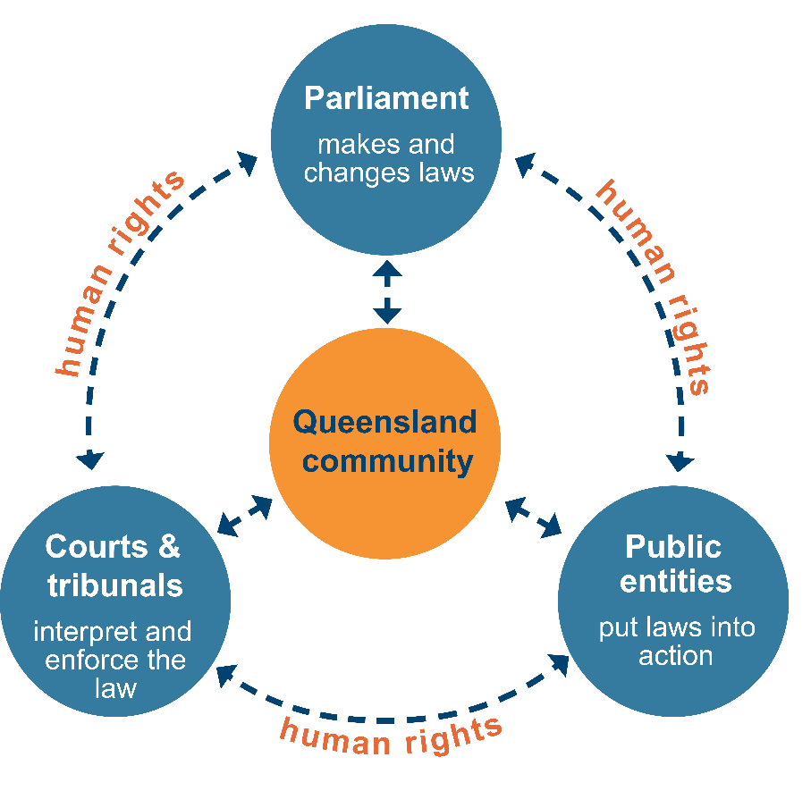
A dialogue model is aimed at prevention rather than litigation, and retains the sovereignty of Parliament.
It means that human rights are considered across the three arms of government – when the Parliament makes laws, when government applies laws, and when courts and tribunals interpret laws.
There is a mechanism for the court to inform the government if legislation is inconsistent with human rights, but it doesn’t affect the validity of the legislation and Parliament has the final say.
It encourages people to talk to public entities if they feel their human rights have been unreasonably limited or not considered at all.
Under the Act, a complaint may be made to the Commission about human rights, provided a complaint has first been made to the public entity. The dispute resolution process is consistent with a dialogue model as it encourages resolution through discussion. The dialogue model is strengthened by the Commission’s capacity to make recommendations for improvements to further human rights compatibility. Section 88 of the Act allows the Commission to prepare a report about a human rights complaint which includes recommendations of actions to be taken by public entities to ensure its acts and decisions are compatible with human rights.

Public entities
Public entities have obligations to make decisions and act compatibly with human rights, and to give proper consideration to human rights when making decisions.
A public entity is an organisation or body performing a public function in and for Queensland.
There are two types of public entities, although the following terms are not used in the Act:
Core public entities are government entities. This includes:
- government agencies and departments
- public service employees
- the Queensland Police Service and other emergency services
- state government ministers
- public schools
- public health services, including hospitals
- local government, councillors, and council employees.
Functional public entities are only considered public entities when they are performing a function of a public nature on behalf of the state. Organisations funded by the government to provide public services would fall under this category. Functional public entities could be non-government organisations (NGOs), private companies, or government owned corporations. A private company funded to run a prison, or an NGO providing a public housing service, would be considered a functional public entity.

Human rights and the parliament

The role of parliament
The Act requires parliament, the courts, and the executive to act compatibly with human rights. Parliament is responsible for making and passing laws, and under the dialogue model courts cannot overrule legislation because it is not compatible with human rights. Parliament therefore has a crucial role to ensure that legislation is compatible with human rights before it passes into law. Once a law is passed, any future human rights compatibility assessment will generally only arise if raised in litigation.
Parliament’s obligation is to consider whether limitations on human rights are justified. This occurs through the tabling of Statements of Compatibility and Human Rights Certificates, the Committee process, and Parliamentary debate.

Override Declarations
The parliament may override the Act by declaring that new legislation has effect despite being incompatible with human rights. This provision is intended to be used only in exceptional circumstances including war, a state of emergency, or an exceptional crisis situation constituting a threat to public safety, health, or order.
As with the first year of operation of the Act, parliament has not relied on Override Declarations when passing legislation in this reporting period.

Statements of Compatibility
Queensland Parliament must scrutinise all proposed laws for compatibility with human rights. From 1 January 2020, a member who introduces a Bill must table a Statement of Compatibility when introducing the Bill, and the responsible portfolio Committees must consider the Bill and report to the Legislative Assembly about any incompatibility with human rights.
There were a total of 38 bills introduced during the 2020–21 financial year that were accompanied by Statements of Compatibility. Several of these lapsed due to the dissolution of parliament following the end of a term of government. Twenty-four relevant Bills were passed during the reporting period. This excludes appropriation Bills and Bills introduced prior to the commencement of the Act (1 January 2020). Portfolio Committees completed 32 inquiries into Bills that were introduced in the parliament and then referred to Committees for examination.
Statements of Compatibility must explain why any limitation of rights is demonstrably justifiable. The Queensland Legislation Handbook provides guidance and a template for completion of the Statement of Compatibility by the relevant department. The statements set out the human rights issues, including which human rights are engaged or are of relevance. The statements then explain how the legislation meets the proportionality test in section 13 of the Act, which allows for rights to be subject to reasonable limits that can be demonstrably justified in a free and democratic society based on human dignity, equality, and freedom.

Human Rights Certificates
Human Rights Certificates must accompany new subordinate legislation and are drafted by the Minister responsible for the subordinate legislation. There were 214 new pieces of subordinate legislation tabled in the 2020-21 financial year accompanied by Human Rights Certificates.
The format and content of the Human Rights Certificates is similar to that of the Statements of Compatibility, described above.

Portfolio Committees
Parliamentary Committees play an important role in Queensland’s Parliament by monitoring or investigating issues and scrutinising proposed laws. Compared to other Parliaments with human rights scrutiny functions, the Queensland Parliament does not have a dedicated scrutiny Committee. For example, in the ACT, Victoria, Commonwealth, and United Kingdom parliaments, a dedicated Committee is responsible for scrutinising all legislation against specific human rights.
Instead in Queensland, similar to the model used in the New Zealand Parliament, there are 7 portfolio Committees made up of members of parliament, and it is their job to enquire into proposed laws before they are debated by parliament. Under the Act, the portfolio Committee responsible for examining a Bill must consider and report to the parliament about whether or not the Bill is compatible with human rights. Further, in an important feature of the Queensland system, Committees must also consider and report to the parliament about the Statement of Compatibility tabled for the Bill.
An advantage of the Queensland Parliamentary committee system is that committees generally invite submissions to aid in their consideration of a Bill, and hold public hearings where evidence is heard. The Committees then report to parliament about the Bill and may make comments about the Statement of Compatibility.
These Committees also consider subordinate legislation, such as regulations, including reporting on any issues identified by the Committee in its consideration of the Human Rights Certificates tabled with the subordinate legislation.
These portfolio Committees may also have a broader remit than traditional technical scrutiny Committees in other parliaments. Under section 93 of the Parliament of Queensland Act 2001, these Committees can consider several matters including ‘the policy to be given effect by the legislation’.

Consultation with the Commission
The Commission is encouraged by the fact that some agencies continue to consult with the Commission about the human rights implications of proposed Bills and subordinate legislation during the drafting stage. This consultative approach has been prompted, in part, by the requirement for a Statement of Compatibility or Human Rights Certificate. The Commission is available to discuss human rights implications at an early stage to ensure compliance with the Act is achieved through collaborative engagement.

Assessing parliament's role in promoting a human rights culture
As the Commission observed in last year’s report on the Human Rights Act 2019, a ‘culture’ of human rights signifies more than mere compliance with the Act.
The dialogue model, which prioritises discussion, awareness-raising, and education over an enforcement and compliance model, supports this goal of building gradually towards a human rights culture. Parliament has a key role to play in this process.
The Explanatory Notes to the Human Rights Bill 2018 state that Parliament and Parliamentary Committees play an important role in to facilitating broader public debate about proposed laws, and that Committees can assist parliament in assessing the human rights implications of new laws. This includes providing effective scrutiny independent from the government and to allow for public participation in human rights dialogue and debate.
With respect to the progress of human rights culture in the public service, the Commission has adopted the cascading culture change model, where human rights culture starts with legislation and flows down through regulations, policies, procedures and services through to the individual (see page 75). This emphasises that unless the legislation and regulations are human rights compatible, there will be limited benefit in changing policies and procedures.
With this in mind, the Commission has developed a further set of indicators to discuss how a human rights culture is developing within the parliament. These indicators are based on the experiences of other human rights jurisdictions and the specific role portfolio Committees play in Queensland’s unicameral parliament.
The Queensland Parliament is uniquely placed to assess the human rights implications of proposed legislation. It is a democratic body, representing the Queensland community, with the power to call on expert evidence and advice. Nonetheless, assessing the efficacy of parliamentary human rights scrutiny is not necessarily a straightforward exercise. It involves complex weighing of different public interests and the impact on society of a proposed law. Perhaps reflecting this, unlike for public entities involved in the dialogue model of human rights protection, there are no internationally agreed principles about parliament’s role.
Similar examinations have taken place in other jurisdictions, including discussion of the role of parliamentary scrutiny introduced by the Human Rights Act 2004 (ACT), Charter of Rights and Responsibilities Act 2006 (Vic), Bill of Rights Act 1990 (NZ), and Human Rights Act 1998 (UK). In analysing the work of the Commonwealth Parliament’s Joint Committee on Human Rights (PJCHR), academics have suggested that several aspects of the ‘deliberative impact’ of the parliamentary scrutiny regime are ascertainable:
- The first is the extent to which the human rights scrutiny regime has caused proponents of legislation, typically ministers, to more fully justify their policies and Bills from a human rights perspective.
- The second is the extent to which it has caused the broader cohort of parliamentarians to discuss and debate human rights issues on a more regular basis.
- Another — less visible — kind of deliberative impact within the executive can also be identified. This is the ‘feedback loop’ whereby, through correspondence concerning particular Bills and instruments, proponents of legislation and the Committee engage in a human rights dialogue that results in iterative improvements in the quality of later Statements of Compatibility.
Drawing on the work of academics and that of the ACT and Victorian Human Rights Commissions, the Commission has developed indicators to help analyse the extent to which parliament is engaging in a robust debate about human rights, and to what extent human rights is having an impact on the development of legislation.
These indicators explore the extent to which legislation is assessed for human rights compatibility, the adequacy of Statements of Compatibility, and how this is discussed through the parliamentary process. Such indicators do not objectively judge if a Bill is compatible or otherwise. Instead, they capture how concerns are raised through the scrutiny process used in Queensland, and if such concerns are robustly debated in the parliament.

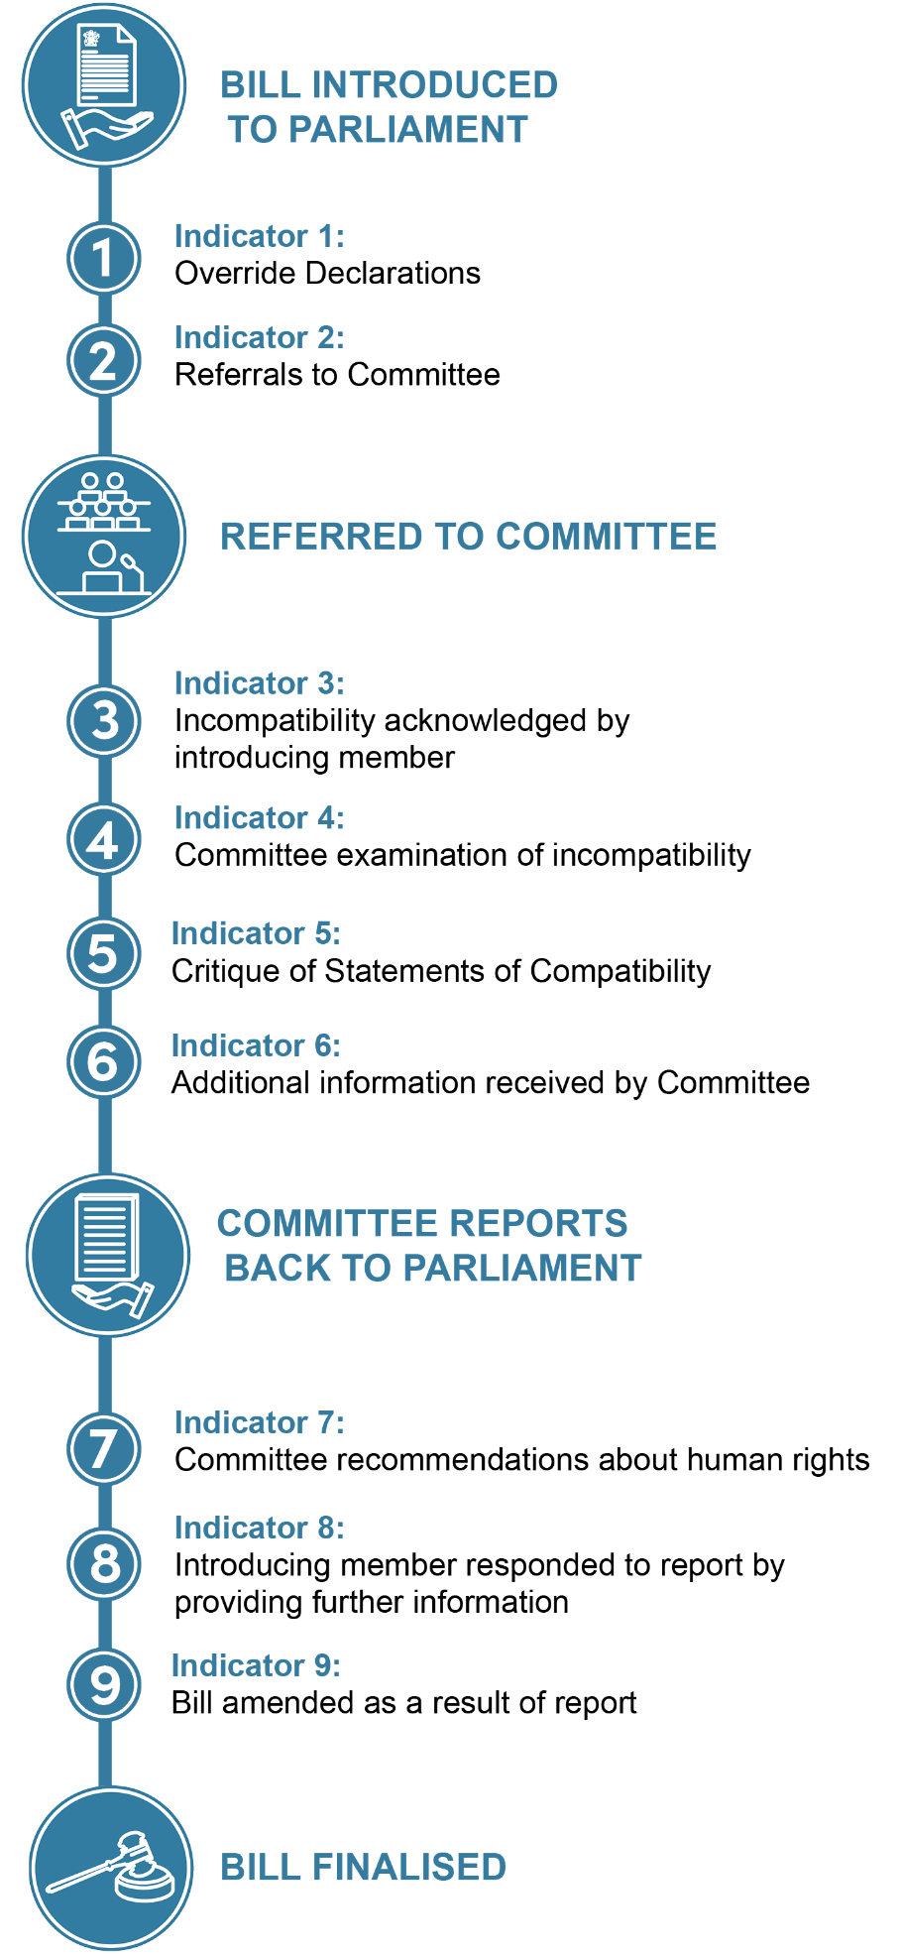
Figure 2: Indicators of parliamentary human rights culture diagram

Indicator 1: Override Declarations
Parliament may, in exceptional circumstances, expressly declare an Act has effect despite being incompatible with human rights. This indicator considers whether Override Declarations were relied upon by parliament in the 2020-21 financial year.
No Bills were introduced or passed with Override Declarations.

Indicator 2: Referrals to Committee
This indicator considers whether bills were passed on an urgent basis and therefore were not referred to Committee and subject to the usual parliamentary scrutiny.
Three Bills during the reporting period were declared urgent and therefore debated without inquiry by the relevant portfolio Committee.

Indicator 3: Incompatibility acknowledged by introducing member
This indicator considers whether Bills had explanatory materials (including the Explanatory Notes and Statement of Compatibility) in which the introducing member raised potential incompatibility.
Statements of Compatibility for two Bills discussed potential incompatibility.

Indicator 4: Committee examination of incompatibility
This indicator considers whether portfolio Committees discussed statements of partial incompatibility or proposed Override Declarations after these were raised by the introducing member.
In relation to the Youth Justice and Other Legislation Amendment Bill 2021, the potential incompatibility identified by the introducing minister was also discussed by the Legal Affairs and Safety Committee’s report.
In contrast, in the statement for the Defamation (Model Provisions) and Other Legislation Amendment Bill 2021, the Attorney-General concluded that:
While I acknowledge the amendments in the Bill limit the right to privacy and reputation and in doing so may be open to conclude that the amendments are incompatible with human rights, it is my view that the limitation is reasonable and justified and appropriately balanced with the right to freedom of expression.
The Committee considered the limitation of several rights in detail but did not appear to comment upon the Attorney-General’s statement.

Indicator 5: Critique of Statements of Compatibility
This indicator considers whether portfolio Committees determined that Statements of Compatibility were inadequate in reports to parliament.
Committee reports identified deficiencies in 10 Statements of Compatibility, meaning that of the Bills referred to Committee, approximately half were found to have adequate statements. Improvements to statements recommended by Committees included:
- providing sufficient evidence to enable a robust analysis of whether the proposed measures will be effective at achieving their stated aims and which less restrictive alternatives had been considered
- including the views of stakeholders and their suggestions about reasonably available alternatives, where targeted consultation was undertaken in developing the Bill
- providing greater detail to assist the Committee’s consideration
- providing more detailed descriptions of the positive rights impacts of the Bill, including more detailed reference to the relevant provisions of United Nations instruments
- engaging more directly with international law and comparative law sources by drafters of Statements of Compatibility, particularly when describing the nature of the rights protected under the Act
- identifying the particular clauses of a Bill being addressed by Statements of Compatibility and applying the limitations analysis to each human right being addressed.

Indicator 6: Additional information received by Committee
This indicator considers whether portfolio Committees received further information and whether this resolved concerns about lack of justification for human rights limitations.
This indicator is particularly relevant to the Queensland scrutiny process, as the ongoing dialogue between departments, the Committees and stakeholders through the inquiry process allows further justification information to be elicited from the government and published in the Committee reports.
Of those 10 Statements of Compatibility in which Committees identified deficiencies, on 4 occasions the Committee received further information through the inquiry process to address some or all issues.

Indicator 7: Committee recommendations about human rights
This indicator considers whether portfolio Committees made recommendations about human rights compatibility in reports to parliament.
It appears no formal recommendations about human rights were made during the reporting period, however in relation to one Bill, the Committee did make a specific comment encouraging the minister to respond to its concerns in her second reading speech.

Indicator 8: Introducing member responded to report by providing further information
This indicator considers whether the member of parliament introducing the Bill responded to Committee recommendations and/or provided further justification for limitations on human rights.
This indicator is relevant to only one Bill in 2020-21, the COVID-19 Emergency Response and Other Legislation Amendment Bill 2021. In a comment, the Economics and Governance Committee encouraged the Attorney-General to make clear during her second reading speech the expectation on local councils as to how extended temporary meeting provisions would be used. While not explicitly cited, some of these concerns were relevant to human rights and the Committee noted it would have welcomed further detail in the statement. The Attorney-General responded to the Committee’s concerns about local council meetings in her speech, and also took the opportunity to address other issues identified in the Committee report.
In relation to other legislation, while not formally required to do so, the minister did table further information to justify limitations on rights.

Indicator 9: Bill amended as a result of report
This indicator considers whether parliament responded to human rights issues raised in the Committee process by amending the Bill.
While not formally recommended by a Committee, the government did move amendments to the Youth Justice and Other Legislation Amendment Bill 2021 arising from concerns raised during the inquiry about the use of the term ‘tracker’ in the Bill. The Bill passed with these amendments.

Significant legislation 2020-21
A summary follows of legislation introduced in the 2020–21 financial year that raised significant human rights issues. In last year’s annual report, the Commission noted the discussion of cultural rights in the portfolio Committee report regarding the Forest Wind Farm Development Bill 2020, which was introduced last reporting period and passed on 12 August 2020.

Youth Justice and Other Legislation Amendment Act 2021
The Youth Justice and Other Legislation Amendment Act contains significant limitations on human rights. While the scrutiny process demonstrates some positive developments in the implementation of a culture of human rights, it is concerning that it passed unamended despite the human rights limitations identified by many stakeholders and the Committee.
The Act introduced changes to bail laws, including a trial of electronic monitoring of children on bail, and created a presumption against bail for children charged with certain offences. It also created a trial of increased police powers to stop a person and scan for knives and enhanced obligations on owners of vehicles in relation to hooning offences.
The Commission made a submission to the Legal Affairs and Safety Committee’s inquiry, stating concerns that the measures significantly limit human rights, and may not achieve, or be proportionate to achieving, the stated purposes of enhancing community safety. The submission noted the lack of evidence to support the effectiveness of the measures, and that they will likely result in an increase to the number of children and young people in detention.
In its report, the Committee noted several significant human rights limitations but ultimately concluded adequate justification had been provided to demonstrate these limitations were reasonable.
For example, the Committee noted ‘that the effectiveness of electronic monitoring at reducing the rate of reoffending on bail is far less clear than the position reflected in the Statement of Compatibility’. Nonetheless, the safeguards contained in the Bill, and the fact that the changes only applied in certain locations and were subject to evaluation, provided ‘some limitations on the rights-intrusive impacts of the proposed changes’.
The Committee was also concerned about the presumption against bail, noting the Commission’s concerns that the Statement of Compatibility failed to justify why the reverse onus would apply to specific offences which pose varying risks to the community. The Committee noted the previous Declaration of Incompatibility issued by the ACT Supreme Court under that jurisdiction’s human rights legislation, finding a presumption against bail for an adult could not be interpreted compatibility with human rights. The Committee further noted that:
…reversing the onus for bail means that more children will be likely to be detained regardless of whether they present an unacceptable risk to the community, because the provisions burden the accused child with the task of ‘showing cause’ as to why they should not be detained on bail. This burden will be particularly difficult for certain children to discharge, including those from dysfunctional family backgrounds or children with a complex range of psychological, social and health-related needs. Aboriginal and Torres Strait Islander children, who are already disproportionately overrepresented in the youth justice system, may face particular barriers to discharging the burden imposed by clause 24, further increasing the likelihood that they will be refused release on bail. This constitutes a significant infringement on the child’s right to liberty, and to be presumed innocent and contravenes many of the standards set out in the United Nations Convention on the Rights of the Child. The prospect of pre-trial custodial detention also impacts the child’s rights in a range of other ways, including limiting their capacity to prepare a defence against the charge, and removing access to the child’s support networks or educational or health care service providers…
… While the Statement of Compatibility claims that the increased prospect of pre-trial detention for recidivist child offenders will inevitably improve community safety, this assumption has been challenged in numerous studies and reports.
Nonetheless, the Committee was satisfied that the provisions were reasonable and demonstrably justified in the circumstances.
Similarly, the Committee also discussed the potential compatibility issues with shifting the legal burden of proof on to the defendant in relation to ‘hooning offences’. Despite its conclusion that the limitations were reasonable, the Committee encouraged:
continued reliance on the existing range of reasonably available alternatives (including the Queensland Government’s existing traffic camera monitoring system) to improve the investigation and prosecution of ‘hooning offences’ that have far less rights-intrusive impacts and may be equally or more effective at deterring this type of activity, particularly among young offenders.
The Committee discussed several other aspects of the Bill’s compatibility with human rights in detail, including:
- creating a new aggravating factor in sentencing that the child committed the offence while released into the custody of a parent or at large for another offence
- amending the Charter of Youth Justice Principles, and
- providing powers for police to stop a person and use a handheld scanner to scan for knives.
The Committee noted how significant many of those limitations were, and in some cases questioned whether those provisions were potentially incompatible. In conclusion, the Committee cautioned that:
…insufficient evidence was provided to enable a robust analysis of the extent to which the measures proposed in the Bill would be effective at achieving their stated aims, and the extent to which alternative (less rights restrictive) options had been fully explored. The analysis above also details the areas where information in the Statement of Compatibility was insufficient or absent.
The Commission remains concerned that the Bill passed with such significant limitations on human rights. In particular it is apparent the changes have led to many more young people being detained in the youth justice system. The pressure on detention centre capacity means there is significant risk of children (as young as 10) being held for unacceptably prolonged periods in police watch houses.
The government did not formally respond to the Committee’s concerns, however the Act is subject to an evaluation.
While the extensive human rights dialogue did not result in substantive change to the Bill, it did result in a change to wording. In submissions made to the Committee, stakeholders raised concerns with the term ‘tracking device’ and ‘tracker’ in the Bill. The government amended this term to be ‘monitoring device’, and noted that this change promoted several human rights including the right to equality and cultural rights in the Act.

COVID-19 related legislation
On 29 January 2020, a public health emergency was declared under section 319 of the Public Health Act 2005 due to the outbreak of COVID-19 in China. Early in the COVID-19 pandemic, restrictions introduced via legislation were declared urgent and passed through parliament with limited scrutiny. This trend continued into late 2020 with the COVID-19 Emergency Response and Other Legislation Amendment Act 2020 introduced on the 26 November 2020 and debated and passed without amendment on 2 December 2020.
COVID-19 related amendments were also made during the debate stage of the Corrective Services and Other Legislation Amendment Bill 2020 and therefore not subject to Committee scrutiny. Given the significant limitation on rights arising from the extraordinary measures introduced in response to COVID, it is imperative that they are subject to proper parliamentary scrutiny.

COVID-19 Emergency Response and Other Legislation Amendment Act 2020
In 2020 new powers were created for the Chief Health Officer and others to respond to the pandemic. In addition, temporary and, in some cases, extraordinary legislative measures were introduced to allow for flexible and rapid responses to a range of things disrupted, caused or affected by the pandemic. The majority of these measures were initially to expire on 31 December 2020.
This Act extended the operation of all COVID-19 related legislation deemed necessary to respond to the emergency until 30 April 2021 or an earlier date to be prescribed by regulation. New changes were also proposed, including the power to make regulations to facilitate transitional arrangements.
Changes unrelated to COVID-19 were also proposed to amend the Local Government Act 2009 to retrospectively change the way mayoral and local councillor vacancies are filled. The Statement of Compatibility acknowledged that these amendments limited the right to take part in public life (s 23 of the Human Rights Act), and that this limitation could be lessened if the amendments did not apply retrospectively. This would result in a runner-up being appointed to fill any vacancies prior to commencement. The statement stated that this measure was not adopted because this would not provide individuals in these local government areas with the same further opportunity to vote or be elected to fill the vacancy in the office of a mayor as other local governments. In relation to a vacancy in the office of a councillor, it would not enable the local government to balance the cost of holding a by-election with the availability of a runner-up, as would apply for other local governments. The minister therefore considered that this approach would not achieve the identified purpose as effectively as the amendments proposed in the Bill.
The Bill was declared urgent, not referred to Committee and passed without amendment in December 2020.
Retrospectively changing how local government elections are determined is a significant limitation on rights, and coupled with the other COVID-19 related measures, it was unfortunate this Bill did not have the benefit of Committee scrutiny.

Public Health and Other Legislation (Extension of Expiring Provisions) Amendment Act 2021
This Act extended the operation of amendments to the Public Health Act 2005 (Qld), to authorise the Chief Health Officer and emergency officers to restrict the movement of any person or group of persons to limit, or respond, to the spread of COVID‐19 in Queensland including requiring people to quarantine in particular places.
In its report, the Health and Environment Committee concluded that all human rights limitations in the bill were reasonable and justifiable. However, while the Committee found that the Statement of Compatibility provided a sufficient level of information to facilitate understanding of most aspects of the Bill, it was lacking in some areas.
For example, the report noted that the statement did not consider whether a person may be precluded from accessing regular health services during restrictions on their movement, limiting the right to equality and right to access health care without discrimination. Similarly, the statement did not discuss how people with disabilities may be disproportionality impacted by directions restricting movement and contact with others. There was also a potential impact on a patient’s mental health care treatment should the patient be moved from an authorised mental health service to another place for the purpose of complying with a detention order or direction.
Further, the statement did not consider if a power granted to the Chief Health Officer and emergency officers to publish a notice or direction to business owners and operators to open, close and limit access to the facility, would impact on their right to property under section 24 of the Human Rights Act.
The Committee also found that the statement did not discuss the compatibility of the Chief Health Officer’s broad power to give 'any direction the Chief Health Officer considers necessary to protect public health', with rights protected in the Act. The Committee noted that the Chief Health Officer is a public entity under the Human Rights Act, and so, provided the power is exercised compatibly with the obligations imposed on public entities under the Act, the statutory power will not be incompatible with human rights.
The Commission has been concerned about a lack of transparency which has made it difficult to ascertain whether those obligations are being met. With this issue in mind, the Commission has frequently suggested that in making decisions using these powers the Chief Health Officer and other relevant decision makers should provide a statement of reasons including how they have given proper consideration to human rights in making decisions and/or acted compatibly with human rights.
The Bill passed on 24 February 2021.

COVID-19 Emergency Response and Other Legislation Amendment Act 2021
This Act extends various temporary powers enacted in 2020 to respond to the COVID-19 pandemic, including to allow the modification of legislative requirements by regulation or secondary instruments to:
- reduce physical contact between persons
- change statutory time frames
- ensure the continuation of court and tribunal proceedings.
The Act also made amendments to local government arrangements including various measures to facilitate the holding of local government by-elections and fresh elections in a way that helps minimise serious risks to the health and safety of persons caused by COVID-19.
Extending such extraordinary powers engaged several human rights. Through its inquiry, the Economics and Governance Committee identified several concerns, which were ultimately resolved through further dialogue. In its report, the Committee identified deficiencies in the Statement of Compatibility, but resolved this by reference to additional information provided by Department of State Development, Infrastructure, Local Government and Planning (DSDILGP) and Local Government Association of Queensland (LGAQ):
While the Committee considers that the Statement of Compatibility could have offered greater explanation to justify the provisions, the Committee notes advice provided elsewhere by the DSDILGP and by the LGAQ, which explained the need for the proposed amendments to allow local governments to decide rates and charges for the 2021-22 financial year outside of the annual budget meeting.
The Committee also sought further information from the Attorney-General to support members in their consideration of concerns arising from temporary changes to local government elections and by-elections in response to COVID-19. The Committee encouraged the Attorney-General to provide this information during her second reading debate. The Attorney-General did so and took the opportunity to provide further information in her speech on other matters raised in the Committee process. The Commission notes this is an example of a growing human rights dialogue within the parliament.
The Bill passed on 20 April 2021.

Transport and Other Legislation (Road Safety, Technology and Other Matters) Amendment Act 2020
This Act introduced and supported the ongoing operation of a digital driver licence app, and included amendments for a trial using cameras to detect seatbelt offences and drivers using mobile phones. The technology initially uses machine-learning algorithms to review the images and identify patterns of behaviour. This is a growing area of regulation and human rights law, with the Australian Human Rights Commission earlier this year releasing its report of the human rights implications of governments using artificial intelligence to aid regulation.
In its report into the Bill, the former Transport and Public Works Committee noted stakeholder concerns with the limitations on the right to privacy arising from both the licence app and the use of cameras to detect offences. Human rights were discussed throughout the report and the Committee included a detailed assessment of compatibility with the Act, as well as a privacy impact assessment provided by the department.
The report also noted the submission of the Office of the Information Commission (OIC) about the potential for inappropriate access to personal information from law enforcement and other authorised officers if a person handed over their device to display their digital licence. While being satisfied that the intent of the legislation was that a person was not required to hand over their phone, the Committee supported the OIC’s suggestion that the wording of the legislative provision prohibiting law enforcement and other authorised officers from requiring an individual to hand over their device be reconsidered to ensure the intent is clear.
Rather than recommending a change to the Bill, the Committee urged the department to continue to consult with key stakeholders, including the OIC, in relation to the privacy aspects of the project. The Committee also agreed with OIC’s suggestion that the Privacy Impact Assessment be updated throughout the life cycle of the project. The Committee formally recommended that:
- a thorough review be undertaken subsequent to the implementation of the Digital Licence App prior to the expansion of the project to include other authorities, and
- a review of the provisions relating to the legislative provision prohibiting law enforcement and other authorised officers from requiring an individual to hand over their device be undertaken to ensure the intent is clear.
In relation to the new camera detection provisions, the Committee noted several stakeholder concerns about the privacy implications arising from the collection of images from the inside of every vehicle that passes a camera and the use of artificial intelligence to analyse these images. These concerns were heightened by the lack of certainty about the destruction of images and the potential for them to be used for other offences. The proposed reversal of the onus of proof for drivers charged with relevant offences also limited rights to fair trial and to be presumed innocent (sections 31 and 32 of the Human Rights Act). The report also discussed the risk of infringement notices being issued to people who are exempt from wearing a seatbelt, engaging the right to equality (s 15).
The report included further information from the department responding to these concerns. The Committee suggested that the department take the time to revisit the issues raised by stakeholders in order to consider if and where additional operational improvements can be made to fully address stakeholders’ concerns.
Overall, the Committee concluded that the limits on rights were reasonable and justifiable. However, the Committee found it was necessary to seek additional information beyond the Statement of Compatibility to reach this conclusion, and published that information in its report to facilitate understanding of the Bill and its compatibility. While ideally every Statement of Compatibility would be sufficient, it is a positive aspect of the Queensland parliamentary scrutiny process that additional information can be elicited and published prior to a Bill being debated.
The Government tabled a response to the recommendations during the debate stage, indicating its support and committing to an extensive education and training strategy to promote understanding of how the digital licence app will work.
The Bill passed on 14 July 2020.

Corrective Services and Other Legislation Amendment Act 2020
This Act responded to risks identified in the Crime and Corruption Commission’s Taskforce Flaxton: An examination of corruption risks and corruption in Queensland prisons, and implements recommendations from the Queensland Parole System Review. Amendments included alcohol and drug testing and searching of Corrective Services staff, prohibiting staff from having an intimate relationship with a prisoner, and prohibiting prisoners convicted of certain offences from being accommodated in low custody facilities.
In making a submission to the Legal Affairs and Safety Committee, the Commission recommended that in applying human rights principles, the blanket prohibition relating to low custody was inappropriate for some prisoners, and that the provisions relating to alcohol and drug testing of staff should be amended so that these measures are the least invasive. The Committee concluded the Bill was generally compatible with human rights.
However, further significant amendments were tabled by the government during the debate stage, some unrelated to the original purposes of the Bill. These included amendments to health legislation to support the government’s response to COVID-19, including increasing the maximum penalty of breaching public health orders. The Statement of Compatibility acknowledged that the amendments limited several rights, however these were not subject to the usual scrutiny through the Committee process. The urgency of these amendments was not clear. As the Commission discussed in last year’s report on the operation of the Act, as the Queensland dialogue model of human rights protection provides parliament with the final say on compatibility of laws, the scrutiny process is critical to human rights protection.
The Bill, as amended, passed on 16 July 2020.

Meriba Omasker Kaziw Kazipa (Torres Strait Islander Traditional Child Rearing Practice) Act 2020
This Act creates a new system to legally recognise cultural adoption practices of Torres Strait Islander peoples. Although the Bill restricted the rights of children and families, it is consistent with the cultural rights of Torres Strait Islander peoples, and was supported by the Commission’s submission to the Health, Communities, Disability Services and Domestic and Family Violence Prevention Committee.
While in general the Committee found a sufficient level of information in the Statement of Compatibility to facilitate understanding of the Bill, it also identified that further information would have enabled more robust consideration of rights compatibility. The Committee noted that relevant sources of information were available to the proponents of the Bill that relate directly to the issues, including information obtained through the extensive consultations conducted with Torres Strait Islander people and contained in previous published reports.
Rather than seeking more information from the minister, the Committee suggested improvements to future statements:
Given that one of the purposes of the HRA is to generate a dialogue on human rights within the Queensland Parliament and broader community, the Committee also encourages drafters of statements of compatibility to engage more directly with international law and comparative law sources, particularly when describing the nature of the rights protected under the HRA.
An example of an area for improvement singled out by the Committee was more detailed descriptions of the positive rights impacts of the Bill. In particular, including more detail of the UN Convention on the Rights of the Child and United Nations Declaration on the Rights of Indigenous Peoples.
The Bill was passed, and commenced on 1 July 2021.

Public Service and Other Legislation Amendment Act 2020
This Act gave effect to stage one reforms arising from the recommendations of the independent review of the public sector employment laws. This included changes to emphasise the government’s commitment to employment security, providing for more transparency and consistency in public service appeals, establish positive performance management principles, and clarify thresholds and guidance for taking disciplinary action.
In its report, the Education, Employment and Small Business Committee noted that a clause of the Bill was arguably incompatible with the rights to fair trial and equality under the Act. The provision may prevent a person being legally represented in public service appeals. The Committee stated that the Statement of Compatibility did not provide adequate justification for this limitation.
As this issue was raised in the inquiry process after the department had provided its consideration and formal response to issues raised in submissions to the inquiry, the Committee suggested the department consider addressing the issue in of stage 2 of the public sector reforms.
In response to formal recommendations made by the Committee, the government moved other amendments to the Bill, but not in relation to this issue. However, in its response to the Committee report, the government only noted the Committee’s suggestion that it consult with the Queensland Law Society and relevant stakeholders about this issue.
The Bill passed on 3 September 2020. The Commission remains concerned a piece of legislation with a potentially incompatible provision was passed by parliament, particularly as it is unclear if the government intends to address this issue.

Waste Reduction and Recycling (Plastic Items) Amendment Act 2021
This Act introduced a ban on some of the most common single-use plastic items in our community. The Act recognises that continued access to a single-use plastic item such as a straw is important for some members of our community with a permanent or temporary disability to meet their healthcare needs. Exempt businesses, including pharmacies, hospitals, schools, and medical and dental clinics, will be able to continue purchasing and providing single-use plastic items to those who need them. The Statement of Compatibility stated that no human rights were engaged or limited by the amendments because straws will remain available (such as by the person purchasing them separately at a pharmacy).
In its report, the Natural Resources, Agricultural Industry Development and Environment Committee found that the Statement of Compatibility provided only limited examination of issues faced by people with who may need a plastic straw. The Committee concluded that the Statement of Compatibility did not contain sufficient information and did not identify substantial human rights issues. The Committee noted that creating an additional exemption for a hospitality business who supplies a plastic straw to a person requiring one due to a disability or health condition, would be a reasonable way of further minimising the risk of humiliating or limiting experiences.
In response to this issue being raised by another member during debate, the minister committed to continuing to work with key stakeholders to clarify where and how people could still access single-use plastic items in their daily lives.
The Bill passed on 10 March 2021.

Child Protection and Other Legislation Amendment Act 2021
A purpose of this Act was to enhance the approach to permanency under the Child Protection Act 1999, and to clarify that adoption is an option for achieving permanency for children living in care.
It provides that adoption is the third preference (after being cared for by family, and being cared for by another family member) – except for Aboriginal or Torres Strait Islander children, where the third preference is foster care, and the fourth preference is adoption.
Our submission considered the changes did not sufficiently safeguard the rights of the child and their birth family, and were premature in light of the review of the Adoption Act 2009 in 2021. The Bill was initially considered by the Legal Affairs and Safety Committee (LASC), but lapsed at the end of the last parliament.
When the Bill was reintroduced after the new parliament was formed, it was considered by the Community Support and Services Committee (CSSC). The Commission joined with other bodies, including the Queensland Family and Child Commission, in a joint submission that recommended that the changes be accompanied by active efforts to implement the Aboriginal and Torres Strait Islander Child Placement Principle and that there is independent oversight of permanency decisions.
The CSSC agreed with the human rights analysis undertaken previously by the LASC, which concluded the bill was compatible with human rights and any limitations were reasonable and demonstrably justified.
The Commission’s joint submission was cited during debate of the Bill, which passed on 23 March 2021.

Criminal Code (Consent and Mistake of Fact) and Other Legislation Amendment Act 2021
This Act implemented recommendations of the Queensland Law Reform Commission to clarify that consent to a sexual act is not given simply because the person doesn’t say anything, and that if an act is done or continues after consent is withdrawn, the act is done or continued without consent. For a defendant claiming mistaken belief about consent, regard must be had to what the defendant did to ascertain consent, and regard must not be had to the voluntary intoxication of the defendant.
The Commission’s submission supported these amendments to the Criminal Code, and recommended that the government monitor this area of the law, particularly the impact on the rights of victims.
In its report, the Legal Affairs and Safety Committee noted that these aspects of the Bill engaged several rights of a defendant including to a fair hearing (section 31 of the Human Rights Act) and the presumption of innocence (s 32). However, the Committee concluded that they were not limited because an accused would still have the charge heard by an impartial court and the onus of proof beyond reasonable doubt remained on the prosecution for every element of the offence.
The Committee recommended that in light of the comments of submitters, that relevant ministers undertake consultation with key stakeholders groups as a matter of urgency to address sexual violence in Queensland. The government supported this recommendation and on March 2021 announced a wide-ranging review into the experience of women across the criminal justice system to be undertaken by the Women’s Safety and Justice Taskforce, led by the Honourable Margaret McMurdo AC.
The Bill included additional amendments relevant to human rights including changes to the legal fidelity fund under the Legal Profession Act, which were found by the Committee to be reasonable. The Bill also included requirements for the Commissioner for Liquor and Gaming to publish information concerning particular decisions. The Committee sought and published additional clarification it received from the department to facilitate understanding of why personal information was not excluded from information required to be published. The Committee was satisfied with this explanation.
The Bill also proposed to extend the period of an initial police banning notice from 10 days to one month. A police banning notice prevents a person from entering or remaining on licenced premises or safe night precincts, or attending or remaining at a public event at which liquor will be sold. The notice may also prevent a person from entering or remaining in a ‘stated area’ designated by a reasonable distance or location from a particular premises or public event. The Committee found the limitations on the rights to freedom of movement and freedom of assembly were proportionate.
The Committee noted that the Statement of Compatibility did not address whether provisions concerning new ID scanning requirements for regulated premises were compatible with the right to privacy. In considering the safety of patrons, staff and the community in and around licenced venues, the Committee found the requirements were justified.
As well as the failure to consider the right to privacy in this context, the Committee raised several other issues with the Statement of Compatibility:
- It was lengthy because it identified rights that were not limited.
- It set out a proportionality analysis that was of ‘questionable utility’.
- It would have been improved by identifying the particular clause of the Bill being addressed and applying the limitations analysis to each human right being addressed.
In a positive sign for Queensland’s growing human rights dialogue, while the Attorney-General was not formally asked or required to respond to these issues, she tabled additional material in response to the Committee’s concerns.
The Bill was passed, and the amendments to the Criminal Code commenced on 7 April 2021.

Nature Conservation and Other Legislation (Indigenous Joint Management—Moreton Island) Amendment Act 2021
In November 2019, the Federal Court of Australia made a native title consent determination recognising the Quandamooka people's native title rights on Moreton Island. As part of the consent determination process, a number of settlement outcomes were negotiated between the State of Queensland and the Quandamooka people, including an agreement to work towards joint management of protected areas on Moreton Island, or Mulgumpin as it is known to the Quandamooka people. The primary objective of this Act is to provide the legal framework for the joint management of protected areas on Moreton Island by the State and Quandamooka Yoolooburrabee Aboriginal Corporation (QYAC).
The Statement of Compatibility noted that the Bill protected and promoted the right to property (s 24) and the cultural rights of Aboriginal peoples (s 28). This right was referred to by several members during the debate of the Bill.
The Bill passed on 13 May 2021.

Disability Services and Other Legislation (Worker Screening) Amendment Act 2020
This Act implements a nationally consistent framework to screen disability service providers, with the aim of protecting people with disability from violence, abuse, neglect, and exploitation.
In our submission to the Health, Communities, Disability Services and Domestic and Family Violence Prevention Committee, the Commission recommended the government give further consideration of:
- barriers experienced by Aboriginal and Torres Strait Islander applicants and the impact on Aboriginal and Torres Strait Islander people with disability
- making Blue Card (working with children) screening tests consistent with disability worker screening
- whether there are sufficient privacy protections for the collection, use, and sharing of information obtained for worker screening.
In its report, the Health, Communities, Disability Services and Domestic and Family Violence Prevention Committee discussed these and similar concerns expressed by other stakeholders. The Committee’s report published further information from the department including about additional funding to build the capacity of Aboriginal and Torres Strait Islander organisations to provide services under the NDIS. The department also included information about efforts to improve the cultural capability of the Blue Card system. The Committee discussed the right to privacy in detail, citing information from the department responded to our concerns about protective measures for maintenance of individuals’ privacy. The Committee also considered the limitation on rights arising from the reduced ability of people with a criminal record or some other factor from their past to successfully apply for any NDIS-funded disability work, or to have their status cancelled in the event of a charge or new incident. The Committee determined this represented a limit on the right to employment after a spent conviction, and limits the potential to fully rehabilitate and integrate into society (arising under the right to equality and right to privacy and reputation). The Committee noted case law from Victoria that provided support for the argument that consideration of a person’s irrelevant criminal record may constitute an arbitrary interference with that person’s right to privacy.
The Committee found the limitations on rights had been sufficiently justified, particularly because of the purpose of protecting people living with disabilities. It also found the Statement of Compatibility provided a sufficient level of information to facilitate understanding of the Bill.
A Statement of Reservation was made by two members of the Committee, citing the Commission’s concerns about the limitation on the right to privacy arising from the collection, use and sharing of information in the course of the workers screening application.
During the Bill’s debate, members of parliament mentioned the Commission’s concerns about the impact of the changes on Aboriginal and Torres Strait Islander persons in regional and remote communities. During debate, additional advice from the department as well as concerns expressed in the Statement of Reservation were also referenced.
The Bill was passed without amendment in December 2020.

Summary of the role of parliament in 2020-21
The Commission’s analysis focuses on the passage of primary legislation through the Parliament, including the assessment of Bills and Statements of Compatibility by portfolio Committees. The volume of Human Rights Certificates means the same detailed analysis cannot be undertaken for these. However, their publication and consideration by portfolio Committees remain an important aspect of the human rights dialogue process.
The application of these new indicators to legislation considered in the reporting period suggests that human rights compatibility is being addressed both through submissions to Committees and in the human rights commentary in Committee reports. These are promising signs early after the passing of the Human Rights Act. Less promising is that legislation introduced in response to the COVID-19 pandemic continues to be declared urgent and not subject to any Committee scrutiny prior to debate.
This analysis of the remaining bills reveals it was rare for Committees to formally make recommendations or comments about human rights compatibility, such as seeking additional information, changes to Statements of Compatibility, or amendments. Nonetheless, in some cases deficiencies in Statements of Compatibility are being resolved through more information being provided to the parliament. It is a positive feature of the Queensland Parliament’s process that Committees can collate this information through the inquiry process and then publish it for the benefit of the community. This approach ensures all human rights limitations can be considered and potentially resolved by the time of the Committee’s reports, prior to the bill being debated.
However, in several cases Committees discussed deficiencies in the Statement of Compatibility or other concerns with human rights limitations without making a formal request for more information, or making a recommendation that a bill be amended. This usually meant no further information was provided by the government to justify a limitation, nor were amendments to the bill apparently considered. This is despite significant legislation being introduced to the parliament this year including in response to the COVID-19 pandemic. Other notable legislation enacted in the period created a reverse onus for bail for young people charged with certain offences, and introduced the ability for courts to require young people to wear GPS ankle bracelets. The Statement of Compatibility accompanying this Bill noted there may be arguably partial incompatibility but this did not lead to any consequence through the scrutiny process.
Nonetheless, in a positive development for human rights dialogue, on some occasions ministers tabled additional information or tabled amendments addressing human rights issues raised through the scrutiny process, even if these were not formally requested or recommended.

Human rights in courts and tribunals

The role of courts and tribunals
The separation of powers as outlined in the Constitution of Queensland 2001 requires the separation of the legal and political processes. However, courts and tribunals are required to consider the Human Rights Act 2019 when:
- interpreting legislation
- acting in an administrative capacity
- human rights have ‘direct’ application to its functions, and
- human rights grounds have been ‘piggy-backed’ on to the proceedings.

Interpreting legislation
Section 48 of the Act requires that all legislation is interpreted in a way that is compatible with human rights, to the extent that is consistent with the purpose of the legislation.
If legislation cannot be interpreted in a way that is compatible with human rights, it is to be interpreted in a way that is most compatible with human rights, to the extent that is consistent with the purpose of the legislation.
‘Compatible with human rights’ means the provision does not limit a human right, or limits a human right only to the extent that it is reasonable and demonstrably justifiable in a free and democratic society based on human dignity, equality, and freedom. The Act sets out factors that may be relevant in deciding whether a limit on a human right is reasonable and justifiable.
In SF v Department of Education [2021] QCAT 10, Queensland Civil and Administrative Tribunal (QCAT) applied section 48 in interpreting the Education (General Provisions) Act 2006. The case concerned whether a person applying to home school their child was required to provide a street address, in circumstances where the person feared for their safety if their location became known.

Declarations of incompatibility
The Supreme Court or the Court of Appeal may make a declaration of incompatibility, if the court considers that legislation cannot be interpreted in a way that is compatible with human rights. The experience of other jurisdictions is that this power is used rarely. Queensland courts did not exercise this power in the 2020–21 financial year.

Acting in an administrative capacity
When courts and tribunals are acting in an administrative capacity they are public entities under the Act and are required:
- to act and make decisions in a way that is compatible with human rights, and
- when making a decision, to give proper consideration to human rights relevant to the decision.
The following Queensland tribunals have acknowledged they are acting in an administrative capacity and therefore a public entity with obligations under the Human Rights Act 2019.
Table 2: Administrative decisions in Queensland tribunals 2020-21
Subject matter | Case
Queensland Industrial Relations Commission when deciding an exemption application under section 113 of the Anti-Discrimination Act 1991 | Re: Ipswich City Council [2020] QIRC 194
QCAT when appointing a guardian or administrator under the Guardianship and Administration Act 2000 | JF [2020] QCAT 419; DLD [2020] QCAT 237
QCAT when reviewing a decision of the Department of Child Safety, Youth and Women | RE and RL v Department of Child Safety [2020] QCAT 151
QCAT when reviewing a decision of Blue Card Services. | TRE v Director-General, Department of Justice and Attorney-General [2020] QCAT 306
Land Court when making recommendations under the Mineral Resources Act 1989 and making an objections decision under the Environmental Protection Act 1994. | Waratah Coal Pty Ltd v Youth Verdict Ltd & Ors [2020] QLC 33
Mental Health Review Tribunal | See published statements of reasons on the MHRT website.

In 2020-21, Queensland courts have stated the following are judicial decisions.
Table 3: Judicial decisions in Queensland courts 2020-21
Subject matter | Case
Bail applications | Dunshea v Director of Public Prosecutions (Qld) [2021] QCA 102
Court of Disputed Returns proceedings | Innes v Electoral Commission of Queensland & Anor (No 2) [2020] QSC 293
Application for trial without jury orders in criminal proceedings | R v NGK [2020] QDCPR 77 and R v Logan [2020] QDCPR 67

Direct application
The Act imposes direct obligations on courts and tribunals to act compatibly with human rights to the extent that the court or tribunal has the function of applying or enforcing those rights. The obligation applies whether or not the court or tribunal is acting in a judicial or administrative capacity.
The rights engaged when performing judicial functions include:
- equality before the law
- fair hearing, and
- rights in criminal proceedings.
Other rights have been found to apply directly to court functions. For example, in Innes v Electoral Commission of Queensland (No 2) [2020] QSC 293, the Court of Disputed Returns held that its function, to hear disputes about the election of a person, included applying or enforcing the right to take part in public life as protected by section 23 of the Human Rights Act 2019.

Piggy-back matters
There is no standalone cause of action for a breach of human rights. Human rights arguments can be ‘piggy-backed’ on legal proceedings against a public entity that, under a different law, allege an act or decision of the public entity was unlawful. For example, an application for judicial review of a decision made by a public entity can include a ground that the public entity breached its section 58 obligations under the Human Rights Act 2019 – that is, the decision is not compatible with human rights or proper consideration was not given to human rights.
A person can still obtain (non-financial) relief if they successfully demonstrate a breach of section 58 of the Human Rights Act 2019, even if they are not successful in their primary grounds for relief.

Referrals to Supreme Court
If a question of law arises in a court or tribunal proceeding about the application of the Human Rights Act 2019, or statutory interpretation in accordance with the Act, it may be referred to the Supreme Court of Queensland.
The Commission is not aware of any such referrals occurring in the financial year.

Queensland cases that have considered or mentioned the Act
In the financial year ending 30 June 2021, Queensland courts and tribunals considered or mentioned the Act in 59 matters. A detailed list of cases is available in Appendix A.
Table 4: Number of matters where Queensland courts and tribunals considered or mentioned the Human Rights Act
Court | Number
Court of Appeal Queensland | 3
Supreme Court of Queensland | 13
District Court of Queensland & pre-trial rulings | 3
Land Court of Queensland | 3
Queensland Civil and Administrative Tribunal, Appeals | 1
Queensland Civil and Administrative Tribunal | 30
Queensland Industrial Relations Commission | 6
Total | 59

Key cases
Cases across Queensland courts have considered the Human Rights Act. A number of key cases from the reporting period are noted below.

Interpreting legislation
SF v Department of Education [2021] QCAT 10 involved an application of a mother, who had experienced domestic violence, to home school her child. To keep her family safe, she did not disclose her residential address which the Department considered was a mandatory requirement. QCAT first interpreted the relevant provisions of the Education (General Provisions) Act 2006 in accordance with ordinary rules of statutory interpretation. It then considered the Human Rights Act 2019, concluding that an interpretation that allowed for alternative contact details, in circumstances where residential details would risk the health and safety of the family, was consistent with the overarching objects and guiding principles of the governing Act and compatible with human rights.
Taniela v Australian Christian College Moreton Ltd [2020] QCAT 249 concerned a complaint of discrimination on the basis of race or sex against a school which required a male student to cut his hair. In concluding that unlawful discrimination had occurred on a plain meaning of the Anti-Discrimination Act 1991, QCAT briefly noted that a human rights interpretation encouraged the same outcome. This matter is currently on appeal.
In Coonan v Registrar of Births, Deaths and Marriages [2020] QCAT 434, QCAT considered an appeal from a decision of the Registrar of Births, Deaths and Marriages to record a parent as ‘mother’ on a birth certificate, rather than as ‘father’, consistent with the parent’s gender identity. While the proceedings commenced before 1 January 2020 which meant the Human Rights Act 2019 did not apply, QCAT still noted a decision involving the application of the UK Human Rights Act 1998 and the rights of the child in its interpretation of the relevant law.

Acting in an administrative capacity
The Land Court is currently considering objections to Waratah Coal Pty Ltd’s (Waratah) application for a mining lease and environmental authority to develop a coal mine. In Waratah Coal Pty Ltd v Youth Verdict Ltd & Ors [2020] QLC 33, the Court considered Waratah’s application to strike out any objections that relied on the Human Rights Act 2019 due to the Court’s lack of jurisdiction to consider those objections. The parties agreed that the Land Court was a public entity acting in an administrative capacity when making recommendations under the Mineral Resources Act 1989 and when making an objections decision under the Environmental Protection Act 1994. In accordance with the Court’s obligations as a public entity, their recommendations and objections had to be compatible with and give proper consideration to human rights. The Court dismissed the strike out application.
A second decision, Waratah Coal Pty Ltd v Youth Verdict Ltd & Ors (No 2) [2021] QLC 4, related to Waratah’s 170 requests for further and better particulars from the objectors, which included objections on human rights grounds. The Department of Environment and Science, a statutory party to the proceeding, suggested there are 5 steps involved in applying human rights obligations placed on public entities under section 48:
- Section 58(1)(a) – ‘Engagement’: whether the prospective decision is relevant to a human right (and which right) ….
- Section 58(1)(a) – ‘Limitation’: if a right is relevant, is that right limited by the decision...
- Section 13 – ‘Justification’: whether such limits as do exist are reasonable and can be demonstrably justified.... There are two overlapping requirements within this step’: (i) Legality... [and] (ii) proportionality...
- Section 58(1)(b) – ‘Proper consideration’: even if the limits be lawful and proportionate, the decision made must give proper consideration to the rights said to be engaged;
- Section 58(2)- ‘Inevitable infringement’: this operates where the public entity could not reasonably act differently or make a different decision because of a statutory provision or under law.
The Court found that the objectors only had to respond to one of Waratah’s requests, and that otherwise sufficient detail had been provided for Waratah to choose and brief its expert witnesses.
In Attorney-General for the State of Queensland v GLH [2021] QMHC 4, the Mental Health Court found the regime established by the Mental Health Act 2016 to be compatible with the Human Rights Act 2019. Accordingly, any condition imposed on a forensic order must be the least restrictive of rights, and only to the extent necessary to address an unacceptable risk to safety. The Court further considered the interaction between human rights and the evaluation of unacceptable risk. The decision also records the reasons of the Mental Health Review Tribunal below, and its deliberation of human rights, which was ultimately confirmed.

Direct application
The Supreme Court in Innes v Electoral Commission of Queensland & Anor (No 2) [2020] QSC 293 considered the direct application of the right to take part in public life to the Court of Disputed Returns, as well as the application of human rights to statutory interpretation where there is no ambiguity. However, the court did not consider the case was ‘an appropriate vehicle for reaching solid conclusions about the operation of the HR Act in Queensland’.

Discussion of particular rights
In Attorney-General for the State of Queensland v Sri & Ors [2020] QSC 246, the Supreme Court considered human rights in an application for a mandatory injunction to prevent a planned protest which involved the blockade of Brisbane’s Storey Bridge. The Commission intervened in these proceedings. The court decided that limiting the rights of freedom of movement of the broader community outweighed the rights of the protestors to peaceful assembly and freedom of expression, and it was therefore appropriate to make the injunction.
Fernwood Womens Health Clubs (Australia) Pty Ltd [2021] QCAT 164 and Re Ipswich City Council [2020] QIRC 194 concerned applications for exemptions under the Anti-Discrimination Act 1991. In both cases, QCAT held that it was acting in an administrative capacity and was therefore a public entity with obligations under the Human Rights Act 2019. In making its decisions, QCAT considered the right to equality, and in particular the provision that measures taken for the purpose of assisting or advancing a disadvantaged group does not constitute discrimination.
In TRE v Director-General, Department of Justice and Attorney-General [2020] QCAT 306, QCAT reiterated its obligations in reviewing Blue Card decisions to both interpret legislation compatibly with human rights as well as comply with human rights obligations as a public entity. TRE alleged that refusing her a positive notice and Blue Card would contravene her right not to be tried or punished more than once. QCAT noted that the purpose of the review was not to impose additional punishment on TRE, but rather to protect children. In both this case and an earlier case of HAP v Director-General, Department of Justice and Attorney-General [2020] QCAT 273, QCAT emphasised the rights of children to protection, and noted that once issued, Blue Cards are unconditional and fully transferable across a range of employment and business.
In Mohr-Edgar v State of Queensland (Legal Aid Queensland) [2020] QIRC 136, Legal Aid Queensland applied to suppress the names of employees who had been identified by the complainant in allegations before the Queensland Industrial Relations Commission (QIRC). Legal Aid Queensland’s grounds included that the publication of the names would limit the employees’ right to privacy and reputation. The QIRC dismissed the application, noting that there was nothing unlawful or arbitrary about the complainant’s approach and therefore the right to privacy and reputation did not lead to a conclusion that the orders should be made. The QIRC also considered the fundamental principle of open justice in making the decision.
In MJP [2020] QCAT 253, QCAT considered rights to freedom of movement, to privacy, and to not be subjected to medical treatment without his free and informed consent relevant to its decision to appoint a MJP a guardian. In circumstances where MJP was found not to have capacity to make the relevant decisions, any limitation of rights was reasonable and justified, and consistent with MJP’s dignity that these fundamental and important life decisions be made.

Human Rights Case Law Project
The Commission acknowledges the work of the University of Queensland’s Human Rights Case Law Project team, overseen by Professor Tamara Walsh that has continued to compile case notes of human rights cases in Queensland for the benefit of legal practitioners, researchers, students, and the public.

Interventions
The Attorney-General and the Queensland Human Rights Commission have the right to intervene in proceedings before a court or tribunal where there is a question of law about the application of the Human Rights Act, or a question about how legislation is to be interpreted in accordance with the Act.

Commission notifications
For proceedings before the Supreme Court or District Court in which there is a right of intervention, parties must give notice in the approved form under section 52 of the Human Rights Act 2019 to the Attorney-General and the Queensland Human Rights Commission. The Commission also receives notifications of proceedings outside the requirements of the Act.
In 2020-21, the Commission received 26 notifications or requests to intervene under the Human Rights Act 2019. Of those, 15 were notices under section 52 of the Act.

Commission interventions
The Commission has published a guideline about when the Commission might intervene in proceedings. Relevant factors include:
- whether human rights form a significant, and not peripheral, issue to the proceedings
- whether the proceedings involve a new or unsettled area of law, or would clarify a disputed interpretation of the law
- whether the Commission can add value to the proceedings, having regard to the parties to the proceedings and whether they are represented
- the court or tribunal in which the proceedings are brought, and whether it is an intermediate or final hearing
- resource constraints.

The Commission intervened in 3 matters before the Supreme Court and 2 matters before the Mental Health Court during 2020-21.
The first of the Supreme Court matters was an application for an injunction relating to a proposed ‘sit in’ protest on the Story Bridge in Brisbane. The Commission made submissions about the right to peaceful assembly, the relevance of the rights of others and of public health and safety, and the onus of establishing that a limitation of a right is reasonable and proportionate. The Supreme Court’s decision to grant the injunction has been published: Attorney-General for the State of Queensland v Sri & Ors [2020] QSC 246.
Shortly before the publication of this report, a decision was handed down in Owen-D'Arcy v Chief Executive, Queensland Corrective Services [2021] QSC 273. A prisoner applied for judicial review of two related decisions to continue his separation from others, after being held in solitary confinement since 2013. The Commission made submissions about the obligations on public entities, including to consider the rights of all relevant people, and on the meaning of relevant rights such as the right to humane treatment when deprived of liberty and the right to life. The court found the right to humane treatment was limited by the decision and the respondents did not discharge the onus of demonstrating that limitation was reasonable. The decision also set out the requirements for a public entity to give ‘proper consideration’ to human rights when making decisions. As the public entity contravened its obligations under the Human Rights Act, the court concluded the decisions were unlawful. The court will hear the parties on a form of orders.
The Commission is still awaiting the Supreme Court’s decision in another proceeding that is subject to reporting and publication restrictions. The Commission’s submissions related to statutory interpretation and the obligations imposed on public entities under the HR Act.
Both Mental Health Court matters were appeals from decisions of the Mental Review Tribunal, and are not open to the public. In the first matter, due to the issues ultimately relied upon by the parties, the Commission withdrew from the proceedings.
The second matter considered the impact of human rights on powers under the Mental Health Act 2016 to impose or remove conditions on a forensic order. We submitted that unless the condition is found to be necessary to mitigate an ‘unacceptable risk’ to safety, the Tribunal’s decision to remove the condition should be confirmed and is compatible with human rights. Our submissions also included human rights jurisprudence in different contexts in the assessment of ‘unacceptable risk’. The court dismissed the appeal: Attorney-General for the State of Queensland v GLH [2021] QMHC 4.

Attorney-General interventions
In 2020-21, the Attorney-General intervened in 9 matters under the Act. Two related to proceedings in which the Commission also intervened and are discussed above. Three are ongoing and/or subject to publication restrictions. The remaining 4 matters concerned:
- A judicial review application of a decision by a public entity to cancel the applicant’s certificate of competency under coal mining safety legislation. The respondent sought to have the judicial review dismissed because there were concurrent civil appeal proceedings available before the Industrial Magistrates Court. The applicant argued the alternative proceedings required him to testify against himself, constituting an unreasonable limitation on his rights in criminal proceedings under section 32 of the Human Rights Act. The Supreme Court found the Industrial Magistrates Court proceedings were a ‘much more suitable avenue for resolution of the question of whether or not the applicant ought to have his certificate of competency cancelled’. The court agreed with the Attorney-General that section 48 of the Act was not engaged in interpreting the provisions (Whiteley v Stone [2021] QSC 31).
- An application to stay committal proceedings. This matter was discontinued.
- A matter involving whether the Electoral Commission of Queensland should take into account goods and services tax (GST) in assessing expenditure caps under the Electoral Act 1991. On a plain reading, the court found the expenditure caps include GST. In the alternative, if there was ambiguity, the court found that that interpretation was compatible with human rights (freedom of expression and right to take part in public life) and better achieved the statutory purpose.
- Extradition proceedings in which a question arose as to whether Magistrates acting under the Extradition Act 1988 (Cth) are required to act compatibly with human rights. It was held that Magistrates are not public entities under the Act when acting under Commonwealth legislation.

Summary of the role of courts and tribunals in 2020-21
Overall, the influence of the Human Rights Act 2019 on courts and tribunals is developing, although it is has not been long since the Act commenced. While there have been a number of mentions of human rights in decisions, on most occasions the Act has not been a central focus. The Commission anticipates some key decisions of the Supreme Court (noted above in Interventions) that might provide more insight in the next financial year.

Human rights and the public sector

Obligations on public entities
Public entities have obligations to act and make decisions in a way that is compatible with human rights. This section provides an update on how the Act is making an impact on state public entities, councils, tertiary institutions and functional public entities.

Public sector training
While there was less demand for human rights training when compared with the extremely high demand in 2019–20, in 2020–21 the Commission again provided substantial training for public sector entities about human rights. The number of sessions conducted is outlined below.
Table 5: Training sessions conducted by the Commission 2020-21
Training | Number
Introduction to the Human Rights Act | 48
Introduction to the Human Rights Act – webinar | 20
Introduction to the Human Rights Act – train-the-trainer | 11
Human rights in mental health – webinar | 15

Human Rights Unit update
In the first year of the Act, the Department of Justice and Attorney-General's Human Rights Unit (HRU) was critical in coordinating the implementation of the Act approach across the state government.
In 2020-21, the HRU has continued to:
…serve a central leadership, coordination and support role for Queensland Government departments as well as continuing the process of embedding human rights into business-as-usual operations.
The HRU developed and distributed communication and awareness resources, factsheets, and guides, and delivered education and training to policy and legislation officers. It also supported departments in their reviews of legislation, policies and procedures for compatibility with human rights by providing resources, information and advice.
After the initial period of preparing government departments for commencement of the Human Rights Act 2019, the HRU’s efforts have focused on supporting departments to embed human rights into their business as usual activities.

Developing a human rights culture
The Human Rights Act 2019 contains a key object of developing a human rights culture in the Queensland public sector, where the human rights of individual people are respected and promoted.

Cascading culture change model
In the previous financial year, the Commission adopted the cascading culture change model in which human rights culture starts with legislation and flows down through regulations, policies, procedures, and services through to the individual.
Figure 3: Cascading culture change model
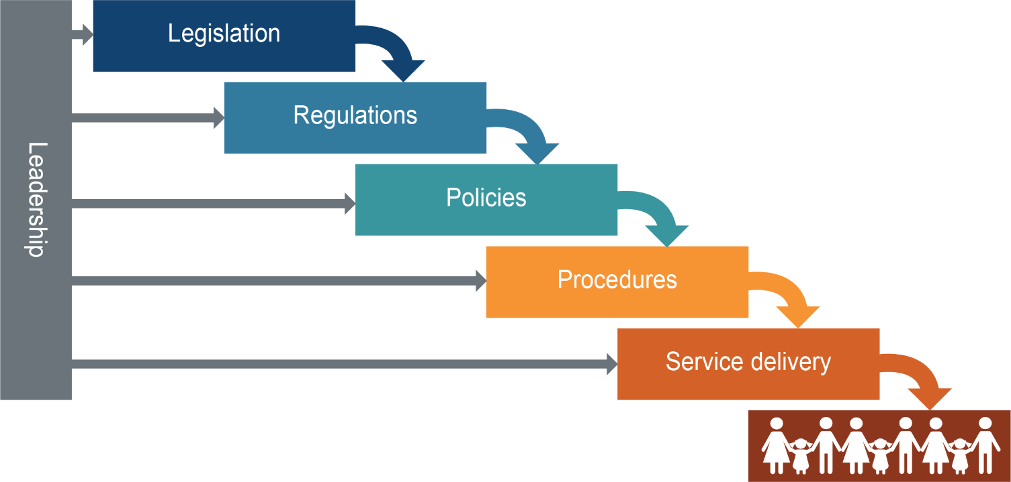

The model recognises that unless legislation and regulations are human rights compatible, there will be limited benefit in changing policies and procedures. Similarly, service delivery is unlikely to improve if policies and procedures are not human rights compliant. For a human rights culture to develop, strong leadership needs to be present at every stage: at the strategic, operational levels and among individual public sector workers on the front line.

Human rights leadership
For this financial year the Commission has focussed on the theme of leadership. How can leaders in the public service prioritise human rights to ensure that culture change steadily continues to grow in an organisation? During a global pandemic, the importance of human rights leadership is elevated as leaders are increasingly required to balance rights in extremely challenging and complex social and economic contexts. While managing crises has always been a feature of leadership in Queensland, a state impacted heavily by natural disasters, the sustained nature of the COVID-19 pandemic and need for ongoing responses to rapidly changing circumstances has increased the need for leadership where human rights are front and centre in strategic decision-making.

Indicators of a human rights culture
In the first year of the Act, the Commission developed a set of 7 indicators that identify actions that may further the development of a human rights culture, reflecting the Cascading culture change model:
Indicator 1: Education and staff development
Indicator 2: Community consultation and engagement about human rights
Indicator 3: Awareness raising and support for related entities (including functional public entities engaged by the public entities i.e. contractors)
Indicator 4: Reviews and development of legislation or subordinate legislation / local laws or subordinate local laws
Indicator 5: Review of policies and procedures
Indicator 6: Implementation of internal complaint management for human rights complaints
Indicator 7: Future plans to further the goals of the Act
While the same indicators were maintained this year to ensure efficient measurement can happen over time, the questions used to prompt responses from public entities changed – this was intended to reflect that most public entities had already to a large extent implemented and operationalised the Act. Therefore, the questions this year were focused on what might come next after the initial implementation of the Act.
See Appendix B from page 172 of this report for the full Indicators of a Developing Human Rights Culture including the specific questions asked of public entities.
We used the Indicators to survey 8 state government public entities, selected because of the relevance of their work to the human rights of people in Queensland. These agencies provided responses to questions about the Indicators:
- Department of Children, Youth Justice and Multicultural Affairs
- Department of Communities, Housing and Digital Economy
- Department of Education
- Department of Seniors, Disability Services and Aboriginal and Torres Strait Islander Partnerships
- Queensland Civil and Administrative Tribunal
- Queensland Corrective Services
- Queensland Health
- Queensland Police Service.
To broaden the survey, we sought responses from a small cross-section of metropolitan, regional, and remote local governments. Responses to questions about the Indicators were provided by the following 6 councils:
- Brisbane City Council
- Ipswich City Council
- Mackay Regional council
- Gold Coast City Council
- Logan City Council
- Sunshine Coast Council.
The full responses from the public entities are not provided below, but rather this section contains a general summary and highlights from the information provided to the Commission, furnished with examples.

State public entities

Indicator 1: Education and staff development
The Commission asked the public entities about staff education, general awareness raising, whether tailored examples were incorporated, the number of staff who had received training and by which delivery method, feedback sought about training and whether training was delivered for new staff.
During the first year, the Commission noted a high uptake of training across the state public entities surveyed and this trend has continued in most organisations with the majority of surveyed public entities reporting that three quarters of their workforce (or more) have received at least one training module on the Act.

Education and staff development summary
Table 6: Training provided by surveyed state government public entities to their employees 2020-21
State government entity | Training received during reporting period
Queensland Police Service (QPS) | 498 new enrolments  Total of 15,311 members have now completed the training (approx. 93.9 per cent of sworn and unsworn members)
Queensland Civil and Administrative Tribunal (QCAT) | 24 staff received training through learning management system
Department of Children, Youth Justice and Multicultural Affairs (CYJMA) | 858 staff completed mandatory e-learning module on the Act (75% staff overall have completed)  2633 completed training on a new mandatory online complaints management course which incorporates human rights (65% staff overall have completed)
Department of Seniors, Disability Services and Aboriginal and Torres Strait Islander Partnerships (SDSATSIP) | 83.65% of current employees have completed the Human Rights Act 2019 mandatory awareness training, with a further 958 staff completing the Human Rights role-specific training, and 14 staff completing other role-specific Human Rights training.
Department of Education | Delivered targeted sessions to over 1100 school-based leaders, regional support officers and central office staff  Partnered with the Queensland Human Rights Commission (QHRC) to deliver tailored train-the-trainer sessions to over 200 regional and central office staff, between February and September 2021  94,000 staff had completed training as of 30 June 2021, in addition to targeted training in certain areas e.g. customer complaints
Queensland Health (QH) | Training intensity depends on level of impact of work activities on human rights – e.g. mental health units  Approx. 1.5% of staff have completed official online training  Difficult to identify overall completion rate as many staff have completed Commission training, Crown law training and/or work unit specific training.
Queensland Corrective Services (QCS) | 7094 staff have completed online training across custodial, community corrections and corporate areas.  700 are enrolled in mandatory training.
Department of Communities, Housing and Digital Economy (CHDE) | Delivered to staff through online learning platforms, with tailored training for particular business areas in 2020-21 including Housing and Homelessness Services, Community Services, local community service centre staff, community centre auditors, Smart Service Queensland leadership.

Tailored training
In the first year, several state public entities noted that specific training, tailored to the organisation or work group and containing real-world examples from the participants’ everyday work, was needed to understand and embed knowledge and understanding of human rights. Many had committed to this in the next financial year, and it is pleasing to see that this did happen in many Departments.
The QPS’s human rights Community of Practice has built on the importance of workshopping rights in real-world scenarios, and meets regularly to discuss human rights and share practical learnings across the service. QPS training provides clear examples of situations general duties officers would regularly find themselves in and requires members to assess how human rights intersect with police powers and responsibilities in those situations.
QCS continues to use the RAPID test (Relevant rights; Authorisation; Proportionality and purpose; Individual and impartial, and Document), formulated during the implementation of the Act in the first year. The test has now been promoted through a short video. Information includes case studies for how the RAPID test can be applied to provide further guidance to staff. Feedback received from staff indicates that the RAPID test is working well and staff are using it to apply in their work.
At CYJMA, advice is provided to new child safety officers (CSOs) in their mandatory training pertaining to the Act, what the Act means in child protection practice, and how to act compatibly with the Act in their roles. CSOs undertake relevant scenarios in their training to assist to embed their knowledge. This is supplemented by the ongoing use of the Child Safety Practice Manual which provides advice about obligations under the Act.
Similarly, the training developed for the Disability Accommodation, Respite and Forensic Services division within the Department of Seniors, Disability Services and Aboriginal and Torres Strait Islander Partnerships (SDSATSIP), included specific service delivery examples, to illustrate how to manage and address risk with regards to human rights in practice.
The DCHDE described ten workshop sessions delivered to business areas in Housing and Homelessness Services and Smart Service Queensland:
Participants were sent resources and an activity pack, ahead of interactive scenario-based sessions on how to properly consider human rights. Very positive feedback gathered on these sessions highlighted the value of tailored, scenario-based training.

Awareness raising activities
QH provided a number of examples of awareness raising activities across different HHSs and the Department, including:
- QH commits to developing a culturally capable workforce and actively applies section 28 of the HR Act. The Aboriginal and Torres Strait Islander Health Division includes commitments and strategies for how staff will increase their understanding of section 28 and cultural capability in staff Career Success Plans.
- The Office of Prisoner Health and Wellbeing (OPHW) has engaged Health Consumers Queensland, Queensland’s peak health consumer body, to provide education sessions for Prison Health Service’s staff and custodial staff in correctional facilities regarding the health rights of prisoners.
- The Health Directions Exemption Service worked in partnership with Legal Services and Crown Law to develop a human rights assessment template and guide to assess and record human rights considerations specifically for exemption requests. A training program was developed for Health Directions Exemption Service staff and has been delivered since early 2021.
- HHS senior leadership groups such as Medical Leaders and Forensic Child and Youth Mental Health Officers received specific human rights training provided face-to-face by the HHS’s Legal Services based on human rights implications specifically for their work activities. One HHS also provided education about specific human rights impacts in certain paediatric services.

QCS’ Champions Network is made up of 110 members with knowledge of human rights and the interface with the correctional environment. The network has been an effective tool in providing two-way communication with the field, including information to inform QCS specific frequently asked questions.
Human Rights Day continued to be a focus for awareness raising for organisations including QH, CHDE, QPS and QCS. For example, QCS noted that:
On 10 December 2020, the Deputy Commissioner, Organisational Capability issued a broadcast to QCS staff promoting Human Rights Day. The broadcast acknowledged the significant achievements across QCS to support the commencement of the HRA and acknowledged QCS’ ongoing commitment to human rights.
CHDE released a short video on International Human Rights Day 2020 which demonstrated to staff how human rights applies to their everyday work, particularly those in housing:
The video was introduced by Mr Mick Gooda, First Nations Advisor, and featured two staff members talking about what human rights mean in their work.
- The first staff member, from Human Resources’ Workforce Diversity team, spoke to the interface between human rights, diversity and cultural awareness with a specific focus on staff empowerment and cultural capability.
- The second staff member, from the Specialist Response Team in Housing and Homelessness Services explained “it’s not simply about the person’s housing needs—from a human rights perspective it’s about how does the housing actually help the person meet other interdependent goals, such as their economic outcomes, their social outcomes, their cultural outcomes, their access to healthcare, and their health and wellbeing”. She gave an example of how the department applied this perspective to promote a client’s right to access healthcare: “We were looking for housing for a person in a particular location in Brisbane and, you know, the stock was really tough, but in negotiating with the customer, their family, and the hospital, we were able to identify that that health need that they had could be delivered from another hospital in a different location and they were happy to consider that location. Guess what? We found them a property.”

The Social Policy and Legislation Branch in QH also celebrated Human Rights Month with a staff education session on the conventions for briefing the former Attorney-General and incoming Minister for Health and Ambulance services on human rights. The session focused on the obligations on public entities and incorporating compatibility into briefing materials. It included examples of how to identify limitations, compatibilities and impact statements, including all steps in a section 13(2) analysis.
To celebrate a culture of human rights, a Hospital and Health Service (HHS) has produced a video on the meaning of human rights in the HHS and the importance of protecting human rights when delivering health services to the public. The video was broadcasted by former Chief Operating Officer now Acting Chief Executive, Adjunct Professor Jackie Hanson, to all staff on 10 December 2020 to reflect the significance of International Human Rights Day in our organisation.

Future focus
Almost all of the state public entities noted that training is mandatory and has been incorporated into induction for new staff, which will be essential to ensure that knowledge is not lost over time as a result of staff turnover.
At the QPS, training was compulsory for all members up to the level of Chief Superintendent and Executive Director in the last reporting period, and now forms part of induction training for all new members.
As well as formal training, resources are generally available to staff on an ongoing basis through intranets.
For example, a human rights microsite on the QCS intranet provides relevant resources and information to assist staff understand their obligations under the Human Right Act. It includes Queensland Government factsheets, guidelines, posters, presentations and videos. The microsite also includes a summary of updates to QCS policies and procedures and Commissioner and Deputy Commissioner broadcast announcements.

Impact of COVID-19
While in the first year of the Act, COVID-19 was seen as a barrier to achieving the training goals set by organisations, a move to online training including webinars and video-conferencing has meant that no state public entities were reporting similar issues in the second year.

Indicator 2: Community consultation and engagement
The Commission asked state public entities about the extent to which they have provided information to the community about human rights and consulted relevant sectors of the community when developing legislation and policies.

Community engagement
Department of Education delivered internal and external communication campaigns, and has invested in targeted learning resources including animation:
Over 20 targeted resources have been developed to raise awareness and knowledge amongst staff to assist them in meeting obligations under the Act. Within this suite of resources, two public-facing animations have been published to further build awareness and understanding of human rights within both schools and the broader Queensland community. The animations contextualise human rights considerations by using an example of student dress code.
The Queensland Health Mental Health Act 2016 website now includes a statement acknowledging the Human Rights Act and directs members of the public to the Commission’s website and resources for further information. The statement acknowledges the obligations of all Queensland Health staff, including in HHSs, to comply with the Human Rights Act and consider human rights in making decisions or performing a function under the Mental Health Act.
Over 2020/21, DCYJMA developed and implemented a communication strategy for human rights. It includes social media promotion (across Twitter and LinkedIn accounts), which are predominantly sector focussed. Outcomes include:
- DG message to foster carers providing a link to information
- DG message to parents providing a link to information
- DG message to the sector with a link to information
- A brochure has been developed outlining the process to make a complaint about human rights targeted at general clients and young people in residential care
- Developed a new poster for display in child safety service centres on making a complaint about human rights
- The poster for young people has been posted to the DCYJMA website
- We reviewed the departmental brochure on making a complaint to include the process for making a human rights complaint
- This brochure has been posted to the DCYJMA website
- We added new content to the departmental complaints’ webpage on human rights with a direct link to the QHRC
- We published a message on Kicbox, an app for children and young people in out of home care to access information
- We have posted human rights content on the DCYJMA Twitter account
- Features are posted on the intranet, the DCYJMA home page, the Queensland Government community support franchise page and SFCF homepages
- We have published features on the departmental external website
The SDSATSIP reported on a number of human rights related community engagement activities such as:
….through its regular ‘eblast’ Newsletter by promoting consultation opportunities for all jurisdictions, especially where input from people with lived experience of disability is encouraged. The eblasts also enable key information and updates from the Disability Royal Commission into Violence, Abuse, Neglect and Exploitation of People with Disability to be shared amongst a broad subscriber base of people with lived experience, their families, carers, and those working within the disability sector. A human rights approach informed heavily by the United Nations Convention on the Rights of Persons with Disabilities has been a key theoretical approach taken by the Disability Royal Commission in informing their Inquiry.
And:
The annual Elder Abuse Awareness Campaign was again delivered in 2020–21 to safeguard the right of older people to live free from abuse. The theme of the campaign was “Together we can stop elder abuse”, and encouraged older people, their friends and family who have concerns about an individual at risk of, or experiencing elder abuse, to act by contacting relevant services and supports.
The Department of Education has been looking for opportunities to embed human rights in the classroom to improve human rights literacy for children:
The Department of Education supports a whole school approach to talking about and teaching human rights. Mapping of the Curriculum into the Classroom (C2C) units, using the learning area of Humanities and Social Sciences (HASS), was conducted to highlight potential opportunities for embedding human rights education across the P-10 curriculum. This has informed the design of an overarching introduction to human rights for teachers and learning resources for Prep, Year 4 and Year 8. These resources will be available to teachers in 2021-22.
Also, information for parents and families was updated in the reporting period:
The Department [of Education] promoted the revised Legal requirements to make reasonable adjustments for students with disability factsheet across all Queensland state schools and updated the external students with disability website providing information for parents and families about Disability Standards for Education requirements.
QCAT has undertaken a Guardianship Reform Project to better inform parties and the public about guardianship and administration application and hearing processes. This project commenced in March 2021 and included website redesign, reviews of relevant forms and the production of three videos (two animated and one live-action) to help individuals understand what to expect before, during and after a guardianship hearing.

Community consultation
QPS engaged with the Queensland Government’s LGBTI Roundtable and community groups to make policy changes regarding transgender, gender diverse and intersex people in the watch house. Further details of the policy changes achieved are noted under Indicator 5.
QH referred to 2 community engagement and consultation groups that aim to protect human rights of marginalised groups during COVID-19:
- COVID-19 Pandemic Response Culturally and Linguistically Diverse Engagement Team; and
- COVID-19 Working Group – Disability support in the Queensland community
Aboriginal and Torres Strait islander Health Division at QH is working in partnership with the Queensland Aboriginal and Islander Health Council (QAIHC) the Aboriginal and Torres Strait Islander community-controlled health peak body, First Nations health consumers and community members to progress the First Nations health equity reform agenda. The co-design process so far has included the release of a Health Equity Discussion Paper and 17 state-wide consultation sessions across the HHSs, with 450 participants including non-government organisations and community.
At DCHDE, the Housing and Homelessness Services area hosted a co-designed workshop with the Queenslanders with Disability Network, which:
…brought together people with lived experience of disability and HHS staff, including departmental Occupational Therapists, and staff from Housing Partnerships, and Property Operations and Support. The workshop built awareness and knowledge about best practice in the delivery of services for people with disability.
- Mr Scott McDougall, Queensland Human Rights Commissioner, opened the workshop reminding participants about the intent and requirements of the Human Rights Act 2019 and the need for accountability and transparency in decision making.
- Real case scenarios were used to explore practice and impact of housing response based on human rights, inclusion and person-centred approaches.
- Key insights from the workshop will be shared more broadly across Housing and Homelessness Services as part of the ongoing awareness of service responses for people living with disability.
An example provided by QH of where community consultation resulted in a positive human rights changes occurred during the review of a Hospital and Health Service’s eligibility criteria for their midwifery services. Feedback from the community consultation and engagement identified the need to develop and improve these services in areas that will promote and protect various human rights, particularly the right to the protection of families and children.

Indicator 3: Awareness-raising and support for related entities
The Commission asked state government entities what awareness raising they had done to ensure that contractors or providers engaged by them act compatibly with human rights, and whether human rights has been embedded into formal contracts.

Information for related entities
Over 2020/21, CYJMA worked to update its training for foster carers through their Triple R program (roles, rights and responsibilities) to incorporate human rights. Carer training is a joint responsibility of the department and funded Foster and Kinship Care agencies. DCYJMA have updated content for pre-service training which includes updating content on the Human Rights Act and its application to carers. The Statement of Commitment between CYJMA and the foster and kinship carers of Queensland has also recently been updated.
The Department of Education reported working closely with the Parents and Citizens Association (P&C) Queensland, including through the development of a Human Rights Act 2019 fact sheet and consultation on the department’s human rights awareness resources, which includes material to assist department staff in communicating with P&Cs on human rights obligations, and a link to the external P&C Queensland Human Rights fact sheet.
In 2020-21 financial year, QCS also provided information on the Act to education service providers engaged by the agency.
CHDE noted their collaboration with Queensland Council of Social Service (QCOSS), aiming to improve human rights literacy across the housing and homelessness sector, which is made up of a number of non-government organisations working with the Department. This project is featured under the heading Functional public entities – A human rights approach to housing and homelessness services on page 117.

Human Services Quality Framework
As explained in last year’s report, the Queensland Government’s Human Services Quality Framework (HSQF) was updated to include specific Act requirements, taking effect from 1 January 2020.

The SDSATSIP reported the following progress in relation to the framework:

During 2020–2021, 135 HSQF independent audits that included HR Act requirements were completed for non-Government human services. In eight of these audits, issues were identified with organisations’ conformance with HR Act requirements. However, the continuous improvement framework within HSQF has ensured that all these issues have either been addressed or are scheduled to be addressed by the organisations, in line with HSQF Scheme timeframes.
HSQF audits have also allowed for independent HSQF auditors to make observations to improve organisations’ human rights-related practices and to identify achievements and good practice.
To ensure that independent HSQF certification bodies and auditors understand the HR Act, comprehensive information has been provided to them about relevant training and resources available, including through the Queensland Human Rights Commission.
The Queensland Council of Social Service (QCOSS) partners with HSQF to provide support to assist non-Government organisations to implement and meet HSQF requirements. QCOSS updated its downloadable HSQF-aligned policy/procedure templates for non-Government organisations to include a Human Rights Policy and Procedure. QCOSS has also conducted a range of webinars and information sessions on the HR Act for the non-Government human services sector.

Formal agreement requirements
As part of their 2020–21 service agreements with the SDSATSIP, organisations that receive disability advocacy funding must comply with guidelines which cite the need to support people with a disability on an individual basis to uphold their rights and interests, and to increase the control they have over their lives through representation and building the person’s capacity for self-advocacy.
The QPS has also embedded human rights obligations into its formal contracts with related entities. As a matter of course the QPS includes clauses in its contracts requiring related entities to comply with their obligations under Australian law, including specifically under the Act where it applies to that related entity.

Indicator 4: Review and development of legislation
The Commission asked state public entities what processes they have put in place to review human rights compatibility in legislation or subordinate legislation they administer. Public entities were also asked to give an example, if possible, of legislation introduced that works to respect, protect, or promote rights, along with any examples of good practice in ensuring proper consideration of human rights in legislation development.

Laws that promote human rights
SDSATSIP noted the passage of two significant pieces of legislation:
- Disability Services and Other Legislation (Worker Screening) Amendment Regulation 2021 – while rights were limited this was ultimately found to be sufficiently justified.
- Meriba Omasker Kaziw Kazipa (Torres Strait Islander Traditional Child Rearing Practice) Act 2020 – significant as it promotes cultural rights protected under the Act.
Both are described in further detail in the Human rights and the Parliament – significant legislation in 2020-21 section of this report (page 38).
The QCS highlighted the passage of Community Based Sentences Act 2020 and the associated regulation. These promote freedom of movement and the protection of families and children by providing the ability for an offender to request to have their sentence transferred by registration and enforced in Queensland or interstate under the CBS Act, despite serving a community-based sentence that would otherwise limit movement to Queensland or the State in which it was imposed. This can support an offender’s connection with family and children, effective rehabilitation, reintegration, and supervision. In turn, this can support an offender’s rehabilitation and right to education, health services and family, depending on the reasons for the transfer.
CHDE noted the introduction in the reporting period of the Housing Legislation Amendment Bill 2021, and in particular how it:
…amends residential tenancy law creating a statutory framework for ending a tenancy or rooming accommodation agreement in cases of domestic violence. The amendment helps to achieve the purpose of supporting and protecting individuals from domestic and family violence by enabling them to take steps to protect themselves and escape the violence, thereby protecting and promoting the right to protection of families and children.
QH noted that in August 2020, the Health Legislation Amendment Act 2020 amended the Hospital and Health Boards Act 2011 to:
- include a requirement that each Hospital and Health Board have at least one member who is an Aboriginal person or Torres Strait Islander person; and
- require each HHS to develop and implement an Aboriginal and Torres Strait Islander Health Equity Strategy.
The Health Equity Strategies Regulation provides a framework to guide each HHS to achieve a greater impact on health equity and support greater engagement and collaboration in the design, delivery and monitoring of healthcare services.
QH notes that these changes:
…support the cultural rights of Aboriginal peoples and Torres Strait Islander peoples and promotes better health and wellbeing outcomes through genuine co-design, co-ownership and co-implementation. The right to health services is also supported by requiring HHSs to state various key performance measures and other actions to actively eliminate racial discrimination and institutional racism.

Indicator 5: Review of policies and procedures
The Commission asked state public entities about reviews of policies and procedures, and development of guides or tools to support decision-making, as well as any changes to service delivery.

Progress of policy and procedure review
State public entities mostly reported that general reviews for compatibility had concluded, and some reported ongoing human rights assessments as and when policies are introduced or amended.
At the Department of Education a Human Rights Impact Assessment must now be completed for all new and reviewed departmental policies. The human rights impacts of over 20 policies, frameworks and projects have been considered over the reporting period to ensure compatibility with the Act. In particular cases, policies and procedures were updated to explicitly reference the Act (e.g. the School Performance Policy and Procedure, released in February 2021, which guides school leaders to continuously improve and evaluate school actions that contribute to all students’ learning and wellbeing).
The Department of Education’s individual employee grievances policy and procedure was also reviewed and amended to embed the consideration of human rights in managing grievances, and advice of avenues for external review including through the Queensland Human Rights Commission.
QCAT also continues to review and adapt its procedures on an ongoing basis and as required to ensure that it is best placed to assist people to resolve disputes through the access to tribunal services during the COVID-19 public health emergency. For example, during greater Brisbane’s ‘snap’ lockdowns, arrangements are made for hearings to proceed by phone at QCAT and across southeast Queensland or by video conference. This ensures the rights of individuals to a fair hearing are protected during the period of the snap lockdown.
Queensland Health is continuing to progress with its review of all policies and procedures for compatibility with human rights. As previously reported, the review is finding that most if not all, are compatible with human rights. Overall, the reviews have resulted in some minor changes to the wording to:
- include statements about human rights obligations for awareness purposes
- specifically identify human rights relevant to the particular policy or procedures
- make minor wording changes to ensure clarity and provide examples about the limited situations or circumstances that may justify limiting a person’s rights, and
- to ensure that the appropriate recordkeeping practices are built into decision-making processes.
Queensland Ambulance Service have developed a specific Human Rights Policy and have identified areas where the protection of human rights can be strengthened. For example, a new operational procedure to support the policy is under development relating to the transport of assistance animals with patients.

Practice changes
Disability Accommodation, Respite and Forensic Services (DARFS) reviewed its practices in line with the implementation of the Act to ensure compatibility with human rights. A statement was developed to assist DARFS staff to consider, understand and recognise a person’s human rights in every decision they make relating to clients when providing direct care and support to clients. There has not been a substantiated claim of breaching human rights against DARFS since the implementation of the Act Statement and awareness training.
An interesting example of how a human rights assessment process can work happened during a review of dental services at one HHS. A human rights issue was identified in that there could be a limitation on the access to culturally appropriate healthcare for the provision of dental (gum) products. Before the human rights assessment the process had been to offer a range of ‘most common’ gum colour options. After the assessment, a more inclusive and diverse range of colour matches for dental (gum) products has been made available.

Tools and resources
The CHDE noted the following resources developed to improve staff capability to act compatibly with rights:
- A human rights advice service was added to the support provided by the Service Delivery Help Desk to frontline Housing staff. The service assists staff with general human rights queries as well as the proper consideration process.
- A large internal business system for social housing tenancy management, was updated with expanded content on human rights. The new material assists Housing staff with information, scenario-based examples and guidance on properly considering human rights.
- A ‘Human Rights Compatibility Consideration Guide’ was developed to assist staff in the proper consideration of human rights in decision-making and to support good-practice recordkeeping. The guide incorporates a flowchart that links to a suite of five compatibility findings.
- A ‘Human Rights Compatibility Report’ template was developed to assist staff document proper considerations made in relation to Ministerial and Director-General briefing notes.

Impacts on service delivery
The survey responses indicate that the Act has led to meaningful dialogue and some policy changes, a few of which are highlighted below.

Human rights of trans and gender diverse people promoted in changes to Operational Procedural Manual
During the reporting period, the Queensland Police Service:
- amended its Operational Procedures Manual (OPM) to modernise operational policies about searching trans, intersex and gender diverse people and policies about prisoner segregation
- approved an internal gender affirmation HR policy to support our people to bring their authentic and best self to work, and to solidify our commitment to creating a safe and inclusive workplace.
These policy changes were made following consultation with stakeholders including the Queensland Human Rights Commission, the Queensland Government LGBTI Roundtable and community groups. These direct consultations with experts ensured the policies were robust and inclusive, while respecting and promoting human rights.

Human rights dialogue around fresh air in hotel quarantine
The Commission, QPS and Queensland Health had a number of meetings during the reporting period, working towards a hotel quarantine environment which is the least restrictive on human rights possible, while still responding proportionately to the health crisis during COVID-19. These conversations reflect one of the goals of the Act: to create dialogue around the meaning and purpose of human rights.
For a period, this dialogue resulted in QPS and QH maintaining a focus on human rights by ensuring people had access to fresh air, including through sourcing appropriate accommodation, fresh air walks, and other supports the person might need. Unfortunately, because of the introduction of more contagious variants of COVID-19, and a lack of available hotels with balconies or opening windows, access to fresh air was not sustained in the longer term. On the other hand, purpose-built quarantine facilities are currently under construction which will hopefully improve conditions in future.

Virtual visits, court appearances and prisoner health
Last year, the Commission highlighted the introduction by QCS of the virtual prisoner visits with family, which promoted the rights to freedom of expression and protection of families and children. All 11 high security correctional centres, Helena Jones, and Capricornia Low Security Centre have this capability, which can be utilised when lockdowns are required to prevent COVID-19 entering the prison environments.
Court video-conferencing has also been expanded which may promote fair hearing and rights in criminal proceedings by reducing delays when a prisoner cannot attend court in person.
During the reporting period, a state-wide Memorandum of Understanding between QH and QCS for the delivery of health services to prisoners was updated to align with human rights – this replaces 8 separate MOUs to improve consistency of service, and is accompanied by a new strategy Reducing the barriers to health and wellbeing: The Queensland Prisoner Health and Wellbeing Strategy 2020-2025.

Locked wards and seclusion under the Mental Health Act
QH noted a number of examples of strengthened protection and promotion of human rights as a direct result of the review of policies and procedures, and in particular in the mental health area. These developments include:
- A review of the MH Act Statement of Rights in 2021 resulted in the inclusion of an acknowledgement of staff obligations under the HR Act, including that a doctor or authorised health practitioner must if requested explain to or refer a patient to the HR Act.
- Requiring clinicians performing functions or exercising powers under the MH Act to ensure unique age-related, cultural and spiritual, gender-related, religious and communication needs are recognised, respected and followed to the greatest extent practicable. The policies also highlight consideration of timely involvement of a person’s local supports.
- Human rights assessment of the Locked Ward Policy and Directive issued 2013, which identified that there may be less restrictive ways to achieve the objectives of the current policy and directive, prompting a review of the policy to be commenced in 2021 which may lead to discretion in locking wards.
- Support for a trial of discretionary locking at a Mental Health Service in South East Queensland for a period of six months, the evaluation of which will form the review project.
- Amendments to the Chief Psychiatrist’s Seclusion Policy provide a greater level of guidance on seclusion management under other legal frameworks and encourages services to seek local advice and refer to local HHS policy. Services are directed to also consider whether patients meet the criteria for treatment and care under the MH Act. Services are now also required to escalate matters in which any seclusion management occurs under legal frameworks other than the MH Act as a significant event and/or as a potential non-compliance event to the Chief Psychiatrist. In addition the policy also clarifies expectations regarding appropriate use of emergency authorisation of seclusion in relation to limiting consecutive authorisations.
QH also committed to future:
…development of a system and checklist for documenting human rights considerations as part of decision making under the MH Act in relation to Chief Psychiatrist public interest decisions (for directing psychiatrist reports and making references to Mental Health Court) to ensure adequate documentation of the decision-making process. This will be supported by internal training on incorporating human rights consideration into this decision-making process.

Indicator 6: Internal complaints
The Commission asked state government entities how they have incorporated human rights into complaint handling processes and whether barriers have been identified to identifying, considering and responding to complaints.
The results were promising, with some agencies indicating service improvements in direct response to issues raised under the Act.
In 2020/21 CYJMA took the following actions regarding internal complaints:
- worked with the Queensland Ombudsman to deliver complaint management training to more than 210 staff in the department both centrally and regionally and also key staff from each CSSC. The training included how to manage and report on human rights complaints.
- strengthened the human rights reporting both for complaints and Professional Standards areas of the department.
- released and implemented a ‘First Attempt at Resolution Practice Guide,’ a resource for front-line service centre staff to support them in managing early resolution of complaints. This includes content on considering human rights in decision making.
The CYJMA noted that the decision-making framework designed in 2020 to assist decision-making is compatible with human rights considerations regarding family contact and other relevant service provision is still being utilised by frontline staff.
SDSATSIP noted that its publicly available Complaints Management Policy embeds the application of human rights in the assessment of all complaints and that:
The inclusion of human rights into the policy has changed the way complaints are assessed as human rights issues are actively sought now, and if identified, referred to the relevant service area for assessment, or advice provided to contact the Human Rights Commission.
In responding to complaints, QCAT has engaged directly with clients about human rights issues for the purpose of responding to issues raised, gaining an understanding of the issue direct from the client and at the same time identifying any need for process improvement, as well as QCAT staff training.
QH had already incorporated human rights into existing complaints processes but is continuing to improve and refine the process across the system as it has been identified as an area that needs further work. QH did however report some success in resolving complaints internally, for example:
Complaints alleging breaches of the right to privacy in relation to patient records are a common theme arising for human rights complaints. Of substantiated complaints, most of these have been resolved internally by providing the complainant with an apology and the requiring the subject employee to undertake further privacy training.

Learning from complaints
QCAT expressed that it has:
processes in place to manage human rights complaints and ensure dialogue in terms of learnings in response to those complaints. An example of this is that QCAT’s Management Team (Registry) ensures that any factors which are raised in a complaint requiring registry consideration and change are discussed as a team. This is to make sure that lessons learned, and registry changes are cascaded to all team members. In practical terms this promotes a dialogue about the nature, meaning and scope of human rights.
The CHDE also indicated a genuine intention to learn from complaints by building ‘human rights profiles’ at departmental and divisional levels: The rights most commonly exercised by complainants in the reporting period were: the right to equality; freedoms of expression and movement; privacy and reputation; and the right to property. The human rights profiles will be used to inform the design of training, resources and engagement campaigns, tailored with a focus on the rights most often engaged throughout the department’s portfolio areas.
QH reported that Hospitals and Health Services (HHSs) are using complaints as training and awareness opportunities and examples about service delivery and access to services to make improvement, for example:
One HHS has implemented a process to analyse trends and themes that are forming from human rights complaints. This information will be used to inform improvements for the provision of health services for patients and their families.
Some HHSs report human rights complaint data every month to their Quality and Safety Committee, Executive Leadership Teams and the HHS Boards to ensure senior leadership is aware of the concerns that are being raised by patients and their families in relation to human rights.

Changes implemented following complaints
Some state public sector entities had noted service improvements as a response to issues arising from complaints.
The Department of Education provided the following case study to illustrate this:
The department remains committed to embedding human rights into complaints processes to prompt further policy change. A specific example of this commitment can be observed through the management of a human rights complaint utilising the department’s customer complaints management framework.
A complaint was received by the region, following a procedural error that resulted in a breach of the student’s privacy and reputation. As an outcome of the complaint, a review of the department’s Managing student absences and enforcing enrolment and attendance at State Schools procedure was undertaken, resulting in additional processes being put in place.
Following a complaint, the CHDE determined its first ‘non-compatible’ finding during the reporting period took steps in response:
A divisional feedback loop was established to ensure proper governance in relation to such findings. The dialogue-based approach used has successfully ensured that relevant staff have the information needed to continue to refine processes and support capability with a human rights lens.
QH provided a number of examples of how early complaints had been the trigger to improve human rights compatible decision-making in relation to mask-wearing:
HHSs are reporting that the application and communication of mandatory mask requirements for visitors has improved with patients attending outpatient appointments as a result of concerns raised earlier about human rights.
For example one HHS identified an opportunity to ensure staff were aware of the requirements and an escalation path to follow where a visitor has identified that they have an exception for the mandatory mask requirements. Staff were provided with information and education about how to consider and balance human rights if informed that someone has an exemption reason for not wearing a mask.

Challenges or barriers to dealing with complaints
No agencies identified COVID-19 restrictions as a particular barrier to dealing with complaints. However, QPS noted that an extra layer of complexity in that:
QPS regularly enforce directions made by the Chief Health Officer under her statutory powers. Because complaints about this type of enforcement also relate to the exercise of the Chief Health Officer’s power to make those directions, they involve both the QPS and Queensland Health. These complaints are referred to Crown Law to act on behalf of the State.
One challenge noted by CHDE was the changes in portfolios after the commencement of the new Queensland Parliament following the 2020 state election, which has meant realigning approaches to human rights implementation.

Indicator 7: Future plans
The Commission asked state public entities what future plans they had to achieve the objects of the Act, which are:
- to protect and promote human rights
- to help build a culture in the Queensland public sector that respects and promotes human rights
- to help promote a dialogue about the nature, meaning and scope of human rights.
Most of the entities had plans prepared for the next year and beyond to continue to embed human rights.
The future plans for CYJMA include:
- Working across the organisational units to continually improve and streamline the process for human rights complaints, including recording and reporting mechanisms to promote transparency and accessibility for complainants
- Commencing monthly auditing of human rights complaint allegations to ensure human rights allegations are being accurately recorded and managed by complaint investigators
- Mandatory training for new Child Safety staff in complaints management which includes human rights considerations
- Continual communiques to staff and NGOs to ensure human rights considerations are always at the fore in relation to our work across the department
- Continual updates to our key peaks and stakeholders of our progress towards embedding human rights and provide opportunities for collaboration to ensure the strengthening of compatibility with human rights
- Continuing to consider human rights compatibility as part of the scheduled review of departmental policies and procedures
- Development of a communications plan for young people in detention
- Development of a feedback mechanism for internal CYJMA staff in relation to existing training and future skill and knowledge development
The SDSATSIP noted future plans including:
- Working towards nationally consistent authorisation processes for the use of restrictive practices as part of specialist disability services – all policies and procedures relating to restrictive practices are currently under review
- Continued active focus on maximising opportunities for Queenslanders with disability to access specialist disability services
- Supporting the human rights approach of the Royal Commission into Violence, Abuse, Neglect and Exploitation of People with Disability
- Review of legislative incompatibilities in the Aboriginal and Torres Strait Islander Partnerships business area.
The Department of Education will continue to embed its approach to strengthening and ensuring sustainability of implementation measures across its business areas. The department has embedded responsibility in each line area for ongoing implementation and support in capability development to meet obligations under the Act. Capability and development will be advanced further by the release and communication of human rights in education curriculum resources.
QCAT expressed a commitment to continuing to promote human rights training to staff, including training modules available through DJAG Human Rights Unit and the Queensland Human Rights Commission. QCAT is also committed to on-the-job human rights training and using practical everyday examples and situations to:
- help staff deal with human rights matters/issues as they arise;
- ensure an ongoing dialogue about human rights considerations; and
- enhance the capability of staff in anticipating, identifying and responding to human rights issues.
To support the objects of the Act, QCS will continue to implement cultural change across the agency (including complaints management, training and communications, RAPID framework and Champions Network), and ensure the ongoing consideration of human rights in policy and legislative development.
CHDE will continue to work with QCOSS on Stage 2 of the project with Housing and Homelessness Services.
QH is committed to continuing to embed a culture of human rights into the organisation. The Queensland Health Human Rights Working Group will continue to meet as long as representatives feel the need and to ensure momentum is maintained across the system.
QH noted an ambitious list of future plans across HHSs and the Department and some highlights include:
- As human rights continue to be embedded across the system Queensland Health plans more efficient approaches to collecting complaints data, considering lessons learnt and identifying key themes. This will inform the development of further Queensland Health scenario-based exercises that will be built into existing resources and training. As the complaints process is being finessed and more complaints are forthcoming, Queensland Health will look to analyse increasingly substantive complaint data.
- The Independent Patient Rights Adviser Network is in final phase of beta testing the MyRights Application (App), which can be downloaded onto mobile phones and tablets. The App provides information about consumer and carer rights under the MH Act via interactive tutorial videos.
- One HHS is establishing a Human Rights Review Panel that will meet regularly and has capacity to provide guidance to staff regarding the application of human rights within the HHS.
- Other HHSs are in the process of onboarding and training human rights champions or ambassadors within their HHSs to provide support and coaching for other staff.
- As a state-wide paediatric health service, Children’s Health Queensland is developing an age appropriate children’s guide to human rights to assist patients and families in promoting and understanding their human rights. Comprehensive consumer engagement with children, young people and families who attend the facilities and engage with the service is planned.

Local government public entities

Indicator 1: Education and staff development
The Commission asked councils about the education and training provided to staff, including the number of people trained, mode of training, and how the training will be incorporated in induction of new staff and ongoing professional development. Here is a summary of the responses.
Table 7: Staff training completed by key local government entities, 2020-21
Local councils | Training received during reporting period
Ipswich City Council | Council’s legal services delivered a series of tailored human rights workshops targeting senior management and human rights champions.  Council’s legal services developed online human rights training in September 2021.  Incoming staff receive human rights online training from the Commission's ‘public entities online training module’ with 724 staff completing the training module.
Logan City Council | Council has developed mandatory online training for councillors, staff and incoming staff.  Council has developed a bespoke induction program with focused Human Rights Act modules.
Sunshine Coast Council | Council has developed ‘Human Rights Act Awareness training’ with a face-to-face learning module and online training modules that require decision making compatible with human rights tailored to Council.  12% of staff have completed the training, this is due to the impact of COVID-19 on the face-to-face training.  All incoming staff receive an online Code of Conduct training which specifically incorporates human rights obligations.
Gold Coast City Council | Customer-facing teams have received online training.  Council’s Legal Services branch has met with various areas across Council to discuss the Act.  Council has provided online training through the Commission’s website.
Mackay Regional Council | No training implemented in relevant period.
Brisbane City Council | Training has taken various forms, dependent on the needs of specific work areas, and has included workshops for staff to identify the ways in which human rights may arise in their roles, formal training on the justification of limitations process under s 13 of the Human Rights Act 2019 and an informal “lunch and learn” session which sought to raise awareness and create discussions around embedding a human rights culture in Council.

Most of the councils were able to provide human rights training for their staff; however, many of them were impacted by the COVID-19 pandemic. Many councils took the initiative to develop their own training for staff in human rights. Councils such as Brisbane City Council are in the process of developing human rights online training modules to reach broader staff. Gold Coast City Council have organised their in-house Counsel to advise teams of human rights obligations.
Ipswich City Council provided tailored human rights training to 20% of ongoing staff, and 724 incoming staff completed the online training module. Where training had occurred, the roll out was still in the early stages. Sunshine Coast Council were able to provide 12% of staff with human rights training.
Brisbane City Council hired a Senior Human Rights Officer to be the point of contact for all human rights-related matters. Ipswich City Council and Sunshine Coast Council encouraged the discussion of human rights by publishing information through internal and external material such as quarterly newsletter.
Sunshine Coast Council explained that:
Both the online and face to face Human Rights Act Awareness training modules encourage discussion and feedback during the session or through a post session survey. The training is regularly updated and improved based on this feedback. We also regularly check the forgov.qld.gov.au/humanrights website for any new training materials and update our records accordingly.

Indicator 2: Community consultation and engagement
The Commission asked councils about the extent to which they have provided information to the community about human rights and consulted with relevant sectors of the community.

Community engagement and information, and community consultation
A number of councils have made concerted efforts to ensure that their constituents know about the Act, understand they have human rights, and are informed about the option of complaining about council services. Some councils have conducted engagements that are framed around human rights, but community engagement has been difficult due to COVID-19 restrictions on holding public meetings.
Many councils have provided information on human rights to the community through their websites. Brisbane City Council has updated its website and made their Senior Human Rights Officer available to meet with community inclusion work areas.
Gold Coast City Council updated their engagement polices and utilise their current methods of community engagement, such as complaints, to refine their human rights policies.
Ipswich City Council continues to dedicate a whole webpage to human rights and is engaging through their Community Reference Group. The Council states that the methods of consultation were diverse and included:
- digital engagement on Shape Your Ipswich – survey and open comment tools
- three ZOOM webinars – two for the whole-of-community and one targeted at young people
- market research (semi-structured tele-interviews)
- face-to-face workshop and yarning circle with the Murri Interagency
- artistic visioning competition and an Instagram competition
- school-based surveys
- iFuture displays [(corporate plan)] and paper-based surveys at all community centres
- study circles, supported by a DIY Community Conversation Guide
- three face-to-face drop-in sessions at the Central, Rosewood and Springfield libraries (with interpreters).

Indicator 3: Awareness-raising and support for related entities
The Commission asked councils about what steps they have taken to raise awareness of the Act with contractors or service providers engaged by them.
Awareness-raising
Progress has been made by councils in advising related entities about their duties under the Act. Most councils have updated, or are in the process of updating, their policies to ensure that third parties understand their obligations. Some councils have also created specific fact sheets or changed contracts to reflect the Act’s requirements.
Sunshine Coast Council has a comprehensive framework for its procurement and contracting activities, underpinned by legislative requirements. At present, their contracts require contractors to comply with any and all legislation relevant to, or in any way applicable to, the contractor performing its obligations under the contract. They support their contractors by incorporating consultation on their legislative obligations during this procurement process.
Ipswich City Council supports its contractors by sending letters to all its suppliers advising:
- the commencement of the Act
- the requirement for ‘functional public entities’ to comply with the Act
- enclosing the fact sheet (Contractors and Grant Recipients of Council – Obligations under the Human Rights Act’) council developed during the last reporting period
- directing them to the Commission website for more information and resources.

Indicator 4: Reviews and development of laws
The Commission asked councils to point to a local law or subordinate local law that has been introduced in the financial year 2020-21 that is significant in terms of human rights and provide any examples of good practice in ensuring the proper consideration of human rights is part of local law development.
Although no new laws or amendments were adopted in the 2020-21 financial year, it is positive that councils are reviewing current processes in the development of local laws and subordinate local laws to ensure that they are consistent with Council’s objectives of creating a culture of human rights within their relevant regions.

Indicator 5: Review of policies and procedures
The Commission asked councils to report on reviews of policies and procedures for compatibility for human rights including examples of changes to policies, procedures or service delivery, if any.

Review of policies and procedures
All surveyed local councils have endeavoured to review and amend laws, policies, templates and administrative directions to ensure they are consistent with the Act.
Logan City Council sought assistance from an external provider to review and assess compatibility with the Act.
Sunshine Coast Council have reviewed their policies and procedures:
…by qualified and skilled professionals within the council who are adept at this task, ensuring policies and procedures align to and incorporate relevant legislative obligations.
It is Sunshine Coast Council’s position that policies and procedures are compatible with relevant right protected in the Human Rights Act 2019, and do not limit a human right. Those procedures that have been identified as potentially limiting a person’s rights, contain actions/directions as a result of risk assessments, however the relevant legislation justifies the action/direction deeming them compatible.
Sunshine Coast Council states a positive change that has resulted from this review:
First Nations Aboriginal and Torres Strait Islander Employment Guideline has been developed in response to Council’s initiative towards more inclusive recruitment and our obligations under Council’s Reconciliation Action Plan.
Ipswich City Council has commenced the review of its policies, procedures and administrative directives but extended the deadline for completion due to the volume of documents. They have also decided to implement a cross-departmental policy review working group to assist in completing the review. The working group will consist of policy officers from each department who will meet on a regular basis to review the outstanding policy documents.
Brisbane City Council has reviewed approximately 370 policies, procedures and guidelines. Each of these have been reviewed for their compatibility with human rights and only a nominal number of documents were identified as requiring minor amendments to ensure human rights compatibility.
Brisbane Council has identified policies which they understand positively engage human rights:
In particular, Council’s suite of ‘Zero Harm’ policies which seek to ensure staff safety positively engage the right to life. Similarly, Council’s Aboriginal Cultural Heritage procedure positively engages the cultural rights of Aboriginal and Torres Strait Islander Persons under s 28 of the Human Rights Act 2019.
Mackay Regional Council has reviewed its policies, and the normal process is where policies have a human rights component, a definition and statement will be included in the policy.

Tools and guidance
In addition, some local councils including Brisbane City Council, Ipswich City Council and Gold Coast City Council have created or amended checklists and cover pages to provide guidance to ensure staff make human rights compatible decisions.
Ipswich City Council has amended its policy, procedure and administrative directive templates to include a mandatory human rights section. Prior to adopting a new policy document, or amending an existing policy document, a human rights impact assessment must be undertaken using the human rights impact assessment checklist.

Indicator 6: Internal complaints
The Commission asked councils about how they have incorporated human rights into complaint handling processes and whether barriers to identifying, considering, and responding to complaints have been found during this process.
Sunshine Coast and Gold Coast City councils are utilising tools such as case file coversheets or checklists to ensure that human rights are considered in every case. However, the responses indicated that very few complaints were identified across the surveyed councils.

Mackay Regional Council has integrated human rights complaints in their policy and procedure but has not observed any change to complaints generally, and did not receive any human rights complaints in the reporting period.
Brisbane City Council explained the process by which complaints are dealt with:
Complaints which contain a human rights component are handled by or in consultation with Council’s Senior Human Rights Officer. All complaints are handled sensitively and expediently, with a comprehensive human rights impact assessment conducted to ensure an appropriate response and identify any areas for improvement within Council. Council has received a low volume of human rights complaints in the 2020/21 period. The performance of the complaints process will continue to be monitored in order to identify and implement improvements where appropriate.

Indicator 7: Future plans
The Commission asked councils about their future plans to achieve the objects of the Act. The responses indicated a strong commitment to finalising planned activities to embed the Act into council business.
All councils intend to provide further training for staff and information for contractors, and continue to review policies and procedures to ensure they are compatible with human rights.
Ipswich City Council would also like to develop fact sheets on specific human rights issues and develop community engagement by publishing information in the quarterly newsletter.
Mackay City Council endeavours to implement human rights into leadership and induction packages, add human rights into community groups and plans for future community engagement and consultation surveys. They will add human rights to commercial and contractual considerations and documents and align human rights with other similar conditions such as workplace health and safety.

Sunshine Coast Council is continuing their commitment to human rights by not only continuing the training but also by keeping:
…human rights obligations at the front of mind for all employees when decision-making is required across the business.
Some of the high priorities for Logan City Council include:
- Provision of targeted face to face training for Council employee’s that are more likely to deal with human rights issues or receive and deal with human rights complaints;
- Consideration of the implementation of human rights questions and concepts into the recruitment processes of Council and into annual staff performance reviews;
- Offer training session to contractors on the Human Rights Act and obligations imposed on functional ‘public entities’.

Progress towards a human rights culture in government and councils
The Queensland Government employs a large and decentralised workforce which requires advice, education, and awareness about human rights obligations on an ongoing basis. In 2020–21, state public entities employed around 235,447 staff. Of these, 34% worked in education and 40% in health. Nine out of 10 employees worked in frontline roles, and most (64%) worked in regional areas.
In a geographically large and diverse state, there are additional challenges in training the whole of the public sector workforce and in reaching regional and remote communities to educate and consult about their rights. In this context, the numbers of public servants who have already received training is impressive.
The Commission is encouraged that both policy reviews and complaints are uncovering issues that are then being addressed at an early stage by some public sector entities. One such example is the review of a mental health policy for locked wards which will eventuate in a trial of discretionary locking of doors depending on individual circumstances. The fact that several public sector entities commented about an intention to learn from human rights complaints, rather than adopting a defensive position, is also encouraging as it will hopefully result in continuous improvement.
In Queensland there are 77 local government areas, each tasked with individually implementing the Act. Without coordination of this process, it is likely that this rollout will be patchy. Councils overall appear to be at an earlier stage compared with the state government entities in embedding the Act, with fewer staff having been trained, and very few human complaints being made (or identified). The Commission expects that this has been a combination of COVID-19 diverting resources, minimal to no resourcing for dedicated implementation teams, and also the lack of an overall coordinated approach. In contrast, the Queensland public sector entities have had the benefit of the ongoing support of the Department of Justice’s Human Rights Unit.
On the other hand, some of the larger and more well-resourced councils in the South-East Queensland region have made some promising progress, dedicating staff to the task of implementing the Act and communicating to the public about their rights.

Human rights leadership
In a public service environment that is increasingly complex and resource-poor, it might be tempting for public sector leadership to complete formal implementation activities and treat human rights as a box now ticked. This is of course the antithesis of what is expected under the Act.
Reassuringly, some of the government departments and councils surveyed for this report recognised culture building as a long-term leadership goal. While reflecting the importance of aligning the organisation’s core values with the promotion and respect of rights, CYJMA expressed that senior leaders have:
…a long-term commitment to continually building on the capacity of the department relating to the promotion of human rights, both internally and externally, providing opportunities for capacity building through skill and knowledge development for all staff and building a positive culture that is value driven.
Brisbane City Council has also demonstrated a commitment to the long-term, by hiring a dedicated Senior Human Rights Officer to carry on the Council’s work of implementing the Act and developing a human rights culture.
The need to respond to the Commission’s human rights Indicators has in itself encouraged shared vision and responsibility at the executive level for human rights culture. For example:
One HHSs has assigned responsibility for each indicator to an Executive to champion and to be responsible for tracking and responding to questions in relation to indicators 1 – 6. All indicators have been supported by executive leaders through their planning activities and engagement with staff and consumers, using Executive Leadership Committee as a formal mechanism to maintain awareness and obtain endorsement of relevant initiatives.

Education as a first priority
The importance of leading meaningful and ongoing education was expressed by a number of public sector entities, including QPS, QCS and QCAT along with Brisbane, Logan, Ipswich and Sunshine Coast councils.
An example follows of a leadership team prioritising the ongoing training of senior staff:
QCAT’s senior leadership team ensures that training is coordinated for both the Tribunal and the Registry staff. The Tribunal’s training includes a ‘First Friday’ training session, facilitated by one of QCAT’s Senior Members. This training provides a forum for the members and adjudicators to discuss issues, including those relating to human rights.
This is particularly significant as QCAT has made the majority of human rights decisions compared with other courts or tribunals.
Members of the QPS Senior Executive Leadership Team regularly discuss human rights considerations in their business as usual activities, where relevant to a topic. To assist them in this work, they receive briefings and advice from the QPS Legal Division on the operation and implementation of the Act.
Brisbane City Council has identified strong enthusiasm and commitment across leadership when it comes to understanding and implementing obligations under the Act, recognising that in the early phases the focus must be on education.
Logan City Council has similarly expressed that senior leadership has been “diligent” in their support of embedding human rights across the business with an implementation timeline now approved.
Senior management in Ipswich City Council has demonstrated a commitment to embedding human rights by employing an officer dedicated to the role of coordinating the implementation of the Act, and supporting and participating in this ongoing work.

Human rights as a strategic goal
Including the need to respect, protect and promote human rights as a strategic goal in planning documents will hopefully ensure that public sector leaders will keep human rights front in decision-making.
For example, CYJMA expressed an intention to continue to make progress towards embedding human rights in everyday business through including human rights in their strategic plan.
Also, the CHDE’s 2021-25 strategic plan features the Department’s commitment to human rights as follows:
Respecting, protecting and promoting human rights as the cornerstone of a fair and inclusive society.
QPS’ Strategic Plan 2021-2025 also includes a commitment to respect, protect and promote human rights in decision-making and actions.
Similarly the commitment to human rights at the senior leadership level is evident through Department of Education Strategic Plan 2021-24 and Department of Education Human Rights Framework.
Further to this commitment, senior leaders within the Department of Education have conducted consultation with specialist units to enhance the presence of human rights within Cultural Leadership Capability.
Another strategy to keep human rights on the agenda is reflected in DSATSIP’s approach:
The HR Act implementation is also an item for quarterly consideration at the department’s Board of Management meetings, which includes a written update on implementation progress.
Sunshine Coast Regional Council’s Senior Leadership also consider the application of human rights in the preparation of all reports and recommendations for consideration by Council at its Statutory Meetings.
Embedding human rights in strategic direction and then keeping it on the agenda at the highest levels are important strategies to maintain focus in the long-term.

Human rights focussed leadership during COVID-19
QH noted that, despite the challenges presented by COVID-19:
There has also been a system wide change management process to keep human rights at the forefront of everything we do. The culture of properly considering human rights in all actions and decisions is being embedded in policies and procedures system wide.
In fact, many of the examples provided of positive developments have derived from issues arising because of COVID-19. While it is now difficult to imagine a response to COVID-19 without a Human Rights Act 2019, there are certainly signs that leadership during a time of crisis has been positively influenced by the framework provided by the Act.

Human rights in vocational and tertiary institutions
Further education bodies including public universities and vocational education bodies in Queensland are bound by the Human Rights Act 2019 and are required to report about complaints and other activities under section 97 of the Act.
The annual reporting periods for universities are by calendar rather than financial year, but the Commission has drawn on the content from the 2020 reports in compiling this summary.
Some actions had been taken towards building a culture of human rights, but approaches were fairly inconsistent. Most institutions had commenced or completed a policy review, but few reported on any particular changes that had been made as a result. Some had commenced training but none indicated that training was mandatory. Only a handful of complaints were identified as being about human rights; it is unclear whether the further education bodies were requiring a complainant to refer to ‘human rights’ specifically for it to be categorised as such.

Policy review
TAFE Queensland noted that:
In 2020-21, TAFE Queensland has taken a proactive approach to further the objectives of the Human Rights Act 2019. TAFE Queensland is in the process of reviewing and undertaking amendments to policies and procedures, and the business practices underpinning these, to address the organisation’s human rights responsibilities.
Griffith University’s (Griffith) report highlighted an initiative to review and strengthen policies on academic freedom and freedom of speech to ensure that policies reflect diverse viewpoints. Griffith further noted that student and academic policies are under view to ensure alignment with the Act.
Queensland University of Technology (QUT) reported that it has been:

…integrating human rights considerations into policy and procedure including the QUT Staff Code of Conduct, QUT Student Code of Conduct, Management of student misconduct policy, and various policies relating to the hiring and accessing of university spaces.
QUT also noted that the particular issues considered in reviewing the Staff Code of Conduct included academic and intellectual freedom and initiatives on sexual assault and sexual harassment.
James Cook University (JCU) noted it had updated policies, processes and procedures with respect to human rights compatibility.
University of Queensland (UQ) had implemented processes to ensure new policies and procedures and amendments to existing policies and procedures have adequate regard to the principles for the protection of freedom of speech and academic freedom, and are compatible with human rights.
University of Sunshine Coast (USC) had updated existing policies and legislation, and created a decision-making tool to support human rights compatible decision-making. A human rights certification is included in papers presented to the University Executive and approval requests to the Vice-Chancellor and President.
University of Southern Queensland (USQ) reviewed complaint policies and procedures to include guidance for staff, students and the public about human rights complaints processes. 14 human resource policies were revised, executive management were briefed on human rights principles and the implications of the Act and processes were established to embed human rights principles into future policy development.

Complaints
Central Queensland University, QUT, USQ and USC reported that they had not received any human rights complaints in 2020. TAFE also reported that they not received human rights complaints in the 2020-21 period.
JCU reported the details of 3 human rights complaints – 2 of which had been resolved through the Commission’s conciliation process, and 1 that was before QCAT. Two of the 3 were about reasonable adjustments for a disability and another was about exclusion from a program where a student was deemed not suitable to continue.
Griffith University received 5 human rights complaints in 2020, 4 of which were unsubstantiated, and 1 which was currently under investigation at the time of writing.
UQ received 2 complaints during 2020 that raised human rights concerns and those were under consideration at the time of writing.

Training
QUT had commenced training key staff about the requirements of the Act and developed internal guidelines to assist decision-makers in giving proper consideration to human rights.
A human rights awareness training package was made available to all Griffith staff in 2020.
USC had rolled out staff training and awareness activities, and resources regarding human rights on the intranet.

Functional public entities
Functional public entities are those which are only public entities when they are performing certain functions. Including these under the Act reflects the modern operation of the government, where non-government entities are engaged in various ways to deliver services to the public, on behalf of the government or another public entity. A private company managing a prison would fall under this category: they would be a functional public entity when delivering their prison management services, but not for other work they may carry out as a private company not on behalf of the state.
Functional public entities have a vital role to play in building a human rights culture in Queensland, as many have a direct role in the delivery of essential services including disability services, aged care and housing.
An example of a positive, collaborative approach towards building a human rights culture led by and involving non-government organisations is described below.

A human rights approach to housing and homelessness services
Queensland Council of Social Service (QCOSS) and the Department of Communities, Housing and Digital Economy (DCHDE) are working in partnership to develop human rights literacy and strengthen the capacity of the housing and homelessness sectors to act compatibly with the Act.
This year, QCOSS has delivered activities and created resources to support the housing and homelessness sectors’ understanding of the Act, covering key topics including the role of public entities, the nature and scope of protected human rights, complaints handling and giving proper consideration when making decisions.
From March to June 2021, QCOSS has supported 1177 interactions ranging from bespoke face-to-face training workshops to online webinars and access to a broad range of project resources.

Table 8: Engagements in the QCOSS and DCHDE human rights partnership
Engagement type | March to June 2021
Website views | 384
Newsletter reads | 293
Resources accessed – video and written resources | 220
Community of Practice Forum views | 93
One-on-one supports | 4
QCOSS-hosted online events – participants (2 events) | 104
Stakeholder hosted events – participants (5 events) | 79
Total | 1177

The project continues until March 2022, with more events and activities scheduled.
Project engagement has attracted interest from sectors beyond housing and homelessness, with 22 per cent of engagement with the project coming from public health, community health, education, neighbourhood centres, family support services and local government.
Insights from those who are engaging with the project include:
‘I would like participants to understand their human rights, so they have some power to keep us accountable for our actions’ - Tina, Anglicare Central Queensland (ACQ).
‘My takeaway was the importance of designing processes that alleviate pressures from service users’ - Rikki.
‘I would like to see a human right around housing’ - Anonymous survey response.
‘It's been empowering to us to know we can draw from legislation to enhance our advocacy skills’ - Kia, Micah Projects.
The Queensland Human Rights Commission is engaged as a project stakeholder along with Q-Shelter, Queensland Youth Housing Coalition, Tenants Queensland, Queenslanders with Disability Network, Aboriginal and Torres Strait Islander Housing Queensland and the Council to Homeless Persons (Queensland). The important contribution of project partners has supported sector participation and provided expert advice on emerging issues and service trends. Common issues in the sector include property allocations, property transfers, arrears management, breach notices and evictions, neighbour disputes and situations involving domestic and family violence.

Human rights champions
QCOSS is working intensively with five community service providers and 15 department staff (from across the state) as Human Rights Champions. Through training, policy development and the co-design of learning resources, project champions are building their confidence to develop new practices, and share their insights across the sector to encourage other providers to understand the benefits of a human rights approach. Practical, real-life scenarios are being used to train staff and the sector about how to give proper consideration.
Insights and hopes from some of our Human Rights Champion organisations:
‘The HR Act may seem daunting at first however can be easily put into practice with plain English and step by step decision making processes.’ - Robyn, Anglicare CQ.
‘Empowerment of our team to implement the Act and have confidence in decision-making. Also, for our tenants to feel that they are being treated with their human rights and dignity intact.’ - Scott, Jacaranda Housing.
‘There is more to work with since this Act has come into our jurisdiction, more than before, much more to work with’ - Sally, SHAC.
‘The organisation saw a fantastic opportunity to ensure that we understand and are applying the Human Rights Act in our policies and procedures and the work we do, and to help us advocate for our families.’ - Kim, AIDRWA.
‘I met with a government agency yesterday and asked them to consider human rights for one of my clients and named the ones I thought they needed to further consider when making decisions about our clients, it worked they got on board with a different line of thinking straight away - WINNING !!’ - Julie, Anglicare CQ.
In this early phase of the work, discussions focused on the responsibilities of public entities, particularly the incorporation of the human rights complaint mechanism and the work involved in giving proper consideration when making decisions. This foundational knowledge was important for all staff. Particularly among frontline staff who need to apply consideration and respond to complaints. It was important for these activities to be embedded in policies and procedures using human rights language. Work is underway to develop tools and resources to support policy development as well as work to co-design operational tools that incorporate human rights consideration into significant decision-making moments, like evictions and service allocations.
Staff engaged with the project are learning and embracing human rights in their everyday work. In a recent learning series, confidence in staff knowledge of the Human Rights Act went from 39% before the sessions to 73% afterwards. The QCOSS project team is witnessing the importance of leadership and organisational culture in improving human rights literacy amongst community service providers.
The next phase of the project will focus on how services can empower participants and work alongside them to advocate for clients and improve service collaboration. The project will also co-design tools and resources with human rights champions to further develop their human rights culture and operational practices.

Optional public entities
Organisations can choose to be declared a public entity by regulation under the Human Rights Act. The Department of Justice and Attorney-General’s fact sheet Opt-in to the Human Rights Act 2019 provides details on how a public entity can choose to ‘opt-in’.
Queensland Advocacy Incorporated became the first to opt-in organisation to be bound by the Act in October 2020. The QAI Director commented on why this step was taken by their organisation:
“Human rights belong to everyone and are fundamental to an inclusive society,” QAI Director Michelle O’Flynn said today. “QAI has always operated within a human rights framework and endeavours to protect and defend the human rights of the most vulnerable Queenslanders, in particular Queenslanders with disability.
“In becoming the first organisation to voluntarily opt-in to be bound by the HRA, QAI seeks to honour our commitment to the UN Convention on the Rights of Persons with Disabilities and hopes to contribute to a broader human rights culture within our community,” Ms O’Flynn continued.

Human rights enquiries and complaints

Introduction to human rights complaints
The Commission receives complaints about human rights where a person believes that a public entity has not given proper consideration to human rights or acted compatibly with human rights.
The Commission is impartial and will not take sides. Our role is not to decide who is right or wrong but to help people resolve complaints.
The Commission’s role is to:
- work to ensure that everyone puts forward their point of view, is listened to, and feels safe
- assist everyone reach agreement about how to resolve the complaint, and
- ensure the process is fair.
The Commission received a large volume of complaints in 2020-21, partly due to COVID-19, and has a backlog resulting in a current delay between lodgement and assessment of around 6 months.
This section contains several graphs to visually represent the enquiries and complaints data held by the Commission. The same information is provided in data tables in Appendix C.

Internal complaints made to public entities
The Act allows a person to make a human rights complaint to the Commission only after 45 business days have elapsed since the person has made an internal complaint to the relevant public entity. This process encourages direct resolution of complaints at the earliest possible stage.
Public entities must ensure an appropriate complaint handling procedure is in place for early resolution of complaints.
Section 91(j) of the Act requires the commissioner to report on human rights complaints made to particular entities, and allows the commissioner discretion to decide which public entities’ complaints to report on here.
The Commission has selected the same public entities who responded to the Indicators in the previous section. The annual reports of state government public entities and information provided to the Commission under section 98 of the Act have been used to compile the following information about complaint numbers and outcomes.
The Commission notes that there are significant variations in how the human rights complaints are reported on between different state public entities which makes it difficult to interpret complaint outcomes, and to discern the overall effectiveness of the internal human rights complaints process.

Table 9: Internal human rights complaints made to public entities, 2020-21
Public entity | Number of complaints | Outcomes
Department of Education | 15 complaints | These complaints were managed according to the Department’s customer complaint management framework.  Action taken for substantiated complaints may include the department overturning a decision, giving an apology, changing a practice or process, providing a service not previously provided or addressing or referring the issue for system improvement.
Department of Communities, Housing and Digital Economy | 30 complaints | 30 complaints, with 29 originating from clients and 1 internal complaint  25 actions or decisions that led to complaints were found to be compatible with human rights  3 actions or decisions that led to complaints were found to be incompatible with human rights  1 outcome is pending  1 referred to Queensland Human Rights Commission
Queensland Police Service | 893 complaints | 893 complaints where it was identified that one or more human rights may have been unreasonably limited.  521 (of the 893) complaints were finalised as at 30 June 2021.  32 instances where human rights were unreasonably limited resulting in the officers receiving managerial resolution and/or fine taken from the officer’s salary. However, in most cases, there was no further action taken as no human rights limitations were detected, or an explanation was provided to the complainant as the officers’ actions were identified as being lawful and reasonable.  In 2020-21, the QPS refined the process and methodology for identifying and recording complaints that may involve a human rights component. Each time the QPS received a complaint, human rights limitations were assessed to determine if any rights were unreasonably limited. The human rights aspect of each complaint was investigated along with the allegation/s, which assisted in determining the appropriate resolution.
Department of Children, Youth Justice and Multicultural Affairs | 124 allegations | 99 of the 124 allegations have been closed and 25 are still active.  Of the closed allegations:  - 38 did not involve a limitation of rights  - 41 involved limitations that were considered to be justifiable and reasonable  - 9 were substantiated and appropriate action has been taken  The remaining were withdrawn (3), referred (3), unable to determine (3) and out of scope (2).
Queensland Corrective Services | 615  complaints | QCS received 615 complaints, including 77 complaints which raised a human rights issue.  Issues raised for this reporting period predominantly fell within the following categories:  - Offender Management (accommodation, communication, safety concerns), and  - Other (visitors/family).  Of the 77 human rights complaints received during this reporting period:  - Nine remain open and 68 have been closed.  Of the 68 closed complaints:  - 55 were not substantiated,  - 1 was substantiated,  - 3 were partially substantiated, and  - 9 had other outcomes (including referred or made to another agency).
Department of Seniors, Disability Services and Aboriginal and Torres Strait Islander Partnerships | 7 complaints | 6 matters found no substantiated breach  1 matter went to conciliation at Commission
Queensland Civil and Administrative Tribunal |  | Annual Report unavailable at time of publication.
Department of Health | 206 complaints | 169 complaints resolved by the Department  12 complaints remain ongoing/open  4 complaints were withdrawn  2 complaints were referred to the QIRC for conciliation  19 complaints were unresolved (including closed or lapsed complaints by the QHRC).

Early complaint resolution
Last year, the Commission received positive reports from some advocates that complaints were being resolved prior to a complaint being lodged with the Commission.
Queensland Advocacy Incorporated (QAI) provided a case study from this reporting period of one such situation:
Amber* is a 38-year-old women with significant disability, who requires a wheelchair for access at all times, has small stature and shortened limbs. Due to health issues associated with her disability, Amber is required to frequently access a Brisbane-based public hospital for specialist treatment.
Amber’s small stature and shortened limbs makes accessing automated ticket machines in commercial car parking facilities impossible. Amber lives independently with minimal support, and drives herself in a modified vehicle to all healthcare appointments. While an NDIS participant, her funding does not extend to cover travel to medical appointments by taxi.
Amber had been utilising designated disabled parking bays in the basement of the Hospital for a number of years, in order to attend her specialist appointments. This arrangement was facilitated by her specialist. Access to the basement parking is regulated by security guards.
In recent months, Amber was denied access to this parking by a security guard on each occasion she sought entry, notwithstanding that there were multiple available spaces visible at the time of each refusal. There was no reasonable explanation provided for this denial, only a direction that Amber instead use a disabled carpark adjacent to the hospital. As this carpark only featured a single car park and is situated on an uphill incline, it was not accessible for Amber. This inability to park in an accessible carpark was restricting her ability to access the health services that are essential for her to maintain her health, and to live.
Amber sought QAI's assistance when her attempts to resolve this matter directly with the liaison officer through the Hospital’s complaints process was unsuccessful. QAI wrote to the Complaints Coordinator of the Hospital, reminding the Hospital of their obligations under the Human Rights Act 2019 (Qld) and expressing concern that the Hospital had not given proper consideration to Amber’s human rights in making the decision to deny her ongoing access to appropriate parking. We sought reinstatement of her access, along with the introduction of protocols to ensure these access rights were respected by all relevant staff.
QAI's letter prompted an immediate response and, within 10 days, our client received a telephone call from the Hospital Director who offered a sincere apology for Amber’s treatment and an assurance that the matter had been addressed and appropriate training introduced to ensure staff were aware of their obligations. Amber was also provided with details of a direct contact person within the Hospital to contact in the event of any problems. Amber has not experienced any further barriers to accessing this parking.
* Name has been changed
A housing service provider has provided the following case study of how the Act is a difference in everyday decisions in the public housing sector:
A young Aboriginal woman was living in a multi-dwelling complex with her sibling over whom she had formal custody under a child safety order. Repeated disruptive incidents over a two year period had left the neighbours feeling fatigued and impacted by this tenant’s behaviour. Following a recent incident at the property involving police, she was issued a Notice to Leave.
The housing provider needed to carefully balance the rights of the neighbours to live in peace, comfort and privacy with the cultural rights of the tenant and the child living at the property.
After making enquiries the housing officer identified that the woman had significant mental health issues and was experiencing serious domestic violence for which she was not receiving support. The housing officer linked the siblings to culturally appropriate supports and decided not to proceed to enforce the Notice to Leave, instead facilitating a transfer to an Indigenous Housing property.
The outcome has been a fresh start for the siblings in a lower density housing complex, with new neighbours who have not complained about disruption or challenging behaviours. The new residence is more suitable for the long-term, including when the younger sibling turns 18.

Enquiries to the Commission
The Commission does not collect demographic data for every enquiry, but those where this information is collected provide some insight. People can enquire with us by phone, email or in person. Those enquiring about human rights may be potential complainants, lawyers or advocates, support persons, or employees from public sector entities.
The Commission received 1,084 enquiries that were identified as being about human rights, up 65% from the previous year (655 enquiries were taken last year). This represents approximately 26.1% of enquiries received by the Commission for the financial year, where the topic of the enquiry was collected. Enquiries about discrimination still predominated (35.1%) but the gap appears to be narrowing.
157 of the 969 human rights enquiries (16%) were about COVID-19, regarding issues such as hotel quarantine, border closures and exemptions, and mask-wearing requirements.
Human rights enquiries came mostly from within Queensland, predominantly from the southeast region but also other regional areas on the coast, with a number also coming from interstate. This may be partly explained by enquiries relating to COVID-19 from people located interstate who were either residents currently outside the state, or non-residents intending to come to Queensland.

Figure 4: Enquiries to the Commission by enquirer location in Australia, 2020-21
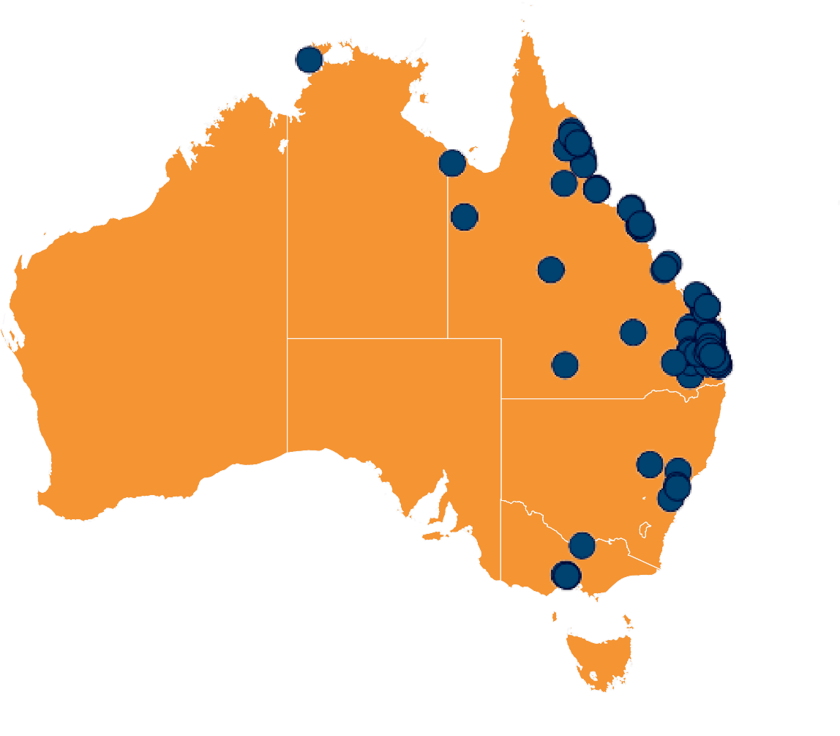
While the vast majority of enquirers were born in Australia, the Commission continued to receive contact from people with diverse backgrounds, but mostly from people born in New Zealand or the United Kingdom. Around 16% of enquirers overall were born outside of Australia.

Figure 5: Country of birth of enquirers born outside of Australia, 2020-21
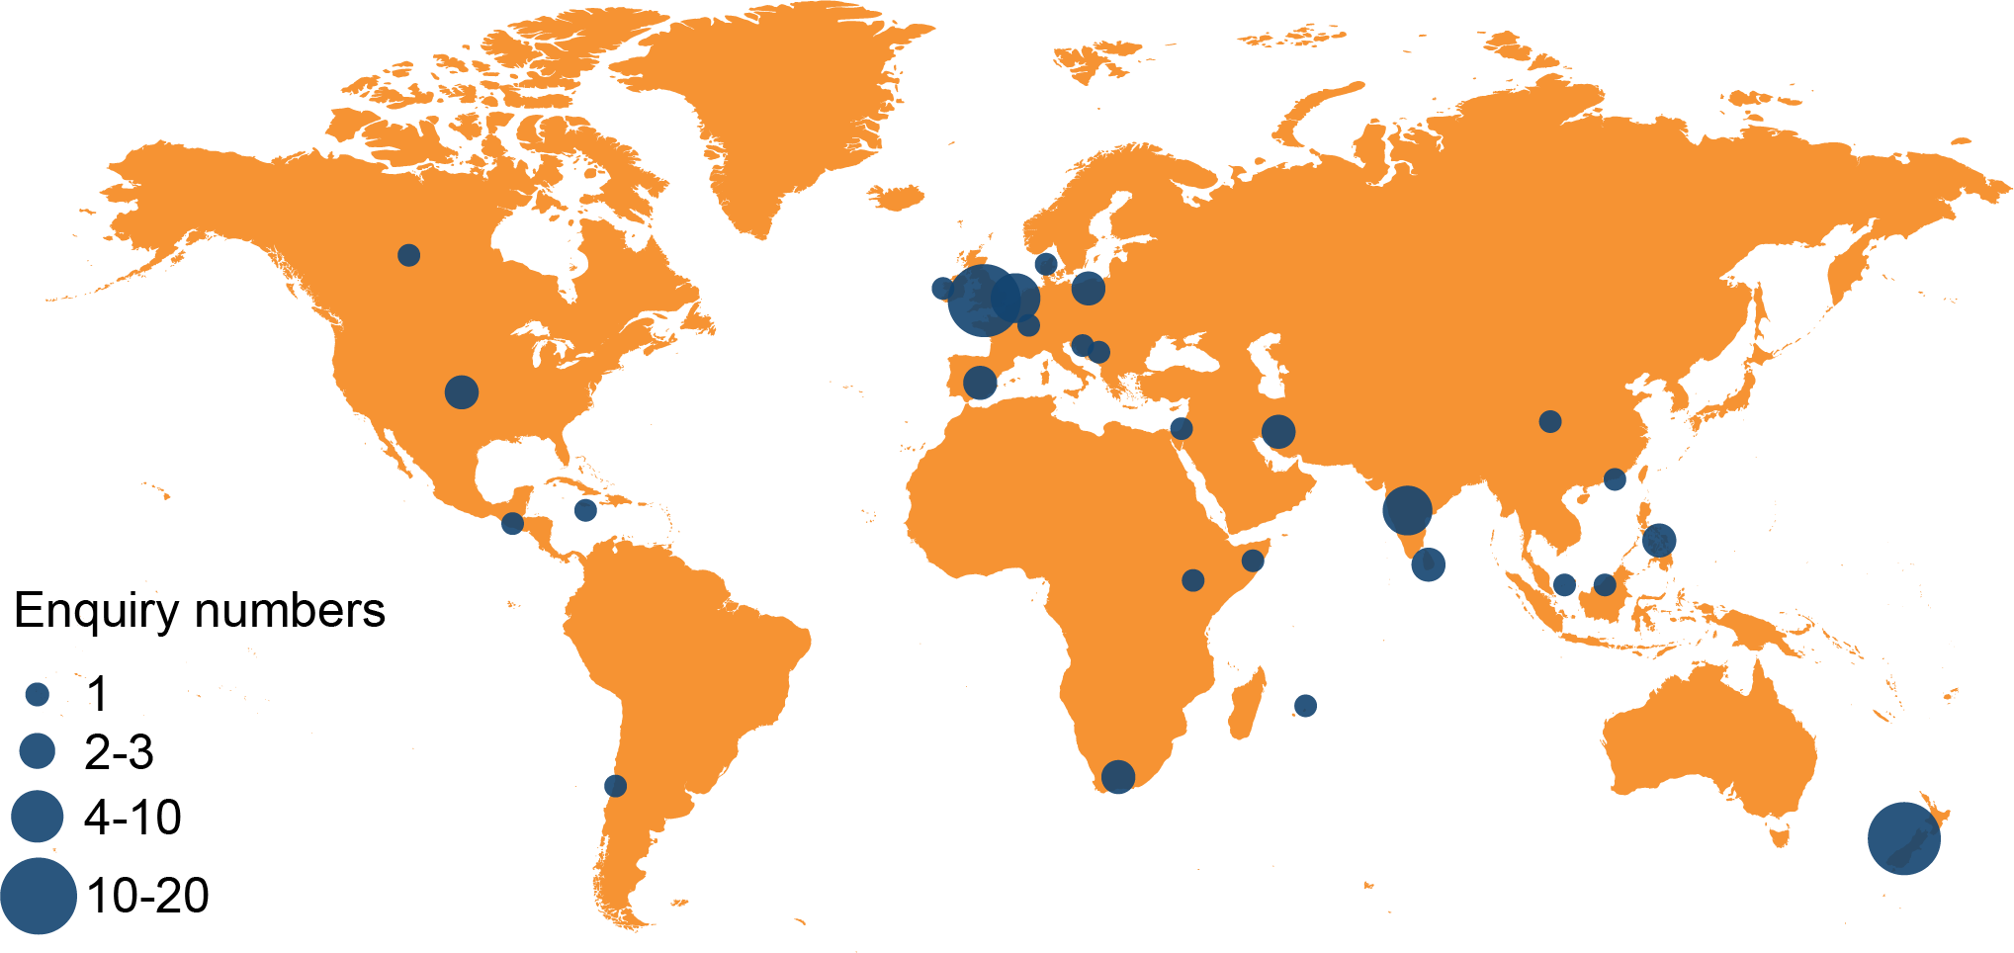

Mirroring the complaints made about human rights, most of the people who enquired about human rights were in the age brackets of 35–44 or 45–54.
Figure 6: Human rights enquiries to the Commission by age bracket, 2020-21
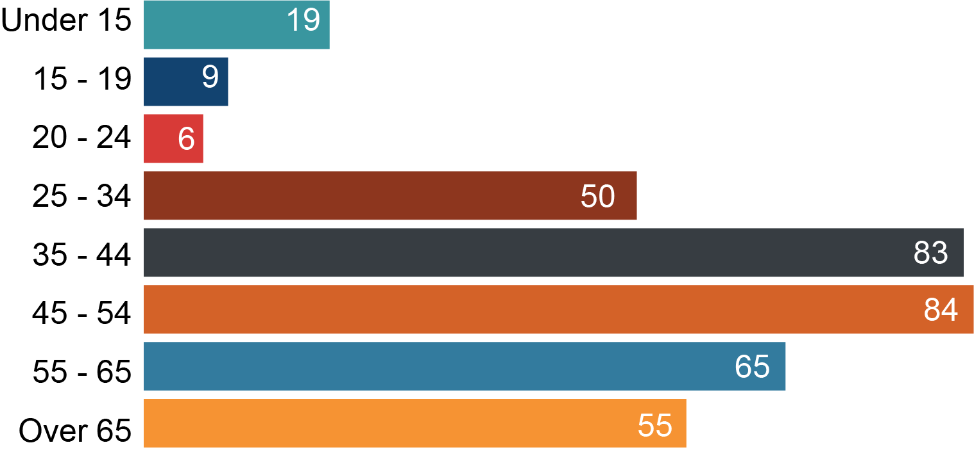

Slightly more women (50.57%) than men (49.2%) enquired at the Commission about human rights, and 0.23% of enquirers identified as neither male nor female. This is in contrast with complaints, where men were more likely than women to make human rights complaints in the reporting period.
Figure 7: Human rights enquiries to the Commission by gender, 2020-21
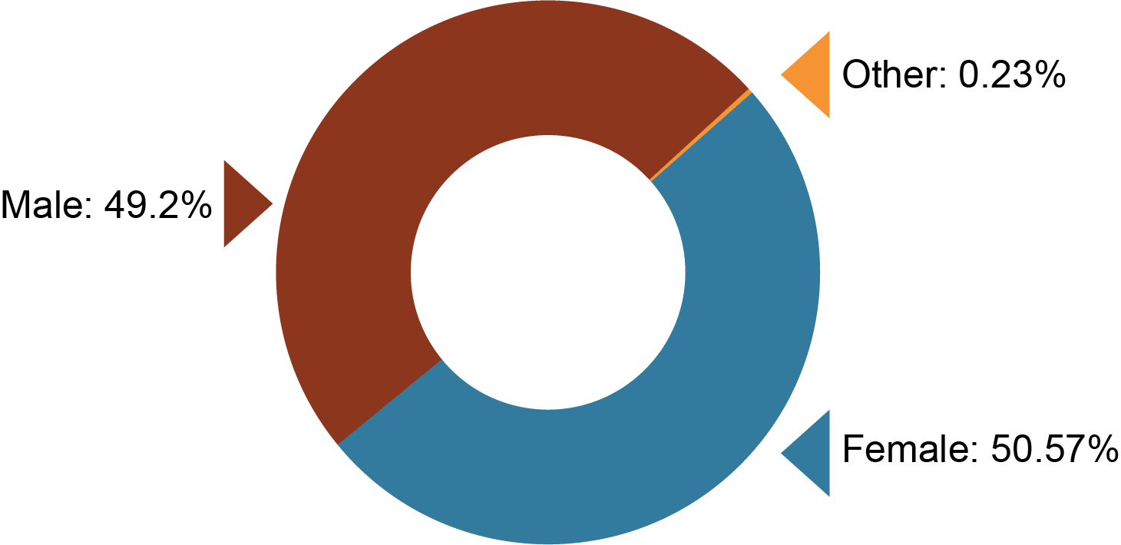

The Commission received 99 enquiries from Aboriginal or Torres Strait Islander people. As well as contacting the Commission’s general phone or email, First Nations people can phone or email a staff member from the Commission’s Aboriginal and Torres Strait Islander Unit to discuss their enquiry. This year’s figure was a significant increase from the 43 enquiries in the previous year. Of the 99 enquirers, 86 were Aboriginal, 4 were Aboriginal and Torres Strait Islander and 4 were Torres Strait Islander.

Complaints to the Commission
The following section will provide information about complaints about human rights made to the Commission in the 2020-21 period.
As noted above, there is currently around a 6 month wait for a complaint to be dealt with. The consequence of a backlog in assessing complaints is that not every complaint that was received in 2020-21 has been assessed at the date of publication, and therefore not every complaint that has been made about human rights will be reflected in the data below. Nonetheless, there is enough data to be able to identify emerging trends in many areas.
Consistent with last year a large number of complaints (21%) finalised in the 2020–21 financial year could not be accepted because the complainant had not first complained to the public entity and waited 45 business days before lodging with the Commission – a requirement under the Act. This has improved since the previous year, when 27% of complaints could not be accepted because these requirements had not been met. Complaints information on the Commission’s website has been updated to make this requirement as clear as possible to potential complainants and hopefully this number will decrease further in time.

Complaints processes and terminology

What is a piggy-back complaint? And what is a human rights only complaint?
Complaints can be accepted under both the Anti-Discrimination Act 1991 and the Human Rights Act 2019 and these are referred to as ‘piggy-back’ complaints. A piggy-back complaint is sometimes also referred to as a piggy-back claim (noting last year’s report almost exclusively referred to this, but the Commission’s terminology has since been updated).
A ‘piggy-back’ complaint is where the complainant has a complaint that falls under the Anti-Discrimination Act 1991 (such as for discrimination) but the complaint also raises human rights issues under the Human Rights Act 2019. Under section 75 of the Human Rights Act 2019, the Commission can deal with such a complaint under the Anti-Discrimination Act 1991 as if it were a contravention of the Anti-Discrimination Act 1991. This can occur where a primary claim of discrimination exists, but the respondent is also a public entity. The complaint parties proceed through conciliation for these matters and the complainant has the option of referring their complaint to the relevant Tribunal, should it not resolve. If a complaint is human rights only complaint, there is no right of referral and no right to compensation.
Conciliation conferences, in which an impartial conciliator assists the parties to resolve the complaint, are held for piggy-back complaints.
The complaints process for human rights only complaints can occur either through a conciliation conference or by early intervention, which is where the matter is resolved by the conciliator who speaks with the parties separately through a shuttle negotiation process.

Who can make a complaint?
A complaint can be made by an individual who is the subject of a human rights breach. That is, where the individual alleges that a public entity has acted or made a decision in a way that is not compatible with their human rights, or has failed to give proper consideration to a human right relevant to a decision that impacts on them. The individual can appoint an agent, or the Commission can authorise another person to make a complaint for the individual. Two or more persons can make a joint complaint.

What is an accepted complaint?
The Commission assesses each complaint received, and records which human rights are relevant based on the allegations raised by the complaint as well as which type of public entity is involved (e.g. state government, local government, or functional entity) and in which sector (e.g. health, education, court services etc.).
An ‘accepted complaint’ means that the Commission has assessed the complaint and decided that the matter should proceed to a dispute resolution process (conciliation or early intervention) to try to resolve the issues.
A complaint can only be accepted if it is made in writing and includes enough details to indicate the alleged contravention to which the complaint relates – see Section 67 Human Rights Act 2019. When deciding whether to accept a complaint, the complaint handler will consider if there has been an unreasonable limitation of human rights.
By accepting a complaint the Commission has not decided that there has been a breach of human rights.

What is a finalised complaint?
A complaint may have been finalised for a number of reasons. It may have been rejected, accepted and resolved, accepted and not resolved, or withdrawn. For more detailed information see the section Outcomes of finalised complaints.

What is an accepted and finalised complaint?
This means a complaint that has been accepted (in any period) by the Commission, and has been finalised in the period 2020-21.

What is a resolved complaint?
‘Resolved’ means that it has been through a complaints process (conciliation or early intervention) and the matter has been resolved to complainant’s satisfaction.

Human rights complaints snapshot
The Commission has identified 369 complaints received in the 2020–21 period as being about human rights.
Of these complaints, 132 were piggy-back complaints, and 237 were human rights only complaints.
Figure 8: Complaints to the Commission shown as piggy-back complaints or human rights only complaints, 2020-21
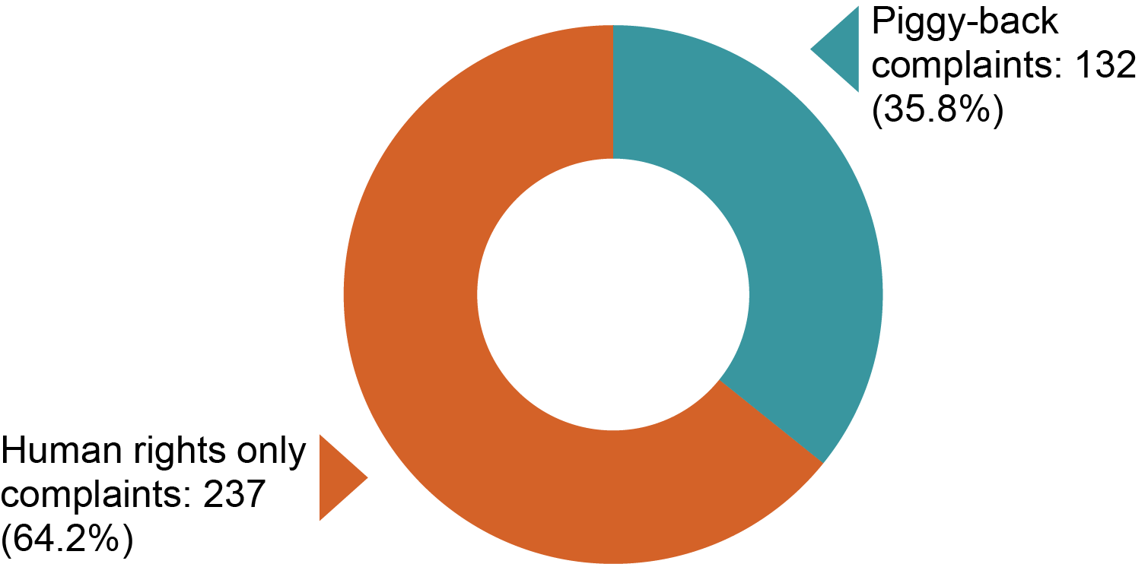
By the end of the 2020–21 financial year:
344 human complaints had been finalised in that year. 235 were human rights only complaints and 109 were piggy-back complaints.
151 of these finalised complaints had been accepted. 56 of these were human rights only complaints and 95 were piggyback complaints.
47 complaints were resolved in the 2020-21 financial year. 19 of the resolved complaints were human rights only complaints and 28 were piggyback complaints.
26 complaints (all piggy-back complaints) were referred to tribunals (14 to the QCAT and 12 to the QIRC).
2 reports were made about unresolved human rights complaints that contained recommendations for the respondents to take to ensure their actions and decisions are compatible with human rights.
Of the 344 complaints finalised in the 2020-21 financial year, 89 complaints were about COVID-19, including issues arising in hotel quarantine and border restrictions. In other words, COVID-19-related complaints made up just over a quarter of finalised human rights complaints.
Appendix C from page 187 of this report contains detailed statistical data presented in data tables.
Figure 9: Human rights complaints snapshot, 2020-21
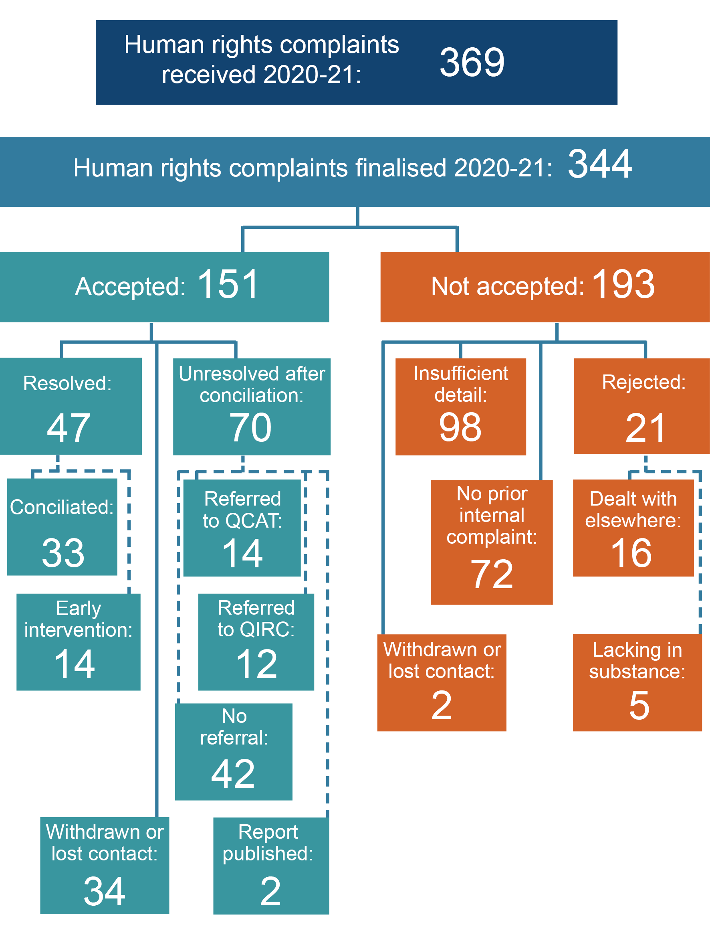

Outcomes of finalised complaints
Around 55% of complaints finalised in the 2020–21 financial year were not accepted by the Commission. Aside from those complaints not indicating an unreasonable limitation on a human right, some complaints could not be accepted where they described events occurring prior to the commencement of the Act on 1 January 2020.
Of the complaints that were accepted, 47 complaints were resolved in the 2020–21 financial year. 26 complaints, some of which had been received in the previous financial year, were referred to Tribunals (QCAT or QIRC).
Figure 10: Outcomes of all complaints finalised in 2020-21
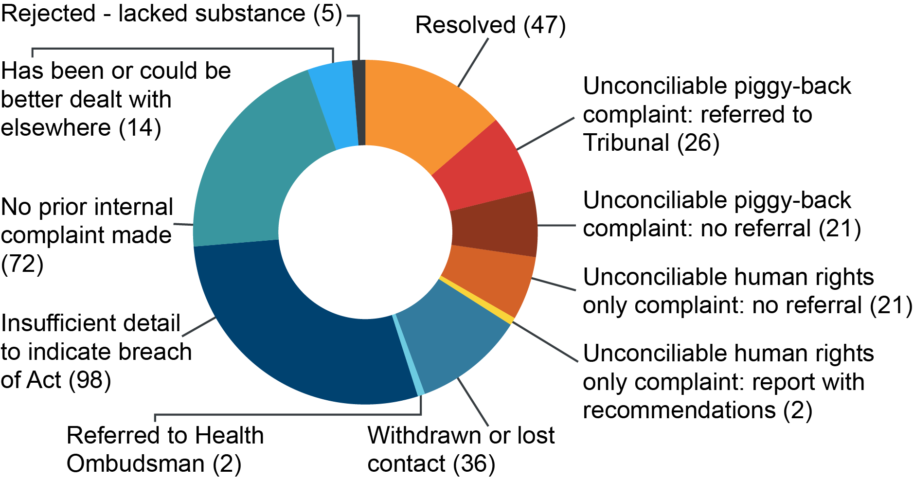
Table 10: Specific outcomes achieved through the Commission’s complaints process 2020-21
Outcome | Number
Apology | 6
Agreement to train individuals/workforce | 4
Agreement for compensation | 4
Policy change/review | 3
Agreement to change the original decision made by the public entity | 1
Policy development/implementation | 1
Service improvement | 1
Free goods/services | 1

Resolution rate for human rights complaints
Compared with complaints made under the Anti-Discrimination Act 1991, the resolution rate appears to be significantly lower for human rights and piggy-back complaints.
Figure 11: Resolution rates by complaint type 2020-21
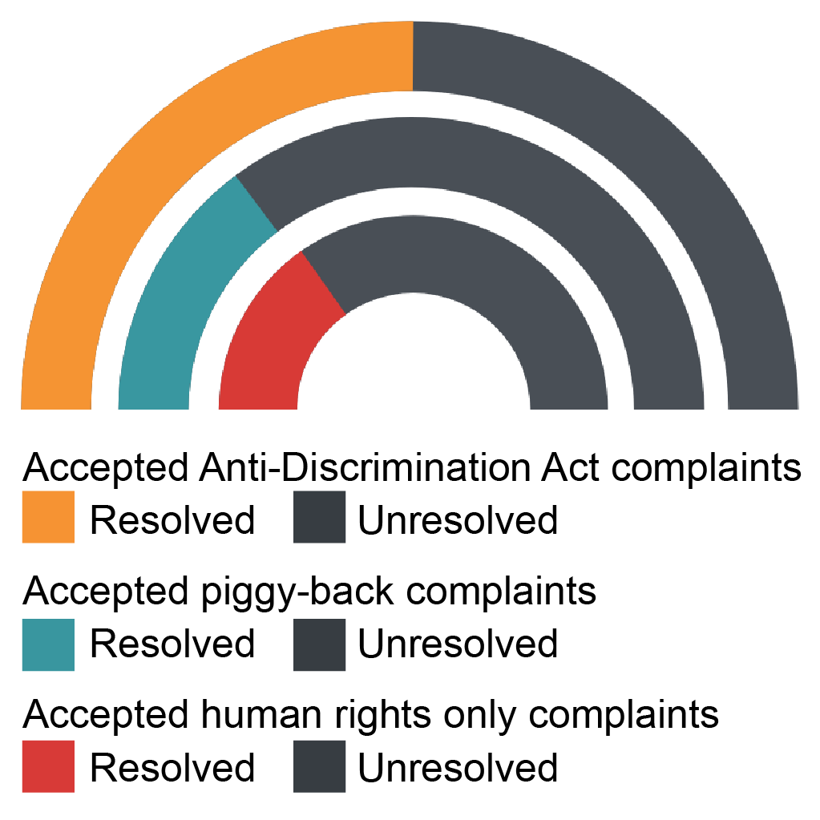
In the reporting period, 50.3% of anti-discrimination complaints (not involving a public entity) were resolved through conciliation. This is consistent with previous years in which resolution rates were somewhere between 50 to 55%.
In contrast, only 29.1% of human rights only complaints were resolved through conciliation and the piggy-back complaints resolved at a similar rate. While it is too early to detect any clear trends, the possible reasons for this may include:
- Without the risk of a potential determination by the tribunal, respondents are less inclined to settle a complaint.
- There is less incentive for the parties (including the complainant) to sign a formal conciliation agreement to settle the matter, or confirm that the matter is resolved, if there is no chance of it progressing further to a tribunal.
- Complaints made about public entities in the administration of state laws and programs are generally less likely to resolve, regardless of the complaint type.
- Significant numbers of complainants who had human rights only complaints (13) lost contact or withdrew their complaints, which may be related to the backlog of complaints. At times a person may have withdrawn because they were satisfied with the outcome, but these situations were not recorded as ‘resolved’.

Human rights identified in all human rights complaints
This section looks at the human rights relevant to the allegations raised in the complaints finalised in 2020–21. The information in this section includes all complaints – piggy-back complaints and human rights only complaints.
The Commission may identify the relevant human right from the information provided in the complaint, or the complainant may indicate that they believe the right has been limited.
Most complaints contain several allegations, and engage more than one human right.
Not all allegations of unreasonable limitations of human rights are accepted. An allegation (that a contravention has occurred) alone is not enough; the complainant must provide sufficient detail about an act or decision that indicates a breach of human rights has occurred in order to have the complaint accepted.
Some complaints that were received in 2020–21 have been assessed and accepted in the 2021–22 financial year (or are in the queue for assessment), and are therefore not included here.

Figure 12: Human rights identified in all complaints, 2020-21

The most frequently identified human right in complaints as a whole was the right to recognition and equality before the law, identified in over half of the human rights complaints made to the Commission. As noted last year, this is because the majority of complaints to the Commission are about discrimination under the Anti-Discrimination Act 1991 which overlaps with this protected right. The right to recognition and equality before the law will likely be engaged in all cases where a complainant is complaining about discrimination and the respondent is a public entity.

The second most common protected right in complaints finalised in the reporting period was the right to humane treatment when deprived of liberty. While these complaints may relate to prisons and other closed environments, the impact of COVID-19 has resulted in a significant number of complaints made by people in hotel quarantine.
The third most common protected right in complaints was the right to freedom of movement. Similar to humane treatment when deprived of liberty, complaints about limitation of this right are high in number because of the impact of COVID-19 and the restrictions placed on free movement of people in Queensland.

Human rights identified in human rights only complaints
The information in this section is about human rights only complaints (i.e. where it is not a piggy-back complaint).
Figure 13: Human rights identified in human rights only complaints, 2020-21

Human rights only complaints featured the same key rights as piggy-back complaints, but humane treatment when deprived of liberty predominated (in around 37% of complaints).

Human rights identified in resolved complaints
This section looks at protected rights identified in complaints that were resolved in 2020–21. The information includes all complaints – piggy-back complaints and human rights only complaints – and again the same three rights featured most often.
Figure 14: Human rights identified in resolved complaints, 2020-21
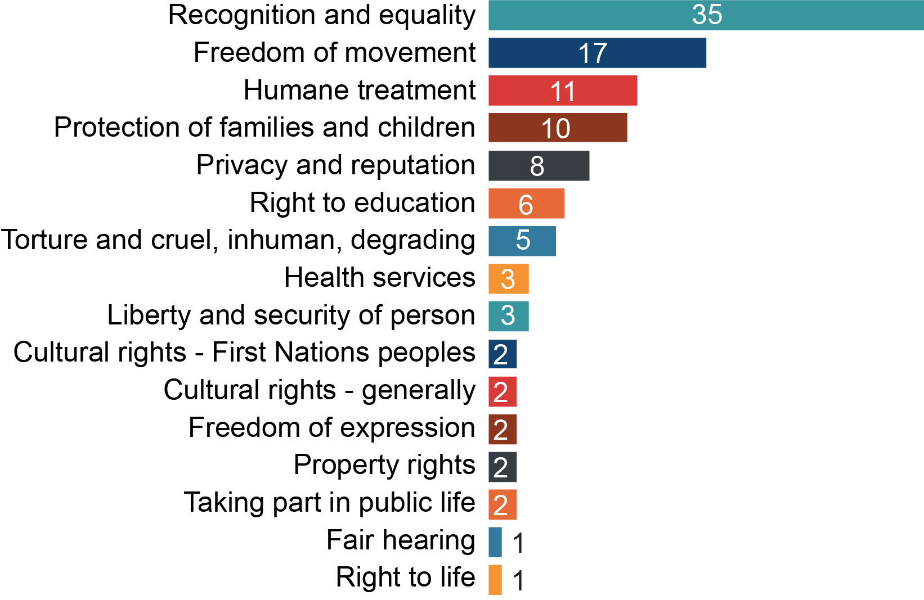

Finalised complaints by sector
The information in this section includes all complaints – piggy-back and human rights only complaints.
Figure 15: Finalised complaints by sector – all complaints, 2020-21

‘Not a public entity’ was recorded when the person complained about a respondent not covered by the Act. For example, a towing company that towed a car impounded by police.
‘Other government services’ are services provided by public entities that do not fit into the key categories as provided in our database. These services might include services such as public transport, legal, or community services.
‘Other state laws and programs’ means government programs that are not services provided to an individual. For example, an entity that enforces fines or regulates individuals or industries such as Queensland Racing Integrity Commission or State Penalty Enforcement Registry.
‘Corrections’ includes both prisons and youth detention, but the vast majority of complaints were about prisons. 4 complaints were finalised about youth detention (1 of which was accepted and finalised), and 41 complaints were finalised about prisons (of which 7 were accepted and finalised). While a relatively high number of complaints were made against prisons, few were accepted and finalised in the reporting period. This may be partly because of further legislative requirements on prisoners making anti-discrimination complaints under the Corrective Services Act 2006.
Complaints about health bodies predominated, strongly influenced by the COVID-19 pandemic, and it remains to be seen whether the trend will continue in future years. The Commission identified 68 finalised health matters about COVID-19 (80% of the total finalised health complaints). Of the complaints about health, most were about health services generally, with 12 being about mental health services.
Similarly, as police have been required to enforce Public Health Directions and hotel quarantine, the number of complaints about police was high because of the COVID-19 situation. The Commission identified 28 of the 58 finalised police complaints that were related to COVID-19 (48% of the total finalised police complaints).
‘Work’ is where a public sector worker is complaining about issues arising in their workplace.
Education complaints comprised allegations of human rights breaches by primary, secondary and tertiary institutions.
Table 11: Human rights complaints to the Commission about the education sector 2020-21
Type | Finalised | Accepted & finalised
Primary | 6 | 5
Secondary | 14 | 10
Tertiary | 10 | 5

Finalised complaints by sector for human rights only complaints
The information in this section reports on human rights only complaints finalised in 2020-21.
Figure 16: Finalised complaints by sector – human rights only complaints, 2020-21

Similar trends can be observed in relation to the complaints made about human rights only, with the same three public entity types – health, corrections, and police being the most complained about in the reporting period.

Demographic information for finalised complaints
The information in this section breaks down complaints by the complainant’s country of birth, sex, and age, based on information provided to the Commission. Demographic data has not been collected for every complaint, but some trends are emerging with the data that has been provided by complainants. The demographic information in this section is about complainants who made piggy-back complaints, as well complainants who made human rights only complaints.
Complaints finalised in the 2020-21 period were lodged mainly from within Queensland. Compared with last year, more complaints were lodged from interstate and particularly from Melbourne and Sydney, reflecting COVID-19 related complaints about border entry restrictions.
Most of the complainants living in Queensland were from the southeast region, but a reasonable number came from coastal regional areas of Queensland. Few complaints were received from people living in remote areas.
Figure 17: Finalised complaints by complainant location, 2020-21
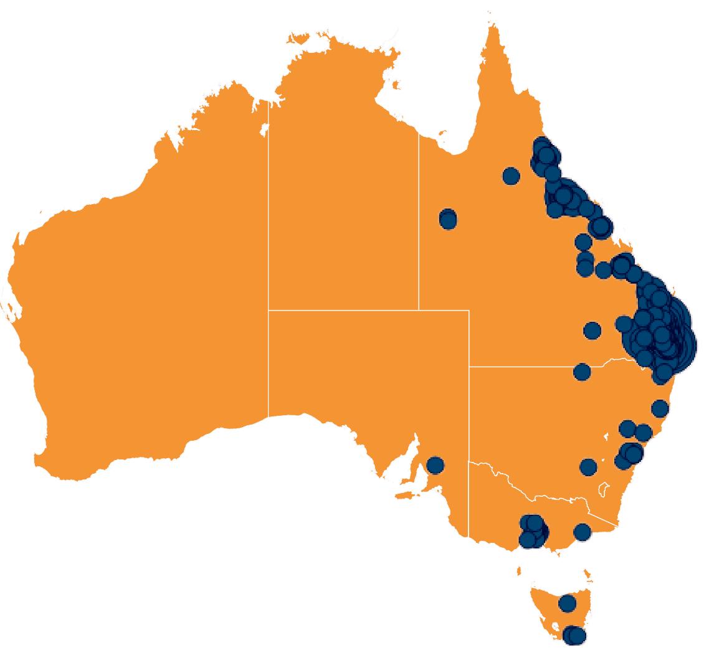
Of the finalised complaints, 54.5% complainants identified as male, and 45.5% identified as female. The gender split for complaints under the Anti-Discrimination Act 1991 is roughly equal. There were more men than women who lodged complaints last year, but the difference was more marked (66.66% male).
Around 74% of complainants were born in Australia, and 26% were born overseas.
Aboriginal or Torres Strait Islander people made up 10.5% of complainants, which is significant given that approximately 4% of the Queensland population is of Aboriginal or Torres Strait Islander descent. In the same reporting period only around 7% of complainants under the Anti-Discrimination Act 1991 were Aboriginal or Torres Strait Islander.
6.5% of complainants had a primary language other than English.
Most complainants were in the brackets of 35 to 44 years (27.7%), and 45 to 54 years (24.1%). This was similar to the results last year, but unlike the previous year, 10 people aged 19 and under made complaints (or complaints were made on their behalf).
Figure 18: Finalised complaints by complainant age, 2020-21
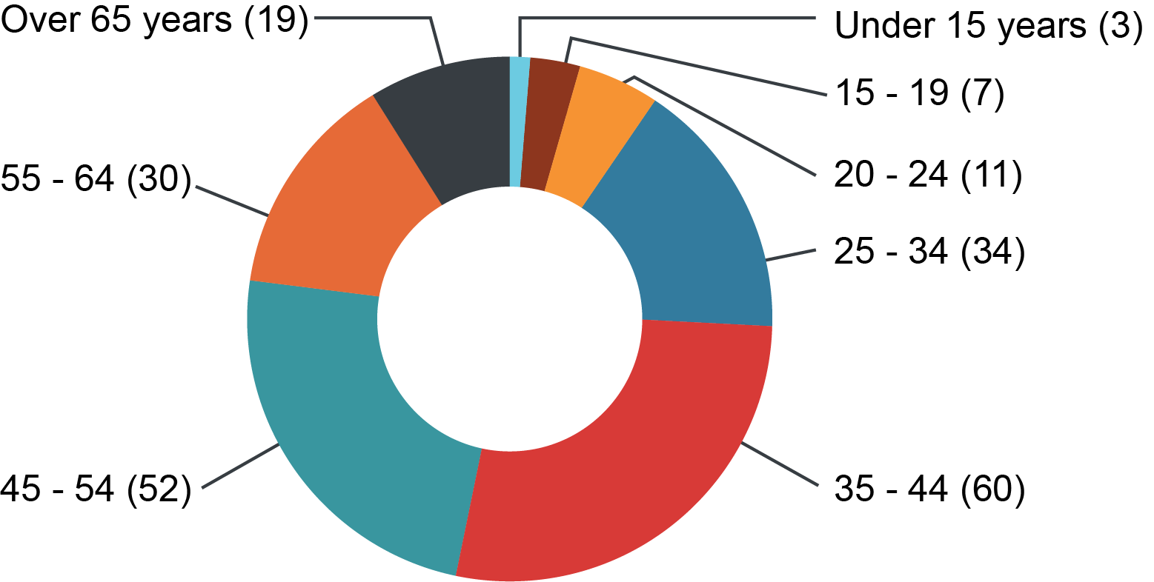

Dispute resolution process: conciliation and early intervention
Compared to the Anti-Discrimination Act 1991, the Human Rights Act 2019 provides a more flexible approach to complaint handling. For urgent situations in human rights only complaints, early interventions replaced conciliation conferences.
Where a complaint was a piggy-back complaint, it was almost exclusively resolved through a conciliation conference, whereas for human rights only complaints it was more likely to be resolved by early intervention. As demonstrated by the resolved case studies (from page 155), early intervention quickly resolved a number of matters that may not have been resolved if the parties needed to wait for a conciliation in a number of weeks’ time. This indicates that flexible and responsive early intervention model is continuing to be a successful one for resolving human rights matters.
Figure 19: Finalised complaints by dispute resolution mode, 2020-21

Corporations carrying out public functions
In the Committee report on the Human Rights Bill in 2018, the Legal Affairs and Community Safety Committee commented that it would be beneficial for the Commission to monitor complaints raised against private corporations undertaking public functions, in light of some concerns raised that the definition of public entity under section 9 may create uncertainty regarding which entities may be captured.
Of the accepted and finalised human rights complaints, the Commission identified three in which a corporation was named as a respondent.
They were:
- a complaint by a prisoner against a privately-run prison;
- a complaint about conditions of hotel quarantine against a hotel contracted by Queensland Health; and
- a complaint against an Aboriginal corporation regarding an application for an Aboriginality certificate required to access state government funded services.

Complaints to other agencies
The Commission is not the only complaints body that has received complaints about human rights in 2020–21.
The Office of the Queensland Ombudsman received 2,159 cases which were assessed as involving a human rights element. Common complaint topics included:
- property rights
- protection of families and children
- humane treatment when deprived of liberty
- privacy and reputation.

Unresolved complaints with recommendations
Where the Commission considers a complaint has not been resolved by conciliation or otherwise, the Commissioner must give the parties a report which includes the substance of the complaint and the actions taken to try to resolve the complaint.
The Commission has the discretion to include details of actions that the respondents should take to ensure its acts and decisions are compatible with human rights. Two reports with recommendations were published in the reporting period:

Prisoner isolation
Complaint lodged against | Queensland Department of Corrective Services
Human Rights Act sections | 30 (Humane treatment when deprived of liberty)
Date report published | 2 February 2021
Summary: The complainant told us she is a vulnerable Aboriginal woman aged in her twenties experiencing a range of mental health conditions. In response to the COVID-19 pandemic, she was placed in isolation for more than 14 days upon her admission to prison. She alleged that during her time in isolation she was deprived of medical treatment, education, exercise, fresh air, and reticulated water. Her alleged treatment included a lack of sufficient medical treatment for her mental health. She also alleged that that the respondents failed to facilitate any communication with her mother, and failed to make adequate arrangements for telephone calls with her lawyers.
The Commissioner did not make findings of fact regarding her treatment, but recommended that Queensland Corrective Services:
- amend relevant policies to clearly state that prisoners isolated in response to the COVID-19 pandemic should not be isolated for more than 14 days, other than where Queensland Health provide clear medical advice that their isolation must continue due to a risk of infection
- ensure prisoners, while in isolation, receive certain minimum entitlements without the caveat of ‘to the greatest extent possible’, including access to confidential medical assessment and mental health services, adequate facilities to communicate with a lawyer and their family. Prisoners should also be given access to complaints procedures and cultural support, and
- provide prisoners with daily access to fresh air and exercise while in isolation, other than in exceptional circumstances.

Hotel quarantine
Complaint lodged against | Queensland Police Service;  Queensland Department of Health
Human Rights Act sections | 30 (Humane treatment when deprived of liberty)
Date report published | 15 October 2020
Summary: The complainant did not get access to fresh outside air during her 14-day stay in mandatory, self-funded hotel quarantine. The windows of her hotel room did not open, and she was not given a fresh air break from her room. The complainant and the respondents disagreed about the reasons for the lack of room breaks. The complaint was not resolved.
In the unresolved complaint report, the Commissioner considered that the complainant’s right to humane treatment when deprived of liberty had been limited and that the Department of Health and/or Queensland Police Service had to demonstrably justify the limitation of the complainant’s rights. To ensure that the acts and decisions of the Queensland Government would in future be compatible with human rights, the Commissioner recommended that:
- opening windows or balconies be included as a minimum standard for the selection of quarantine hotels, and plans be put in place to decommission currently used hotels that do not meet these minimum standards and
- information provided to people in quarantine includes improved communication about decision-making responsibility, rights of review and appeal, and setting realistic expectations about the conditions of quarantine.

Resolved complaint case studies
The following case studies are a selection of resolved outcomes of complaints finalised in the financial year 2020–21.

School and parents work together to support a child with a disability
A mother lodged a complaint on behalf of her 7-year-old son who attends a state school and has a disability which manifests as anxiety, sensory and behavioural problems. The school became concerned about his escalating behaviour and that some of his behaviours could increase the risk of transmission during the COVID-19 pandemic, and issued a notice of suspension as a result. The child’s mother communicated that her son felt confused, upset, anxious, and unwanted. Many of the details were in dispute, and communication between the family and the school had broken down.
Following a conciliation conference, the mother agreed to share information from the child’s treating occupational therapist, and the school agreed to take this report into consideration in the development of an Individual Behaviour Support Plan. To improve future communication, the mother and the school agreed to use a communication book and meet at the beginning of each term to discuss the plan.
Relevant rights: Right to education (s36)
Complaint type: Piggy-back complaint
Attribute: Impairment
Dispute resolution mode: Conciliation conference

Quarantine exemption for woman picking up assistance dog
A woman planned to visit Queensland from interstate to pick up her assistance dog, with her mother and her carer, during a period of COVID-19 border restrictions. She was granted an exemption to come into Queensland where she agreed to isolate for 14 days and then spend a week receiving placement of the dog. However, when they tried to arrange for accessible quarantine accommodation, they were told the woman’s needs could not be met and her exemption approval was withdrawn. The assistance dog had been trained specifically for the daughter’s needs at substantial cost and they were concerned that she would lose the dog allocated to her if she was unable to visit Queensland.
The complainant chose to have this matter dealt with under the Human Rights Act.
Through early intervention the parties negotiated for the exemption to enter Queensland to be re-approved, with Queensland Health organising suitable accommodation for the complainant, her mother, and her carer to complete 14-day hotel quarantine.
Relevant rights: Recognition and equality before the law (section 15), freedom of movement (section 19)
Complaint type: Piggy-back complaint
Attribute: Impairment
Dispute resolution mode: Early intervention

Woman’s mental health deteriorates in hotel quarantine
A woman in hotel quarantine after travelling interstate complained that she was given only five fresh air breaks in 14 days. She felt that the communication was poor – the police would say that fresh air breaks were Queensland Health’s responsibility, and the hotel reception said it was the Queensland Police Service’s role. During her stay her mental health deteriorated. Her GP provided a report to support her request to isolate at home. The woman rang the Acute Mental Health Team but felt that her concerns were dismissed.
In conciliation, the respondents acknowledged how challenging it was for the woman in quarantine while explaining the public health importance of the quarantine system in containing COVID-19. They agreed to help her apply for a quarantine fee waiver on the basis of her personal circumstances.
Relevant rights: Recognition and equality before the law (section 15), freedom of movement (section 19)
Complaint type: Piggy-back complaint.
Attribute: Impairment
Dispute resolution mode: Conciliation conference

Transport service reviews disability policies and commits to training
A woman who had mobility issues made a complaint about the limited number of accessible parks at a bus terminal, and being issued with a number of fines for parking in other places. She said that on two occasions the bus driver refused to engage the ramp, requiring her to struggle up and down the bus stairs.
The complaint was resolved on the basis that the transport service agreed to conduct an internal review of its policies and procedures about the use of ramps, and to provide a copy to all bus drivers employed by it. Employees were also required to attend training on the Anti-Discrimination Act and the Human Rights Act, and an internal training module on human rights and improving services to people with disability was introduced.
Relevant rights: Recognition and equality before the law (section 15)
Complaint type: Piggy-back complaint
Attribute: Impairment
Dispute resolution mode: Conciliation conference

Family experiences challenges in hotel quarantine
A mother and her two children, aged 4 years and 18 months, were in hotel quarantine. The room did not include a balcony or opening windows, and she reported not being allowed to have wellness walks because the baby would not keep a mask on. She was also concerned that the food was not nutritional for children and arrived at an inappropriate time such as 8:00pm.
At the conciliation conference, the respondents acknowledged how difficult the situation had been for the family, and explained the significant issues involved in sourcing appropriate hotels to provide quarantine services to cope with the demand of returned travellers. The woman was satisfied with the discussions at the conciliation conference and felt that the issues had been satisfactorily addressed and resolved. As a gesture of goodwill, the hotel provided hotel vouchers to the family.
Relevant rights: Recognition and equality before the law (section 15), freedom of movement (section 19), humane treatment when deprived of liberty (section 30)
Complaint type: Piggy-back complaint
Attribute: Age, family responsibilities
Dispute resolution mode: Conciliation conference

Unaccompanied children allowed to quarantine at home
Two children aged 15 and 11 were placed alone in hotel quarantine and were unable to leave their room. Their father lived interstate and the mother lived in Queensland. They had been placed in hotel quarantine after flying home to Queensland from an interstate visit with their father.
The Commission dealt with the complaint urgently under the Human Rights Act. Queensland Health was informed about the complaint the same day it was lodged, and they immediately arranged for the children to be returned to their mother’s home that day where they were allowed to quarantine for 14 days.
Relevant rights: Recognition and equality before the law (section 15), freedom of movement (section 19), humane treatment when deprived of liberty (section 30), right to liberty and security of the person (section 29)
Complaint type: Human rights only
Dispute resolution mode: Early intervention

Appropriate accommodation found for family’s quarantine stay
A family was moving back to Queensland after living overseas, and requested to quarantine at home because their 8-year-old daughter has ASD, ADHD, anxiety, and obsessive behaviours. Because of her disability she is prone to meltdowns and has food aversions. The request for exemption from hotel quarantine was rejected.
The complaint was resolved on the basis that the family was allocated more appropriate hotel quarantine accommodation of a 2-bedroom apartment with a kitchen and balcony.
Relevant rights: Recognition and equality before the law (section 15), freedom of movement (section 19)
Complaint type: Piggy-back complaint
Attribute: Impairment
Dispute resolution mode: Early intervention

Alternative to mask-wearing provided for pregnant woman
A hospital required patients to use face masks to prevent the spread of COVID-19, in accordance with official health directions at the time. A pregnant woman asked for an exemption for wearing a mask as due to a trauma background, the experience of having her mouth covered caused claustrophobia and panic attacks.
When the woman enquired with the hospital about an upcoming appointment she was told she would not be allowed in without a mask. She was concerned about missing her in-person appointment, particularly because it was a high-risk pregnancy due to her having a number of medical conditions.
The conciliator from the Commission assisted a resolution with the hospital through early intervention. The conciliator checked with the woman whether the use of a PPE face screen might work as an alternative to the mask. The woman advised that this kind of face covering would not affect her mental health in the way a mask does. The hospital then followed up directly with the woman, advising her that her system would now include a note that she is exempt from wearing a mask and that they would provide her with a face shield instead. The woman expressed her gratitude for the matter being resolved swiftly and to her satisfaction and she was able to attend her medical appointment as planned.
Relevant rights: Protection of families and children (section 26), privacy and reputation (section 25), right to health services (section 37)
Complaint type: Human rights
Dispute resolution mode: Early intervention

Approved absence from social housing allowed mother to pursue training opportunity
A social housing provider had a general rule that absences from the home of more than 5 months were not permitted. A mother of four children needed to leave her home for several months at a time to commence defence force training. She sought to better her employment opportunities, with her husband being the primary carer of the children. One of her four children has an intellectual disability and a hearing impairment. She was told by the housing provider that if she commenced the training as planned, she would be in breach of the 5-month rule and the family would need to leave their home.
Through conciliation it was agreed that the woman would be permitted to be absent from the property to complete the training, on the condition that she provide evidence of the requirement to attend, return to the property shortly after each absence, notify the housing provider once the training was completed, and continue to pay rent and maintain responsibility for the property during her absence.
Relevant rights: Recognition and equality before the law (section 15), freedom of movement (section 18), property rights (section 24), protection of families and children (section 26)
Complaint type: Piggy-back complaint
Attribute: Family responsibilities
Dispute resolution mode: Conciliation conference

Police express regret about asking traditional custodians to move on while exercising their cultural rights
Community leader Adrian Burragubba and his family were camping, practicing their culture, and performing traditional ceremonies on a pastoral lease area. Police officers approached the group and asked them to leave, stating that the mining company Adani had claimed they were ‘trespassing’. The site was the subject of an Indigenous Land Use Agreement but the family opposed the agreement and the mine, saying that Aboriginal people had been exercising their culture by fishing and hunting and performing ceremonies for 40,000 years.
Cultural rights of Aboriginal peoples and Torres Strait Islander peoples are specifically protected by the Human Rights Act, including the right to maintain their distinctive spiritual, material, and economic relationship with the land and waters with which they hold a connection.
The family told the police that they had received expert advice that they could lawfully exercise their cultural rights and responsibilities. However, the police required the group to pack up their equipment and leave within an hour. The family says that this caused grief and trauma.
The Queensland Police Service (QPS) agreed to provide a statement of regret which was able to be shared publicly. The statement acknowledged that the events caused embarrassment, hurt, and humiliation for the complainant and his extended family, that there are complex legal issues and cultural sensitivities, and that the QPS will commit to take into account the issues in the complaint in future responses.
Relevant rights: Recognition and equality before the law (section 15), freedom of movement (section 18), cultural rights – Aboriginal peoples and Torres Strait Islander peoples (section 28)
Complaint type: Piggy-back complaint
Attribute: Race
Dispute resolution mode: Conciliation conference

Health service acknowledges embarrassment experienced by patient with a disability
A man had an acquired brain injury, an inoperable brain aneurysm, and used a wheelchair. After a long recovery and more than 3 years of treatment in hospital and in rehabilitation facilities, he had become independent and started living at home, with a partner. One night the man accidentally fell out of his wheelchair, knocking his face on a tiled floor and becoming trapped under the 164kg chair. While in the ambulance he requested a bottle so that he could urinate. Due to his dexterity challenges and the bumps on the road, he was splashed by some of the urine.
On arrival at the hospital, without asking, the nurses in attendance assumed he was incontinent and fitted him with disposable incontinence underwear. He says that he was not asked for his medical history and this made him concerned for his safety as he had a risk of haemorrhaging again if he hit his head in the wrong place. He requested that the doctor access his ‘my health record’ but says he was told that it’s ‘too late at night to access that’.
During a shift change the man overheard nurses on shift discussing his condition, asking whether alcohol was involved, and commenting that he was incontinent. He felt he was treated as if he had been drunk and that was the reason for the fall. The man felt judged and humiliated by the experience.
The man attended a conciliation conference with representatives of the health service. The complaint parties discussed the complaint and the impact of the experience on the patient. The health service discussed improvement of services in the future, and the complaint was resolved on the basis the man felt he had received a satisfactory explanation.
Relevant rights: Recognition and equality before the law (section 15), right to health services (section 37)
Complaint type: Piggy-back complaint
Attribute: Impairment
Dispute resolution mode: Conciliation conference

Suitable social housing secured for older woman with mobility issues
A 73-year-old woman with lung cancer had been approved for social housing, but had only been offered properties that she considered to be unsuitable for her mobility needs. She also needed a yard area for her dog. At the time she was facing homelessness, as her private rental was up for sale and she had been unsuccessful in applying for around 30 properties in the private market. The social housing provider expressed empathy for her circumstances but explained that demand for housing exceeded the supply, and that allocations had to be made depending on the number of available properties and the needs of those in queue for social housing.
Through the conciliation process, the social housing provider offered the woman a suitable one-bedroom apartment with an enclosed courtyard which was accepted.
Relevant rights: Recognition and equality before the law (section 15), right to privacy and reputation (section 25)
Complaint type: Piggy-back complaint
Attribute: Impairment
Dispute resolution mode: Conciliation conference

Employer takes steps to prevent breaches of privacy and reputation in future
A state government employer suspended an employee who was receiving financial support for her university course and who was alleged to have received the assistance of a colleague for the coursework during work hours. Without first speaking with her about the allegations, the employer emailed the employee’s university to advise them of potential academic misconduct.
The employee complained that this disclosure came before the external investigation had started, that she had not had the opportunity to learn details of the allegation or to respond, and that her employer had been under no obligation to raise the allegation or investigation with the university.
In making a human rights complaint about the issue, she argued that her employer failed to properly consider her human rights – in particular the right to privacy and reputation set out in section 25 of the Human Rights Act. The employee said that her employer’s actions had negatively impacted on her professional and academic reputation.
To resolve the complaint the employer agreed to contact the university and explain there was no evidence of wrongdoing, apologise in writing to the employee, and to review their policies and procedures relating to the issues raised in the complaint.
Relevant rights: Privacy and reputation (section 25)
Complaint type: Human rights only
Dispute resolution mode: Conciliation conference

Human rights in the community

With the ongoing backdrop of COVID-19, human rights discussion in the community is at its highest level for many years. Human rights are impacted every day when emergency public health orders limit movement inter or intra-state and mandate vaccines, social distancing, and wearing masks. During these unprecedented times, Queensland has been fortunate to have the framework of the Human Rights Act 2019 to guide these challenging discussions.

Measuring human rights attitudes
Two recent studies provide some indication of human rights literacy in Queensland. The first was conducted in early 2021 by Amnesty International with a sample of 1,600 people of various ages, genders, and locations across Australia. Some of the general findings included:
- The rights of most importance to people surveyed included the right to vote (86%), freedom from discrimination (84%), right to free speech (83%) and right to equal treatment before the law (83%).
- 36% of people surveyed thought that Indigenous Australians had fewer opportunities than non-Indigenous Australians.
- People surveyed believed that the following groups were most in need of protection of their rights, in order of priority: Indigenous people, refugees, ethnic minorities, immigrants and women.
- 76% of people surveyed wanted national human rights legislation.
More recently, a Queensland study by Griffith University researchers found overwhelming support for human rights, the Human Rights Act 2019, and the Commission. The study, conducted in July 2021, surveyed a randomised sample of 1,000 people living in Queensland. Some key findings included that:
- The priority areas for Queenslanders were child protection, health, aged care, and disability rights.
- The attitudes towards human rights were overall similar between Brisbane and regional Queensland.
- Aboriginal and Torres Strait Islander people responded that human rights were less respected in regions.
- Women were less sure that human rights were being respected than men, especially in health care.
- The age group that was the least supportive of human rights were people over 65.
- Scepticism about effectiveness of human rights protections was higher amongst people on lower incomes.

Attitudes to COVID-19 and human rights
Attitudes to rights limitations during COVID-19 indicated strong support for measures required to slow the spread, with 73% agreeing in the Amnesty study that restrictions on rights were worth it. In the Griffith University study, when asked about Queensland Government’s approach to COVID-19, 64% believed that human rights had been respected during the pandemic.

Knowledge about rights protections
While human rights consciousness is growing, this may not translate to a strong understanding of what legal protections are in place. More than half of respondents to the Amnesty study believed that Australia already had a federal Human Rights Act – which is not the case. While 91% of respondents to the Queensland study thought that protection of human rights and dignity is important, only 43% knew about the Queensland Human Rights Act 2019.
While the Act only commenced in its entirety in January 2020, it is clear that more community education is required to improve human rights literacy in the community.

Community education
Community education is critical to ensuring that the Act meets the goals of protecting and promoting human rights culture and promoting a dialogue about the nature, meaning and scope of human rights.
The Commission’s website remained a key source of information for the community about their rights. In 2020-21, 6 of the 20 most visited pages on the Commission’s website were human rights specific.
The huge increase in enquiries and complaints has resulted in a backlog of complaints, which necessitated significant Commission resources being directed to complaint management and resolution. This has meant a decreased capacity in the Commission to lead the important work of promoting the understanding and acceptance of human rights and the Act in Queensland.
Traditional community engagement opportunities have been limited during COVID-19 with many events being cancelled or moved to an online space, particularly in South-East Queensland. Despite all of this, the Commission ran number of successful engagements in Brisbane and the regions.

Commission engagement activities

Townsville Youth Human Rights Forum
The Forum was a partnership between the Commission and Townsville City Council Youth Council. The aims of the event were to:
- provide a positive platform for Townsville area youth to engage and contribute
- build an understanding of human rights and to raise awareness of the Human Rights Act
- explore young people’s views about human rights issues in the Townsville community and generate ideas to address them, and
- stimulate thinking and identify actions that participants can take to promote an inclusive community where everyone feels welcome and connected.
Interest in the event was strong, with 75 young people registering to attend. Participants heard from three speakers: a local businesswoman with disability, an Aboriginal and Torres Strait Islander man who is a passionate advocate for Indigenous youth, and a young person from a refugee background. The rest of the event centred around hosted conversations in which young people were given a voice on human rights, social justice, and their local community.
Due to the success of this event, the Commission is considering ways to replicate the event in other locations throughout Queensland.
In Brisbane, the Commission participated in a panel discussion for Queensland Health Metro North Alcohol and Drug Service’s Culturally and Linguistically Diverse working group on the impact of COVID-19 on 7 July 2021. Discussions centred around the right to health services, right to life and equality before the law, and the importance of delivering timely information in different languages to ensure all communities understand the risks and the necessary precautions. Further discussions were about how CALD communities could be exposed to police intervention based on lack of understanding of legal obligations, as well as the right to practice their religion which had been due to health restrictions.
The Cairns team ran a number of engagements about human rights, including:
- On 11 August 2020, the Commission presented the results of a community survey relating to increases in racist behaviour and incidents toward people of Asian descent in the Cairns area. The well-attended event was presented in conjunction with the Queensland Police Service and included a session on the Human Rights Act and obligations on public entities.
- On 25 May 2021, the Commission delivered an address to the ordinary Council meeting for Cairns Regional Council as part of Reconciliation Week. The theme of the address was, ‘Reconciliation takes Action’ and used links between the Human Rights Act and the Council’s Reconciliation Action Plan to urge Council to understand their obligations under the Act to work towards real and meaningful reconciliation.
- On the 8 June 2021, the Commission made a presentation at the Diversity and Inclusion Forum in Cairns. The topic included adopting a human rights based approach to work in the sector. The audience included workers in the aged care industry, allied health, and medical professionals.
- Throughout the year the Commission continued to support the Space and Place Youth Activities for Cairns, and linked initiatives through adding a human rights-based lens to projects and helping to build community capacity around the Act.
The Rockhampton team was involved in a number of events that promoted human rights and equal opportunity including:
- The multi-faith dinner, hosted by the Queensland Police Service in partnership with Multicultural Australia, the Queensland Human Rights Commission, Queensland Fire and Emergency Services, and Rockhampton Regional Council. The dinner aims to build on existing community relationships through dialogue and partnerships and focuses on community and religious leaders being seen standing together and promoting the shared values of all faiths. It allows government and other agency representatives to sit down and share a meal with community leaders from our diverse community. This was the fifth year of the event and hosted over 100 people from diverse cultures and backgrounds.
- Neighbour Day: This event encourages social connection and is an opportunity to provide information about household preparedness for people with a disability, their families, and carers. The objectives for this event are to strengthen community connections and create awareness of the additional challenges people with disability face in times of emergency and natural disasters.
- The Commission presented at the joint Central Queensland Multicultural Association and Multicultural Australia Harmony Day celebrations.
The Commission’s Aboriginal and Torres Strait Islander Unit travelled to Mount Isa and met with community to discuss human rights issues as well as delivering training on the Act. The Unit has also delivered human rights training sessions to Aboriginal and Torres Strait Islander shire councils, government and non-government agencies, and First Nations communities.

Human Rights Month
For the sixth consecutive year, we ran our Human Rights Month campaign from 10 November culminating on Human Rights Day, 10 December 2020. The COVID pandemic restricted how the campaign was delivered this year to taking place mostly online.
The campaign aimed to increase the community’s awareness of the new Human Rights Act, and included daily ‘right in focus’ posts on the Commission’s social media platforms to draw attention to individual human rights. We also provided training for key audiences across the month, both online and in person, and developed a supporter kit for stakeholders.

Training for advocates
In late 2020, the Commission introduced new training products for advocates to support vulnerable Queenslanders in accessing protections available to them under the Human Rights Act 2019. The range includes individual products tailored for community advocates, legal advocates, and self-advocates. The intention is to assist those who assist the community to better understand their rights and how the Act can be used to address human rights issues.
In the reporting period:
- 29 sessions were conducted for community advocates
- 7 sessions were conducted for legal advocates, and
- 2 sessions were conducted for self-advocates.

Appendix A: Courts and tribunals

The cases in the tables below are the published decisions of Queensland courts and tribunals that have come to the attention of the Commission.
The sections of the Act listed in the tables are those given on the cover page of the court decision for that case, or in the text of the decision.
In the financial year ended 30 June 2021, Queensland courts and tribunals considered or mentioned the Act in 59 matters.
Table 12: Courts and tribunals which considered or mentioned the Human Rights Act, 2020-21
Court | Number
Court of Appeal Queensland | 3
Supreme Court of Queensland | 13
District Court of Queensland & pre-trial rulings | 3
Land Court of Queensland | 3
Queensland Civil and Administrative Tribunal, Appeals | 1
Queensland Civil and Administrative Tribunal | 30
Queensland Industrial Relations Commission | 6
Total | 59

Supreme Court of Queensland, Court of Appeal
Table 13: Considerations or mentions of the Act in the Supreme Court of Queensland, Court of Appeal, 2020-21
Case | Cause of action | Human Rights Act 2019 sections
Baggaley v Commonwealth Director of Public Prosecutions [2020] QCA 179 (28 Aug 2020) Fraser, McMurdo, Mullins JJA | Criminal (bail application) | ss 29(5)(b), 29(5)(c), 29(7)
R v Morrison [2020] QCA 187 (4 September 2020) Sofronoff P and Philippides JA and Davis J | Application for leave to appeal against sentences | s 29
R v Hickey [2020] QCA 206 (21 September 2020) Morrison and Mullins, JJA, Jackson, J | Application for extension of time for leave to appeal against sentence | s 34

Supreme Court of Queensland
Table 14: Considerations or mentions of the Act in the Supreme Court of Queensland, Court of Appeal, 2020-21
Case | Cause of action | Human Rights Act 2019 sections
Attorney-General (Qld) v Carter [2020] QSC 217 (21 July 2020) Jackson J | Application under s 13 DP(SO)A for either a continuing detention order or supervision order. | [59] re liberty & freedom of movement
Attorney-General for the State of Queensland v Sri & Ors [2020] QSC 246 (8 Aug 2020) Applegarth J | Application for injunctions to restrain certain parties from attending a sit-in protest and encouraging others to attend | ss 13, 19, 20, 21, 22, 23
Westpac Banking Corporation & Anor v Heslop & Anor (No 2) [2020] QSC 256 (21 August 2929) Bradley J | Brief mention of unlawful detention in case involving guarantor debt - did not apply (had not been enacted at the time) | [244]–[246] allegations of beaching Article 12 UDHR
Innes v Electoral Commission of Qld & Anor (No 1) [2020] QSC 273 (22 Sept 2020) Ryan J  (A-G intervener) | In Court of Disputed Returns – Application to reopen hearing – wish to include human rights arguments | [27] mention of s 31
Innes v Electoral Commission of Qld & Anor (No 2) [2020] QSC 293 (24 Sept 2020) Ryan J | In Court of Disputed Returns – where applicant believes election should have been postponed because of COVID health risk – taking part in public life arguments | ss 5(2)(a), 8, 9, 13, 15(2), 16, 23, 31, 48, 53, 58, 59
Innes v Electoral Commission of Qld & Anor (No 3) [2020] QSC 320 (21 Oct 2020) Ryan J  (A-G intervenor) | Costs application | HRA mentions [2], [20], [29], [32], [33]
Attorney-General for the State of Queensland v Haynes [2020] QSC 348 (2 Nov 2020) Jackson J | Application for a supervision order under DP(SO)A | s 31  See [30]
Accoom v Pickering [2020] QSC 388 (7 Dec 2020) Henry J | Application by the deceased’s mother concerning release of the body for a funeral – both protagonists are Aboriginal and rely on Aboriginal custom for arguments | ss 28, 48
Whiteley v Stone & Anor [2021] QSC 31 (4 March 2021) Dalton J  (A-G intervenor) | Application for judicial review of a decision to cancel the applicant’s certificate of competency under the Coal Lining Safety & Health Act 1999 | [32] A-G said s 48 HRA not engaged
Ryle v Venables & Ors [2021] QSC 60 (31 March 2021) Davis J | Application for judicial review of decision to reject complaint | ss 3, 118
Dunlop & Anor v Body Corporate For Port Douglas Queenslander CTS 886 & Ors [2021] QSC 85 (27 April 2021) Henry J | Application relating to claim for losses from a body corporate’s termination of letting c& caretaking agreements. | s 48  [68] statutory interpretation compatible with HR
MJE v Strofield (Magistrate) & Anor [2021] QSC 126 (3 June 2021) Martin J | Application for review of decisions pursuant to the Judicial Review Act and for statements of reasons given by judicial officers | [8]  No section number mentioned
Re Dunshea [2021] QSC 163 (24 June 2021) Freeburn J | Bail application | s 9(1), 9(4), 29(5), 58

District Court of Queensland and pre-trial rulings
Table 15: Considerations or mentions of the Act in the District Court of Queensland and pre-trial rulings, 2020-21
Case | Cause of action | Human Rights Act 2019 sections
R v NGK [2020] QDCPR 77 (Judgment given 17 June 2020, reasons published 1 July 2020) | application for a no jury order due to COVID | ss 4(f), 32(2), 48(1), 58(1)
EH v QPS; GS v QPS [2020] QDC 205 (28 August 2020) Fantin DCJ | Appeal under s 222 Justices Act 1886 | [50] discussion of right of peaceful assembly and mention of HRA
R v Deacon [2021] QDCPR 8 (26 February 2021) Smith DCJA | Application pursuant to s 590AA of the Criminal Code 1899 | ss 13, 19, 25, 26

Land Court of Queensland
Table 16: Considerations or mentions of the Act in the Land Court of Queensland, 2020-21
Case | Cause of action | Human Rights Act 2019 sections
Waratah Coal Pty Ltd v Youth Verdict & Ors [2020] QLC 33 (4 Sept 2020) Kingham, P | Application to strike out objections under the Mineral Resources Act 1989 | ss 3(b), 3(c), 4(b), 9(1), 10(1)(a), 15, 16,24,25(a), 26(2), 28, 58(6), 59
Waratah Coal Pty Ltd v Youth Verdict Lts & Ors (No 2) [2021] QLC 4 | Application for mining lease (application for further and better particulars of objections to a mining lease and environmental authority) | ss 8, 13, 58
Cement Australia (Exploration) Pty Ltd & Anor v East End Mine Action Group Inc & Anor (No 4) [2021] QLC 22 (30 June 2021) McNamara, M | Objections to application for mining lease and amended environmental authority | ss 2, 8, 13, 24, 58, 59

Queensland Civil and Administrative Tribunal appeals
Table 17: Considerations or mentions of the Act in Queensland Civil and Administrative Tribunal appeals, 2020-21
Case | Cause of action | Human Rights Act 2019 sections
DAMA v Public Guardian [2020] QCATA 161 (2 December 2020) Howard Senior Member, Traves M | Application for a stay of the operation of orders made by the Tribunal in relation to guardianship proceedings | ss 13, 25

Queensland Civil and Administrative Tribunal
Table 18: Considerations or mentions of the Act in the Queensland Civil and Administrative Tribunal, 2020-21
Case | Cause of action | Human Rights Act 2019 sections
DLD [2020] QCAT 237 (2 July 2020) Allen M | Application for the appointment of a guardian and administrator | ss 9, 13,15, 19, 24, 25, 26, 29, 30, 31, 37
MJP [2020] QCAT 253 (9 July 2020) Endicott M | Application to review the appointment of a decision-maker under the Guardianship and Administration Act | s 48, 17, 19, 24, 25
Taniela v Australian Christian College Moreton Ltd [2020] QCAT 249 (10 July 2020) Traves M | Anti-discrimination matter | ss 27, 48
HDM v Dept Child Safety, Youth & Women [2020] QCAT 272 (14 July 2020)  Paratz and Ellis M, Quinlivan Presiding Member | Application to review decision refusing applicant to become kinship carer for her great granddaughter | ss 4(b), 4(f), 58(5)
AB v CD [2020] QCAT 295 (14 July 2020) Adjudicator Walsh | Application for a minor debt for collection and recovery of an assessed child support over-payment by one parent to another  Note: question of extraterritoriality | s 25
FBN v Director-General, Department of Justice and Attorney-General [2020] QCAT 260 (15 July 2020) Kanowski M | Review of blue card decision | [54]
HAP v Director-General, Department of Justice and Attorney General [2020] QCAT 273 (21 July 2020) Gardiner M | Review of blue card decision | ss 13, 48
WDE v Director-General, Department of Justice and Attorney-General [2020] QCAT 301 (4 August 2020) McDonnell M | Review of blue card decision | ss 13, 48, 58
TRE v Director-General, Department of Justice and Attorney General [2020] QCAT 306 (5 Aug 2020) McDonnell M | Review of blue card decision | ss 13, 58
REB v Director-General, Department of Justice and Attorney-General [2020] QCAT 312 (5 August 2020) Hughes, M | Blue card negative notice | ss 13, 26
NGV v Director-General, Department of Justice and Attorney-General [2020] QCAT 319 (19 August 2020) Kanowski, M | Blue card negative notice | s 31
Dowling v Director-General, Dept Justice and Attorney-General [2020] QCAT 340 (25 Aug 2020) McDonnell M | Review decision to issue a negative notice – convictions related to political protests | ss 13, 58
JR v Director-General, Department of Justice and Attorney-General [2020] QCAT 332 (2 September 2020) Hughes, M | Blue card negative notice | s 13
PXS v Director-General, Department of Justice and Attorney-General [2020] QCAT 342 (7 Sept 2020) Milburn M | Review of negative notice and cancellation of blue card – unsuccessful prosecutions – possession of ‘tainted property’ | ss 8, 26(2), 58
Petrak v Griffith University & Ors [2020] QCAT 351 (11 Sept 2020) Gordon M | Anti-discrimination matter | ss 13, 31
CC [2020] QCAT 367 (18 September 2020) Allen M | Guardianship | ss 13, 19, 24, 25, 37
JF [2020] QCAT 419 (4 November 2020) Traves M | Guardianship and administration for adults | s 9(4)
Sheraton v Director-General, Department of Justice and Attorney-General [2020] QCAT 431 (9 November 2020) McDonnell M | Blue card negative notice | ss 13, 58
Coonan v Registrar of Births, Deaths and Marriages [2020] QCAT 434 (11 November 2020) Traves M | Review of administrative decision | ss 9, 108
FH [2020] QCAT 482 (7 December 2020) Traves M | Guardianship | s 9(4)
HFI [2020] QCAT 481 (4 December 2020) Goodman M | Guardianship and administration matters for adults | s 13
Wildin v State of Queensland [2020] QCAT 514 (9 December 2020) Hughes M | Anti-discrimination matter | ss 15, 19
VDG v Director-General, Department of Justice and Attorney-General [2020] QCAT 506 (15 December 2020) Kent, M | Blue card negative notice | [60] refers to s 58, 108(2)
WW v Director-General, Department of Justice and Attorney-General [2021] QCAT 7 (8 January 2021) McDonnell, M | Blue card negative notice | ss 13, 58
SF v Department of Education [2021] QCAT 10 (13 January 2021) Hughes M | Review of administrative decision | ss 48, 58, 15, 26, 25, 36
River Glen Haven Over 50s Village [2021] QCAT 26 (19 January 2021) Traves M | Application for exemption to the Anti-Discrimination Act 1991 | [25] Given decision, no need to consider submissions by QHRC in relation to application of HRA
ZB v v Director-General, Department of Justice and Attorney-General [2021] QCAT 82 (9 March 2021) Deane M | Blue card negative notice | ss 8, 13, 21, 23, 26, 27, 31,34, 36, 48, 58, 108
TSG v Director-General, Department of Justice and Attorney-General [2021] QCAT 98 (16 March 2021) Deane, M | Blue card negative notice | ss 8, 13, 21, 23, 26, 27, 28, 31, 34, 36, 58, 108
HH [2021] QCAT 103 (23 March 2021) Traves M | Guardianship and administrative matters for adults | s 9(4)
Fernwood Womens Health Clubs (Australia Pty Ltd [2021] QCAT 164 (14 April 2021) | Application for exemption – Anti-Discrimination Act 1991 | ss 9, 58, 15

Queensland Industrial Relations Commission
Table 19: Considerations or mentions of the Act in the Queensland Industrial Relations Commission, 2020-21
Case | Cause of action | Human Rights Act 2019 sections
Mohr-Edgar v State of Queensland (Legal Aid Queensland) [2020] QIRC 136 (31 August 2020) Pidgeon IC | Discrimination (interlocutory) | s 25
Re Ipswich City Council [2020] QIRC 194 (17 November 2020) Merrell DP | Discrimination (application for exemption) | ss 5, 7, 8, 9, 13, 15, 48, 58
Wilson v State of Queensland (Public Trust Office) [2021] QIRC 84 (16 March 2021) Dwyer IC | Public service appeal – appointment to position at higher level | [22] mention of HRA
Mancini v State of Queensland (Queensland Fire and Emergency Services) [2021] QIRC 192 (2 June 2021) McLennan IC | Anti-discrimination – application in existing proceeding | s 15
Dean-Braieoux v State of Queensland (Queensland Police Service) [2021] QIRC 209 (11 June 2021) Merrell DP | Public service appeal – decision made under a Directive | ss 15, 25, 26, 29, 37
Re: Leidos Australia Pty Ltd [2021] QIRC 229 (28 June 2021) Hartigan IC | Discrimination (application for exemption) | ss 3, 4, 5, 7, 8, 9, 13, 15, 25, 48, 58

Appendix B: Human rights indicators

Indicators of a developing human rights culture: State government

Indicator 1: Staff awareness, education, and development
- How has staff awareness been raised about the Act?
- What education and training on the Act has been provided?
- Does the training include examples specifically tailored to the organization to illustrate how to put human rights into practice?
- Approximately what percentage of staff have received training?
- Which work groups or areas of the agency have received training? What training has been provided to senior leadership? What was the mode of delivery of the training? For example, online, face-to-face, both online and face-to-face, or other? Has the training been delivered by internal staff, or external providers?
- What has been the impact of increased working from home arrangements on the design and delivery of training?
- Has human rights been included in induction training (onboarding of new staff)? Does ongoing professional development/training for staff include human rights? If so, what is the mode of the delivery of the training?
- What feedback do you collect about education and training? How is it used to design future training and/or resources?

Indicator 2: Community consultation and engagement about human rights
- Have you conducted any community consultation and engagement, such as with stakeholders, clients, or consumers about human rights?
- What information have you provided to the community about human rights?
- Have you consulted relevant sectors of the community about proposed changes to, or development of, legislation, regulations, policies, procedures, services etc. which may impact human rights?
- Please provide details, including how did the community consultation and engagement impact on any decision-making/policy formulation, or other?

Indicator 3: Awareness raising and support for related entities (including functional public entities engaged by the entity i.e. contractors)
- Have you raised awareness of human rights with contractors/providers engaged by your agency? If so, provide details. For example, has human rights been embedded into formal contracts?
- What support in ensuring compatibility with the Act have you provided to providers engaged by your agency? If any, provide details.

Indicator 4: Reviews and development of legislation or subordinate legislation
- Please point to legislation or subordinate legislation that has been introduced in the financial year 2020–21 that:
  - has a significant impact on human rights;
  - works to respect, protect, or promote human rights
- Please provide any examples of good practice in ensuring the proper consideration of human rights is part of legislation development.

Indicator 5: Review of policies and procedures
- Has your agency reviewed policies and procedures for compatibility with human rights?
- Please provide an example of the way in which the review of policies and procedures has resulted in positive change?
- In particular, have you developed any new guides or other tools to assist staff to act and make decisions that are compatible with human rights, and to properly consider human rights when making decisions?
- Has any review of policies and procedures resulted in a change to service delivery? If so, please provide examples.

Indicator 6: Internal complaint management for human rights complaints
- How successful has your agency been in integrating human rights complaints into internal complaints processes? If possible, provide examples of what has been achieved.
- Does your agency face any barriers in successfully identifying, considering, and responding to human rights complaints? If so, what are they?
- Please provide examples of where a complaint has been resolved through the internal complaints process and/or has resulted in policy/procedure/practice review, service improvements or change for the agency.

Indicator 7: Future plans
What future plans does your agency have to achieve the objects of the Act in:
- protecting and promoting human rights;
- building a culture in the Queensland public sector that respects and promotes human rights; and
- helping promote a dialogue about the nature, meaning, and scope of human rights.

Additional question:
How has senior leadership demonstrated a commitment to embedding human rights generally, and in particular with respect to the Indicators 1 – 6 noted above?

Indicators of a developing human rights culture: Councils

Indicator 1: Staff awareness, education and development
- How has staff awareness been raised about the Act?
- What education and training on the Act has been provided?
- Does the training include examples specifically tailored to the council to illustrate how to put human rights into practice?
- Approximately what percentage of staff have received training?
- Which work groups or areas of the council have received training? What training has been provided to senior leadership? What was the mode of delivery of the training? For example, online, face to face, both online and face to face, or other? Has the training been delivered by internal staff, or external providers?
- What has been the impact of increased working from home arrangements on the design and delivery of training?
- Has human rights been included in induction training (onboarding of new staff)? Does ongoing professional development/training for staff include human rights? If so, what is the mode of the delivery of the training?
- What feedback do you collect about education and training? How is it used to design future training and/or resources?

Indicator 2: Community consultation and engagement about human rights
- Have you conducted any community consultation and engagement, such as with stakeholders, clients, or consumers about human rights?
- What information have you provided to the community about human rights?
- Have you consulted relevant sectors of the community about proposed changes to, or development of, legislation, regulations, policies, procedures, services etc. which may impact human rights?
- Please provide details, including how did the community consultation and engagement impact on any decision-making/policy formulation, or other?

Indicator 3: Awareness raising and support for related entities (including functional public entities engaged by the council i.e. contractors)
- Have you raised awareness of human rights with contractors/providers engaged by the council? If so, provide details. For example, has human rights been embedded into formal contracts?
- What support in ensuring compatibility with the Act have you provided to providers engaged by the council? If any, provide details.

Indicator 4: Reviews and development of local laws and subordinate local laws
- Please point to a local law or subordinate local law that has been introduced in the financial year 2020-21 and that:
  - has a significant impact on human rights;
  - works to respect, protect, or promote human rights
- Please provide any examples of good practice in ensuring the proper consideration of human rights is part of local law development.

Indicator 5: Review of policies and procedures
- Has the council reviewed policies and procedures for compatibility with human rights?
- Please provide an example of the way in which the review of policies and procedures has resulted in positive change?
- In particular, have you developed any new guides or other tools to assist staff to act and make decisions that are compatible with human rights, and to properly consider human rights when making decisions?
- Has any review of policies and procedures resulted in a change to service delivery? If so, please provide examples.

Indicator 6: Internal complaint management for human rights complaints
- How successful has the council been in integrating human rights complaints into internal complaints processes? If possible, provide examples of what has been achieved.
- Does the council face any barriers in successfully identifying, considering, and responding to human rights complaints? If so, what are they?
- Please provide examples of where a complaint has been resolved through the internal complaints process and/or has resulted in policy/procedure/practice review, service improvements or change for the council.

Indicator 7: Future plans
What future plans does the council have to achieve the objects of the Act in:
- protecting and promoting human rights;
- building a culture in the Queensland public sector that respects and promotes human rights; and
- helping promote a dialogue about the nature, meaning, and scope of human rights.

Additional question:
How has senior leadership demonstrated a commitment to embedding human rights generally, and in particular with respect to the Indicators 1 – 6 noted above?

Appendix C: Complaints and enquiries data tables

Refer to section Human rights complaints snapshot for explanations of terms such as ‘accepted’, ‘resolved’ and ‘finalised.’
Table 20: Country of birth of enquirers, 2020-21
Enquirer country of birth | Number of enquirers
Australia | 343
New Zealand | 12
United Kingdom | 11
India | 5
Netherlands | 4
Philippines | 3
United States of America | 3
Iran | 2
Poland | 2
South Africa | 2
Spain | 2
Sri Lanka | 2
Canada | 1
Chile | 1
China | 1
Croatia | 1
Denmark | 1
El Salvador | 1
Hong Kong | 1
Ireland | 1
Israel | 1
Jamaica | 1
Malaysia | 1
Mauritius | 1
Singapore | 1
Slovakia | 1
Somalia | 1
Switzerland | 1
Uganda | 1

Table 21: Human rights enquiries to the Commission by age bracket, 2020-21
Enquirer age range | Number of enquirers
Under 15 | 19
15 - 19 | 9
20 - 24 | 6
25 - 34 | 50
35 - 44 | 83
45 - 54 | 84
55 - 64 | 65
Over 65 | 55

Table 22: Outcome of finalised complaints – inclusive of piggy-back complaints and human rights only complaints, 2020-21
Outcome of finalised complaints – all (piggy-back complaints and human rights only) | No. finalised
Information provided indicates not covered by the HR Act | 98
Prior internal complaint requirements not met | 72
Accepted and resolved | 47
Withdrawn or lost contact | 36
Unconciliable piggy-back complaint: referred to Tribunal | 26
Unconciliable piggy-back complaint: no referral | 21
Unconciliable human rights only complaint: no referral | 21
Has been or could be dealt with better elsewhere | 14
Rejected - lacked substance | 5
Unconciliable human rights only complaint: report with recommendations published | 2
Referred to Office of the Health Ombudsman | 2

Table 23: Human rights identified in all finalised human rights complaints – inclusive of piggy-back complaints and human rights only complaints, 2020-21
Relevant human right | Allegations made in finalised complaints 2020-21 | Allegations made in accepted and finalised  complaints 2020-21
Cultural rights—First Nations peoples | 24 | 5
Cultural rights—generally | 26 | 3
Fair hearing | 64 | 2
Freedom from forced work | 6
Freedom of expression | 59 | 10
Freedom of movement | 127 | 54
Freedom of thought, conscience, religion | 24
Humane treatment when deprived of liberty | 140 | 44
Not tried or punished more than once | 8
Peaceful assembly | 16 | 2
Privacy and reputation | 117 | 32
Property rights | 36 | 3
Protection from retrospective criminal laws | 10
Protection of children in the criminal process | 12 | 1
Protection of families and children | 80 | 29
Recognition and equality before the law | 298 | 103
Right to education | 39 | 17
Right to health services | 67 | 13
Right to liberty and security of person | 56 | 10
Right to life | 45 | 6
Rights in criminal proceedings | 23 | 1
Taking part in public life | 35 | 4
Torture & cruel, inhuman, degrading | 77 | 14

Table 24: Human rights identified in finalised human rights only complaints, 2020-21
Relevant human right | Allegations made in finalised complaints 2020-21 | Allegations made in accepted and finalised complaints 2020-21
Cultural rights—First Nations peoples | 10 | 2
Cultural rights—generally | 12 | 1
Fair hearing | 34
Freedom from forced work | 4
Freedom of expression | 25 | 3
Freedom of movement | 65 | 26
Freedom of thought, conscience, religion | 17
Humane treatment when deprived of liberty | 84 | 30
Not tried or punished more than once | 3
Peaceful assembly | 6
Privacy and reputation | 49 | 12
Property rights | 20 | 2
Protection from retrospective criminal laws | 5
Protection of children in the criminal process | 7
Protection of families and children | 44 | 12
Recognition and equality before the law | 77 | 18
Right to education | 17 | 5
Right to health services | 27 | 9
Right to liberty and security of person | 29 | 7
Right to life | 21 | 3
Rights in criminal proceedings | 14 | 1
Taking part in public life | 14
Torture & cruel, inhuman, degrading | 37 | 7

Table 25: Human rights identified in resolved human rights complaints, 2020-21
Relevant human right | Allegations made in resolved complaints 2020-21
Cultural rights—Aboriginal peoples and Torres Strait | 2
Cultural rights—generally | 2
Fair hearing | 1
Freedom of expression | 2
Freedom of movement | 17
Humane treatment when deprived of liberty | 11
Privacy and reputation | 8
Property rights | 2
Torture & cruel, inhuman, degrading | 5
Protection of families and children | 10
Recognition and equality before the law | 35
Right to education | 6
Right to health services | 3
Right to liberty and security of person | 3
Right to life | 1

Table 26: Finalised human rights complaints by sectors – inclusive of piggy-back complaints and human rights only complaints, 2020-21
Public entity by sector | No. finalised complaints
Accommodation/housing | 13
Child Safety | 15
Corrections | 45
Court services | 19
Disability | 7
Health | 86
Local government agency | 22
Not a public entity | 4
Other government services | 26
Other state laws and programs | 33
Police | 60
Public education | 30
Transport | 2
Work | 35

Table 27: Accepted and finalised human rights complaints by sectors – inclusive of piggy-back complaints and human rights only complaints, 2020-21
Public entity by sector | No. accepted and finalised complaints
Accommodation/housing | 7
Child safety | 4
Corrections | 8
Disability | 2
Health | 45
Local government agency | 13
Other government services | 5
Other state laws and programs | 11
Police | 34
Public education | 20
Transport | 1
Work | 24

Table 28: Finalised human rights complaints by sectors – human rights only complaints, 2020-21
Public entity by sector | No. finalised complaints
Accommodation/housing | 8
Child safety | 9
Corrections | 42
Court services | 17
Disability | 5
Health | 67
Local government agency | 11
Not a public entity | 4
Other government services | 17
Other state laws and programs | 29
Police | 40
Public education | 14
Transport | 1
Work | 9

Table 29: Accepted and finalised human rights complaints by sectors – human rights only complaints, 2020-21
Public entity by sector | No. accepted and finalised complaints
Accommodation/housing | 2
Corrections | 8
Court services | 3
Health | 5
Local government agency | 3
Other government services | 2
Other state laws and programs | 7
Police | 15
Public education | 5

Table 30: Finalised complaints by complainant age bracket, 2020-21
Complainant age group | No. of finalised complaints
Under 15 | 3
15-19 | 7
20-24 | 11
25-34 | 34
35-44 | 60
45-54 | 52
55-64 | 30
Over 65 | 19

Owen-D’Arcy v Chief Executive, Queensland Corrective Services [2021] QSC 273
Explanatory Notes, Human Rights Bill 2018 44.
Section 95 of the Act requires the Attorney-General to cause an independent review of the operation of the Act up until 1 July 2023.
Section 96 of the Act requires the Attorney-General to cause a second independent review of the operation of the Act for the period July 2023 to July 2027.
Human Rights Committee, General comment no. 36, Article 6: right to life, UN Doc CCPR/C/GC/36, (3 September 2019).
Meriba Omasker Kaziw Kazipa (Torres Strait Islander Traditional Child Rearing Practice) Act 2020.
See Resolved complaint case studies on page 155 under the title ‘Police express regret about asking traditional custodians to move on while exercising their cultural rights’.
A total of 1,490 complaints were received by the Commission, with the majority being complaints falling under the Anti-Discrimination Act 1991. The human rights and piggy-back complaints together make up around 24.7% of complaints received.
A ‘human rights only’ complaint is where the complaint was dealt with only under the Human Rights Act 2019.
A ‘piggy-back complaint’ is where the complaint raises issues under the Anti-Discrimination Act 1991 and the Human Rights Act 2019. Under section 75 of the Human Rights Act, the Commission may decide that a human rights complaint would be more appropriately dealt with by the Commission as a complaint under the Anti-Discrimination Act 2019. These were referred to as ‘combined claims’ last year but the Commission’s terminology has since changed.
See Transport Legislation (Disability Parking and Other Matters) Amendment Act 2020 passed on 14 July 2020; Ministerial and Other Office Holder Staff and Other Legislation Amendment Act 2020 passed on 16 July 2020; Biodiscovery and Other Legislation Amendment Act 2020 passed on 13 August 2002; Health Legislation Amendment Act 2020 passed on 13 August 2020; and Criminal Code (Child Sexual Offences Reform) and Other Legislation Amendment Act 2020 passed on 9 September 2020.
Queensland Government Department of the Premier and Cabinet, ‘3.5 Role of drafter’, Queensland Legislation Handbook (Web Page, 17 June 2021).
Explanatory Notes, Human Rights Bill 2018, 29.
These issues are discussed in Professor Judy McGregor and Professor Margaret Wilson, Parliamentary Scrutiny of Human Rights in New Zealand: Glass Half Full? (December 2019).
ACT Human Rights and Discrimination Commissioner, Look who’s talking: A snapshot of ten years of dialogue under the Human Rights Act 2004 (Report, 2014).
Michael Brett Young, From Commitment to Culture: The 2015 review of the Victorian Charter of Rights and Responsibilities Act 2006 (Report, 2015); Jeremy Gans, ‘Scrutiny of bills under bills of rights: is Victoria’s model the way forward?’ (Conference Paper, Australia-New Zealand Scrutiny of Legislation Conference, 6-8 July 2009); See also the annual reports made by the Victorian Equal Opportunity and Human Rights Commission on the operation of the Charter of Rights and Responsibilities.
Judy McGregor and Margaret Wilson, Parliamentary Scrutiny of Human Rights in New Zealand: Glass Half Full? (AUT University and University of Waikato, December 2019).
Joint Committee on Human Rights, United Kingdom Parliament, The Committee’s Future Working Practices’, (Twenty-third report of session 2005-06, July 2006); Daniella Lock, Fiona de Lodras and Pablo Grez Hidalgo, ‘Parliamentary Engagement with Human Rights during COVID-19 and the Independent Human Rights Act Review’, UK Constitutional Law Association (Web Page, 3 March 2021).
George Williams and Daniel Reynolds, ‘The Operation and Impact of Australia’s Parliamentary Scrutiny Regime for Human Rights’ (2015) 41(2) Monash University Law Review 470; Renuka Thilagaratnam, Human Rights Scrutiny Blog: New and notes on Australia’s Parliamentary Joint Committee on Human Rights (Blog Post).; Australian Law Reform Commission, ‘Scrutiny Mechanisms’ in Traditional Rights and Freedoms – Encroachments by Commonwealth Laws (Report No 129, December 2015).
Human Rights Act 2019 s 43.
Appropriation (Parliament) Bill 2020, Appropriation Bill 2020, and COVID-19 Emergency Response and Other Legislation Amendment Bill 2020.
Youth Justice and Other Legislation Amendment Bill 2021 and the Defamation (Model Provisions) and Other Legislation Amendment Bill 2021
Legal Affairs and Safety Committee, Queensland Parliament, Inquiry into the Youth Justice and Other Legislation Amendment Bill 2021 (Final Report, April 2021) 54.
Statement of Compatibility, Defamation (Model Provisions) and Other Legislation Amendment Bill 2021, 11.
Transport and Other Legislation (Road Safety, Technology and Other Matters) Amendment Bill 2020; Building Industry Fairness (Security of Payment) and Other Legislation Amendment Bill 2020; Forest Wind Farm Development Bill 2020; Meriba Omasker Kaziw Kazipa (Torres Strait Islander Traditional Child Rearing Practice) Bill 2020; Public Service and Other Legislation Amendment Bill 2020; Public Health and Other Legislation (Extension of Expiring Provisions) Amendment Bill 2020; Waste Reduction and Recycling (Plastic Items) Amendment Bill 2020; Criminal Code (Consent and Mistake of Fact) and Other Legislation Amendment Bill 2020; COVID-19 Emergency Response and Other Legislation Amendment Bill 2021; Youth Justice and Other Legislation Amendment Bill 2021.
Legal Affairs and Safety Committee, Queensland Parliament, Youth Justice and Other Legislation Amendment Bill (Report, April 2021) 122-123.
Economics and Governance Committee, Queensland Parliament, COVID-19 Emergency Response and Other Legislation Amendment Bill 2021 (Report No 6, April 2021) 46.
Health, Communities, Disability Services and Domestic and Family Violence Prevention Committee, Queensland Parliament, Meriba Omasker Kaziw Kazipa (Torres Strait Islander Traditional Child Rearing Practice) Bill 2020 – for our children’s children (Report No 40, August 2020) 108, 5.2.
Legal Affairs and Safety Committee, Queensland Parliament, Criminal Code (Consent and Mistake of Fact) and Other Legislation Amendment Bill 2000 (Report No 3, February 2021) 84, 4.2.3.
Transport and Other Legislation (Road Safety, Technology and Other Matters) Amendment Bill 2020; Building Industry Fairness (Security of Payment) and Other Legislation Amendment Bill 2020; Criminal Code (Consent and Mistake of Fact) and Other Legislation Amendment Bill 2020; COVID-19 Emergency Response and Other Legislation Amendment Bill 2021.
Economics and Governance Committee, Queensland Parliament, Inquiry into the Covid-19 Emergency Response and Other Legislation Amendment Bill 2021 (Report, April 2021), 42.
See, for example, information tabled by the Attorney-General in relation to the Criminal Code (Consent and Mistake of Fact) and Other Legislation Amendment Act 2021.
Legal Affairs and Safety Committee, Queensland Parliament, Inquiry into the Youth Justice and Other Legislation Amendment Bill 2021 (Final Report, April 2021) 101.
Legal Affairs and Safety Committee, Queensland Parliament, Inquiry into the Youth Justice and Other Legislation Amendment Bill 2021 (Final Report, April 2021) 102.
Re application for bail by Islam (2010) 175 ACTR 30.
Legal Affairs and Safety Committee, Queensland Parliament, Inquiry into the Youth Justice and Other Legislation Amendment Bill 2021 (Final Report, April 2021), 109.
Legal Affairs and Safety Committee, Queensland Parliament, Inquiry into the Youth Justice and Other Legislation Amendment Bill 2021 (Final Report, April 2021), 122.
Legal Affairs and Safety Committee, Queensland Parliament, Inquiry into the Youth Justice and Other Legislation Amendment Bill 2021 (Final Report, April 2021), 122-123.
Statement of Compatibility, Youth Justice and Other Legislation Amendment Bill 2021, Amendment during consideration in detail to be moved by the Honourable Mark Ryan MP, Minister for Police and Corrective Services and Minister for Fire and Emergency Services, 22 April 2021.
Health and Environment Committee, Queensland Parliament, Inquiry into the Public Health and Other Legislation (Extension of Expiring Provisions) Amendment Bill 2020 (February 2021).
Health and Environment Committee, Queensland Parliament, Inquiry into the Public Health and Other Legislation (Extension of Expiring Provisions) Amendment Bill 2020 (Report, February 2021), 43-50.
Economics and Governance Committee, Queensland Parliament, Inquiry into the Covid-19 Emergency Response and Other Legislation Amendment Bill 2021 (Report, April 2021), 39.
Queensland, Parliamentary Debates, Legislative Assembly, 20 April 2021, 927-928 (Shannon Fentiman, Attorney-General).
Australian Human Rights Commission, Human Rights and Technology (Final Report, 2021).
Transport and Public Works Committee, Queensland Parliament, Inquiry into the Transport and Other Legislation (Road Safety, Technology and Other Matters) Amendment Act 2020 (Report, May 2020).
Transport and Public Works Committee, Queensland Parliament, Inquiry into the Transport and Other Legislation (Road Safety, Technology and Other Matters) Amendment Act 2020 (Report, May 2020) 16.
Ibid 38.
Queensland Government, Response to Transport and Public Works Committee Report No 39, 14 July 2020.
Queensland Crime and Corruption Commission, Taskforce Flaxton: an examination of corruption risks and corruption in Queensland prisons, December 2018.
Walter Sofronoff, Queensland Parole System Review (Final Report November 2016).
Legal Affairs and Community Safety Committee, Queensland Parliament, Inquiry into Corrective Services and Other Legislation Amendment Bill 2020 (Final Report, May 2020) 57.
Statement of Compatibility, Corrective Service and Other Legislation, Amendment Bill 2020, Amendments during consideration in detail to be moved by the Honourable Mark Ryan MP, Minister for Police and Corrective Services and Minister for Fire and Emergency Services, 22 April 2021.
Health, Communities, Disability Services and Domestic and Family Violence Prevention Committee, Queensland Parliament, Meriba Omasker Kaziw Kazipa (Torres Strait Islander Traditional Child Rearing Practice) Bill 2020 – for our children’s children (Report No 40, August 2020) 108.
Ibid.
Education, Employment and Small Business Committee, Queensland Parliament, Public Service and Other Legislation Amendment Bill 2020 (Report No 34, August 2020) 52.
Queensland Government, Public Service and Other Legislation Amendment Bill 2020 – Response to Committee Report (2020).
Natural Resources, Agricultural Industry Development and Environment Committee, Queensland Parliament, Waste Reduction and Recycling (Plastic Items) Amendment Bill 2020 (Report No 8, August 2020) 42.
Queensland, Parliamentary Debates, Legislative Assembly, 10 March 2021, 489 (MAJ Scanlon), 489.
Legal Affairs and Safety Committee, Queensland Parliament, Criminal Code (Consent and Mistake of Fact) and Other Legislation amendment Bill 2020 (Report No 3, February 2021) 84, 4.2.3. https://documents.parliament.qld.gov.au/TableOffice/TabledPapers/2021/5721T64.pdf
Queensland Government, Criminal Code (Consent and Mistake of Fact) and Other Legislation Amendment Bill 2020 – Response to Committee Report (24 March 2021).
Health, Communities, Disability Services and Domestic and Family Violence Prevention Committee, Queensland Parliament, Inquiry into the Disability Services and Other Legislation (Worker Screening) Amendment Bill 2020 (Report, August 2020) 12.
See ZZ v Secretary, Department of Justice and Department of Transport [2013] VSC 267.
Health, Communities, Disability Services and Domestic and Family Violence Prevention Committee, Queensland Parliament, Inquiry into the Disability Services and Other Legislation (Worker Screening) Amendment Bill 2020 (Report, August 2020) 64.
COVID-19 Emergency Response and Other Legislation Amendment Bill 2020. Two appropriation Bills were also declared urgent, although by their nature, such Bills are less likely to limit human rights.
Youth Justice and Other Legislation Amendment Act 2021.
https://www.mhrt.qld.gov.au/resources/published-statement-of-reasons
Waratah Coal Pty Ltd v Youth Verdict Ltd & Ors (No 2) [2021] QLC 4 [9].
The University of Queensland School of Law, ‘Published cases referring to the Human Rights Act 2019 (Qld)’, Human Rights Case Law Project (Web Page).
Queensland Human Rights Commission, ‘Intervention guidelines’ Legal information (Webpage, 3 February 2020).
Department of Justice and Attorney-General (Qld), Annual Report 2020-2021, 42.
‘Celebrating Human Rights’, Metro North Hospital and Health Service (2021). Available at: https://vimeo.com/488799756
See the Human rights complaints and enquiries – internal complaints made to public entities section of this report for the number and outcome of complaints received by the 9 key state government entities.
Department of Children, Youth Justice and Multicultural Affairs (Qld), Annual Report 2020-2021, 33.
Public Service Commission (Qld), ‘Queensland public sector workforce profile as at March 2021 – quick facts’ (web page).
TAFE Queensland, Annual Report 2020-21, 20.
Griffith University, Annual Report 2020, 26.
QUT, Annual Report 2020, 12.
Ibid 11.
The University of Queensland, Annual Report 2020, 33.
University of the Sunshine Coast, Annual Report 2020, 44-45. t
University of Southern Queensland, USQ Annual Report 2020, 22. t
TAFE Queensland, Annual Report 2020-21, 20. t
James Cook University, 2020 Annual Report James Cook University, 23.
Griffith University, Annual Report 2020, 26.
The University of Queensland, Annual Report 2020, 48.
QUT, Annual Report 2020, 12-13.
Griffith University, Annual Report 2020, 26.
University of the Sunshine Coast, Annual Report 2020, 44.
Queensland Advocacy Incorporated, Media release, 2020. Available at: https://qai.org.au/2020/10/06/qai-first-to-opt-in-to-be-bound-by-human-rights-act-2019/
Explanatory Notes, Human Rights Bill 2018, 37.
Department of Education, Annual Report 2020-2021, 49.
Department of Communities, Housing and Digital Economy, Annual Report 2020-2021, 37.
Queensland Police Service, Annual Report 2020-21, 11.
Department of Children, Youth Justice and Multicultural affairs, Annual report 2020-2021, 35.
Queensland Corrective Services, Annual Report 2020-21, 36.
Department of Seniors, Disability Services and Aboriginal and Torres Strait Islander Partnerships, Annual Report 2020-2021, 48.
Department of Health, Annual Report 2020-21, 106.
5,849 enquiries were received overall by the Commission in 2020-21. In 4,166 of these, an alleged breach of legislation was discussed.
See Human Rights Act 2019 s 65.
Human Rights Act 2019 s 64(3).
QCAT hears complaints made under the Anti-Discrimination Act 1991 (Qld) but not resolved at the Commission that are not work-related.
QIRC hears complaints made under the Anti-Discrimination Act 1991 (Qld) but not resolved at the Commission that are work-related.
Based on the last 5 financial years of data, anti-discrimination complaints in the area of administration of state laws and programs have resolved at a rate of 38.5%, in contrast to other areas such as work (51.4%), accommodation (55.1%), education (51.9%), and good and services (55%),
Note that the names of rights sections are abbreviated. For a full list of rights see section of this report entitled Introduction to the Human Rights Act - Protected Rights.
Corrective Services Act 2006 pt 12A div 2 ‘Restrictions on Complaints’, in particular ss 319E–319F.
This is reasonably consistent with the Department of Health’s annual report, which reported 206 human rights complaints, 88% of which related to the department’s response to the COVID-19 pandemic restrictions and exemptions under the. See Department of Health (Qld), Annual Report 2020-2021, 107.
Queensland Treasury, ‘Population estimates and projections’, Aboriginal peoples and Torres Strait Islander peoples (Web Page, 23 January 2019).
Legal Affairs and Community Safety Committee, Queensland Parliament, Human Rights Bill 2018 (Report No. 26, February 2019) 13.
Queensland Ombudsman, Annual Report 2020–21, 7. https://documents.Parliament.qld.gov.au/tableoffice/tabledpapers/2021/5721T1461.pdf - p7
Human Rights Act 2019 s 88(1)-(3)
Human Rights Act 2019 s 88(4)
Standard adopted by the South Australian Department for Health and Wellbeing in a complaint case study reported in the Ombudsman SA Annual Report 2020-21 (2021) 30, 31.
If the complaint is arguably a case of discrimination as well as a human rights breach, a person may elect to have their complaint dealt with under the Anti-Discrimination Act 1991 or the Human Rights Act 2019. The HR Act can at times be a more expedient way to deal with urgent complaints, particularly where early intervention is appropriate.
Amnesty International Australia, ‘2021 Human Rights Barometer: What are Australians current attitudes to their rights and the rights of others?’, Amnesty International Australia (PDF, 8 August 2021).
Eddie Ngaluafe, ‘Griffith News: Most Queenslanders support human rights – survey finds’, Griffith University (22 September 2021).
Human Rights Act 2019 s 3(a) and (c).
Human Rights Act 2019 s 61(d).

