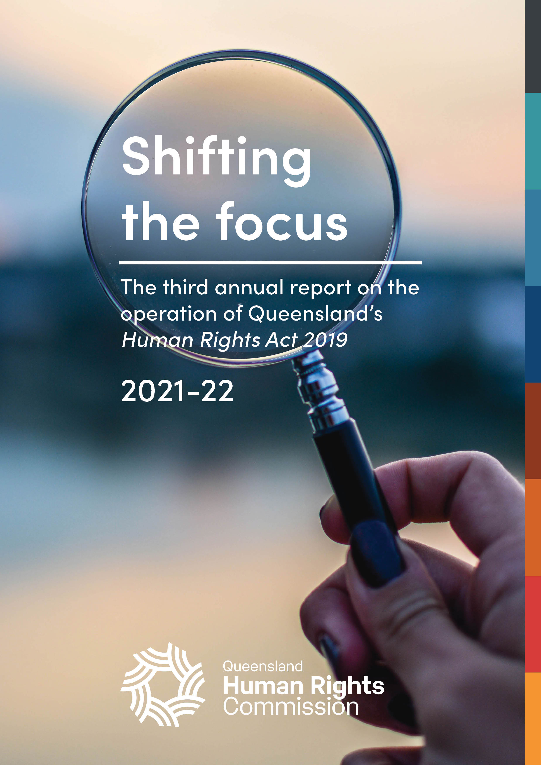

Annual report on the operation of the Human Rights Act 2019

2021-22
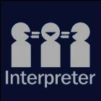
The Queensland Human Rights Commission is committed to providing accessible services to Queenslanders from all culturally and linguistically diverse backgrounds. If you have difficulty in understanding the annual report, you can contact us on toll free 1300 130 670 and we will arrange an interpreter to effectively communicate the report to you.
English: If you’d like us to arrange an interpreter for this report, please call us on 1300 130 670.
Spanish: Si desea que nosotros para solicitar un intérprete de este informe, por favor llámenos en 1300 130 670
French: Si vous souhaitez organiser un interprète pour ce rapport, veuillez nous appeler au 1300 130 670
Chinese: 如果您想让我们为此报co告安排传译员，请致电我们 1300年 130 670
Arabic: إذا كنت تريد منا أن يرتب مترجما لهذا التقرير، يرجى الاتصال بنا على 1300 130 670
German: Wenn Sie uns einen Dolmetscher für diesen Bericht anordnen möchten, rufen Sie uns bitte auf 1300 130 670
Turkish: Lütfen bizi arayın 1300 130 670 bizimle bu rapor için bir tercüman istiyorsanız,
Japanese: このレポートのための通訳の手配を希望する場合は、1300年 130 670 に問い合わせください。
Dutch: Als u wij dat wilt te regelen een tolk voor dit verslag, bel ons op 1300 130 670
Korean: 우리가이 보고서에 대 한 해석자를 정렬 작업을 원하시면 전화 주시기 바랍니다에 1300 130 670

© Queensland Human Rights Commission 2022
ISSN 2652-8835 (online)
Licence: This annual report is licensed by Queensland Human Rights Commission under a Creative Commons Attribution
(CC BY) 4.0 International licence.
To view a copy of this licence, visit: http://creativecommons.org/licenses/by/4.0/
CC BY Licence Summary Statement: In essence, you are free to copy, communicate and adapt this annual report, as long as you attribute the work to the Queensland Human Rights Commission.
Attribution: Content from this annual report should be attributed as: Queensland Human Rights Commission, 2021-2022 Annual report on the operation of the Human Rights Act 2019.

This publication is available in electronic format on the Commission’s website at: www.qhrc.qld.gov.au.

Contents
Commissioner’s foreword 5
About the Commission 7
About this report 8
Report summary 9
Report highlights 13
Human rights timeline: 2021-22 18
About the Human Rights Act 2019 20
Human rights and the parliament 26
The role of Queensland Parliament 27
Human rights indicators 30
Significant legislation 2022-22 36
Summary of the role of parliament in 2021-22 44
Human rights in courts and tribunals 46
The role of courts and tribunals 47
Key cases 52
Interventions 56
Summary of the role of courts and tribunals in 2021-22 58
Human rights and the public sector 60
Obligations on public entities 61
Developing a human rights culture 61
Indicators of a human rights culture 62
State public entities 63
Local government public entities 83
Human rights leadership 92
Progress towards a human rights culture in government and councils 95
Building Belonging: A Review of Queensland’s Anti-Discrimination Act 96
Functional public entities 98
Human rights complaints 99
About human rights complaints 100
Complaints made directly to public entities 100
Early complaint resolution 104
Complaints made to the Commission 105
Resolved complaint case studies 124
Human rights in the community 130
Community education and training 131
Appendices 134
Appendix A: Courts and tribunals 135
Appendix B: Human rights indicators 138
Appendix C: Complaints data tables 142
Appendix D: Human rights timeline 2021-22 149

Commissioner’s foreword
Since the Human Rights Act became fully operational on 1 January 2020, COVID-19 has been the lens through which we’ve viewed much of its impact.
Complaints about COVID-19-related issues have comprised the bulk of human rights complaints received by the Commission, and formed the biggest share of our public comment and awareness-raising about the Act. The work of many of Queensland’s public entities in developing human rights compatibility assessment tools has been sharply focussed on pandemic response measures. Courts are grappling with multiple matters which will require them to assess the human rights impact of now-lapsed public health directions, while parliament has continued to pass COVID-related legislation and extend emergency powers.
While it is no surprise that an international pandemic and its inescapable impact domestically has been the focal point for Queensland’s newly minted human rights legislation, three years into the Act’s operation, it is time to lift our eyes to the horizon and expand our understanding of how human rights protections apply to acts and decisions beyond those related to COVID.
Looking forward, it is important to welcome signs of progress while also being realistic about shortcomings or areas which need further attention.
Human rights complaints to the Commission are still heavily COVID-focussed, but advocates have reported encouraging successes in using human rights arguments in the housing and homelessness sector to secure good outcomes for their clients without the need to engage in a formal complaint process. This is the dialogue model in action and is a promising sign of what is possible to achieve outside the formal complaints process.
The work of parliamentary committees in examining human rights compatibility is becoming more sophisticated and detailed, and while this has not yet led to recommendations for proposed legislation to be amended it is nonetheless a welcome development and an area we hope to continue to see growth in over the coming years.
The ability to enforce rights is fundamental to the effectiveness of human rights protections. This year there have been important developments in Queensland’s emerging human rights jurisprudence. These include the Supreme Court’s ruling about inhumane treatment of a prisoner subjected to prolonged solitary confinement and the Land Court’s historic decision to allow evidence to be given ‘on country’ by First Nations witnesses after a consideration of their cultural rights under the Act.
Outside COVID, public entities are still in varying stages of implementing the Act, and approaches differ depending on the size and sector of the entity, as well as its location. Identifying when complaints from clients or service users are human rights-related continues to challenge most public entities. This is particularly the case where the complainant does not raise the Act themselves, or where there are inconsistencies between different divisions of the organisation in terms of complaint handling. These challenges are reflected in the complaints data from public entities contained in this report.
Councils too appear to have widely differing approaches to implementation, partly as a result of funding and resourcing issues. The lack of resourcing for smaller and more remote councils is an ongoing concern in terms of the Act’s operation, and there appears also to be a gap in including human rights considerations in local government law-making processes statewide.
As the pandemic begins to subside it is critical we all reflect on how the Act will be used to protect and promote human rights into the future, where COVID-19 issues are less likely to dominate and other challenges come to the fore.

Scott McDougall
Commissioner
Queensland Human Rights Commission

About the Commission
The Queensland Human Rights Commission (the Commission) is an independent statutory body established under the Anti-Discrimination Act 1991. The Commission was formerly the Anti-Discrimination Commission Queensland and was renamed the Queensland Human Rights Commission on 1 July 2019 following the passage of the Human Rights Act 2019 (the Act). The functions and powers of the Commission under section 61 of the Act are:
- to deal with human rights complaints;
- if asked by the Attorney-General, to review the effect of Acts, statutory instruments and the common law on human rights and give the Attorney-General a written report about the outcome of the review;
- to review public entities’ policies, programs, procedures, practices and services in relation to their compatibility with human rights;
- to promote an understanding and acceptance, and the public discussion, of human rights and this Act in Queensland;
- to make information about human rights available to the community;
- to provide education about human rights and this Act;
- to assist the Attorney-General in reviews of this Act under sections 95 and 96;
- to advise the Attorney-General about matters relevant to the operation of this Act; and
- another function conferred on the Commission under this Act or another Act.

About this report
Section 91 of the Act requires that, as soon as practicable after the end of each financial year, the Commissioner must prepare an annual report about the operation of the Act during the year. The purpose of this report is to provide a resource for government, parliament, and the community on the operationalisation of the Act and the degree to which it is achieving its objectives. The Act will be reviewed in 2023 and 2027, and the content of this report will provide evidence of how the Act has operated in its early years.

Report summary
Table 1: Required information for this report under section 91 of the Human Rights Act 2019
Section | Required information
91(2)(a) | details of any examination of the interaction between this Act and other Acts, statutory instruments and the common law  This provision relates to section 61(b) of the Act. In May 2021, Queensland’s Attorney-General asked the Commission to undertake a review of the Anti-Discrimination Act 1991 (Qld) pursuant to section 61(b) of the Human Rights Act and section 235(k) of the Anti-Discrimination Act 1991. The review report, Building Belonging – Review of Queensland’s Anti-Discrimination Act 1991, was handed to the Attorney-General on 29 July 2022. For more information see the Human rights and the public sector chapter.
91(2)(b) | details of all declarations of incompatibility made  No declarations of incompatibility were made in the 2021–22 financial year.
91(2)(c) | details of all override declarations made  No Override Declarations were made in the 2021–22 financial year.
91(2)(d) | details of all interventions by the Attorney-General or the commission under section 50 or 51  The Commission intervened in 10 court matters, 8 in the Supreme Court and 2 in the Coroners Court.  The Attorney-General intervened in 10 matters, 8 of which are the same matters in the Supreme Court in which the Commission intervened. Of the remaining, 1 matter is subjection to publication restrictions and 1 is ongoing.
91(2)(e) | the number of human rights complaints made or referred to the commissioner  The total number of human rights complaints lodged with the Commission during the reporting period is not ascertainable, due to the large increase in complaints lodged and the impact this has had on assessment timeframes and reporting.  Complete data is however available for the first two quarters of the financial year from 1 July 2021 to 31 December 2021. In this 6-month period, the Commission received 251 complaints identified as human rights complaints, of which:  157 were human rights only complaints.  94 were piggy-back complaints.
91(2)(f) | the outcome of human rights complaints accepted by the commissioner for resolution by the commission, including whether or not the complaints were resolved by conciliation or otherwise  Of the 191 accepted complaints finalised in the 2021–22 financial year:  61 complaints were resolved  41 complaints were referred to the Queensland Civil and Administrative Tribunal  16 complaints were referred to the Queensland Industrial Relations Commission.  For more information, see the Human rights enquiries and complaints – Outcomes of finalised complaints and Resolved complaint case studies sections.
91(2)(g) | the number of human rights complaints resolved by the commission  In the 2021–22 financial year, 61 complaints were resolved and finalised, comprising:  12 human rights only complaints resolved and finalised by the Commission; and  49 piggy-back complaints resolved and finalised by the Commission.  For more information, see the Human rights enquiries and complaints – Human rights complaints snapshot.
91(2)(h) | the number of conciliation conferences conducted under this part  170 conciliation conferences relating to human rights were scheduled in the 2021–22 financial year. Piggy-back complaints accounted for 137, and 33 were for human rights only complaints.  For more information, see the Human rights enquiries and complaints – Dispute resolution process: conciliation and early intervention section.
91(2)(i) | the number of public entities that were asked or directed to take part in a conciliation conference, and the number that failed to comply with a direction to take part  Most accepted complaints involved more than one respondent, and some public entities were directed to attend on more than one occasion. Overall, 192 discrete respondents were directed to take part, of which 138 were individual people, and 54 were public entities such as government departments or councils.  No public entities failed to comply with a direction to attend a conference in the 2021–22 financial year.  For more information, see Human rights enquiries and complaints – finalised complaints by sector.
91(2)(j) | the number of human rights complaints received by particular public entities decided by the commissioner  This information is too detailed to reproduce in the report summary.  See the Human rights complaints – Complaints made directly to public entities.
88(4) | details of action the commissioner considers the respondent should take to ensure its acts and decisions are compatible with human rights, following an unresolved conciliation  None were published in the financial year.

Report highlights

Impact of COVID-19
This year, 43% of the human rights complaints finalised by the Queensland Human Rights Commission related to COVID-19, up from 25% the previous year. These complaints commonly raised issues about vaccination, wearing masks, border restrictions, and hotel quarantine. The high proportion of COVID-19-related complaints has influenced the complaints data presented in this report and continues to determine the agencies most complained about (e.g. health agencies and police) and the rights most often identified in complaints (e.g. freedom of movement).
More information on complaints about human rights is available under the Human rights complaints chapter of this report.
The Queensland Parliament has continued to extend the public health emergency period through short-term legislation. While the Commission acknowledges the need to manage the spread of COVID-19, the Commission recommends that this be achieved through long-term legislation that incorporates safeguards to protect human rights, rather than through the continued use of extraordinary powers.
More information on COVID-19-related legislation is available under the Human rights and the parliament chapter of this report.
Public entities have reported that they continue to consider human rights and make decisions about COVID-19 using a rights-based approach.
Queensland Corrective Services have made decisions to increase or decrease control measures in correctional environments subject to a human rights assessment.
Queensland Health has a human rights compatibility assessment as part of the decision-making process for COVID-19 exemption applications. In one instance, consideration of the human rights of affected individuals led to a ‘class exemption’ being made to ensure parents who are COVID-19 positive (or close contacts) can visit their babies in the neonatal intensive care unit after a reduced mandatory isolation period.
More information on human rights culture in the public sector is available in the Human rights and the public sector chapter of this report.

Shifting the focus beyond COVID
Since the Human Rights Act became fully operational on 1 January 2020, the pandemic has largely been the focus of public discourse about human rights, as well as much of the work of those with obligations under the Act. Complaints about COVID-19-related issues have formed the bulk of complaints received at the Commission, public entities have developed tools to assist them to make decisions compatibility with human rights in relation to COVID-19, courts have considered human rights in matters about COVID-related restrictions, and parliament has passed COVID-related legislation and used emergency powers.
The Commission is now reflecting on how the Act will be used to protect and promote human rights in the next period in which COVID-19 issues are less likely to dominate.

Human rights dialogue in housing sector
The housing sector has been proactive in implementing the Human Rights Act as demonstrated by a partnership between the Queensland Council of Social Service and the Department of Communities, Housing and Digital Economy to build the capacity of organisations working in the housing and homelessness sector in Queensland.
More information on this partnership is available in the section of this report Human rights and the public sector – Functional public entities.
The Commission heard from community legal advocates that human rights issues raised by public housing tenants were being resolved directly with public housing providers.
Consistent with research findings across human rights jurisdictions in Australia, while there are few reported tribunal and court decisions to indicate that the Human Rights Act is having a significant impact on the sector, the Commission continues to hear that informal discussions and negotiations between advocates and housing service providers framed around the Human Rights Act is leading to early resolution of disputes. In her recent research on human rights jurisdictions in Australia (Queensland, ACT, and Victoria) Professor Tamara Walsh ran focus groups with lawyers, who told her that while many people were hesitant to raise rights-based arguments before tribunals, human rights dialogue was taking place ‘behind the scenes’ in negotiations with social housing providers.
Early resolution of complaints means that parties can avoid the investment of time and resources required by formal complaints processes or proceedings in courts and tribunals. Case studies provided by community legal centres in the section Human rights complaints – early complaint resolution demonstrate the dialogue model working at its best.

Human rights-based policy reform
Human rights considerations were central to the Commission’s recent review of the Anti-Discrimination Act 1991, conducted during the reporting period. The Terms of Reference asked the Commission to consider whether there is a need for any reform to enhance and update the Act to best protect and promote equality. In undertaking the Review, the Commission was required to have regard to compatibility of the Anti-Discrimination Act with the Human Rights Act. The Human Rights Act, including its proportionality test in section 13 of the Act, provided the framework for balancing human rights, especially when considering whether additional groups need protection under the Act, and in examining whether exemptions from discrimination should be changed or removed. The process of reviewing the Anti-Discrimination Act also presented an opportunity to learn from and integrate guidance from international human rights law.
More information is available in the section Human rights and the public sector – Building Belonging: A Review of Queensland’s Anti-Discrimination Act.

Human rights and the courts
Queensland case law on the Human Rights Act from courts and tribunals is gradually emerging, and the outcomes of a number of matters in which the Commission intervened in the reporting period are still to be published.
However, this year in Owen-D'Arcy v Chief Executive, Queensland Corrective Services [2021] QSC 273, the Supreme Court provided important guidance on the obligations placed on public entities in the Human Rights Act.
As an indicator of the extent to which tribunals and courts are starting to consider human rights, the Commission identified 86 cases in which courts or tribunals mentioned the Act. The majority were in tribunal proceedings, including guardianship matters, discrimination, privacy, blue card reviews, and industrial matters. This is up from 59 mentions in the 2020-21 financial year, but as with the previous period, the Act was not the central focus of many cases, despite the mention.
More information is available in the section Human rights in courts and tribunals. Full details of the particular courts and tribunals and causes of action are contained Appendix A: Courts and Tribunals.

Progress in the parliament
The Commission identified 36 Bills that were introduced to the Queensland Parliament during the reporting period, and 21 relevant inquiries that were completed in relation to Bills introduced. Human rights were considered in Statements of Compatibility prepared by government departments in relation to these Bills and by portfolio committees in their inquiry reports.
This report assesses the progress of the developing human rights culture in parliament against a set of indicators that the Commission introduced in our 2020-21 report. As with the previous year, the Commission has observed that it is rare for parliamentary committees to formally make recommendations or comments about human rights compatibility, such as seeking additional information, changes to a Statement of Compatibility, or legislative amendments.
In summary, while relevant human rights issues are being identified and discussed in committee reports, the Human Rights Act does not at this stage seem to be having much of an effect on the outcomes of the legislative process once a Bill is before parliament.
For the third year, no Bills passed with an Override Declaration, which is where parliament can expressly declare a new operates despite being incompatible with rights. However, in one instance the Legal Affairs and Safety Committee suggested an Override Declaration in circumstances that did not appear to be exceptional (such as war or another crisis). The Commission observes that rather than suggesting an Override Declaration, better alternatives may have been available, such as recommending amendments to the Bill, seeking further justification for rights limitations or recommending that the Bill not be passed.
More information is available in the section Human rights and the parliament.

Human rights timeline: 2021-22
Below is a brief timeline of some significant events relevant to the operation of the Act in its third year.
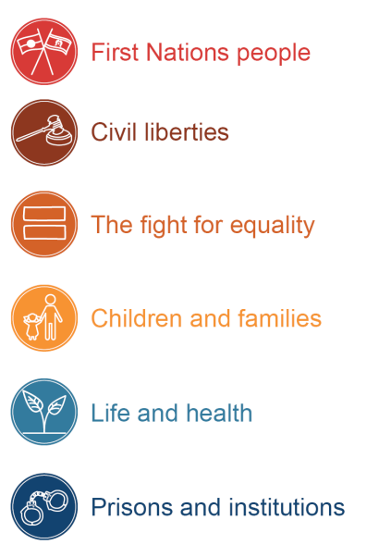
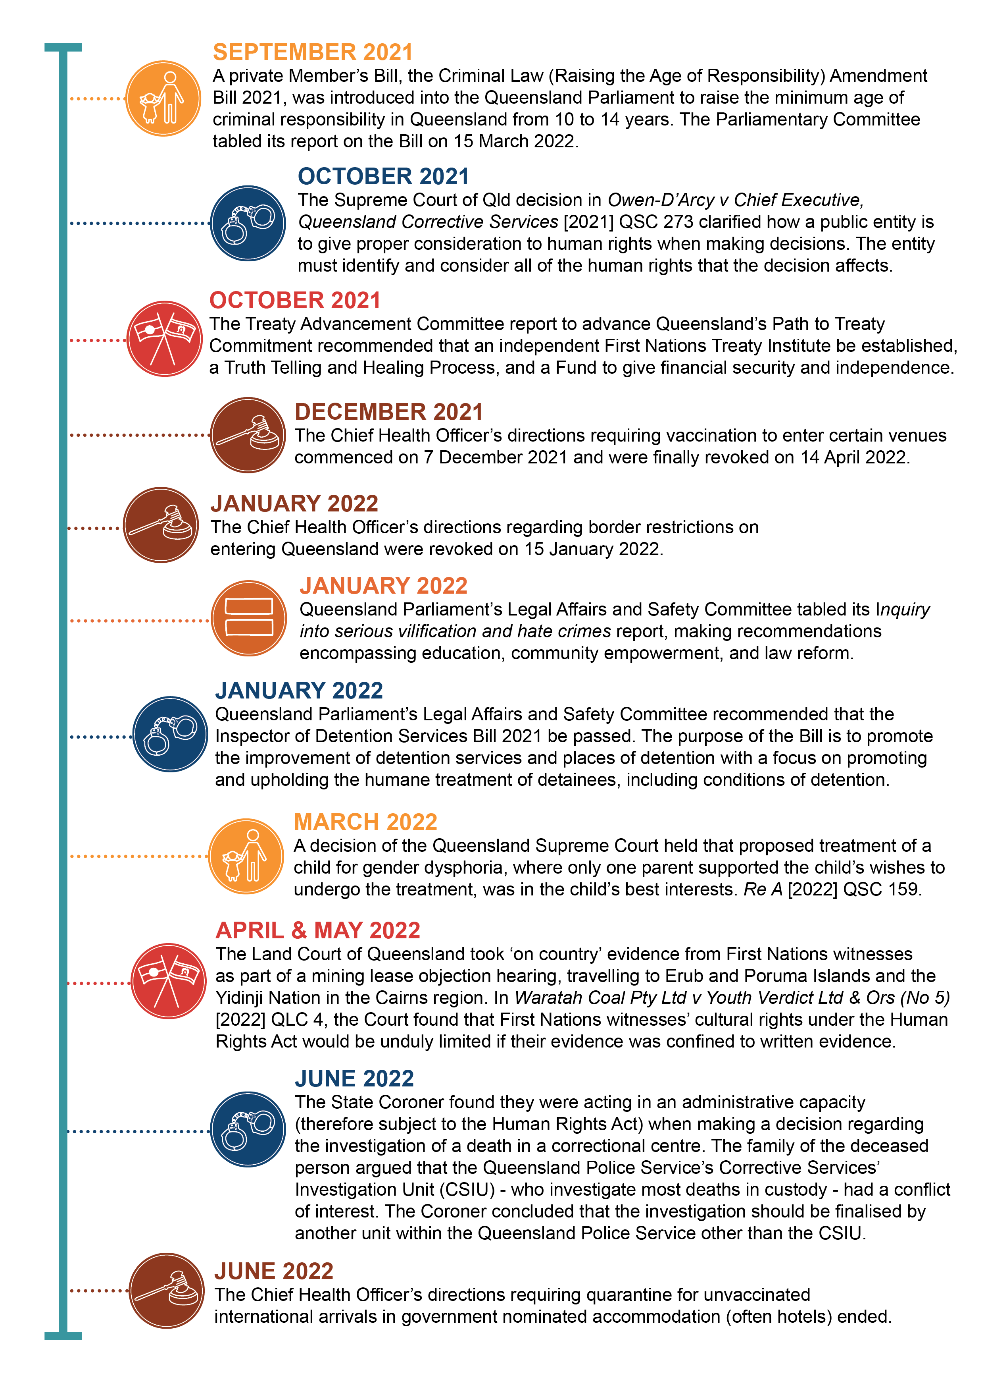



About the Human Rights Act 2019

What are human rights?
Human rights are rights inherent to all human beings.
By promoting respect for human rights, we recognise the dignity and worth of all people.
Human rights should only be limited in a way that can be justified in a free and democratic society based on human dignity, equality, freedom, and the rule of law.

Modern human rights law
The modern idea of human rights derives from the Universal Declaration of Human Rights which was adopted by the United Nations General Assembly in 1948. Australia has shown its commitment to human rights by ratifying treaties, including the International Covenant on Civil and political Rights (ICCPR) and the International Covenant on Economic, Social and Cultural Rights (ICESCR). However, a treaty only becomes a direct source of individual rights and obligations once it is incorporated into domestic legislation.

About the Human Rights Act 2019

Objects of the Act
The main objects of the Act are:
- to protect and promote human rights; and
- to help build a culture in the Queensland public sector that respects and promotes human rights; and
- to help promote a dialogue about the nature, meaning and scope of human rights.

Protected human rights
The Act consolidates and establishes statutory protections for certain rights recognised under international law, including those drawn from the ICCPR and the ICESCR.

The following human rights are protected under the Act:
- Right to recognition and equality before the law (section 15)
- Right to life (section 16)
- Right to protection from torture and cruel, inhuman or degrading treatment (section 17)
- Right to freedom from forced work (section 18)
- Right to freedom of movement (section 19)
- Right to freedom of thought, conscience, religion and belief (section 20)
- Right to freedom of expression (section 21)
- Right to peaceful assembly and freedom of association (section 22)
- Right to take part in public life (section 23)
- Property rights (section 24)
- Right to privacy and reputation (section 25)
- Protection of families and children (section 26)
- Cultural rights – generally (section 27)
- Cultural rights – Aboriginal peoples and Torres Strait Islander peoples (section 28)
- Right to liberty and security of person (section 29)
- Right to humane treatment when deprived of liberty (section 30)
- Right to a fair hearing (section 31)
- Rights in criminal proceedings (section 32)
- Rights of children in the criminal process (section 33)
- Right not to be tried or punished more than once (section 34)
- Retrospective criminal laws (section 35)
- Right to education (section 36)
- Right to health services (section 37)

Government obligations
The Act places obligations on all three arms of government, the legislature, the judiciary and the executive. This means that:
Parliament (the legislature) must consider human rights when proposing and scrutinising new laws.
Courts and tribunals (the judiciary) so far as is possible to do so, must interpret legislation in a way that is compatible with human rights.
Public entities (the executive) – such as state government departments, local councils, state schools, the police and non-government organisations and businesses performing a public function must act compatibly with human rights.
The Act makes it clear that rights can be limited, but only where it is reasonable and justifiable.
This report contains sections reflecting the progress gained by all three arms of government towards the goals of the Act.
- For more information on the parliament see Human rights and the parliament in this report.
- For more information on courts and tribunals see Human rights in courts and tribunals in this report.
- For more information on public entities see Human rights and the public sector in this report.

The dialogue model
Figure 1: Diagram of the dialogue model
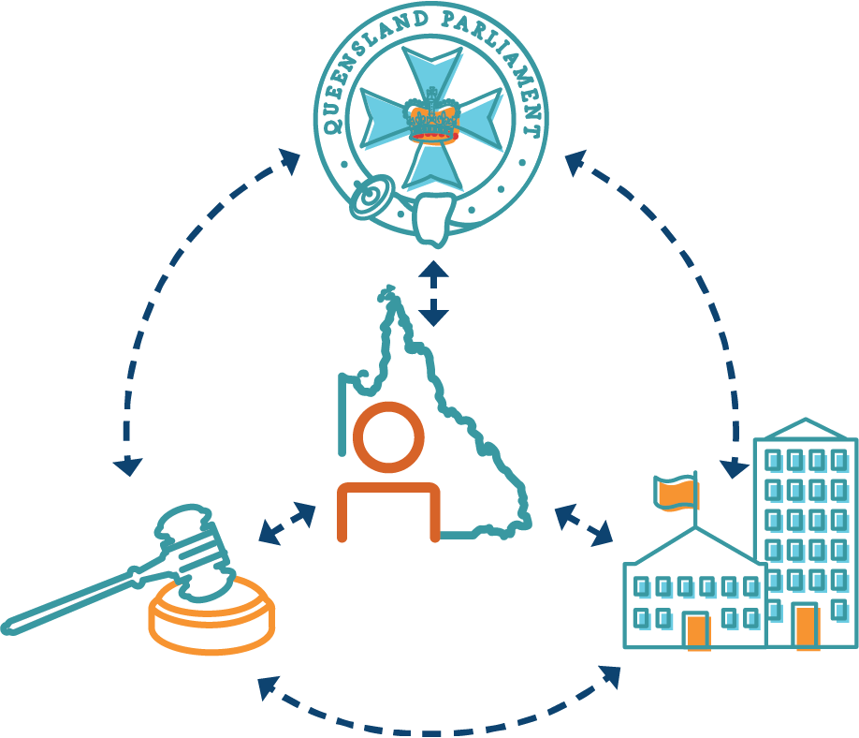

A dialogue model is aimed at prevention rather than litigation, and retains the sovereignty of parliament.
It means that human rights are considered across the three arms of government – when the parliament makes laws, when government applies laws, and when courts and tribunals interpret laws.
There is a mechanism for the court to inform the government if legislation is inconsistent with human rights, but it doesn’t affect the validity of the legislation and parliament has the final say.
It encourages people to talk to public entities if they feel their human rights have been unreasonably limited or not considered at all.
Under the Act, a complaint may be made to the Commission about human rights, provided a complaint has first been made to the public entity. The dispute resolution process is consistent with a dialogue model as it encourages resolution through discussion. The dialogue model is strengthened by the Commission’s capacity to make recommendations for improvements to further human rights compatibility. Section 88 of the Act allows the Commission to prepare a report about a human rights complaint which includes recommendations of actions to be taken by public entities to ensure its acts and decisions are compatible with human rights.

Public entities
Public entities have obligations to make decisions and act compatibly with human rights, and to give proper consideration to human rights when making decisions.
A public entity is an organisation or body performing a public function in and for Queensland.
There are two types of public entities, although the following terms are not used in the Act:
Core public entities are government entities. This includes:
- government agencies and departments
- public service employees
- the Queensland Police Service and other emergency services
- state government ministers
- public schools
- public health services, including hospitals
- local government, councillors, and council employees.
Functional public entities are only considered public entities when they are performing a function of a public nature on behalf of the state. Organisations funded by the government to provide public services would fall under this category. Functional public entities could be non-government organisations (NGOs), private companies, or government owned corporations. A private company funded to run a prison, or an NGO providing a public housing service, would be considered a functional public entity.

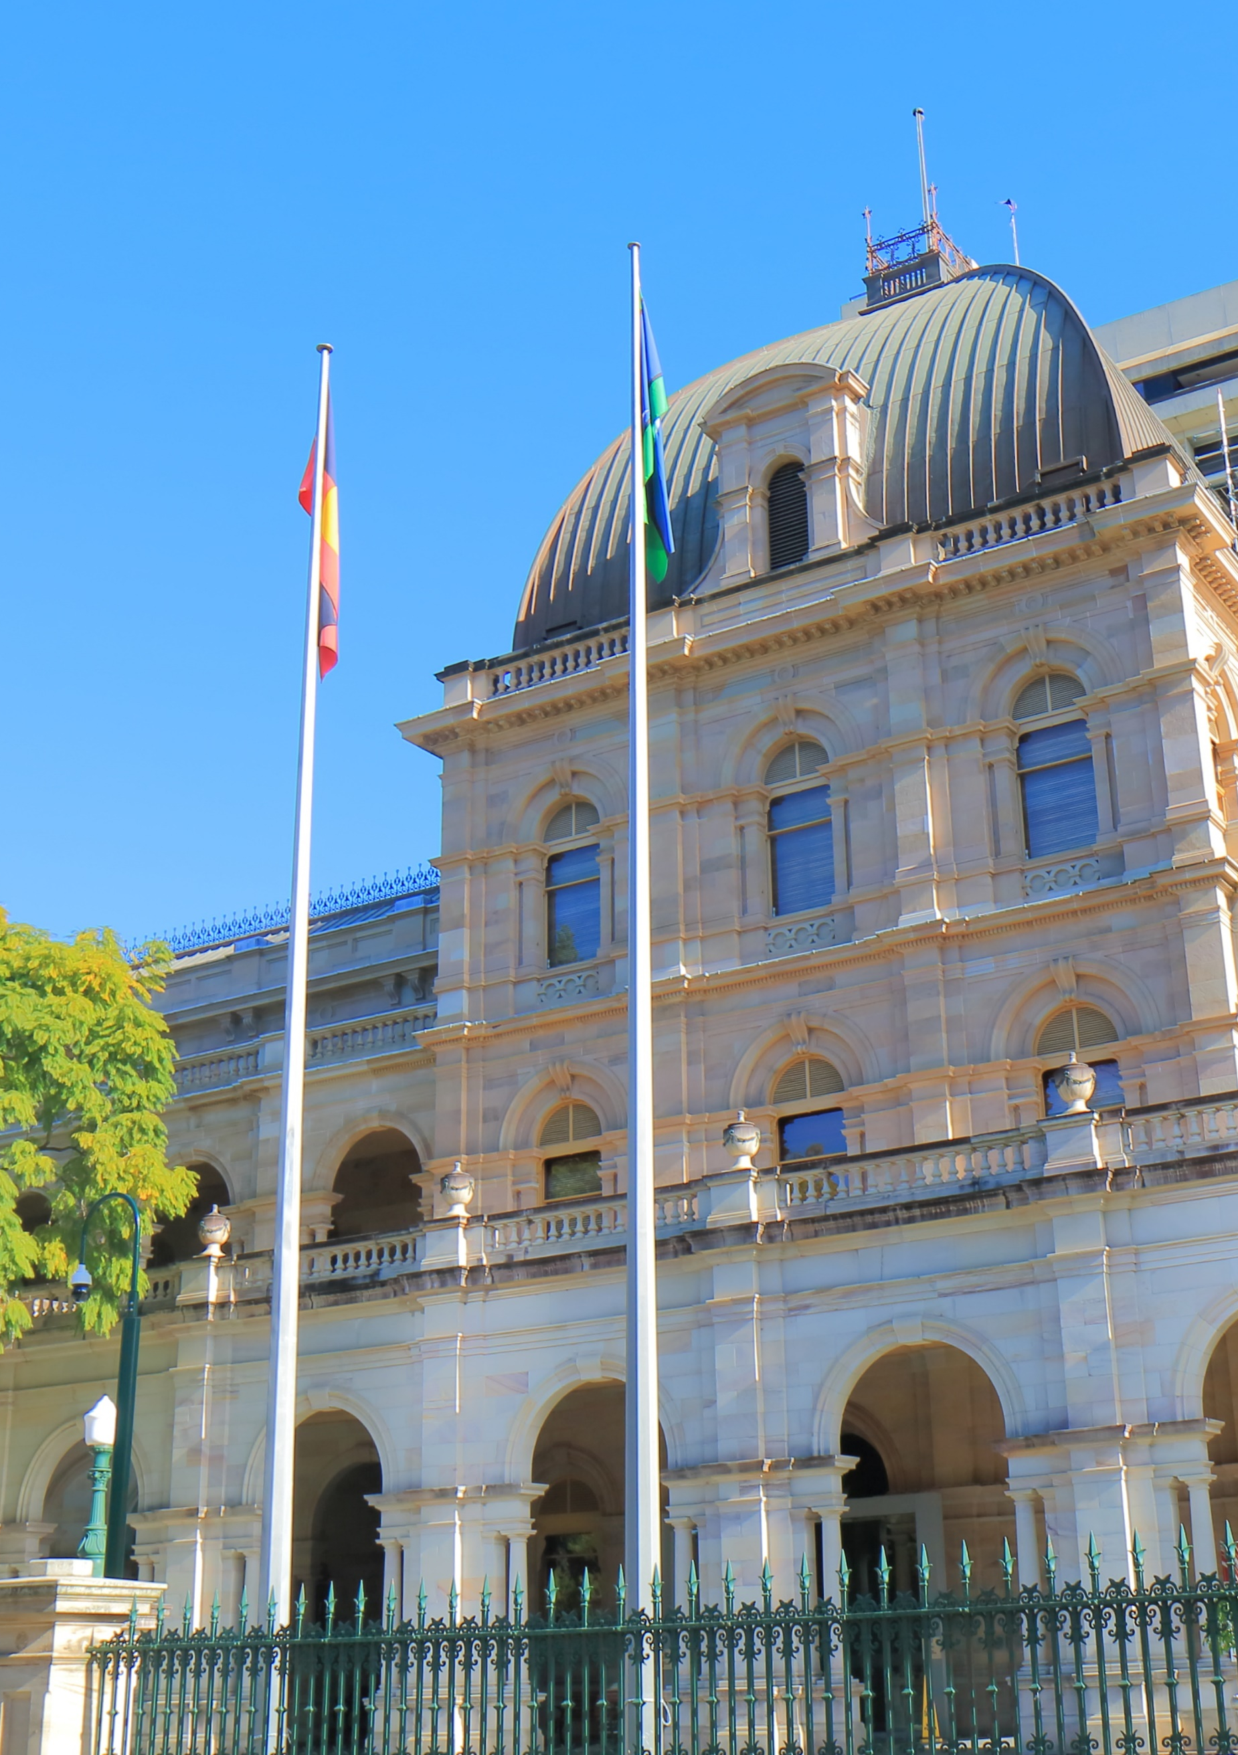

Human rights and the parliament

The role of Queensland Parliament
The Act requires parliament, the courts, and the executive to act compatibly with human rights.
Parliament is responsible for making and passing laws, and must consider whether any limitations on human rights are justified. This occurs through the tabling of Statements of Compatibility with Bills and Human Rights Certificates for subordinate legislation, scrutiny through the committee process, and parliamentary debate. Once a law is passed, any future human rights compatibility assessment will generally only arise if raised in litigation.
The Supreme Court or Court of Appeal cannot invalidate legislation under the Human Rights Act. Instead, it may make a Declaration of Incompatibility where the court is of the opinion that a statutory provision cannot be interpreted compatibly with human rights. This starts a procedure whereby the incompatibility is brought to the attention of the Attorney-General and parliament, but does not affect the validity of the law.

Override Declarations
Parliament may override the Human Rights Act by including an Override Declaration with a Bill expressly declaring that the Act, or a provision of the Act, has effect despite being incompatible with one or more human rights. This power is intended to be used only in exceptional circumstances and the Act gives the examples of: war, a state of emergency, an exceptional crisis situation constituting a threat to public safety, health, or order. A provision of an Act containing an Override Declaration expires five years after the provision commences.
Parliament has not relied on any Override Declarations when passing legislation in this reporting period, although as discussed below an Override Declaration was proposed in a report by a portfolio committee regarding the Police Powers and Responsibilities and Other Legislation Amendment Bill 2021.

Statements of Compatibility
The Queensland Parliament must scrutinise all proposed laws for compatibility with human rights. A member who introduces a Bill must table a Statement of Compatibility with the Bill, and the responsible portfolio committees must consider the Bill and report to the Legislative Assembly about any incompatibility with human rights.
A total of 36 Bills (accompanied by Statements of Compatibility) were introduced during the 2021–22 financial year. Portfolio committees completed 21 relevant inquiries into Bills that were introduced in the parliament and referred to committees for examination during the reporting period. These committees also completed an additional 6 reports, for Bills introduced in the 2020–21 financial year. All but one of these Bills passed during the reporting period.
Statements of Compatibility must explain why any limitation of human rights is demonstrably justifiable. The Queensland Legislation Handbook provides guidance and a template for completion of the Statement of Compatibility by the relevant department. The statements set out the human rights issues, including which human rights are engaged or are of relevance. The Statements then explain how the legislation meets the proportionality test in section 13 of the Act, which allows for rights to be subject to reasonable limits that can be demonstrably justified in a free and democratic society based on human dignity, equality, and freedom.

Human Rights Certificates
Human Rights Certificates must accompany new subordinate legislation and are drafted by the minister responsible for the subordinate legislation. Based on the Commission’s review of the Queensland legislation website, there were approximately 198 new pieces of subordinate legislation accompanied by Human Rights Certificates, tabled in the 2021–22 financial year.
The format and content of the Human Rights Certificates is similar to Statements of Compatibility, described above.

Portfolio committees
Parliamentary committees enhance the democratic process by monitoring or investigating issues, reporting to parliament, and scrutinising proposed laws.
The Queensland Parliament has 7 portfolio committees made up of government and non-government members of parliament, and it is their job to inquire into proposed laws before they are debated in parliament. Under the Act, the portfolio committee responsible for examining a Bill must consider and report to the parliament about whether or not the Bill is compatible with human rights and consider and report to parliament about the Statement of Compatibility tabled with the Bill.
A strength of the Queensland Parliamentary committee system is that committees generally invite submissions to aid in their consideration of a Bill and hold public hearings at which evidence is heard. This provides an opportunity for broader public debate about proposed laws. In the context of human rights legislation, they can assist parliament in assessing the human rights implications of new laws, expose legislation to effective scrutiny independent of the executive, and allow for public participation in the human rights dialogue and debate. The committees then report to parliament about the Bill and may make comments about the Statement of Compatibility.
The portfolio committees also consider subordinate legislation, such as regulations, and report on any issues they identify through their consideration of the Human Rights Certificates tabled with the subordinate legislation.

Human rights indicators
The dialogue model adopted in the Act aims to promote a dialogue about human rights between the three arms of government (the legislature, executive, and judiciary) with each arm having a legitimate role to play, while parliament ‘maintains sovereignty’. This model which prioritises discussion, awareness-raising, and education over an enforcement and compliance model, supporting the goal of building gradually towards a human rights culture.
The Commission has developed a set of indicators regarding the development of a human rights culture within the parliament. These indicators are based on the experiences of other human rights jurisdictions and the specific role portfolio committees play in Queensland’s unicameral parliament.
The Queensland Parliament is uniquely placed to assess the human rights implications of proposed legislation. It is a democratic body, representing the Queensland community, with the power to call on expert evidence and advice. However, assessing the efficacy of parliamentary human rights scrutiny involves complex weighing of different public interests and the impact on society of a proposed law.
The Commission is grateful for the opportunity to make submissions and appear before portfolio committees, and in our experience, committees are generally open to hearing about human rights issues arising under Bills and during inquiries. The Commission acknowledges the critical work of committee members, staff, and advisers in building a human rights culture in Queensland.
The observations in this report are not based on the Commission’s direct experiences of the parliamentary scrutiny system, but are primarily drawn from the portfolio committee reports, submissions made to committees, statements of compatibility, and parliamentary debate.
These indicators explore the extent to which legislation is assessed for human rights compatibility, the adequacy of Statements of Compatibility, and how this is discussed through the parliamentary process. The indicators do not judge whether a Bill is compatible or not. Rather, they capture how concerns about human rights compatibility are raised through the scrutiny processes used in Queensland, and if such concerns are robustly debated in the parliament.

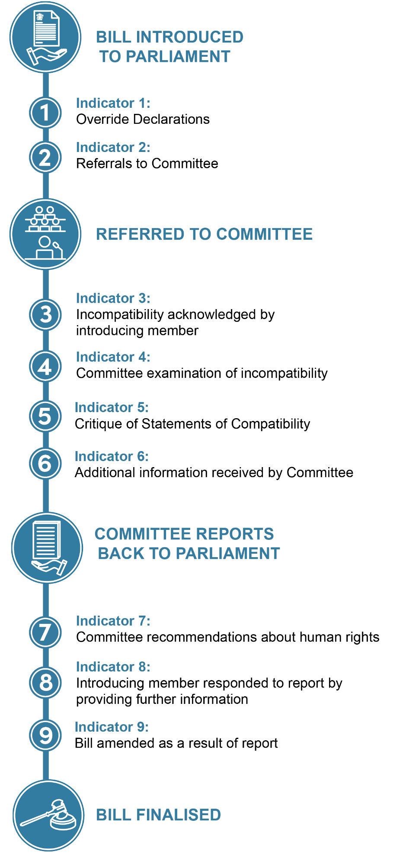
Figure 2: Indicators of parliamentary human rights culture diagram

Indicator 1: Override Declarations
Parliament may, in exceptional circumstances, expressly declare an Act has effect despite being incompatible with one or more human rights. This indicator considers whether Override Declarations were relied upon by parliament in the 2021–22 financial year.
No Bills were introduced or passed with Override Declarations.

Indicator 2: Referrals to committee
This indicator considers Bills that were passed on an urgent basis and therefore not referred to committee and subjected to usual parliamentary scrutiny.
Only one non-appropriation Bill during the reporting period was declared urgent and therefore debated without inquiry by the relevant portfolio committee. However, this Bill was related to appropriation Bills and debated cognately with them.

Indicator 3: Incompatibility acknowledged by introducing member
This indicator considers Bills that had explanatory materials (including Explanatory Notes and Statement of Compatibility) in which the introducing member raised potential incompatibility.
The Commission was unable to identify any Statements of Compatibility that stated a Bill was potentially incompatible with rights.

Indicator 4: Committee examination of incompatibility
This indicator considers discussion by portfolio committees of statements of partial incompatibility or proposed Override Declarations after these were raised by the introducing member.
As above, for Bills introduced during the reporting period, no portfolio committee was required to consider statements of partial incompatibility.

Indicator 5: Critique of Statements of Compatibility
This indicator considers determinations by portfolio committees in their reports to parliament that Statements of Compatibility were inadequate.
Committee reports published during 2021–22 identified deficiencies in 6 Statements of Compatibility compared with 10 last year.
Issues identified in Statements of Compatibility included:
- failure to consider all relevant human rights limited by the Bill.
- failure to particularise justifications for limiting individual human rights.
- insufficient justification for limitations to satisfy the justification criteria set out in section 13 of the Act, such as less restrictive alternatives to achieve the stated purpose or more information about proposed safeguards. In one case, this lack of justification led the committee to question if provisions of the Bill may be incompatible.
- further consideration necessary on how the approach in the Bill differs from approaches taken to similar issues in other human rights jurisdictions.

Nearly three-quarters of committee reports published this year found the Bills they were examining had adequate statements.

Indicator 6: Additional information received by committee
This indicator considers further information received by portfolio committees and whether this resolved concerns about lack of justification for limitations on human rights.
This indicator reveals the effectiveness of Queensland’s scrutiny process, as the ongoing dialogue between government departments, committees, and stakeholders through the inquiry process allows further information to be elicited from the government about human rights compatibility and published in committee reports.
In those reports that discussed human rights limitations, on 8 occasions the committee published additional information regarding the limitations provided by the government.

Indicator 7: Committee recommendations about human rights
This indicator considers recommendations made by portfolio committees about human rights compatibility in reports to parliament.
The Commission was unable to identify any formal recommendations about human rights' compatibility made in reports during the reporting period; however, committees did make specific comments in relation to three Bills seeking further information from the government regarding concerns about human rights compatibility.

Indicator 8: Introducing member responded to report by providing further information
This indicator considers whether the member of parliament introducing the bill responded to committee recommendations and/or provided further justification for limitations on human rights.
As discussed further below, on one occasion further information regarding human rights compatibility was provided through the government response to the committee report and in the debate stage, although the committee’s recommendation on this issue did not specifically identify the human rights computability issues. These were however discussed in the committee’s report.

Indicator 9: Bill amended as a result of report
This indicator considers amendments to Bills as a result of human rights issues raised in the committee process.
It appears no Bills were amended during the reporting period arising from human rights issues raised in portfolio committee reports.

Significant legislation 2022-22
A summary follows of legislation introduced in the 2020–21 financial year that raised significant human rights issues.

Voluntary Assisted Dying Bill 2021
This Bill was developed after extensive community consultation conducted by independent and parliamentary bodies, including a comprehensive review by the Queensland Law Reform Commission. The parliamentary process for consideration of this Bill provided a positive example of the dialogue model of human rights.
The Bill and Statement of Compatibility were discussed at length throughout the Health and Environment Committee’s report, not just in the formal technical ‘compliance’ analysis at the end of the report. In response to concerns about limitations on human rights raised by stakeholders, additional information was provided to the committee by the Department of Health. After a detailed human rights compatibility analysis, the committee concluded that any limitations on rights were reasonable and justifiable. However, the committee was of the view that careful consideration should be given to the practical operation of the provisions concerning entities that refuse to provide direct access to the voluntary assisted dying scheme. Protection of human rights was also discussed at length during debate on the Bill, which passed without amendment.

Housing Legislation Amendment Bill 2021
This Bill implemented key objectives of the Queensland Housing Strategy, including changes to grounds for eviction. The Community Support and Services Committee’s report not only considered rights specifically protected in the Human Rights Act, but also the right to housing.
The committee noted the severity of penalties in the Bill and queried whether a less restrictive option might be to apply lesser penalties or impose civil penalties. However, as this was not included as a formal recommendation, it is unclear if the government or parliament considered this suggestion.

Police Powers and Responsibilities and Other Legislation Amendment Bill 2021
This Bill restricted the ability of certain prisoners to apply for parole. In its report, the Legal Affairs and Safety Committee found the Statement of Compatibility failed to consider and justify limitations on the rights to: equality before the law (section 15), protection from torture and cruel, inhuman or degrading treatment (section 17), and humane treatment when deprived of liberty (section 30). The committee was particularly concerned that the changes would be found to be incompatible with the right to protection from being treated or punished in a cruel, inhuman or way contained in section 17(b) of the Human Rights Act.
The particular aspects of the proposed amendments that were potentially incompatible were:
- the possibility for a declaration to be made precluding the prospect of release despite the prisoner achieving rehabilitation during the term of the declaration, and therefore no longer being a person required to be detained for the protection of the community from the risk of reoffending
- the prospect of ‘rolling’ declarations being made that would deny a life-sentenced prisoner the possibility of ever being released, and removing the hope of release
- the altering of conditions on which prisoners currently serving life sentences may be released is incompatible with the proposition (accepted by the European Court of Human Rights) that a prisoner is entitled to know ‘at the outset of [their] sentence’ what they must do to be considered for release, and under what conditions, including when a review of their sentence would take place, or could be sought.
The committee found it could be argued that the justification provided by the State was insufficient to satisfy various criteria in the proportionality test (section 13) in the Act. The primary aim of the restricted prisoner declaration was to protect victims’ families, friends, and the broader community from further trauma caused by restricted prisoners being considered for parole at ongoing short intervals. A secondary aim was the protection of the community, given that a declaration will prevent certain people who present an unacceptable risk to the community from applying for parole and being released into the community.
The committee stated:
… no evidence is provided to support the assertion that victims’ families, friends and the community experience trauma caused by restricted prisoners being considered for parole under the currently permitted yearly intervals. There is no evidence that restricted prisoners in fact apply for parole each year. It is not apparent how persons other than those required to be notified would find out that a life prisoner has made an application for parole. By contrast, the experiences of the courts in Europe, New Zealand, and Canada show that the harms suffered by prisoners who are denied the opportunity to seek parole are sufficiently concrete as to be the basis for challenges to the highest courts in each of those jurisdictions.
The committee also noted that it could be argued that the secondary purpose (protection of the community) was not rationally connected to the proposed amendments.
In relation to other amendments in the Bill, the committee identified that the right not to be tried or punished more than once (section 34 of the Act) was limited by the addition of 9 Commonwealth child sexual abuse offences as reportable offences under Queensland law. While the committee concluded the limitation was reasonable, it noted that this was not dealt with in the Statement of Compatibility.
The Bill also expanded the scope of banning notices to include persons who unlawfully possess a knife. The committee found the Statement of Compatibility failed to consider the right to privacy in relation to the reasonable expectation of privacy that may exist within a person’s vehicle in which a knife may be located.
The committee concluded that the Bill was compatible with the Human Rights Act other than the proposed amendments concerning the introduction of restrictions for certain prisoners to apply for parole. The committee considered that these amendments may be incompatible with the right to be free from cruel, inhuman or degrading treatment or punishment and the right to humane treatment in detention.
However, rather than recommending that the government amend the Bill to ensure compatibility, or to provide further justification, the committee identified that making an Override Declaration under section 43 of the Act would alleviate the risk that these proposed amendments are found to be incompatible with rights protected by the Human Rights Act. The committee suggested that an Override Declaration would remove the application of the Act, if the government considered that there were exceptional circumstances that could justify the parliament making such a declaration.
While the Human Rights Act and these issues were discussed during the debate stage of the Bill, no such Override Declaration was made.

Health and Other Legislation Amendment Bill 2021
This Bill proposed amendments to various legislation to improve the operation and provision of health services in Queensland. While the amendments generally strengthened human rights protections, the Commission made submissions regarding unjustified human rights limitations imposed by the current framework for people found unfit for trial under the Mental Health Act 2016, as well as recommending clarification and amendment of provisions that restrict publication of reports of proceedings of the Mental Health Court and the Mental Health Review Tribunal.
To ensure the protection of patient privacy, the Commission and others commented on proposed amendments to the Hospital and Health Boards Act 2011 that expand access to Queensland Health hospital information to external-allied health services.
The State Development and Regional Industries Committee noted their concern about amendments to the Termination of Pregnancy Act that could require students undertaking a clinical placement to assist in termination of pregnancies even if they hold a conscientious objection. In a positive example of the dialogue model, the committee published additional information received from Queensland Health regarding the limitation on rights arising from these concerns. Despite this, the committee noted that the Statement would have benefited from further detail on amendments relating to the Termination of Pregnancy Act. The committee recommended that the Minister provide this detail in the second reading speech, which she did.

State Penalties Enforcement (Modernisation) Amendment Bill 2022
This Bill included a framework to allow the State Penalties Enforcement Registry (SPER) staff to wear body-worn cameras to promote the integrity of the enforcement process.
In its report, the Economics and Governance Committee concluded it required further information about the use of the body-worn cameras and the storage, sharing, and disposal of recordings to fully assess whether there are less restrictive means available. In the committee’s view, it was not clear what principles would govern the timing of cameras being switched on or off, and whether there are circumstances in which SPER officers would be required not to use their body-worn cameras (for example, if children are present). While the Statement of Compatibility indicated that SPER currently has guidelines and procedures relating to the use of body-worn cameras and storage and use of footage, no further detail was provided. The committee noted:
The comment in the explanatory notes and statement of compatibility that ‘it is commonplace for body-worn cameras to be used by agencies that have legislative enforcement functions’ is not supported by any evidence, but it seems possible that the public is unaware of the use of body-worn cameras by agencies other than police.
…
The statement of compatibility says that the number of people impacted by the use of body-worn cameras is unlikely to be significant, since ‘body-worn cameras will typically be operated by SPER enforcement officers when exercising functions…against debtors who are subject to escalated enforcement action’. In the committee’s view, this is not a relevant consideration. All individuals are equally entitled to the protection of their human rights; the fact that only a small number of people may have their rights impinged upon should not affect the assessment of compatibility.
Similarly, the fact that ‘recording of persons other than SPER debtors will be inadvertent or incidental’ does not change the fact that those persons may experience an interference with their right to privacy. Indeed, the recording of personal information of people who are not the subject of SPER proceedings is more likely to be considered arbitrary, as there is no reasonable justification for collecting that information. The limitation would be less restrictive if clear provisions were in place to minimise the interference with the rights of third parties.
The committee also commented on the need for Statements of Compatibility to consider not only the amendments contained in the relevant Bill, but the compatibility of the entire legislation as amended.
Section 38 of the HRA requires that a statement of compatibility address whether the Bill is compatible with human rights.
As the Explanatory Note to the HRA explains, ‘the purpose of the statements of compatibility is to elevate the consideration of human rights in legislative debate and to increase the transparency and accountability of Parliament.’
In the committee’s view, this requires a consideration of the overall impact on human rights of the law following the passage of the Bill, and not just a comparison of the pre- and post-amendment effect of specific changes. Allowing this approach would permit laws which are clearly incompatible with human rights to escape scrutiny when being amended, on the basis that interferences were already occurring prior to the amendment. Instead, compatibility should be assessed substantively, having regard to the full effect of the laws as they will operate post-amendment. This will help to ensure that the objects of the HRA can be genuinely fulfilled.
However, because the committee did not make formal recommendations about these issues, it appears that the government has not responded formally or informally and that the Human Rights Act was not discussed in the debate.

COVID-19 related legislation
On 29 January 2020, the Minister for Health made an order under the Public Health Act 2005 declaring a public health emergency for all of Queensland in relation to coronavirus disease (COVID-19). The declared public health emergency for COVID-19 has been extended until 31 October 2022.
Given the ongoing threat of COVID-19, the Commission acknowledges the rationale for continued use of extraordinary powers that were implemented during the reporting period. Nonetheless, throughout the pandemic the Commission has recommended additional safeguards for human rights and that the government consider promulgating these into long-term legislation to cover COVID-19 and any future pandemics or emergencies. Key safeguards the Commission has recommended include: parliamentary oversight, the publication of human rights considerations for all Public Health Directions, a clear process for a person to seek a review of a decision about a Public Health Direction to quarantine, and precise and tailored power for a direction to make vaccination mandatory.

Public Health and Other Legislation (Extension of Expiring Provisions) Amendment Bill 2022
This Bill extended several temporary amendments – including powers given to the Chief Health Officer and emergency officers – to require physical distancing, restrict movement and gatherings, require people to quarantine or self-isolate, and to implement other containment measures. Several submissions to the portfolio committee argued that a more human rights compatible approach would be to provide greater parliamentary oversight in the making of Public Health Directions and this was reflected in the debate of the Bill. According to the Statement of Compatibility, relevant safeguards included that the Chief Health Officer was a public entity under the Human Rights Act when making a public health direction, and therefore required to give proper consideration to human rights and act compatibly with human rights. However, in its submission to the Committee, the Commission noted that this is an unsettled area of law and therefore that safeguard may not apply. The Commission observes that it would have been preferable for the Bill to make the necessary amendments to ensure this protection applied.

Justice Legislation (COVID-19 Emergency Response – Permanency) Amendment Bill 2021
This Bill proposed to permanently legislate various temporary changes enacted to respond to the COVID-19 pandemic.

Public Health and Other Legislation (Further Extension of Expiring Provisions) Amendment Bill 2021
This Bill extended various provisions enacted in response to the COVID-19 pandemic. One issue raised through submissions and discussed in the portfolio committee’s report was the potential for data collected through the Check In Queensland app for COVID-19 contact tracing being used by government agencies for other purposes. This and other limits on human rights were raised in submissions and discussed throughout the report. The government also provided additional justification for human rights limitations to the committee. The committee commented that it would ‘welcome’ the Minister’s consideration of the potential limitation on the right to property arising from the Bill, however it does not appear the government formally responded to this comment.
In contrast, the government did respond to concerns about the use of data from the Check In Qld app. During debate on the Bill, the Minister moved amendments to protect privacy, albeit without specifically referencing the right to privacy under section 25 of the Act. The Statement of Compatibility to the amendments noted that submissions to the committee’s inquiry had raised concerns about the right to privacy and discussed how the amendments were compatible with this right. While they did not pass, other amendments were proposed based on human rights concerns.

Summary of the role of parliament in 2021-22
The Commission’s analysis focuses on the passage of primary legislation through the parliament, including the assessment of Bills and Statements of Compatibility by portfolio committees. The volume of Human Rights Certificates tabled with subordinate legislation means the same detailed analysis cannot be undertaken for these. However, their publication and consideration by portfolio committees remain an important aspect of the human rights dialogue process.
The application of the nine human rights indicators outlined above to legislation considered in the reporting period suggests that human rights compatibility is being addressed both through submissions to committees and in the human rights commentary in committee reports. Comparing last year’s analysis of performance against these indicators to this year’s suggests that the culture of human rights dialogue continues to develop in the Queensland Parliament. There are positive signs, such as the discussion of human rights compatibility during the third reading debate stage of Bills. It remains a positive feature of the Queensland Parliament’s process that committees can collate and consider additional information through the inquiry process and then publish it for the benefit of the community. This approach ensures that limitations on human rights can be considered and potentially resolved by the time the committee delivers its report, prior to the Bill being debated.
One development that the Commission has observed during the reporting period is that committees have extended their consideration of human rights compatibility to all sections of their reports, rather than confining their analysis to a single section. This includes highlighting human rights concerns raised in submissions and using this material to inform the formal, technical analysis of human rights compatibility, usually included at the end of committee reports. The Commission hopes this trend continues and becomes the norm for all committee reports to ensure a thorough consideration of all human rights concerns.
During the reporting period, as was observed last year, several committee reports discussed deficiencies in Statements of Compatibility or raised other concerns about limitations on human rights without making a formal request for more information, or making a recommendation that a Bill be amended. This usually meant no further information was provided by the government to justify a limitation, nor were amendments to the Bill forthcoming.
The Commission respectfully suggests that, wherever possible, rather than recommending an Override Declaration for potentially incompatible legislation, portfolio committees could instead consider making recommendations about how Bills could be amended to ensure compatibility, seek further justification for the limitation on rights, or recommend to parliament that the Bill not be passed.
The Commission also welcomes the approach of the Economics and Governance Committee that a Statement of Compatibility should not merely consider the compatibility of proposed amendments in isolation, but the overall compatibility of legislation as amended. The Commission agrees that this will help to ensure that the objects of the Human Rights Act can be genuinely fulfilled.



Human rights in courts and tribunals

The role of courts and tribunals
The Westminster system of government as it operates in Queensland requires separation of the three arms of government: the legislature (parliament), the executive, and the judiciary. However, each of these arms is required to consider the Human Rights Act 2019 when acting or making decisions. Courts and tribunals are required to consider the Act when:
- interpreting legislation
- acting in an administrative capacity
- carrying out functions where human rights have ‘direct’ application, and
- dealing with matters in which human rights grounds have been ‘piggy-backed’ onto an existing cause of action.

Interpreting legislation
Section 48 of the Act requires that all legislation be interpreted in a way that is compatible with human rights, to the extent possible that is consistent with the purpose of the legislation.
If legislation cannot be interpreted in a way that is compatible with human rights, it is to be interpreted in a way that is most compatible with human rights, to the extent possible that is consistent with the purpose of the legislation.
‘Compatible with human rights’ means that the statutory provision does not limit a human right, or limits a human right only to the extent that is reasonable and demonstrably justifiable in a free and democratic society based on human dignity, equality, and freedom. In section 13, the Act sets out factors that may be relevant in deciding whether a limit on a human right is reasonable and justifiable.
In BSJ [2022] QCAT 51, the Queensland Civil and Administrative Tribunal (QCAT) was asked to consider whether a man had legal capacity to transfer property and whether there was a presumption of undue influence regarding the transaction. In relation to section 48 of the Act, QCAT adopted the approach taken by several Justices of the High Court in the decision of Momcilovic v R (2011) 245 CLR 1, which concerned the equivalent Victorian legislation, that the section only applies when different interpretations are available based on the language of the provision being interpreted, and having regard to the purpose of the provision. In this case, as there was no ambiguity in the definition of ‘capacity’ under the Guardianship and Administration Act 2000, or the meaning of ‘undue influence’ under the Powers of Attorney Act 1998, application of section 48 did not arise.
The Coroners Court has accepted that section 48 must be applied to the interpretation of section 45 of the Coroners Act 2003, which sets out the coroner’s obligations in relation to the scope of coronial investigations and findings.

Declarations of Incompatibility
The Supreme Court or the Court of Appeal may make a Declaration of Incompatibility if the court considers that a statutory provision cannot be interpreted in a way that is compatible with human rights. The experience of other jurisdictions is that this power is rarely used, and Queensland’s Supreme Court did not exercise this power in the 2021–22 year.

Acting in an administrative capacity
When courts and tribunals are acting in an administrative capacity, they are public entities under the Act and are required to:
- act and make decisions in a way that is compatible with human rights, and
- give proper consideration to human rights relevant to decisions they make.
In 2021–22, the following Queensland courts and tribunals acknowledged that they are acting in an administrative capacity and are therefore a public entity with obligations under the Human Rights Act 2019, in the circumstances outlined in Table 2a.

Table 2a: Cases confirming where courts and tribunals are acting in an administrative capacity in 2021-22
Subject matter | Case
Coroners Court when directing or requesting a particular unit within the Queensland Police Service to be responsible for the investigation of a death in custody | Ruling in the Inquest into the death of Selesa Tafaifa (Coroners Court of Queensland, T Ryan, State Coroner, 20 June 2022)
Land Court in relation to the conduct of a hearing of a mining objection | Waratah Coal Pty Ltd v Youth Verdict Ltd & Ors (No 5) [2022] QLC 4
QCAT when deciding an exemption application under section 113 of the Anti-Discrimination Act 1991 | Sunshine Coast Regional Council (No 2) [2021] QCAT 439; Miami Recreational Facilities Pty Ltd [2021] QCAT 378
QCAT when making an interim order for the appointment of a guardian under the Guardianship and Administration Act 2000 | EB [2021] QCAT 434; DP [2021] QCAT 271
Mental Health Court when reviewing a decision of the Mental Health Review Tribunal to remove a condition from a person’s forensic order (community category) | Attorney-General for the State of Queensland v GLH [2021] QMHC 4

Table 2b: Cases where tribunals have stated they are not acting in an administrative capacity in 2021-22
Subject matter | Case
QCAT when making a declaration of capacity under the Guardianship and Administration Act 2000 (as opposed to the appointment of a substitute decision maker) | BSJ [2022] QCAT 51
QCAT when dealing with a referred privacy complaint under section 176 of the Information Privacy Act 2009 | AA v State of Queensland (Office of Industrial Relations) [2021] QCAT 258

Direct application
The Act imposes direct obligations on courts and tribunals to act compatibly with human rights to the extent that the court or tribunal has the function of applying or enforcing those rights. The obligation applies whether or not the court or tribunal is acting in a judicial or administrative capacity.
The rights most likely to be engaged when performing judicial functions include:
- recognition and equality before the law (section 15)
- fair hearing (section 31)
- rights in criminal proceedings (section 32), and
- liberty and security of person (section 29).
In an application for a declaration of capacity, the QCAT considered that the rights to equality before the law and to a fair hearing applied directly to QCAT (BSJ [2022] QCAT 51).

Piggy-back matters
There is no standalone legal remedy available through the courts for an alleged breach of human rights. However, human rights arguments can be added to, or ‘piggy-backed’ on, legal proceedings against a public entity that, under a different law, allege an act or decision of the public entity was unlawful. For example, an application for judicial review of a decision made by a public entity might also include a claim that the public entity breached its section 58 obligations under the Human Rights Act 2019 to act or make a decision in a way that is compatible with human rights and to give proper consideration to a human right relevant to the decision.
In these actions, a person can obtain (non-financial) relief if they successfully demonstrate a breach of section 58 of the Human Rights Act 2019, even if they are not successful in their primary claim for relief.
Owen-D'Arcy v Chief Executive of Queensland Corrective Services [2021] QSC 273 and SQH v Scott [2022] QSC 16 are examples of matters in which human rights were piggy-backed, in the case of the first, to a judicial review, and in the second, to a statutory appeal.

Referrals to Supreme Court
If a question of law arises in a court or tribunal proceeding about the application of the Human Rights Act 2019, or statutory interpretation in accordance with the Act, it may be referred to the Supreme Court of Queensland.
The Commission is not aware of any such referrals occurring in 2021-22.

Queensland cases that have considered or mentioned the Act
In the financial year ending 30 June 2022, courts and tribunals considered or mentioned the Act in 86 matters. Details of the cause of action for each matter are available in Appendix A.
Table 3: Number of matters where courts and tribunals considered or mentioned the Human Rights Act.
Court | Number
Federal Court of Australia | 1
Fair Work Commission | 2
Court of Appeal Queensland | 1
Supreme Court of Queensland | 3
District Court of Queensland | 4
Land Court of Queensland | 2
Mental Health Court Queensland | 1
Coroners Court Queensland | 1
Queensland Civil and Administrative Tribunal, Appeals | 4
Queensland Civil and Administrative Tribunal | 44
Queensland Industrial Relations Commission | 23
Total | 86

Key cases
Queensland courts from a range of jurisdictions considered the Human Rights Act, and a selection of key cases from the reporting period are summarised below.

Owen-D'Arcy v Chief Executive, Queensland Corrective Services [2021] QSC 273
A prisoner applied to the Supreme Court for judicial review of two related decisions to continue his solitary confinement – which had been ongoing for 7 years – for a further 6 months. Alleged breaches of the respondent’s obligations under the Human Rights Act were piggy-backed onto the judicial review application, and proved central to the proceedings, as the only successful grounds involved human rights.

Proper consideration
The court clarified what it means to give proper consideration to human rights in making a decision under the Act and dismissed the idea that section 58(5) of the Act, which is unique to Queensland, ‘codified’ the existing position in Victorian case law.
Instead, section 58(5) sets out two elements necessary to demonstrate that proper consideration has been given to a human right, namely:
- identifying the human rights that may be affected by the decision; and
- considering whether the decision would be compatible with human rights.
Justice Martin stated that identifying the relevant human rights ‘is an exercise that must be approached in a common sense and practical manner’.
In this case, the decision-maker only referred to the applicant's right to peaceful assembly and freedom of association. By failing to identify the prisoner’s right to humane treatment when deprived of liberty, the respondent had failed to give proper consideration to human rights when making the decision.

Compatibility
The court confirmed that the applicant must first demonstrate that a right has been ‘engaged’ or limited. The onus then shifts to the respondent public entity to demonstrably justify the limitation. The standard of proof on the respondent is high and requires a degree of probability which is commensurate with the occasion.
In this case, the court found there was insufficient evidence to show that the applicant had been subjected to torture, inhuman or degrading treatment. However, the applicant’s right to humane treatment when deprived of liberty had been limited, because he had been subject to hardship beyond that experienced by all prisoners by virtue of their detention.
The respondent had not discharged the onus as it had not provided any evidence to support the belief that no less restrictive way of adequately managing the applicant’s risk to others was available. As the respondent had not fulfilled its obligations under the Act, the court concluded that the decisions were unlawful. The applicant was also successful on one ground of judicial review: that the respondent failed to take into account a relevant consideration, namely, the effect of the decision on the applicant’s human rights.

Attorney-General v GLH [2021] QMHC 4
The respondent had been the subject of a forensic order since 2004. On a review of the forensic order, the Mental Health Review Tribunal removed a condition that prevented the respondent from having unsupervised contact with children. The Attorney-General appealed that decision to the Mental Health Court.

Unacceptable risk
The court recognised the regime established by the Mental Health Act 2016 is compatible with the Human Rights Act 2019, and that it was necessary for the court to consider the compatibility of its decision with human rights. The court also held that conditions on forensic orders that limit human rights should only be imposed to the extent necessary to reduce or maintain the risk posed by the person to a not ‘unacceptable’ level; any conditions must be proportionate or no more onerous in their limitation of human rights than required.
In the circumstances of this case, and the expert evidence regarding risk, the appeal was dismissed.

Inquest into the death of Selesa Tafaifa
The Coroner was asked to rule on the conduct of a police coronial investigation into the death of a woman in custody.
The Queensland Police Service unit that would normally carry out such an investigation had been investigating and prosecuting the deceased for criminal charges against Queensland Corrective Services employees. The deceased’s family opposed the investigation by that unit because of conflict-of-interest issues that arose.
The Coroner, acting as a public entity and interpreting legislation compatibly with human rights, took into account a person’s right to life and determined that another unit within the Queensland Police Service should finalise the investigation.

Waratah Coal v Youth Verdict (No 5) [2022] QLC 4
Objectors to a mining lease proposed that the Land Court take ‘on country’ evidence from four First Nations witnesses.
The court acknowledged that it is unlawful for the court to conduct a hearing in a way that is incompatible with human rights. Refusing the application would limit the witnesses’ ability to enjoy and maintain their cultural heritage, specifically the way in which traditional knowledge is imparted, as protected by section 28(2)(a) of the Act. The court granted the application, noting that the inconvenience and cost of an ‘on country’ hearing did not justify the limitation of rights which would result if the witnesses were confined to witness statements.

SQH v Scott [2022] QSC 16
The Crime and Corruption Commission required a person to answer a question that allegedly touched on charges against them and could have an impact on their receiving a fair trial.
The person sought leave to appeal the decision under the Crime and Corruption Act and piggy-backed a human rights claim. The court found that while the person’s right to a fair hearing and right against self-incrimination (that is, the right not to be compelled to testify against themselves or confess guilt) had been engaged, the limit was justified. This included because of the protections in place under the legislative scheme, such as direct use immunity and confidentiality in respect of the identity of the witness and any evidence given. A further protective order required limited disclosure of the evidence to prevent it from being given to the prosecution.

Miami Recreational Facilities [2021] QCAT 378
The Miami Retirement Village applied for a renewal of an exemption previously granted under section 113 of the Anti-Discrimination Act 1991 (Anti-Discrimination Act) for it to restrict accommodation and services in a residential complex to people over 50 years old.
When deciding exemption applications, the tribunal is acting in an administrative capacity and is a public entity. The tribunal identified the right to equality before the law as potentially limited by its decision, and that the factors set out in section 13 of the Human Rights Act to assess proportionality should be considered, along with the aims and objects of the Anti-Discrimination Act. On balance, with emphasis on the short-term effect of ending the exemption, renewal of the exemption was found to reasonably and justifiably limit the right to equality.

Sunshine Coast Regional Council (No 2) [2021] QCAT 439
In another exemption application under the Anti-Discrimination Act, the Sunshine Coast Regional Council sought an exemption to allow it to restrict the grant of permits solely to Aboriginal people and Torres Strait Islander people for the commercial activity of Indigenous tourism on Council-controlled land.
The tribunal concluded that it was not necessary to grant an exemption, as the existing ‘welfare measures’ provision under section 104 of the Anti-Discrimination Act would apply.
Before reaching this conclusion, the tribunal considered if it could interpret section 104 compatibly with the right to equality before the law of non-Indigenous people under the Human Rights Act. The tribunal concluded that the limitation of the human right to equal treatment under the law could be justified. The proposed policy to restrict the grant of permits in the way outlined may also align with section 15(5) of the Human Rights Act as a ‘special measure’. Section 104 of the Anti-Discrimination Act would also amount to a justification of the Council policy should any complaint made against it under the HR Act.

EB [2021] QCAT 434
The Queensland Civil and Administrative Tribunal granted an interim order for the appointment of a guardian for a woman with severe dementia, but refused an interim order for the appointment of an administrator.
In making its decision, the tribunal acknowledged its obligations as a public entity to interpret legislation compatibly with human rights. The tribunal considered the woman’s rights to freedom of movement, privacy and reputation, and fair hearing. The urgent nature of the application, and immediacy of the purpose to protect the woman from the risk of harm justified limiting her right to a fair hearing on a short-term basis, and limits on her rights of free movement and privacy, until the matter is heard.

Interventions
The Attorney-General and the Queensland Human Rights Commission may intervene in proceedings before a court or tribunal in which a question of law about the application of the Human Rights Act arises, or a question about how legislation is to be interpreted in accordance with the Act.

Commission notifications
For proceedings in the Supreme Court or District Court in which a question of law arises that relates to the application of the Act or the interpretation of a statutory provision, parties must give notice in the approved form under section 52 of the Human Rights Act 2019 to the Attorney-General and the Queensland Human Rights Commission. The Commission also receives notifications of proceedings that are not required under section 52 of the Act.
In 2021–22, the Commission received 27 notifications or requests to intervene under the Human Rights Act. Of those, 23 were notices under section 52 of the Act.

Commission interventions
The Commission intervened in two matters before the Coroners Court and eight matters in the Supreme Court.
All the matters in the Supreme Court were applications for judicial review of mandatory requirements for vaccination against COVID-19. The Commission (and the Attorney-General) withdrew from one of the matters when the applicant abandoned their human rights grounds, and the other seven matters are in progress, with no decisions handed down at the time of writing.
One Coroners Court matter is an inquiry into a death in custody, and the other is an inquiry into the deaths of three women who died from complications associated with rheumatic heart disease. Only one interim decision has been handed down in relation to these matters.
During the reporting period, three decisions in which the Commission intervened that were mentioned in last year’s report were delivered. These were:
- SQH v Scott [2022] QSC 16 (4 March 2022)
- Owen-D’Arcy v Chief Executive, Queensland Corrective Services [2021] QSC 273 (22 October 2021)
- Attorney-General for the State of Queensland v GLH [2021] QMHC 4 (delivered 21 June 2021 ex tempore, published October 2021).

Attorney-General interventions
During 2021–22, the Attorney-General intervened in 10 proceedings under the Human Rights Act:
- Eight of those matters are before the Supreme Court and are the same vaccination matters that the Commission has intervened in.
- One matter is subject to publication restrictions.
- One matter is ongoing.
The Attorney-General also intervened in the matters of SQH v Scott [2022] QSC 16 and Owen-D’Arcy v Chief Executive, Queensland Corrective Services [2021] QSC 273 in which judgments were delivered during the reporting period.
A decision was also handed down in TRKJ v Director of Public Prosecutions (Qld) [2021] QSC 297 in which the Supreme Court accepted submissions made on behalf of the Attorney-General. These were to the effect that certain provisions of the Evidence Act 1977 that do not compel a court to read protected communications before granting leave were compatible with human rights. This includes the right to a fair hearing under section 31 of the Human Rights Act.

Summary of the role of courts and tribunals in 2021-22
The Human Rights Act commenced on 1 January 2020 and case law in the superior courts is continuing to develop.
The Supreme Court provided significant guidance this year with Owen-D'Arcy v Chief Executive, Queensland Corrective Services [2021] QSC 273, especially in relation to proper consideration and the onus of proof on each party. Currently, the Supreme Court is considering seven matters subject to interventions by the Commission and Attorney-General that challenge mandatory requirements for vaccination against COVID-19 and raise numerous human rights issues.
Case law has firmly established that Queensland courts and tribunals are subject to the Act when undertaking certain functions. The Land Court, the Mental Health Review Tribunal, and the Coroners Court have all adopted clear positions regarding when they are acting administratively and are therefore public entities with obligations under the Human Rights Act. This has led to positive outcomes, such as the Land Court’s decision to allow evidence to be given ‘on country’ by First Nations witnesses in recognition of their cultural rights.
The Queensland Civil and Administrative Tribunal (QCAT) has also recognised these obligations when deciding exemption applications under the Anti-Discrimination Act for which the Commission provides submissions outlining the key human rights considerations. Other situations in which human rights are regularly considered include appointing guardians under the Guardianship and Administration Act and reviewing decisions to refuse Blue Cards.
In time, the Commission expects that more courts and tribunals will determine when they are acting administratively, and routinely take up their obligations as public entities to act and make decisions compatibly with, and give proper consideration to, human rights.
Courts and tribunals, whether public entities or not, must consider human rights when interpreting legislation and where human rights apply directly to their functions. The Commission noted the absence of specific reference to the Human Rights Act in some cases during the year where human rights generally are discussed. This includes a decision regarding a child’s consent to proposed treatment for gender dysphoria and a decision to consent to sterilisation of a child.
The Commission recognises that there may be limits to judicial consideration where Human Rights Act issues are not raised by the parties. This points to the ongoing importance and value of ensuring that legal advocates and self-represented parties have sufficient awareness and understanding of the role of the Human Rights Act in litigation.



Human rights and the public sector

Obligations on public entities
Public entities have obligations to act and make decisions in a way that is compatible with human rights. This section provides an update on how the Act is making an impact on state public entities, councils, tertiary institutions and functional public entities.

Developing a human rights culture
The Human Rights Act 2019 aims to develop a human rights culture in the Queensland public sector, where the human rights of individual people are respected and promoted.

Cascading culture change model
The Commission has developed the cascading culture change model to illustrate how human rights culture starts with legislation and flows down through regulations, policies, procedures, and services through to the individual.
Figure 3: Cascading culture change model
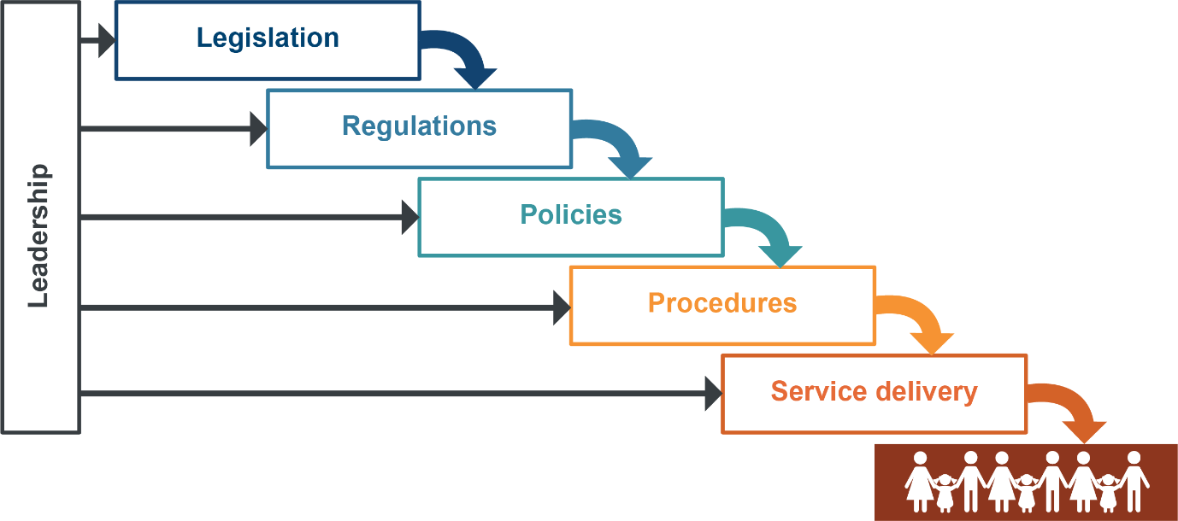
The model recognises that unless legislation and regulations are human rights compatible, there will be limited benefit in changing policies and procedures. Similarly, service delivery is unlikely to improve if policies and procedures are not human rights compliant. For a human rights culture to develop, strong leadership needs to be present at every stage: at the strategic, operational levels and among individual public sector workers on the front line.

Indicators of a human rights culture
In the first year of the Act’s operation, the Commission developed a set of 7 indicators that identify actions that may further the development of a human rights culture, reflecting the elements in the Cascading culture change model. These indicators have become the basis of an annual survey of public entities aimed at evaluating the extent to which the Human Rights Act is influencing the day-to-day business of public entities.
These indicators are:
Indicator 1: Education and staff development
Indicator 2: Community consultation and engagement about human rights
Indicator 3: Awareness raising and support for related entities (including functional public entities engaged by the public entities i.e. contractors)
Indicator 4: Reviews and development of legislation or subordinate legislation / local laws or subordinate local laws
Indicator 5: Review of policies and procedures
Indicator 6: Implementation of internal complaint management for human rights complaints
Indicator 7: Future plans to further the goals of the Act
See Appendix B of this report for the full Indicators of a Developing Human Rights Culture including the specific questions asked of public entities.
In the third year of the Act, we again used these indicators to survey 8 state government public entities, selected because of the relevance of their work to the human rights of people in Queensland. These agencies provided responses to questions about the indicators:
- Department of Children, Youth Justice and Multicultural Affairs (DCYJMA)
- Department of Communities, Housing and Digital Economy (DCHDE)
- Department of Education (DE)
- Department of Seniors, Disability Services and Aboriginal and Torres Strait Islander Partnerships (DSDSATSIP)
- Queensland Civil and Administrative Tribunal (QCAT)
- Queensland Corrective Services (QCS)
- Queensland Health (QH)
- Queensland Police Service (QPS).
We also sought responses from a small cross-section of metropolitan, regional, and remote local governments. Responses to questions about the indicators were provided by the following 7 councils:
- Brisbane City Council
- Ipswich City Council
- Flinders Shire Council
- Mackay Regional Council
- Mornington Shire Council
- Logan City Council
- Sunshine Coast Council.
The full responses from the public entities are not provided below; rather, this section contains a general summary and highlights from the information provided to the Commission, furnished with examples.

State public entities

Indicator 1: Education and staff development
The Commission asked state public entities to report on the extent to which staff awareness about the Act has been raised, what education and training has been provided (including the divisions or work units involved) and through which delivery method (online, face-to-face etc). They were also asked about whether human rights content has been incorporated into induction training and ongoing professional development for staff, and whether examples were provided to tailor training to the particular context.

Mandatory training for all staff
Most agencies reported that online training was their primary method of delivering training and professional development on the Human Rights Act. QH, DSDSATSIP, DCHDE, DCYJMA, QPS, and DE all reported providing mandatory online training on the Human Rights Act during the reporting period.

Tailored training
In addition to mandatory online training, some state public entities reported that training was delivered to specific divisions within their agencies. A combination of frontline, complaints, and policy staff received tailored training about their obligations under the Act.
At DCYJMA the Commission delivered training to the Office of the Child and Family Official Solicitor and Professional Standards teams.
QH reported that Metro North Hospital and Health Service delivered over 450 face-to-face and online training sessions on human rights to the Board, committees, Executive Officers, staff, and consumers, and the Cairns and Hinterland Hospital and Health Service rolled out training for consumer complaint handlers.
At Disability Accommodation, Respite and Forensic Services – DSDSATSIP’s largest business service area, 385 staff completed role-specific human rights training.
Staff from the Strategic Policy and Legislation team at DSDSATSIP completed Human Rights Policy Training led by the Human Rights Unit in the Department of Justice and Attorney-General. This training provided guidance on identifying human rights, undertaking Human Rights Impact Assessments, undertaking section 13 proportionality analysis, and building a human rights culture. Officers also undertook legislative, policy-specific human rights training.
DE reported that, wherever possible, training is tailored to the department’s context to ensure material and human rights scenarios are meaningful and reflect human rights in action in schools, regions, and divisions. For instance, a human rights session was presented to new and recently appointed principals as part of the Principal Induction programs (SIMposiums) held in 2022, with supporting web resources also made available. The Principal Induction program has been offered in person and online to provide greater flexibility and ensure strong uptake by principals.
The QPS delivered specialist human rights training to the Complaint Management Unit within the Internal Investigation Group, which is responsible for assessing human rights complaints.
QCAT provided mandatory ‘One QCAT’ training that included discussion on inclusion and diversity.

Practical application
The DCYJMA reported that they have commenced updating the mandatory iLearn training package and are tailoring it specifically for Child Safety and Youth Justice, with the addition of specific scenarios and examples relating to compatibility, quizzes relating to Child Safety and Youth Justice-related public entities, and the inclusion of the Commission’s decision-making flowchart.
DSDSATSIP reported that an updated suite of human rights scenarios is being developed to support staff in their various roles and business areas within the department to embed an understanding of the requirements of the Act.
QH’s online training module is tailored to the public health system and includes interactive scenarios relating to human rights in a hospital setting.
QPS provided some further detail about the content of their online training which:
...provides clear examples of situations general duties officers would regularly find themselves in and requires members to assess how human rights intersect with police powers and responsibilities in those situations.

Integrating human rights in other training
QPS told us that human rights considerations are also embedded throughout other training products for members at all stages of their careers. This ensures members understand human rights linkages to their everyday work, and includes:
- accessing QPS information – human rights considerations when dealing with information held on police systems
- Cellebrite – human rights requirements relating to collecting and storing personal information from electronic devices during criminal investigations
- child protection investigations – human rights of children and victim-centric and trauma-informed policing
- domestic and family violence
  - protecting victims from coercive control, intimate partner sexual violence, stalking, strangulation, and withdrawal of gender-affirming hormone treatments or contraceptive treatments
  - identifying the person most in need of protection
  - naming children (including unborn children) on protection order applications
  - making police bail decisions to protect victims while ensuring defendants’ rights are safeguarded
- integrity – ethical and professional behaviour of members when interacting with the Queensland community.

Information for staff
QH made resources available on their intranet with links to case law, fact sheets, and promotional material for Human Rights Week.
QCAT staff have access to internal Department of Justice and Attorney General human rights resources, including an induction pack, managers’ toolkit and training presentations, fact sheets, and guides. Resources are designed to:
…help managers lead team discussions, improve their team’s overall understanding of human rights, discuss how human rights apply to their daily work and incorporate human rights within team meetings and activities.
The DCHDE is currently updating their Human Rights Hub to include a suite of new documents (such as flowcharts and instructions) developed to support staff to meet their obligations under the Act.
For Human Rights Week, the Office of the Chief Practitioner in DCYJMA made a podcast for staff from an interview with the Queensland Human Rights Commission’s Deputy Commissioner and a Principal Lawyer. The podcast explored the Commission’s journey and the implementation of the Act in Queensland.
At the DE, resources are provided and maintained on the department’s intranet to allow all staff to build their understanding of human rights and meet their obligations under the Act.
QPS reported that the Service regularly shares information about human rights with all Service members through its internal communications platforms. This includes information about individual human rights, external training events about human rights, and questions and answers about how human rights should be considered in real life situations. Members also raise questions and contribute to discussions through online forums and workplace conversations.
QCS told us that the Service has raised human rights awareness across the agency and supports staff to apply human rights considerations in day-to-day operations. It continues to use the RAPID decision-making tool mentioned in previous reports (relevant rights, authorisation, proportionality and purpose, individual and impartial, document). A human rights ‘microsite’ provides resources and information to assist staff understand their obligations and has been viewed more than 17,700 times since the Act commenced.

Human rights networks
The DCHDE has established a Human Rights Continuous Improvement Network. The role of the Network is to:
- promote a human rights culture across the department
- foster independent human rights capability in all business areas
- act as a forum for sharing information and standards of practice on embedding human rights
- provide updates on the latest human rights developments
- connect employees to human rights resources, advice, training, and direct assistance.
In November 2021, the DCYJMA commenced a Human Rights Action Group, the membership of which includes staff from different workgroups across the department’s portfolio. An action plan has been developed and the group meets quarterly to discuss progress and review priorities in relation to developing a human rights culture in the department.
QCS reported that their Champions Network has been an effective tool in providing two-way communication, including providing information about frequently asked questions that specifically relate to QCS. The champions are members with knowledge of HR in a corrections environment, and are located across the correctional centres.
Queensland Health also referred to its champion program, which will oversee and coordinate human rights objectives into the future including:
- reviewing official briefing precedents to ensure human rights are captured
- reviewing intranet and internet content and communication strategies
- reviewing and updating internal training material
- reviewing processes to communicate human rights expectations of contractors and service providers.

Impact of COVID-19
None of the public entities indicated that COVID-19 had been a barrier to providing training and information to staff about human rights in the reporting period. This was in contrast with the first years of the Act, when public entities were adjusting to impacts from staff regularly working from home.
Induction training
DCYJMA reported that on enrolment all staff are automatically registered for the online course, and the Department continues to update internal training content on their learning and development program for Child Safety Officers to incorporate human rights content.
DE and QPS also confirmed that all staff are required to complete mandatory training during induction.
Human rights training is embedded throughout the three phases of the recruit training program at QPS. This training is delivered multi-modally, via face-to-face, online platforms, and self-paced learning. The recruit human rights training is specifically linked to police powers and how a police officer must consider human rights when exercising their powers.

Human Rights Week
Human Rights Week ran between 1 and 10 December 2021 and remained a focal point for state public entities who used it as an opportunity for internal dialogue about the Act.
At the DCHDE Human Rights Week was used to promote a dialogue about the six human rights most engaged in the work of the department – recognition and equality before the law; freedom of expression; property rights; privacy and reputation; protection of families and children; and cultural rights – Aboriginal and Torres Strait Islander peoples. Initiatives included:
- broadcast message from the DDG
- distribution of a human rights screensaver
- series of news bites
- posting of examples of how departmental staff strongly promote the rights to security and protection of families and children through their work
- promotion of the free QHRC human rights webinars
- intranet articles.
The QPS celebrated Human Rights Week with Service-wide messages from the Commissioner of Police recognising Human Rights Day and encouraging members to make human rights a priority while making public spaces and lives more equal and inclusive.

Indicator 2: Community consultation and engagement
The Commission asked state public entities to report on community consultation and engagement about human rights, and whether information has been provided to the community about human rights.

Community consultation and engagement
As part of the First Nations Reform Agenda, DCHDE created an implementation framework as part of its commitment to reframing its relationships with First Nations peoples. The department has established a standalone First Nations Strategy Unit to ensure that Aboriginal and Torres Strait Islander peoples’ rights, including cultural rights, are at the centre of the department’s commitment to First Nations people.
Arts Queensland collaborated with the First Nations Arts and Cultures Panel to draft a Cultural Engagement Framework to promote cultural rights.
The QPS reported that they engaged with First Nations and multicultural communities throughout Queensland to establish a two-way dialogue between police and Queenslanders. In particular, the QPS engaged closely with the Sikh community to develop information material for police officers about the Sikh five articles of faith, relevant legislation, and considerations police officers need to be aware of about Sikh cultural practices. For example, it is lawful to possess a kirpan or to not wear a bicycle helmet when wearing a dastār. Material was designed in a culturally appropriate way for the Sikh community, including content and artwork. Copies of the material were presented to Gurdwaras around Queensland to raise awareness with members of the Sikh community about their rights. Police stations servicing areas with a Sikh population were also given copies of the material.

Information for the public
DCYJMA reported that human rights posters were distributed to all regions for both young people and staff to display in service centres and detention centres. During Human Rights Week, DCYJMA released media statements to external stakeholders, including young people and carers, as well as peak bodies to disseminate to their networks.
As part of its Guardianship Reform Project, QCAT reported that their website content was comprehensively reviewed and updated to ensure clients and the broader community have access to relevant tribunal information as well as information on human rights more generally.

Legislative and policy reviews
Between November 2021 and January 2022, DSDSATSIP facilitated a consultation process as part of the current review of Queensland’s positive behaviour support and restrictive practices authorisation framework. In recognition of the significant human rights issues involved, the key focus of the review included promoting the reduction and elimination of the use of restrictive practices and ensuring restrictive practices are used only as a last resort and in the least restrictive way possible.
DSDSATSIP is in the process of reviewing cultural heritage legislation to ensure the legislation continues to protect and conserve Queensland's Aboriginal and Torres Strait Islander cultural heritage, while facilitating business and development activity. An options paper was released on 17 December 2021 and disseminated widely, including through First Nations print media and radio (in English and Yumpla Tok) and 430 submissions and survey responses were received. The distinct cultural rights of Aboriginal peoples and Torres Strait Islander peoples (section 28) under the Human Rights Act informed the development of proposals and options in this paper.
West Moreton Hospital and Health Service engaged consumers in a review of the Informed Consent and the Care@Home model of service development that focuses on equitable access to health care, which is relevant to the right to health services without discrimination protected by the Human Rights Act.
DE reported that a mandatory consultation process with key departmental stakeholders has been implemented for new and significantly changed policies and procedures that affect state schools. This consultation process ensures stakeholders are aware of human rights implications and have the opportunity to provide feedback to influence policies and procedures.

Developing programs
DE reported that individual regions and divisions engaged with their communities about human rights when developing new programs. For example, the State Schools division raised human rights in consultations as part of the Students with disability resource allocation review and the development of the new Students with disability – reasonable adjustments resourcing model. The consultations were undertaken through a Stakeholder Reference Group that included representatives from Queensland Advocacy for Inclusion Inc., the Community Resource Unit, unions, and Principals’ Associations.

Indicator 3: Awareness-raising and support for related entities
The Commission asked state public entities to report on the extent to which they had raised awareness about the Human Rights Act with contractors they engage to deliver services, and how they have encouraged and supported compliance of contractors with the Act.

Training and engagement with functional public entities
Housing services in Queensland are delivered by the DCHDE as well as by a range of social housing and Indigenous housing providers. In 2021, Housing and Homelessness Services at the DCHDE commenced a collaborative project with the Queensland Council for Social Services (QCOSS) to embed the Human Rights Act across the Housing and Homelessness Sector – both internal and external to DCHDE. Work on the QCOSS Human Rights, Housing and Homelessness Project between QCOSS and the department continued in 2021–22. To meet their obligations under the Act, QCOSS delivered a range of engagement activities to support the housing and homelessness sector and developed a suite of resources to support staff in the sector. The resources covered proper consideration, human rights complaints, advocacy and governance, as well as practical tools and a case study library.
DCYJMA reported that mandatory foster care training (pre-service training) was updated and now includes information on human rights and the Act. This updated training was delivered in October 2021.
The Parole Board secretarial staff and board members have undergone Human Rights Act training from QCS, and QCS also provided information on the Act to service providers delivering education in prisons.
QCAT has ensured that human rights resources and activities, including training opportunities, extend to all agency contractors.

Contractual obligations
DE reported that human rights considerations are included in all procurement briefs and compatibility assessments before a related entity or contractor is engaged, and requirements to comply with the Act are embedded into the department’s contracts with relevant service providers. As an example, the Queensland Kindergarten Funding Scheme: Funding Category Guidelines 2022 requires approved providers to be aware of their obligations under the Act.
QPS has embedded human rights obligations in its formal contracts with related entities. As a matter of course, QPS includes clauses in its contracts requiring related entities to comply with their obligations under Australian law, including specifically under the Act where it applies to that related entity.
QH reported that human rights expectations are highlighted in procurement processes, including at the ‘request for quote’ and ‘invitation to offer’ stages, and precedent contract and standing offer arrangements include the requirement for suppliers of goods and services to comply with the Human Rights Act. In addition, South West Hospital and Health Services conduct due diligence checks on contractor ability to meet human rights and ethical supply requirements, and Cairns and Hinterland Hospital and Health Service requires supplies to provide details on anti-slavery and human rights abuses in supply chains. Training is provided by the Gold Coast Hospital and Health Service to contractors/providers on how to operationalise human rights considerations within their business.

Indicator 4: Review and development of legislation
The Commission asked state public entities to report on the development of any legislation or subordinate legislation, including examples of the impact of the Human Rights Act, or of good practice in the review and development of laws.

Legislative amendments
DCYJMA referred to two Bills that they consider protect or promote human rights: the Child Protection and Other Legislation Amendment Bill 2020, and the Child Protection Reform and Other Legislation Amendment Bill 2021. The latter passed in May 2022 and DCYJMA considers that it:
- reinforces children’s rights in the legislative framework
- strengthens children’s voices in child protection decisions that affect them
- streamlines, clarifies, and improves the regulation of care.
DSDATSIP developed Human Rights Certificates for regulations relating to ‘dry communities’. As Mornington and Kowanyama Shires requested to maintain a ban on home brew and home brew equipment following the introduction of an alcohol carriage limit, the following human rights under the Act were engaged by the Amendment Regulation: equal protection of the law without discrimination (section 15(3)) and right to property (section 24). The department considered that provisions in the JLOM Act regarding home brew constitute a ‘special measure’ under the Racial Discrimination Act 1975 (Cth). It was recommended that human rights engaged in relation to these purposes were reasonable and justifiable to support local decision-making about alcohol management that imposes constraints on individual liberties for the purpose of promoting safety for the broader community. The department is also undertaking an independent review of the temporary alcohol management arrangements put in place during COVID-19 to inform improvements to policies and processes.
QH provided numerous examples of legislation that they consider protects or promotes human rights. For example, amendments were made to the Mental Health Act 2016 to create safeguards in the use of electroconvulsive therapy, a stronger rights-based approach for decisions and processes regarding patient transfer, strengthening protections for confidential information, and in relation to ‘information notices’ for victims of crime.
Another significant legislative enactment in the health area was the Voluntary Assisted Dying Act 2021 (Qld), some provisions of which are yet to commence. The Act provides a legal framework for voluntary assisted dying in Queensland, allowing eligible people who are suffering and dying to choose the timing and circumstances of their death.

Good practice in legislation development
DE reported that their internal processes are regularly reviewed and updated to ensure they reflect appropriate processes for the completion and publication of Statements of Compatibility, Human Rights Certificates, and Human Rights Impact Assessments. In some teams, examples of these documents are shared with officers to ensure good practice is followed.
The DCYJMA reported that the department:
- considers and assesses the human rights implications in the development of all policy, legislative, and regulatory options and proposals
- thoroughly assesses human rights implications of new legislation and regulation when preparing human rights Statements of Compatibility and Certificates
- has standardised forms and templates that provide prompts for consideration of human rights as part of the briefing process
- ensures that officers attend training about the Act, assessment, and its application when available.

Indicator 5: Review of policies and procedures
The Commission asked state public entities to report on reviews of policies and procedures for compatibility with human rights, whether this has led to any changes (including to service delivery) and whether guidance is available for staff on acting compatibly with the Human Rights Act.

Internal templates and tools
At DCHDE, new whole-of-department policy and procedure templates incorporating human rights considerations have been developed and distributed, along with record keeping templates for assessing compatibility with human rights.
DCYJMA has drafted a Human Rights Impact Assessment procedure, currently under review prior to implementation. This procedure has been developed to assist with Human Rights Impact Assessments for all departmental staff, and incorporates a template to support the assessment of a decision, policy, procedure, document, proposal, or framework This procedure is expected to be implemented in the near future.
DE continued to use a Human Rights Impact Assessment Tool to review policies and procedures. Consideration of human rights is also included in the policy and procedure quality assurance checklist. All departmental policies and procedures are reviewed during development to consider where human rights should be explicitly referenced in decision-making processes to support compliance in decision-making and promote the objectives of the Act.
QH reported that at the Townsville Hospital and Health Service, the policy review process includes a peer review of all human rights assessments to ensure consistency, while building capability across the health service. A ‘purpose-built’ human rights compatibility assessment is factored into the decision-making process for COVID-19 exemption applications, and a companion guide is available for decision-makers.

Policy review
DE reviewed over 20 policies and procedures for human rights compatibility and to improve decision-making including: Student dress code procedure, Student discipline procedure, Refusal to enrol – Risk to safety or wellbeing procedure, and NDIS continuous invasive ventilation support at school procedure.
DE also considered the Act when developing proposed actions in the Occupational Violence and Aggression Prevention Strategy, and concluded that while the human rights impact assessment determined that the strategy potentially limited some rights, the limitation was reasonable and justifiable and therefore compatible with the Act. The human rights impact assessment determined that several rights were promoted by the strategy, including the right to liberty and security of person.
During COVID-19, all decisions made by QCS to increase or decrease control measures to limit the spread of COVID-19 in correctional environments have been subject to a human rights assessment. The QCS worked closely with Queensland Health and the Chief Health Officer to deliver an evidence-based, coordinated response to COVID-19 in the correctional environment and ensure that any limitations or restrictions on rights that result from control measures put in place are achieved in a reasonable and proportionate way.
DCHDE reported reviewing a selection of policies and procedures for compatibility with human rights including workplace rehabilitation, leave policies, standard of conduct, risk management policies and procedures, and climate change policy.
When eHealth Queensland (at QH) were developing a new Health National Individual Healthcare Identifiers (IHI) Policy and standard, they considered human rights and in particular the right to access health care where a person may wish to receive care on a pseudonymous basis. The policy and standard mean that where a person is being issued a pseudonymous healthcare identifier, they must not be refused treatment or discriminated against because they do not wish their healthcare provider to access their IHI.
DCYJMA reported that a review of all Youth Justice policies and procedures was undertaken to ensure they reflect human rights considerations. The review also ensured there are robust processes in place to ensure human rights are considered when new policies and procedures are developed. Risk assessment processes were examined through a human rights lens in relation to Youth Justice staff who work with young people, and adjusted to incorporate a human rights approach. Other policy reviews and updates that contained consideration of human rights included:
- the record of decision for mandatory COVID-19 vaccination
- Voluntary Medical Retirements and Independent Medical Examinations.

The QPS reviewed the Declarable associations policy and procedures and updated it to include express reference to human rights. The policy aims to minimise the risks presented by members failing to identify and properly manage associations that could compromise a person’s duties, reflect adversely on the QPS, lead to a conflict of interest, or compromise the operational effectiveness of the QPS. It reminds members of their obligation to consider human rights during decision-making processes and highlights the right to privacy, freedom of association, protection of families and children, cultural rights generally and Aboriginal peoples and Torres Strait Islander peoples cultural rights.

QCAT reported that they have undertaken a general review of policies and procedures for compatibility with human rights and are continuing to review and adapt procedures on an ongoing basis.

Indicator 6: Internal complaints
The Commission asked state public entities to report on how successful they had been in integrating human rights complaints into existing complaints processes, any barriers that have prevented this from happening, and examples of where internal complaints have led to changes to policies, procedures, practices, or service delivery.

Complaints procedures
DCHDE reported that a new whole-of-department complaints policy and procedure with human rights considerations has been developed and implemented. Complaints reporting templates have been reviewed and updated to support the effective capture of human rights complaints data and human rights training and coaching is being implemented for staff who handle complaints referred to Corporate Services. While this work is currently limited in scope, planning has commenced to develop resources that will enhance human rights capability in complaint handling across the department.
DSDSATSIP reported that all customer complaints received by the department are assessed to determine if the complainant’s human rights may have been adversely impacted. This assessment is undertaken whether or not the complainant refers to a human rights breach in their complaint. The department is undertaking work to devolve complaint management to the local work area where the decision was made or the service delivered. As part of the planned devolution, training will be provided to relevant staff on all aspects of complaint management, including assessing the information received against the human protected by the Act.
DE’s Customer Complaints Management procedure requires each complaint received to be assessed for any breaches of a complainant’s human rights. Human rights complaint data is provided periodically to the Executive Management Board to provide visibility and identify trends and issues.
In the reporting period, QH developed a new fact sheet and a related online training module to assist staff to identify human rights elements in the customer complaints they receive. Cairns Hospital and Health Service has appointed a human rights consumer complaints ambassador to support assessment of human rights consumer complaints.

Challenges in large departments
DCYJMA continued to work on improving human rights reporting for complaints, but have identified a challenge in that Child Safety, Youth Justice and Professional Standards complaints are managed in separate work units within the Department, each with different mechanisms for recording and considering complaints. Similarly, DE raised challenges with consistency in human rights complaint handling over such a large department with staff working over a vast area, commenting that:
maintaining understanding and consistent practice for human rights complaints management can be complex. Our development of clear, consistent and accessible resources supports us to manage these issues and ensure compliance with the Act.
Both DCYJMA and DE sought to address these challenges by building capability and skills of staff who manage complaints through training and professional development.

Policy, procedure, and practice improvements
Public entities continued to report that human rights complaints provided an opportunity to discuss and consider systemic issues, and at times led to policy, procedure, and practice improvements.
QCAT has processes in place to manage human rights complaints, and to learn from the issues raised in those complaints. An example provided was that QCAT’s Management Team (Registry) ensures that any factors raised in complaints that require registry consideration and action are discussed as a team. This promotes discussion and understanding of the nature, meaning, and scope of human rights.
QCS provided an example of an improvement to practice arising from a complaint that resulted in the introduction of a transgender prisoner canteen list as part of the state-wide canteen standardisation. The new list provides trans prisoners with items suitable for their identified gender.
DE reported that internal reviews of customer complaints in which human rights may have been engaged often identify areas for continuous improvement that are shared with the school and Assistant Regional Director. For example, internal reviews of complaint decisions made recommendations that included:
- when notifying parents of an expulsion, the school include details of the facts relied upon in the decision; and
- more formal and regular communication between a school and parents where students require intensive behaviour support.
A selection of case studies highlighting complaints resolved internally by state public sector entities is provided below.

Case study: Prison facilitated virtual access to family funeral
QCS received a human rights complaint from a prisoner who had been denied a leave of absence to attend a family member’s funeral. Due to safety concerns and the high risk the prisoner was deemed to pose, an escort to the funeral was unable to be facilitated. When the human rights complaint was received, a new decision was made to facilitate the prisoner being able to watch a live stream of the funeral. The complaint led to a change to the decision-making paperwork for leave of absence applications, which now requires decision makers to consider this alternative when the leave of absence is not approved.

Case study: Improved respite care as result of complaint
A complainant’s daughter has a disability and attends respite at Accommodation Support and Respite Services (AS&RS) on weekends. The daughter has incontinence and requires support with showering and bathing. The complainant alleged that AS&RS staff had not adequately managed her daughter’s cleanliness, that there were occasions when medication was not administered, and that staff rostering was not appropriate. Although the complainant did not mention the Human Rights Act 2019, the department investigated whether the complaint was a breach under s.17, protection from torture and cruel, inhuman or degrading treatment. While a breach was not able to be determined, a number of service improvements were implemented, including additional training and professional development for residential care officers; enhanced record keeping practices, including more detailed notes for staff changeover; and ensuring female staff were on-shift for future respite stays by the client. The complainant indicated that they were satisfied with the actions the department was taking to address her concerns.

Case study: Exemption to visit neonatal intensive care unit during COVID-19
On 3 March 2022, Queensland Health received a complaint from a health consumer group about the impact of Chief Health Officer public health directions on the ability of parents who are COVID-19 positive or close contacts to visit their babies in the neonatal intensive care unit (NICU).
The Deputy Chief Health Officer engaged with stakeholders on the restrictions under the Hospital Entry Direction, and the Isolation for Diagnosed Cases of COVID-19 and Management of Close Contacts Direction; and agreed these would prevent parents who were a diagnosed person or a close contact from visiting babies in the NICU for 14 days.
The Deputy Chief Health Officer considered the human rights of parents affected by the restrictions, including the protection of families and children, and issued a class exemption for the management of neonatal visitors. The class exemption reduced the restriction period for parents who were diagnosed cases or close contacts from 14 days to 7 days. Rather than waiting until after the 7 day post isolation period, parents were allowed to visit their babies in the NICU after completing the initial 7 day isolation period.
To address the risk of allowing parents to visit vulnerable and high risk settings in the post isolation period, the class exemption outlined strict conditions, including mandatory compliance with local level policies required by hospital operators and the Queensland Clinical Guidelines.
The class exemption was signed on 16 March 2022 and made available to hospital nurseries to provide to parents in appropriate circumstances.

Indicator 7: Future plans
The Commission asked state public entities to report on any future plans to achieve the objects of the Act.

QCS reported that they are exploring the establishment of an officer-level community of practice forum within QCS to create a cross-agency dialogue about embedding of good human rights practice across the agency.
DCHDE plans to continue the Human Rights Continuous Improvement Network by meeting regularly to receive legal updates, discuss new human rights developments, share information and standards of practice, and connect employees to resources, advice, and tailored training. Meetings will also spotlight a real human rights scenario to assess compatibility.
DCHDE also reported that discussions are underway to develop a model in partnership with Housing and Homelessness (HHS) leadership to build capacity and confidence to meet their obligations under the Act of staff based in HHS offices across Queensland. The program vision for HHS is that each HHS office across Queensland will have a critical mass of staff who are able to confidently assess compatibility with human rights in decision-making and complaints.
Human rights training at DCHDE will continue to be tailored to the needs of each division to build confidence and competence in assessing compatibility with human rights and appropriate record-keeping. Work is also underway to develop a risk matrix to guide complaints staff in the appropriate level of action when human rights are engaged in complaints.
While QCAT is experiencing severe resourcing constraints, it restated its commitment to continuing to promote human rights training to staff, and through using practical, everyday examples and situations to:
- help staff deal with human rights matters/issues as they arise
- ensure an ongoing dialogue about human rights considerations
- enhance the capability of staff in anticipating, identifying, and responding to human rights issues.

QH provided examples of proposed work to embed the Human Rights Act, with highlights including:
- implementation of the First Nations Health Equity Reform Agenda by the Aboriginal and Torres Strait Islander Health Division, including by partnering with hospital and health services to address and eliminate racism and racial discrimination
- a review of the Health Directions Exemption Service and its role in the management of COVID-19, which will consider human rights assessments and deliver recommendations for any future pandemic
- appointment of a dedicated human rights officer at Gold Coast Hospital and Health Service
- analysis of complaint data by Children’s Health Queensland to identify themes to inform improvements for patients and families and to inform future staff training
- promotion of the Act by West Moreton Hospital and Health Service at correctional centres in relation to medication management, which is an area that receives a high number of consumer complaints.
The DCYJMA is continuing work on its human rights action plan, and on implementing quality monitoring systems. This includes ongoing communications to staff and external partners, specifically including human rights in new and revised departmental policies and procedures and creating opportunities for ongoing learning.
DSDSATSIP will continue to review Queensland’s positive behaviour support and restrictive practices authorisation framework. The department also reported on future activities with an impact on human rights including:
- leading Queensland’s whole-of-government response and engagement with the Disability Royal Commission
- stage 2 public sector reforms that acknowledge the significance of the right to self-determination of Aboriginal peoples and Torres Strait Islander peoples
- Path to Treaty process.
DE reported that they will continue to maintain the department’s Human Rights Framework, supporting material, and training resources to support staff and build understanding. Future plans include:
- continuing to progress development of a human rights culture in schools and education centres through curriculum resources and capability programs for teachers and school leaders
- continuing to upskill employees in considering human rights in the decision-making and complaints management processes and ensure new staff undertake human rights training
- developing and promoting a human rights-based approach to understanding reading, writing, and broader literacy skills in schools.
The QPS will continue to review its policies to ensure that they protect and promote human rights as reflected in the QPS Strategic Plan 2022-2026, which includes a commitment to ‘respect, protect and promote human rights in our decision-making and actions’. The Service plans to undertake a review of watchhouse procedures in the near future.

Local government public entities

Indicator 1: Education and staff development
To prepare this report on the operation of the Human Rights Act, the Commission surveyed councils about the extent to which staff awareness has been raised about the Act, in particular:
- what education and training has been provided (noting the particular divisions or work units targeted)
- what delivery method was used (online, face-to-face etc)
- whether human rights content has been incorporated into induction training and ongoing professional development for staff
- whether they provide examples to tailor the training to the particular context.
Of the 7 councils surveyed, 4 had provided training for council staff to guide their understanding of the Act in the reporting period (Logan City Council, Brisbane City Council, Ipswich City Council and Sunshine Coast Council). Ipswich City Council advised that, in addition to general council staff, all councillors have completed customised online human rights training and will continue to receive training periodically.
Sunshine Coast Council has developed online Human Rights Act awareness training which was made available to all staff, and 14% of staff had completed it at the time of the survey. An in-person session was prepared but was unable to be delivered in the reporting period.
Brisbane City Council and Ipswich City Council delivered both online and face-to-face training (or hybrid methods) in the reporting period.
Logan City Council continued to roll out training to staff on human rights, using a recently redeveloped online training package, and the council’s Executive Leadership Team were provided with a presentation on the Act and progress on implementation. This council reported delays in delivering face-to-face training because of the impact of COVID-19 and work from home arrangements.

Applying the Act
The councils that provided training incorporated case studies to demonstrate how the Act applies to the everyday work of councils.
Brisbane City Council commented that, as well as promoting effective practice:
Use of relatable case studies and scenarios has also reinforced the relevance of training and enabled collaborative discussions, as well as positive post-training feedback.
In their training, the Sunshine Coast Council incorporated scenarios tailored to the local government context that require decision-making to be compatible with human rights, for example:
The training takes staff through the Manningham City Council experience of limiting access to Council buildings for an unreasonable complainant. This example provides a useful lesson regarding considering whether there is a less restrictive and reasonably available way to achieve the purpose sought, when human rights compatibility is called into question.

Creative ways to raise awareness
Ipswich City Council’s training consists of animated scenarios and interactive multiple-choice questions. The council commented that using animation, video, and interactive formats has better engaged staff, resulted in positive feedback from staff, and increased completion rates.
Brisbane City Council has also employed various internal communication strategies, such as e-newsletters, digital promotion on internal facing TV screens, and posts on the council’s online networking platforms.

Induction materials
At Ipswich City Council, online training is delivered to all new employees. The Sunshine Coast Council’s Code of Conduct training program, which must be completed on induction, incorporates an overview of human rights obligations.

Indicator 2: Community consultation and engagement
The Commission asked councils whether community consultation and engagement about human rights had been conducted, or information provided to the community about human rights.
Brisbane City Council identified opportunities for increased community consultation and engagement about human rights. They told us, for example, that discussions with planning and development services teams have identified how human rights, as well as accessibility and inclusive engagement considerations, can be facilitated early in the development of consultation and communication plans for planning projects.
Ipswich City Council continued to engage the community through a human rights webpage, and launched a Community Panel, a form of community engagement which replaces community reference groups, where panel members can opt in or out of engagement opportunities. The council commented that this:
…presented an opportunity for Council to raise awareness of human rights and to provide information about how human rights have been enhanced through the various projects Council has undertaken.
A human rights section has been developed and included on the Community Panel Member page. This includes information about how public consultation enhances human rights and provides information about human rights and Council’s obligations.
The Sunshine Coast Council has information available on its website, including:
- a statement of council’s commitment to acting compatibly with human rights
- information about making a human rights complaint, and
- a link to the Queensland Human Rights Commission website.
Logan City Council has made its Human Rights Policy and Human Rights Act Guidelines available on their website.
The Sunshine Coast Council and Logan City Council also provided examples of initiatives and programs that promote human rights through community engagement and awareness raising.
For instance, the Sunshine Coast Council co-designed and launched the Sunshine Coast Shine a Light on Racism campaign with members of their Multicultural Advisory Group and Community Strategy Leadership Group. The campaign aims to promote everyone's responsibility in being anti-racist.
Logan City Council told us that Colleen Sam’s truth-telling exhibition, My story: the unbroken spirit of the Kalkadoons, exhibited at the Logan Art Gallery and Living Museum of Logan, gave voice to Aboriginal and Torres Strait Islander communities and supported freedom of expression.

Indicator 3: Awareness-raising and support for related entities
The Commission asked councils about the extent to which they had raised awareness about the Human Rights Act with contractors they engage to deliver services, and how they have encouraged and supported their compliance with the Act.
Some councils did not specifically address this issue but commented that all contractors are required to comply with relevant legislation generally.
Brisbane City Council developed a fact sheet for external entities who may be considered a functional public entity. Internal training has also focused on human rights knowledge and capability development for council officers liaising with community organisations and businesses in their day-to-day duties.
Ipswich City Council started discussions with the Local Government Association of Queensland about the possible development of resources for functional public entities, and in the next financial year council intends to extend human rights training currently offered to staff to these entities (with modifications) and develop a procedure regarding procurement.

Indicator 4: Reviews and development of laws
The Commission asked councils about the development of local laws and subordinate local laws, including any examples of the impact of the Human Rights Act, or any examples of good practice in local law development.
The responses indicated that the Human Rights Act has had little or no impact on the development or amendment of local laws or subordinate local laws in the reporting period. The Commission understands that Guidelines for Drafting Local Laws were developed in 2016, which predates the Human Rights Act and therefore contains no mention of the requirement to consider human rights.
Mackay Regional Council told the Commission that local laws are reviewed in consultation with the community, which includes consideration of human rights, and in compliance with the ‘Local Law Making Process’ set out by the Department State Development, Infrastructure, Local Government & Planning.
Both Ipswich City Council and the Sunshine Coast Council said that there had been no new local laws or subordinate local laws, or amendments in the reporting period, but would consider human rights during the identification, development, consultation and implementation process of local laws.
Brisbane City Council stated that the Health, Safety and Amenity Local Law 2021 includes exemptions that have been specifically utilised to provide authorised officers with discretion in enforcement and ensure compliance with human rights and the Act.
Logan City Council reported that council resolved to propose to amend Local Law No. 1 (Miscellaneous Local Laws) 2022 in relation to regulating camping on council-owned or controlled land. This amendment affects other local laws that regulate parks, jetties, boat ramps, roads, council property, and other public places. The amendment prohibits camping on council property unless authorised or permitted and is a penalty provision.
The council commented that:
While the amendments were reviewed for compatibility with human rights, and it was not considered incompatible, it is noted that the potential human right being affected by these amendments was the freedom of movement. Council considered this and balanced it against public considerations of road safety hazards, inappropriate disposal of waste, environmental impacts and visual amenity issues. The amendments allow for a permit process for camping on Council owned or controlled land in circumstances where the camping will not:
  - Result in harm to human health or safety or personal injury; and
  - Result in property damage or a loss of amenity; and
  - Result in environmental harm or environmental nuisance; and
  - Result in a nuisance.
Balancing the above criteria, it is considered that the amendments promote human rights by allowing freedom of movement where it does not infringe on other’s rights to life and property rights.

Indicator 5: Review of policies and procedures
The Commission asked councils about their review of policies and procedures for compatibility with human rights, whether this has led to any changes (including to service delivery), and whether guidance is available for staff on acting compatibly with the Act.
Some councils had commenced, or in some instances already completed, a review of policies, procedures, and practices for human rights compatibility, and others commented that they had incorporated human rights considerations as policies came up for review. However, the Commission received few examples to indicate that the Human Rights Act is having a significant impact on policies and procedures adopted by councils or has often been a catalyst for change in service delivery.
Brisbane City Council recently started to review its human rights policy and reported that as part of this process an assessment workbook used by planning officers had been enhanced with additional questions and prompts to promote consideration of human rights.
Ipswich City Council completed its review of 473 policies and procedures for human rights compatibility in the reporting, and only found one policy that required significant amendment. As previously reported, the Council’s policy, procedure, and administrative directive templates contain a human rights statement that must be completed prior to adopting a new policy or amending an existing policy. In the reporting period, there were amendments made to the briefing note templates for the CEO and General Manager so they are presented with the same information on human rights as presented to the Council when making decisions. This was to improve consistency and accountability.
During normal policy review processes at Mackay Regional Council, policies that are identified as having a human rights component are updated to contain a definition and statement. However, there were no examples of where the review of policies and procedures has led to changes influenced by the Human Rights Act. In future, the council intends to develop a checklist for policy review to ensure there is an assessment of human rights.
The Sunshine Coast Council pointed to some positive changes to realise the cultural rights of Aboriginal peoples and Torres Strait Islander peoples after policy and procedure review (which included consideration of the Human Rights Act) including the addition of a traditional Welcome to Country at significant events and implementation of cultural awareness training.
Logan City Council has a human rights policy that includes guidance on how complaints are to be addressed and plans to review all of council’s policies and procedures for human rights compatibility. Human rights considerations have been incorporated into decision-making frameworks in some key areas (e.g. land acquisition).

Indicator 6: Internal complaints
Councils were asked about:
- successes in integrating a process for human rights complaints into existing internal complaints processes
- barriers that have prevented this from happening
- examples of where internal complaints have led to changes to policies, procedures, practices, or service delivery.
Councils that responded to the question about internal complaints either reported no complaints or few complaints in the reporting period. Few examples were provided of where the internal complaints process had led to systemic change.
Brisbane City Council received a relatively low volume of complaints involving human rights under an existing procedure for dealing with these matters. The council reported resolving a human rights complaint regarding a local law enforcement decision which led to further training and improvement opportunities. Following the complaint, new guidance documentation for staff was created to assist them in the use of discretion for enforcement purposes to ensure decisions are fair and compatible with the Act.
Brisbane City Council’s Senior Human Rights Officer continued to work closely with complaints management and in-house legal teams to ensure human rights issues are actively identified and that lessons learned from complaint outcomes are cascaded to staff and incorporated into additional training and awareness raising.
Ipswich City Council reported successfully integrating human rights complaints into their internal procedure, and told us that a human rights checklist is completed for all complaints, including privacy complaints. The council reported receiving no human rights complaints in the reporting period, but noted that some human rights issues may be counted as ‘requests for service’ rather than complaints. The council intends to analyse the content of ‘requests for service’ contacts to identify how many raise human rights and will also provide further customised training to complaint handlers.
The Sunshine Coast Council did not specify if they had received any human rights complaints but noted that human rights impacts on complainants are considered when investigation or review findings are considered for determination, conclusion, and actions recommended. The council noted challenges with keeping complaints officers’ knowledge fresh in the early days of implementing the human rights complaints mechanism and indicated that professional development is ongoing to ensure that human rights are identified, considered, and responded to effectively.
Logan City Council reported receiving one complaint that was taken to have been a human rights complaint, but that it was withdrawn by the complainant. Council report that they are reviewing their internal complaint procedure to include human rights complaints. The council’s decentralised administrative action complaints process has been a challenge, particularly as there have not been many requests for advice or support in the area. Human rights issues are either not picked up or are not being presented by complainants. To address this, Council is considering a centralised model for the assessment and triaging of elevated complaints.

Indicator 7: Future plans
The Commission asked councils to report on their future plans to achieve the objects of the Act.
While the Flinders Shire Council had not taken action to date to implement the Human Rights Act into policies, procedures, information or training, they plan to commence that work in the next financial year (2022-23).
Mornington Shire Council is situated in the Gulf of Carpentaria and is one of the most remote and isolated local governments in the state. It serves a community that is a fusion of First Nations peoples and cultures. The council explained that they have not been able to take action to date on the Human Rights Act. However, the council commented that they had raised concerns about human rights to Commonwealth and State governments, particularly around the right to health, as they considered there are serious disparities compared with other parts of Queensland.
Mackay Regional Council had not undertaken any training or a policy review in the financial year but have begun developing learning packages for senior leaders and incorporating human rights content in their induction package to be completed in the 2022-23 financial year. The council indicated that the new learning packages would be mostly for senior leaders and policy staff, as well as complaint management staff. Mackay Regional Council also plans to add human rights to broad community information and specific information for community groups and has planned for future community engagement, and inclusion of human rights in contractual documents with contractors engaged by the council.
The Sunshine Coast Council reported that they are currently developing a human rights policy intended to contribute towards culture building. An organisational Human Rights Implementation Action Plan is also in draft. This Action Plan will consider how to increase training uptake and development of locally contextualised decision-making tools, and is intended to:
…prompt our organisation to step further into the role of promoting a dialogue about the nature, meaning and scope of human rights.
Brisbane City Council will continue to monitor performance and feedback to identify improvement opportunities, including by ensuring training, resources, and corporate messages are current and relevant. Human rights processes will be internally audited in the next financial year, and their Senior Human Rights Officer will continue to engage with all divisions in Council to:
… ensure there is a sustained focus on embedding a culture of human rights.
Ipswich City Council reported on several activities to further the objects of the Act, including in training and the development of fact sheets, and will also revise a human rights impact assessment checklist to make it more user friendly and less legalistic.
Logan City Council is continuing to progress its Human Rights Act action plan to integrate a culture of human rights, and future plans include targeted face-to-face training for employees most likely to deal with human rights issues or complaints, implementation of human rights considerations in reports to Council, inclusion of human rights questions in recruitment processes and staff performance reviews, and providing information to functional public entities engaged by council.

Human rights leadership
The Commission asked public entities (from both state and local government) about the leadership they had shown in building a human rights culture in their organisation. This question was also put to public entities last year. In the 2020-21 report, we highlighted the importance of human rights leadership in the context of an ongoing global pandemic. The cascading culture change model (Figure 3 in this chapter) recognises that a human rights culture can only develop and be sustained over time with strong leadership. In the responses last year to this question, the Commission heard that:
- education and training for staff was the first priority
- respecting and promoting human rights was a strategic goal in some agencies
- COVID-19 had led to challenging decisions with human rights implications for leaders at all levels of government.

Leadership in state public entities
All the surveyed state public entities stated that their leadership teams had maintained focus on the Human Rights Act in its third year.

Training and professional development
State public entities were prioritising ongoing training for staff on proper consideration of human rights and making decisions that are compatible with human rights, and in some cases delivering training to the leadership team themselves.
QCS reported that senior leadership have demonstrated a clear commitment to human rights by ensuring all staff have access to appropriate human rights tools and training.
DCYJMA commented that senior leadership have prioritised building on the knowledge and skills of staff in relation to human rights through training and other innovative information sharing mechanisms. The purpose of this is to create opportunities for learning that are accessible, engaging, and cater to differing learning needs and demographic groups.
DSDSATSIP and DE commented that they are actively promoting staff participation in human rights training and supporting staff to attend.
QH has committed to tailored training for Executive, Board members and senior staff across the system state-wide.

Improving decision-making
The DCHDE Board of Management expressed their commitment to enhancing consideration of human rights in decision-making across the department with a focus on frontline services.
The DE reported that human rights considerations are embedded in senior leaders’ decision-making, which is assisted by ensuring all briefing notes contain information about the impact on human rights of the matter to be approved. Where human rights would be limited, a full explanation including a justification of the limitation/s must be provided.

Strategic plans
Including human rights in a strategic plan can keep the focus of leadership on human rights culture-building. Consideration of human rights is incorporated in strategic plans for some agencies, such as the Department of Education Strategic Plan 2021–25 and the Queensland Corrective Services Strategic Plan 2022-2026.

Leadership in councils
Some councils indicated that senior leadership had committed to embedding a culture of human rights.
The Sunshine Coast Council reported that senior leadership has shown their commitment to the Act by considering human rights when making recommendations for consideration at Ordinary Meetings, and through continued efforts to educate staff to ensure best practice decision-making across the Council.
Logan City Council reported that senior leadership has provided regular updates and sought feedback from executives about how the human rights implementation is unfolding.
Several councils in regional and remote areas were at an earlier stage of implementing the Act. Mackay Regional Council confirmed that a commitment has been made to embed human rights in future, but currently:
Senior leadership has not been afforded the opportunity to demonstrate commitment to embedding human rights generally, as the organisation has not created the context or content for the senior leaders to do so.

Coordination roles
One way in which senior leadership teams can commit to building a culture of human rights is to invest in staff dedicated to this task.
Brisbane City Council told us that employing a dedicated officer with carriage of the Council’s implementation of the Act demonstrates senior leadership’s commitment to the Human Rights Act. Since the employment of a full-time Senior Human Rights Officer, senior leadership groups have actively engaged in consultation and training opportunities to enhance the presence of human rights in branch and divisional management plans and risk profiles, and also promoted training and resources on their local communication channels to emphasise the relevance and importance of human rights knowledge and capability development in their respective work areas.
Ipswich City Council had a part-time senior solicitor coordinating the implementation of the Act across council. Council told us that investing in an appropriately qualified and dedicated officer has ensured that the human rights implementation plan is prioritised, coordinated, and progressed in a timely manner.

Progress towards a human rights culture in government and councils
The Commission has previously recognised the challenges with embedding a culture that respects and promotes human rights throughout a large and decentralised workforce across a vast geographical area.
Training and professional development in the surveyed state public entities and the majority of councils has continued into the third year of the Act. As a minimum, most state public entities offer a mandatory online module (including for new staff on induction) and further tailored training options are available to specific work groups. The larger councils are also providing more in-depth training tailored to particular work groups in additional to general modules. Public entities on the whole are no longer reporting that COVID-19 and work-from-home arrangements are a barrier to delivering training and professional development.
For the first time, in 2021, the Working for Queensland survey of over 80,000 state public sector employees included a question about the Human Rights Act. Seventy-eight percent of workers reported that they understand how the Human Rights Act 2019 applies to their work. This result is an early indication that training and professional development is having a positive effect in building the capacity of state public servants in understanding and applying the Act. The Commission will closely observe these survey results in future years.
With regard to policy review and development, many state public entities and councils indicated that they had established processes in place to ensure the Human Rights Act is considered, and were using assessment tools, checklists, and other resources to assist them identify limitations on rights and assess proportionality. However, based on the information provided, the Human Rights Act did not seem to be having much of an impact on the outcome of policy review or development.
The Commission has observed some challenges across state public entities and councils in identifying human rights complaints, particularly where the complainant does not specifically raise the Act in their complaint to the organisation. These challenges seem to arise from a lack of staff capacity to recognise human rights issues as well as from complaints systems and recording issues, such as uncertainty about what constitutes a ‘complaint’ or where there is no consistency between different divisions of an organisation in complaint handling.
Last year the Commission was encouraged that policy reviews and complaints about human rights were uncovering systemic issues that were being addressed at an early stage by public entities. Case studies received this year from public entities clearly demonstrate the value of the internal complaints process in addressing issues with service delivery.
The implementation of the Act in councils seems to lack a coordinated and consistent approach, which we understand is in part a funding and resourcing issue. In particular there appears to be a gap in including human rights considerations in the local government law-making process. The lack of resourcing of the smaller and more remote councils seems to be an ongoing concern in building a human rights culture. The Commission has observed that councils with dedicated individuals or teams given the role of implementing the Human Rights Act were further advanced with embedding a human rights culture at the time of reporting. The Commission recognises that the resourcing of councils across Queensland is not equal, and the larger, better resourced councils have been able to implement the Act in a more timely and coordinated manner.

Building Belonging: A Review of Queensland’s Anti-Discrimination Act
In May 2021, Queensland’s Attorney-General asked the Queensland Human Rights Commission (the Commission) to undertake a review of the Anti-Discrimination Act 1991 (Qld).
The Anti-Discrimination Act plays a central role in protecting and promoting equality and belonging in Queensland. This Review, which marks the thirtieth anniversary of the Act, provided an opportunity to undertake a holistic re-evaluation of all aspects of Queensland’s discrimination law.
The Terms of Reference asked the Commission to consider whether there is a need for any reform to enhance and update the Act to best protect and promote equality. In undertaking the Review, any reform should have regard to compatibility of the Anti-Discrimination Act with the Human Rights Act.
Human rights considerations were particularly relevant to whether exemptions (or ‘exceptions’) to discrimination should remain in the Act, or whether they need to be amended or repealed. In examining human rights compatibility, the Review team considered whether each current exemption promotes or limits the rights protected by the Human Rights Act, and whether the exemption is a reasonable and proportionate limitation on rights to achieve a legitimate purpose.
The Review’s evaluation of whether reform was needed to existing attributes and whether new attributes should be introduced to the Act also centred human rights considerations. For instance, human rights conventions and other instruments such as the Convention on the Elimination of All Forms of Discrimination against Women, the Convention on the Rights of Persons with Disabilities, and the United Nations Declaration on the Rights of Indigenous Peoples provided guidance on the scope of family, and carer and kinship relationships. In evaluating this material, we recommended a broader attribute of family, carer, or kinship responsibilities to promote these rights.
The Human Rights Act provides a framework for balancing human rights with any proposed limitation on those rights. Taking a human rights-centred approach provided the Review with a solid foundation for making complex decisions and guided the development of the Commission’s recommendations. The benefits of a human rights approach to policy reform included providing a clear framework for balanced, evidence-based decision-making, and the opportunity to learn from and integrate guidance from international human rights law.
The proportionality test in the Human Rights Act is a valuable tool for any organisation weighing up policy reform, and it is encouraging that other agencies undertaking law reform have human rights compatibility included in their terms of reference. The Commission anticipates that including human rights considerations at the earliest stage of the law reform process, prior to legislation being drafted, will enhance law reform in Queensland in the coming years.

Functional public entities
Functional public entities are those that fall within the definition of ‘public entity’ only when they are performing certain functions. Including these under the Act reflects the modern operation of the government, where non-government entities are engaged in various ways to deliver services to the public on behalf of the government or another public entity. A private company that manages a prison would fall under this category, and would be a functional public entity when delivering their prison management services, but not for other work they may carry out as a private company not on behalf of the state.
Functional public entities contribute to building a positive human rights culture in Queensland, as many have a direct role in the delivery of essential services, including disability services, aged care, and housing.

Human rights in housing and homelessness sector
As we reported last year, in 2021 the Queensland Council of Social Service partnered with the Department of Communities, Housing and Digital Economy (DCHDE) and the housing and homelessness sector to build understanding of the Act, increase confidence to work compatibly with the Act, and support sectors to use the Act for person-centred service delivery. This project concluded during this reporting period. Tailored, practical and detailed resources are available on an ongoing basis through Community Door website, which aims to ensure organisations are ‘human rights-aligned’. Jacaranda Housing, a ‘human rights champion’ participating in the project, commented that they became champions:
To receive bespoke guidance that reflects the challenges and operating environment of the community housing sector. Our team has attended training and discussion forums on the Act, but this is a terrific opportunity to ensure we have correctly embedded the Act in all aspects of our decision-making processes and service delivery.



Human rights complaints

About human rights complaints
The Human Rights Act allows a person to make a human rights complaint to the Commission only after first making a complaint to the public entity about the alleged contravention of the Act, and at least 45 business days have elapsed since making that complaint. This process encourages direct resolution of complaints at the earliest possible stage.
This section of the report looks at the human rights complaints received by specific public entities, as reported to the Commission, and at complaints made directly to the Commission.

Complaints made directly to public entities
The Act allows a person to make a human rights complaint to the Commission only after first making a complaint to the public entity about the alleged contravention of the Act, and at least 45 business days have elapsed since making that complaint. This process encourages direct resolution of complaints at the earliest possible stage.
Public entities must ensure an appropriate complaint handling procedure is in place for early resolution of complaints.
Section 91(j) of the Act requires the Commissioner to report on the number of human rights complaints received by particular entities, and allows the Commissioner discretion to decide which public entities’ complaints to report on under this provision.
The Commission has selected the departments that responded to the human rights indicators in the previous section of this report. The annual reports of state government public entities are the source of the following information about complaint numbers and outcomes. Section 97 of the Act requires public entities to prepare an annual report on the details of human rights complaints received including:
- the number received
- the outcome of complaints.
Table 4 gives the number of complaints reported by selected entities in annual reports for 2021-2022 and the previous year. The Commission has included details, where they have been provided, of outcomes of human rights complaints.
Significant variations occur in how human rights complaints are reported by different state public entities. While some reports provide comprehensive information about the type and nature of complaints and their outcomes, other reports contain scant information. While the Commission endorses the need to protect the privacy of complainants and others, the Commission observes that the legislative requirement to provide ‘details’ indicates a level of particularisation is required that is lacking in some reports by public entities. Information in reports can be de-identified to protect the privacy of individuals while giving a useful and detailed account of the complaint.
In the Commission’s view, the standard of information provided by some public entities may indicate that agencies are not identifying all human rights complaints and reporting them in their annual reports. An indication of this is given when large departments only identify a very small number of complaints as human rights complaints, and that in some agencies the complaints identified have significantly reduced since last year, with no explanation given.
Table 4: Internal human rights complaints made to public entities, 2021-22
Public entity | Number of complaints | Outcomes
Department of Education | 6 complaints upheld or substantiated either in full or in part  (15 in 2020-21) | These complaints were managed in accordance with complaints policies and procedures.  Action taken for substantiated complaints may include the department overturning a decision, giving an apology, changing a practice or process, providing a service not previously provided or addressing or referring the issue for system improvement.
Department of Communities, Housing and Digital Economy | 13 complaints  (30 in 2020-21) | 13 complaints, of which 7 were resolved and 6 not yet finalised.  A new whole-of-department complaints policy and procedure with human rights considerations has been developed and implemented.  A new complaints reporting template has been developed to support the effective capture of human rights complaints data.  Assessments of corrupt conduct complaints and public interest disclosures includes consideration of whether any human rights may be potentially impacted by the department’s management and/or investigation of the complaint.
Queensland Police Service | 1,184 complaints  (893 in 2020-21) | 1,184 complaints where it was identified that one or more human rights may have been unreasonably limited.  1,552 possible human rights limitations (one complaint can include more than one human rights limitation).  757 (of the 1,184) complaints were finalised as at 30 June 2022.  48 instances where human rights were unreasonably limited resulting in: 12 apologies, 1 managerial resolution, 19 explanations, 16 disciplinary actions. However, in most cases, there was no further action taken as no human rights limitations were detected, or an explanation was provided to the complainant as the officers’ actions were identified as being lawful and reasonable.  The QPS has updated its complaints and grievance policies, procedures and mechanisms to ensure human rights complaints can be recorded, assessed and responded to appropriately. The QPS examines all complaints received by the QPS to ensure decisions made by the Service and its employees were compatible with the Act.
Department of Children, Youth Justice and Multicultural Affairs | 62 complaints  (124 in 2020-21) | 62 complaints that contained 112 allegations. Of these allegations, 91 have been finalised, with the following outcomes:  - 42 were unsubstantiated (rights not limited)  - 39 were unsubstantiated (rights limited, justified and reasonable)  - 10 were substantiated (limited, not justified and unreasonable).  The remaining were withdrawn (1), unable to be determined (2), still active (12), and unable to be assessed as the matter was before the Children’s Court (6).  No complaints were referred to the QHRC.
Queensland Corrective Services | 693 complaints  (615 in 2020-21) | QCS received 693 complaints, including 117 complaints which raised a human rights issue.  751 complaint issues were identified in the 693 complaints received. Of the 751 issues, 130 were identified as involving a human right under the Act, equating to 17% of all complaint issues received. Those 130 issues fell into the categories of: offender management (59), other (38), visitors and liaison (17), staff (11), access (2), employment (1), offender programs (1), and search (1).  Of the 117 complaints with a human rights component, 108 were finalised and 9 remain open or ongoing.  Of the 108 finalised complaints:  - 65 were not substantiated  - 32 were referred or made to another agency  - 5 were partially substantiated  - 2 complainants were unable to be contacted  - 2 were substantiated  - 2 were ‘other’.
Department of Seniors, Disability Services and Aboriginal and Torres Strait Islander Partnerships | 3 customer complaints  42 staff complaints  (7 in 2020-21) | 3 customer complaints were identified as containing multiple human rights issues. Concerns about 3 human rights were resolved as not substantiated, and concerns about the remaining 4 human rights are not yet finalised.  Of the staff complaints received, none directly referred to the Act, but 42 matters were assessed as containing identified human rights that may have been engaged. Some matters contained multiple human rights issues. Outcomes and resolutions were: 21 resolved as not substantiated, 8 resolved as substantiated, 17 were not yet finalised.
Department of Health | 435 complaints  (206 in 2020-21) | Of the 435 complaints received, 361 were from members of the public and customers, and 74 from complaints such as employee grievances.  - 207 complaints were resolved by the department  - 200 complaints remain ongoing/open  - 4 complaints were withdrawn  - 4 complaints were referred to the QIRC for conciliation  - 20 complaints were unresolved (including closed or lapsed).

Early complaint resolution
This year, advocates told us that the Human Rights Act is continuing to have a positive, beneficial impact whether or not a matter proceeds to a formal complaint at the Commission or to a hearing in a court or tribunal.
LawRight has reported using the Act in its Court and Tribunal Services in the following ways:
- guardianship and administration and blue card review matters in QCAT
- judicial review applications in the Supreme Court
- submissions to the Mental Health Review Tribunal during reviews of forensic orders and applications for electroconvulsive therapy.

LawRight also uses the Act as an advocacy tool in its Community and Health Justice Partnerships to achieve better outcomes for clients when negotiating with government departments. One example of this is the following story:
A single mother of five children from an African country was at risk of being evicted into homelessness from her Department of Housing property. The rental arrears at issue in the case arose from extraordinary circumstances where she had travelled to her homeland but was unable to return home to Australia for a sustained period due to the COVID-19 pandemic. The mother and her case worker were supported to advocate to the Tribunal for the application for a termination order to be dismissed on multiple grounds, including that granting the application would result in an arbitrary limitation on the mother’s human rights. It was argued that the Tribunal should exercise its power in a way that was compatible with human rights, especially having regard to the mother’s right to not be treated in a cruel, inhuman or degrading way which can extend to forcible eviction and considering there were less restrictive methods that could be taken. Ultimately, the parties were able to agree on a less restrictive method and the need for a disputed hearing was avoided.
Townsville Community Law told us that they have:
…advocated for public housing clients using the Human Rights Act on several occasions where a person was feeling unsafe because of the actions of their neighbours in a housing complex. In one instance an older woman had complained to her housing provider that her neighbour had verbally and physically intimidated her, but the housing provider had failed to intervene. The legal service wrote to the housing provider setting out the woman’s rights under the Human Rights Act, including the right to equal treatment, freedom of movement, and the right to privacy, which includes the right to not have a person’s home unlawfully or arbitrarily interfered with. The housing provider swiftly responded once the human rights issues had been raised with them and organised for her to be relocated to a new residence.
Townsville Community Law reflected that in such cases there may be other indirect options such as involving the police or urging the housing provider to instigate processes under residential tenancy laws, however these avenues would often result in eviction or further criminalisation of the tenant with challenging or intimidating behaviour. These processes were also often time consuming while the Human Rights Act allowed for more effective advocacy directly centred around protecting the rights of their clients.

Complaints made to the Commission
The Commission receives complaints when a person believes that a public entity has not given proper consideration to their human rights when making a decision, or acted in a way that is not compatible with human rights.
The Commission is impartial and does not take sides. The Commission’s role is not to decide who is right or wrong, but to help people resolve complaints.
The Commission’s role is to:
- work to ensure that everyone puts forward their point of view, is listened to, and feels safe
- assist everyone reach agreement about how to resolve the complaint, and
- ensure the process is fair.
As with last financial year, the Commission continued to receive a large volume of complaints in 2021–22, and this led to lengthy delays in assessing and conciliating complaints. Complaints to the Commission generally have increased by 93% in three years. Of the complaints that the Commission was able to deal with, 35% alleged a breach of human rights.
Delays in dealing with complaints have made it difficult to ascertain the exact number of human rights complaints made in the reporting period; this is because a complaint needs to be considered in some depth before the Commission can identify and record what ‘type’ of complaint it is.
This section contains information on human rights complaints finalised by the Commission in 2021-22. More detailed information on the data represented in graphs is provided in data tables in Appendix C.

Complaints processes and terminology

What is a piggy-back complaint? And what is a human rights only complaint?
Some complaints raise issues that might be covered by both the Anti-Discrimination Act 1991 and the Human Rights Act 2019.
Under section 75 of the Human Rights Act, if the Commissioner considers that a human rights complaint would be more appropriately dealt with as an alleged contravention of the Anti-Discrimination Act, the Commission may deal with the complaint under that Act, with the consent of the complainant.
A ‘piggy-back’ complaint at the Commission is where a complaint is dealt with under the Anti-Discrimination Act (such as a discrimination complaint) but is against a public entity and therefore raises human rights issues under the Human Rights Act. The human rights aspects of the complaint are ‘piggy-backed’ onto the discrimination claim. The complaint parties usually proceed through a conciliation conference for these matters in which an impartial conciliator assists the parties to resolve the complaint, and the complainant has the option of referring their complaint to the relevant tribunal, if it does not resolve.
A ‘human rights only’ complaint is confined to a complaint about a public entity in relation to an act or decision of the public entity that is not compatible with the person’s human rights, or that proper consideration to a human right relevant to a decision was lacking.
The complaints process for human rights only complaints can occur either through a conciliation conference or by early intervention, which is where the matter is resolved by the conciliator who speaks with the parties separately through a shuttle negotiation process.
If a complaint is a human rights only complaint, there is no right of referral to a tribunal for a decision on the complaint, and no right to compensation.

Who can make a complaint?
A complaint can be made by an individual who is the subject of a human rights breach. That is, where the individual alleges that a public entity has acted or made a decision in a way that is not compatible with their human rights or has failed to give proper consideration to a human right relevant to a decision that affects them.
The individual can appoint an agent, or the Commission can authorise another person to make a complaint for the individual. Two or more persons can make a joint complaint.

What is an accepted complaint?
The Commission assesses each complaint received, and records which human rights are relevant based on the allegations raised by the complaint as well as which type of public entity is involved (e.g. state government, local government, or functional entity) and in which sector (e.g. health, education, court services etc.).
An ‘accepted complaint’ means that the Commission has assessed the complaint and decided that the matter should proceed to a dispute resolution process (conciliation or early intervention) to try to resolve the issues.
Under the Human Rights Act, a complaint can only be accepted if it is made in writing and includes enough details to indicate the alleged contravention to which the complaint relates. When deciding whether to accept a complaint, the complaint handler will consider whether there may have been an unreasonable limitation of human rights.
By accepting a complaint the Commission has not decided that there has been a breach of human rights.

What is a finalised complaint?
A finalised complaint is one which has been dealt with to conclusion, either through our dispute resolution process or through rejection and closure of the complaint file. For more detailed information see the section Outcomes of finalised complaints.

What is an accepted and finalised complaint?
This means a complaint that has been accepted (in any period) by the Commission and has been finalised in the period 2021-22.

What is a resolved complaint?
‘Resolved’ means that a complaint has been through a complaints process (conciliation or early intervention) and the matter has been resolved to complainant’s satisfaction.

Human rights complaints snapshot
By the end of the 2021–22 financial year:
489 human rights complaints had been finalised in that year. 319 were human rights only complaints and 170 were piggy-back complaints.
191 of these finalised complaints had been accepted. 39 of these were human rights only complaints and 152 were piggyback complaints.
61 complaints were resolved in the 2021–22 financial year. 12 of the resolved complaints were human rights only complaints and 49 were piggyback complaints.
57 complaints (all piggy-back complaints) were referred to tribunals (41 to QCAT and 16 to the QIRC).

COVID-19 complaints
Since the start of the pandemic, the Commission has recorded whether the complaint is about COVID-19 or related issues. Common issues featured in these complaints include vaccination, mask-wearing, border restrictions, and quarantine requirements.
An unanticipated influx of complaints of this nature has strained the Commission’s resources and created a backlog of complaints. While the Commission has secured further resources and is taking decisive steps to address this situation, in the short term this has resulted in challenges in identifying the number and nature of complaints made about human rights in the reporting period.
Of the 489 human rights complaints finalised in the reporting period, 212 (43%) were recorded as being about COVID-19. This is a noteworthy increase from the previous year, where 25% of human rights complaints were about COVID-19.

Figure 4: Human rights complaints snapshot, 2021-22
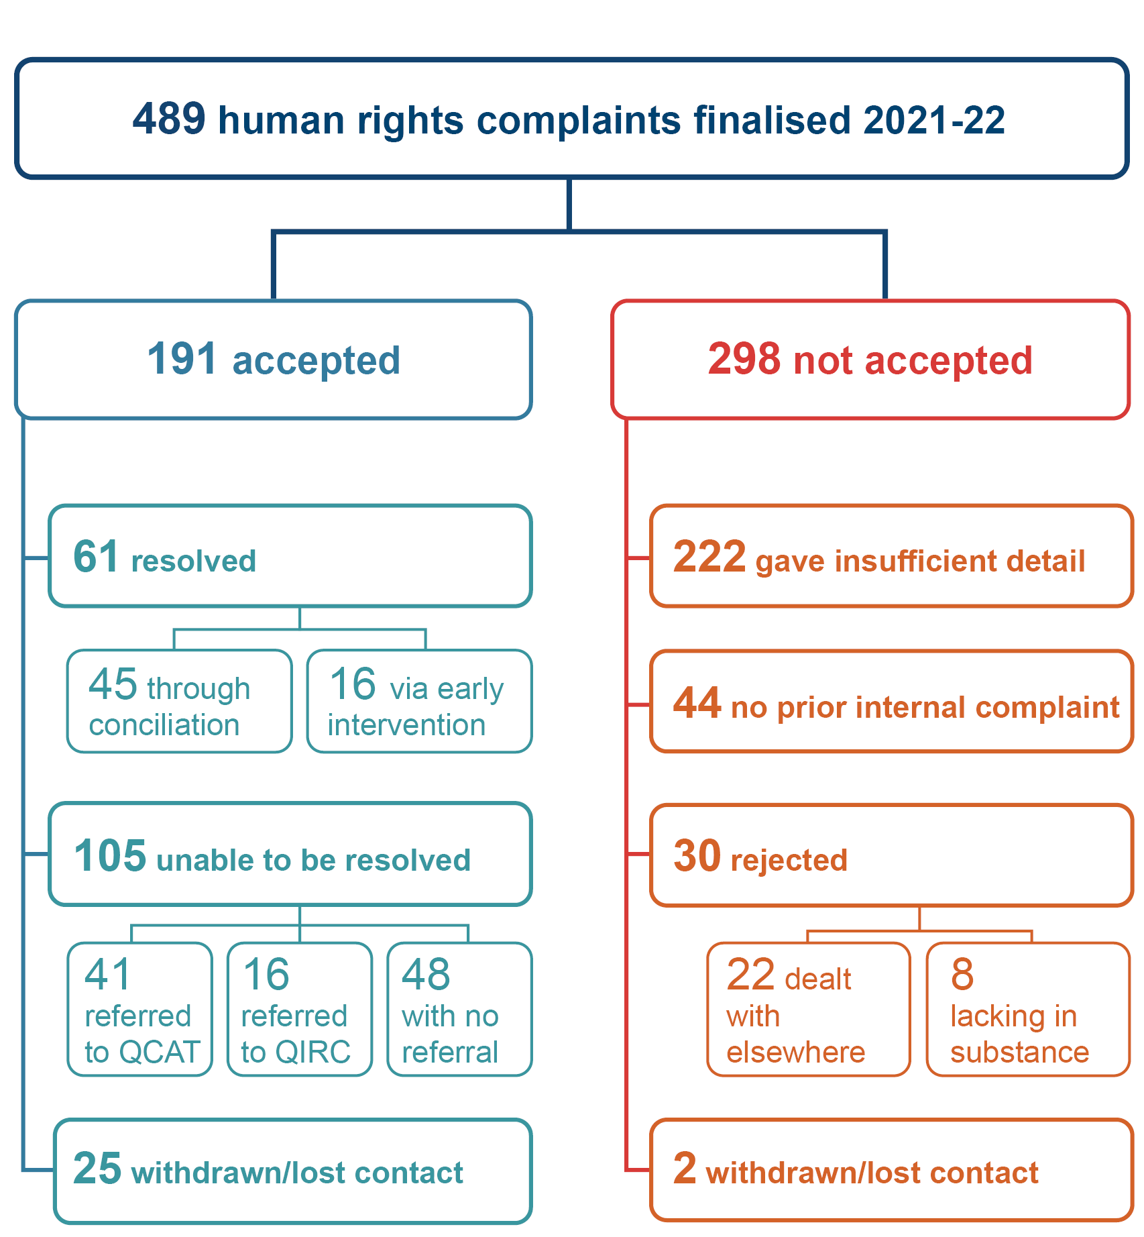

Outcomes of finalised complaints
298 (approximately 61%) of the human rights complaints finalised in the 2021–22 financial year were not accepted by the Commission. Aside from those complaints not indicating an unreasonable limitation on a human right (222 complaints), 22 complaints were not accepted because the Commission determined that the complaint has already been or would be better dealt with by another body, such as through a court or another specific complaints or oversight agency.
In each of the first two years of operation of the Act, the Commission observed that many complaints were being made directly to the Commission rather than meeting the requirement under the Act of first making a complaint to the public entity concerned and waiting 45 days before lodging with the Commission. In the first year, 27% did not meet the internal complaint requirements and this went down slightly to 21% in the second year. However, this has become less common in the third year of the Act with around 9% of complaints being closed by the Commission because this requirement was not met. Updates to the complaints information on the Commission’s website to make this requirement more prominent may have contributed to improved understanding about the processes involved for potential complainants.
Of the complaints that were accepted, 61 complaints were resolved in the 2021–22 financial year. A further 57 complaints, some of which had been received in the previous financial year, were referred to tribunals (QCAT or QIRC).
There were a range of specific outcomes that were obtained through resolving complaints at the Commission, with an apology being the most common outcome, followed by an agreement that one or more respondents to the complaint would receive training about their obligations.
Figure 5: Outcomes of all complaints finalised in 2021-22
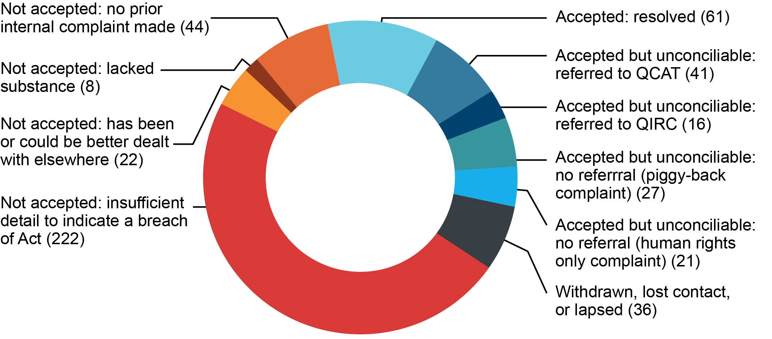

Table 5: Specific outcomes achieved through the Commission’s complaints process 2021-22 (including piggy-back complaints)
Outcome | Number
Apology | 14
Agreement to train individuals/workforce | 9
Agreement for compensation | 8
Policy change/review | 7
Change original decision | 3
Policy development/implementation | 3
Promotion/transfer of job role | 2
Respondents’ explanation accepted | 2
Modifications to improve accessibility | 1
Display of posters/information | 1

Resolution rate for complaints
Compared with complaints accepted under the Anti-Discrimination Act 1991, the resolution rate continues to be significantly lower for human rights and piggy-back complaints.
This year 45.3% of Anti-Discrimination Act only complaints were resolved, compared with 32% of piggy-back complaints and 31.5% of Human Rights Act only complaints.
Figure 6: Resolution rates by complaint type 2021-22
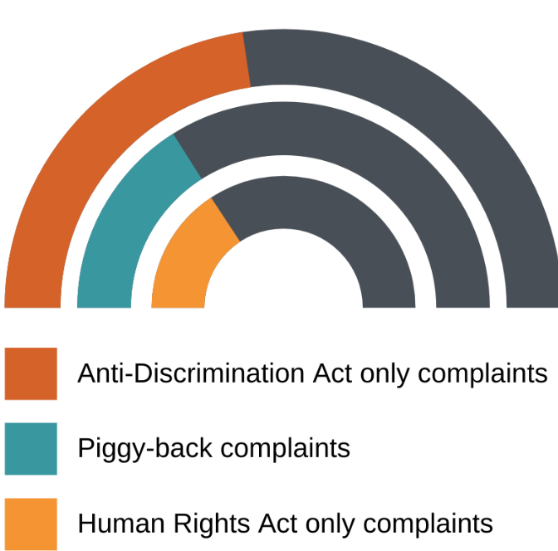
Human rights identified in complaints
The Commission may identify relevant human rights from the information provided in the complaint, or the complainant may indicate that they believe the right has been limited. Most complaints contain several allegations and engage more than one human right.
Not all allegations of unreasonable limitations of human rights are accepted. An allegation (that a contravention has occurred) alone is not enough; the complainant must provide sufficient detail about an act or decision that indicates a breach of human rights has occurred before the complaint is accepted.
Some complaints that were received in 2021–22 have been assessed and accepted in the 2022–23 financial year (or are in the queue for assessment) and are therefore not included here.
The information represented in the following graphs can be found in data tables in Appendix C of this report.

All human rights complaints
Figure 7 shows human rights relevant to the allegations raised in the complaints finalised in 2021–22, and includes all complaints – piggy-back complaints and human rights only complaints.
Figure 7: Human rights identified in all complaints, 2021-22

The most frequently identified human right in complaints was the right to recognition and equality before the law, identified in over half of the human rights complaints made to the Commission. As noted in previous years, this is because the majority of complaints to the Commission are about discrimination under the Anti-Discrimination Act 1991 which overlaps with this protected right. The right to recognition and equality before the law is likely to be engaged in all cases where a complainant is complaining about discrimination and the respondent is a public entity.
The second most common protected right in complaints finalised in the reporting period was freedom of movement. Complaints about limitation of this right continue to be high in number because of the impact of COVID-19 and the restrictions placed on the free movement of people in Queensland in the reporting period. While there were a considerable number of complaints about freedom of movement, they were not as likely to indicate an unreasonable limitation on human rights as complaints about other protected rights.
The third most common protected right in complaints was the right to privacy and reputation. As the scope of this right is broad, complaints arise in a range of circumstances from those involving personal information and data collection through to situations involving social housing.

Human rights only complaints
Figure 8 shows human rights only complaints (i.e. does not include piggy-back complaints which also contain allegations about a breach of the Anti-Discrimination Act).
For human rights only complaints, where a person did not also have a complaint under the Anti-Discrimination Act, freedom of movement was the human right most often identified in complaints made to the Commission and finalised in the reporting period, followed by recognition and equality before the law, and then privacy and reputation. However, in the complaints about human rights only that were accepted by the Commission, privacy and reputation was the most common right identified. While we received more complaints about freedom of movement, more complaints were accepted about humane treatment when deprived of liberty, and privacy and reputation, even though they were fewer in number.
Figure 8: Human rights identified in human rights only complaints, 2021-22

Resolved complaints
Figure 9 shows protected rights identified in complaints that were accepted by the Commission and resolved in 2021–22. This includes all complaints – piggy-back complaints and human rights only complaints – and again the right to recognition and equality before the law, and right to privacy and reputation were the most common.
Figure 9: Human rights identified in resolved complaints, 2021-22

Finalised complaints by sector
The public entities named as respondents in human rights complaints are categorised by their sector as part of the Commission’s data collection.
‘Not a public entity’ was recorded when the person complained about a respondent not covered by the Act. For example, a towing company that towed a car impounded by police. It may also apply where it is a federal body such as Australia Post.
‘Other government services’ are services provided by public entities that do not fit into the key categories as provided in the Commission’s database. For example, an organisation delivering community services.
‘Other state laws and programs’ means government programs that are not services provided to an individual. For example, an entity that enforces fines or regulates individuals or industries such as the Queensland Racing Integrity Commission or the State Penalty Enforcement Registry.
‘Corrections’ includes prisons and youth detention, but this year, all finalised complaints in this area were about prisons and none were about youth detention.
‘Work’ is where a public sector worker is complaining about issues arising in their workplace. In most instances a person is complaining about discrimination or sexual harassment as their primary concern, but their workplace is a public entity.

All human rights complaints
Figure 10 includes all complaints – piggy-back and human rights only complaints – by the sector of the public entity named.
Complaints about health bodies predominated, making up the highest portion of complaints (represented in 192 complaints). This continues the trend from previous years, and has been strongly influenced by the COVID-19 pandemic. Of the health-related complaints, a small number (10) related to mental health services. Complaints about police were probably higher this financial year because of their role in enforcing Public Health Directions (58 complaints).
This year, work was the second most common category of complaint (represented in 60 complaints).
Figure 10: Finalised complaints by sector – all complaints, 2021-22

Education complaints included allegations of human rights breaches by primary, secondary, and tertiary institutions, with most arising in the secondary school setting.
Table 6: Human rights complaints to the Commission about the education sector 2021-22
Type | Finalised | Accepted & finalised
Primary | 8 | 6
Secondary | 16 | 13
Tertiary | 9 | 6

Human rights only complaints
Figure 11 shows human rights only complaints finalised in 2021–22 by the sector of the public entity named.
Figure 11: Finalised complaints by sector – human rights only complaints, 2021-22

Of the complaints made only about human rights, the most common sectors represented in complaints were health, followed by police and corrections.

Demographic information for finalised complaints
The information in this section breaks down complaints by the complainant’s country of birth, sex, and age, based on information provided to the Commission. Demographic data has not been collected for every complaint, but the information captured may demonstrate general trends. The demographic information in this section is about complainants who made piggy-back complaints, as well complainants who made human rights only complaints.
Complaints finalised in the 2021–22 period were lodged mainly from within Queensland. Compared with last year, more complaints were lodged from interstate and particularly from Melbourne and Sydney, reflecting COVID-19 related complaints about border entry restrictions.
Most of the complainants living in Queensland were from the south-east region, and some from smaller regional coastal areas. Few complaints were received from people living in remote areas.
Of the finalised complaints, 50.39% were from female complainants and 46.91% were from male complainants.
Around 75% of complainants were born in Australia, and 25% were born overseas. This was a similar result to last year.
Complainants with a primary language other than English accounted for 5%.
Most complainants were in the age brackets of 35 to 44 years (30.5%) and 45 to 54 years (25.9%).
Figure 12: Finalised complaints by complainant age, 2021-22
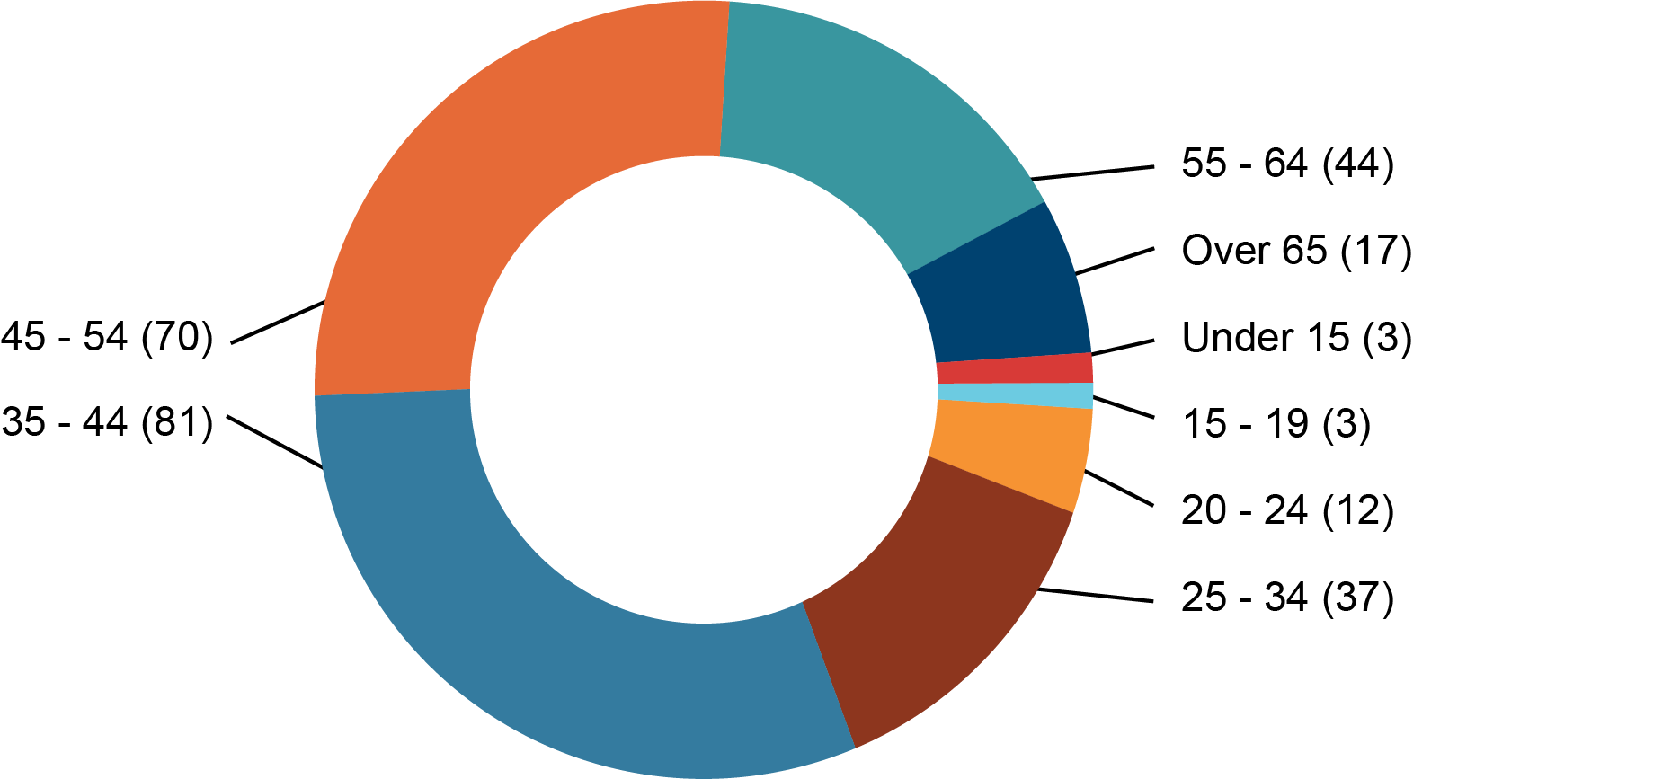
The Commission finalised 25 complaints from people who were Aboriginal or Torres Strait Islander, of whom 20 were of Aboriginal descent, 3 were Torres Strait Islander, and 2 were Aboriginal. This is a similar result from last year, in which we finalised 23 complaints from Aboriginal or Torres Strait Islander people.

Dispute resolution process: conciliation and early intervention
Compared to the Anti-Discrimination Act, the Human Rights Act offers a more flexible approach to complaint handling. For urgent situations in human rights only complaints, early interventions have replaced conciliation conferences.
In the reporting period, 61 complaints were resolved and finalised by the Commission, comprising:
- 12 human rights only complaints
- 49 piggy-back complaints.
Of these, 6 of the human rights only complaints were resolved through early intervention (50% of the human rights only matters resolved), and 10 piggy-back complaints were resolved by early intervention (approximately 20% of the piggy-back complaints).
Our Priority Complaints Team has continued to demonstrate the value in deploying early intervention. The benefits can include reduced waiting times and a flexibility in approach that accommodates the needs of the parties, the urgency of the matter, and the suitability for a conference.
Figure 13: Finalised complaints by dispute resolution mode, 2021-22
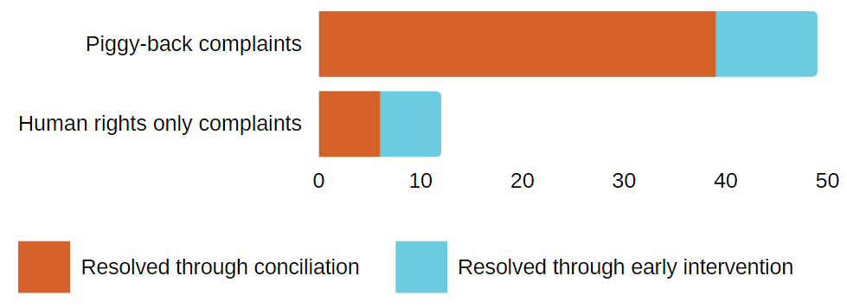

Corporations carrying out public functions
In the committee report on the Human Rights Bill in 2018, the Legal Affairs and Community Safety Committee commented that it would be beneficial for the Commission to monitor complaints raised against private corporations undertaking public functions in light of some concerns raised that the definition of public entity under section 9 may create uncertainty regarding which entities may be captured.
Of the accepted and finalised human rights complaints, we identified three in which a corporation was named as a respondent. They were:
- a security company working for a courthouse
- a service provider in a prison
- a public transport provider contracted to the government.

Complaints to other agencies
Aside from the Commission, other oversight bodies reported receiving complaints about human rights in 2021–22.
The Office of the Queensland Ombudsman received 1,583 cases that were assessed as involving a human rights element. The most common complaint topics were property rights, protection of families and children, right to health services, freedom of movement, and humane treatment when deprived of liberty.
The Office of the Health Ombudsman (OHO) identified 12 health service complaints in the reporting period that potentially engaged at least one human rights issue. The OHO noted that they intend to undertake further work on processes to identify human rights issues in health service complaints.

Resolved complaint case studies
The following case studies are a selection of resolved outcomes of complaints finalised in the financial year 2021–22.

Apology for offensive comments based on gender identity
A transgender woman complained that paramedics made inappropriate comments about her gender identity while she was being transported in an ambulance. This left her feeling agitated and insulted. The complaint was resolved through early resolution, with the respondents agreeing to pay her compensation. The ambulance service apologised for any offence or hurt suffered as a result of the situation and the staff member involved also participated in discrimination training in the workplace.
Relevant rights: Recognition and equality before the law (section 15), right to health services (section 37)
Complaint type: Piggy-back complaint
Attribute: Gender identity
Dispute resolution mode: Early intervention

Improving processes to apply for disability parking
A mother lodged a complaint on behalf of her adult son who has an intellectual disability, autism, and other health issues that result in severe pain and extreme behaviour. The mother applied for a disability parking permit to allow her to park closer to the shops to keep her, her son, and members of the public safe. The parking permit was initially refused because the son did not seem to meet the criteria, which are primarily directed at mobility, and the mother subsequently made a complaint to the Commission.
The woman and a representative of the department responsible for the permit scheme participated in a conciliation conference. In the meantime, the mother made a fresh application and received a permit. During the conference, the mother explained that her son's life was much more difficult during the period when they did not have a permit, but that she felt unable to pursue a formal appeal of the rejection because of her own personal history. She explained her desire for a system that is not so isolating and is more focused on the people involved and their needs, rather than something that is purely bureaucratic. The department’s representative outlined recent reviews to the permit scheme, including consultation and weighing of various needs and interests that occurred.
The complaint was resolved with the parties agreeing that the woman’s feedback about her experience would be given anonymously to the relevant areas of the department (both in policy and customer service).
Relevant rights: Recognition and equality before the law (section 15), protection of families and children (section 26).
Complaint type: Piggy-back complaint
Attribute: Impairment
Dispute resolution mode: Conciliation conference

Treatment of family with disabilities prompts training review
A complaint was made by four members of a family, three of whom have learning disabilities and one who has a physical disability and uses a wheelchair. The family attempted to board a public bus and alleged in their complaint that the driver said there was a ‘bad odour here’ and asked the complainants if they ever took baths and that they needed to use deodorant. Insulted and embarrassed, the complainants got off the bus and in their rush the wheelchair tipped. They alleged the driver said he didn't want to see the wheelchair on his bus again and it was best that they took a taxi. The complainants felt that they could not catch local public transport after the incident.
At the conciliation conference, the respondents did not agree with all the complainants’ assertions, but nonetheless provided written apologies expressing their regret for the incident and confirming that the complainants are genuinely welcome on the bus. The respondents also provided compensation and travel vouchers to the complainants and agreed to review the discrimination training provided to staff to ensure it highlights the impact of discrimination on people who live with disabilities.
Relevant rights: Recognition and equality before the law (section 15), privacy and reputation (section 25).
Complaint type: Piggy-back complaint
Attribute: Impairment, family responsibilities.
Dispute resolution mode: Conciliation conference

More responsive health services for man with Klinefelter syndrome
The Commission received a complaint from a man who is neurodiverse and has Klinefelter syndrome, which is a term that describes people with XXY chromosomes. The man requires testosterone injections of a certain dose and regularity to avoid symptoms such as lethargy, depression, anxiety, and fatigue. As he had been in and out of prison, the man had not received the required testosterone dose at various times, and he lodged a complaint that this was a breach of his right to health services.
The health service responsible for health care in the prison participated in a conciliation conference and agreed to the following:
- apology for any miscommunication regarding his syndrome
- training for prison health staff about the syndrome
- assurances that his medical records/discharge summaries would be available when needed
- referral to see a medical officer to refer for ultrasound and physiotherapy as needed.
We note that is a complaint that could have also been accepted as discrimination on the basis of ‘sex characteristics’ which is not currently a protected attribute under the Anti-Discrimination Act 1991 (Qld). Inclusion of ‘sex characteristics’ as an attribute has been recommended by the Commission in its recent Review of the Anti-Discrimination Act, to ensure better protections of people with variations of sex characteristics, such as Klinefelter syndrome.
Relevant rights: Recognition and equality before the law (section 15), right to health services (section 37).
Complaint type: Piggy-back complaint
Attribute: Impairment
Dispute resolution mode: Conciliation conference

Resolution to complaint promoted family and kinship rights
A prisoner’s mother made a complaint against a prison service provider about a breach of human rights, including the right to maintain family and kinship relationships. Her son was in a prison far from where she lived, and she also cared for his child. Because of the distance, the only way that the woman could keep in touch with her son and ensure her grandchild could maintain a relationship with their father was through phone contact.
Phone calls are made by prisoners through an account that other people are able to deposit funds into. However, the service provider’s rules automatically banned a prisoner from receiving funds after there had been a ‘drawback’ of funds. A drawback occurs when a person outside of the prison deposits money, which is then spent by the prisoner but in the meantime the depositor disputes the charge, leaving the account in a deficit. Even though the drawback had not happened when the mother was depositing funds, the policy meant that she was unable to put money onto her son’s account to allow him to make phone calls to his family.
Through the conciliation process the prison service provider committed to review their policies to ensure they were compliant with the human rights of family members as well as those of prisoners. The mother was also reinstated as a person who was able to send funds to her son.
Relevant rights: Protection of families and children (section 26), right to privacy and reputation (section 25), cultural rights – Aboriginal peoples and Torres Strait Islander peoples (section 28)
Complaint type: Human rights only
Dispute resolution mode: Conciliation conference

Access to health services for a man with disability seeking vaccination booster
The Commission received a complaint from a man with autism who was unable to attend a clinical setting to receive a COVID-19 booster vaccination because of sensory and environmental factors relating to his disability. His anxiety also prevented him from answering phone calls.
He had requested a home visit for a booster shot but was experiencing challenges in getting an appointment. He felt at extreme risk due to his disability and because he was avoiding leaving home, it was causing him to experience social isolation. While he had stated that his preference was for email contact, he was receiving calls by phone from the booking service. Because he did not answer his phone, the appointment was not being booked in and he was becoming increasingly stressed about the situation.
Through the conciliation process, the health service helped arrange for the man to get his booster shot at home. The service also agreed to review the contact centre booking process to ensure that the most appropriate method of communication is used in future.
Relevant rights: Recognition and equality before the law (section 15), right to health services (section 37)
Complaint type: Piggy-back complaint
Attribute: Impairment
Dispute resolution mode: Conciliation conference

Perceptions of cultural safety in health service provision improved
A First Nations man detained in prison told us that he was not receiving culturally safe health care. Through early resolution, the prison health service agreed to continue to work with Queensland Corrective Services to ensure a Cultural Liaison Officer is present during future health-related consultations, and put in place a process where the Nurse Unit Manager would directly request the liaison officer’s presence at all appointments.
The man communicated to the Commission he felt that there had been significant improvement in the way he experienced health care as a result of lodging the complaint. The conciliator sought the assistance of a member of the Aboriginal and Torres Strait Islander Unit at the Commission to manage the complaint process, and the conciliator reflected that the Unit’s involvement had been crucial in ensuring that the complainant felt comfortable and safe during the complaint process.
Relevant rights: Right to protection from torture, cruel, inhuman and degrading treatment (section 17), humane treatment when deprived of liberty (section 30), right to health services (section 37)
Complaint type: Human rights only
Dispute resolution mode: Early intervention



Human rights in the community

Community education and training
The Human Rights Act gives the Commission functions to:
- promote an understanding and acceptance, and the public discussion, of human rights
- make information about human rights available to the community
- provide education about human rights and the Act.
This work is integral to achieving the Act’s objectives of protecting and promoting human rights, building a culture in the public sector that respects human rights, and promoting a dialogue about the nature, meaning and scope of human rights.

Training for public entities
In addition to human rights complaint handling functions, the Commission provides education and training to government and functional public entities (as well as private and not-for-profit sectors), and in the financial year delivered 46 Introduction to the Human Rights Act sessions and 6 Introduction to the Human Rights Act – train-the-trainer sessions.
Sessions on the Human Rights Act were adapted for advocates and legal representatives, and in the financial year we delivered 4 sessions to community advocates and 6 sessions to legal advocates. Many sessions were tailored for the specific needs of workplaces or sectors and helped participants consider the application of the Act through scenarios relevant to their situation. Five webinars specifically designed for people working in the mental health sector and for mental health advocates on Human rights in mental health were delivered in 2021–22.
Face-to-face training is complemented by the Commission’s online learning modules, which were the most popular way to receive training in the reporting period. The Introduction to the Human Rights Act module was completed by 2,142 people and 5,556 people completed the Public entities and the Queensland Human Rights Act module.

Human rights in child protection
A particular focus for the Commission this year has been child protection. This included the delivery of six tailored legal advocates sessions for practitioners from the Department of Children, Youth Justice and Multicultural Affairs and Legal Aid Queensland (five delivered during the financial year), a workshop at the Queensland Foster and Kinship Care Conference, an Introduction to the Human Rights Act tailored for the department, and an information booth at the department's Senior Practitioner forum.
More than 570 department staff accessed the Commission's standard online training Public Entities and Human Rights Act module, and the Commission is in the process of tailoring that module for the department with child safety and youth justice specific material.
The Commission was also involved with collaborations with parents, the department and the Family Inclusion Networks that led to the development and launch of the Charter of Rights for parents involved with the child protection system in Queensland on 1 June 2022.

Website
The Commission’s website remained a key source of information for the community about their rights. In particular, the Commission provided frequently updated information about how the Human Rights Act and the Anti-Discrimination Act applied to topical issues, such as vaccination and mask-wearing in the context of the pandemic. Three of the top five most viewed pages this year were COVID-related and our ‘Vaccination and your rights’ page alone accounted for more than 8% of all website traffic.

Consultation and engagement
The Commission continues to facilitate consultation groups to contribute towards building a culture of human rights in the legal and academic sectors:
- Queensland Academics Human Rights Group: academics undertaking research and sharing information to support Queensland’s developing human rights culture
- Queensland Human Rights Advocates Group: lawyers and advocates who work in discrimination and human rights law.

Human Rights Week
To celebrate Human Rights Week, culminating on 10 December 2021 with Human Rights Day, the Commission ran a campaign called ‘Make equality your priority’ focusing on the right to freedom from discrimination as one of the core foundations of human rights protections. Through this campaign, the Commission encouraged individuals and organisations to engage with and make submissions to the Review of Queensland’s Anti-Discrimination Act. The associated online materials were viewed over 27,000 times.
This year the Commission provided 4 free webinars for the community during Human Rights Week: 2 on Introduction to the Human Rights Act and 2 on Introduction to the Anti-Discrimination Act, and a total of 318 participants attended these sessions during the week.
As part of its Human Rights Week coverage, the Queensland Law Society’s digital magazine, Proctor, published an overview of the operation of the Human Rights Act in 2020-21 written by one of the Commission’s Principal Lawyers.



Appendices

Appendix A: Courts and tribunals
In the financial year ended 30 June 2022, courts and tribunals considered or mentioned the Human Rights Act in 86 matters.
Table 7: Courts and tribunals that considered or mentioned the Human Rights Act, 2021-22
Court | Number
Federal Court of Australia (FCA) | 1
Fair Work Commission (FWC) | 2
Court of Appeal Queensland (QCA) | 1
Supreme Court of Queensland (QSC) | 3
District Court of Queensland (QDA) | 4
Land Court of Queensland (QLC) | 2
Mental Health Court Queensland (QMHC) | 1
Coroners Court Queensland | 1
Queensland Civil and Administrative Tribunal Appeals (QCATA) | 4
Queensland Civil and Administrative Tribunal (QCAT) | 44
Queensland Industrial Relations Commission (QIRC) | 23
Total | 86

Details of the cause of action that gave rise to the mention or consideration of the Human Rights Act 2019 in each court or tribunal matter are given in the following table.
Table 8: Cause of action in court and tribunal matters that considered or mentioned the Human Rights Act in the 2021–2022 period
Court | Cause of action | No
FCA | Covid-19 insurance test case – 1 | 1
FWC | Unfair dismissal – 1  General protections – 1 | 2
QCA | Referral of point of law under Criminal Code | 1
QSC | Appeal from decision of Crime and Corruption Commission – 1  Application for relief for unlawful imprisonment – 1  Judicial review – 1 | 3
QDA | Appeal from decision to stay a summary charge arising from arguably same set of facts that had already resulted in conviction of indictable charge – 1  Breach of lease – 1  Defamation (orders for anonymisation) – 1  Protection order – 1 | 4
QLC | Objection to mining lease – 1  Objection to mining lease (procedural issue) – 1 | 2
QMHC | Condition on forensic order | 1
Coroner | Coronial inquest (procedural issue) | 1
QCATA | Minor civil dispute – 2  Minor civil dispute (tenancy) – 1  Review of blue card decision – 1 | 4
QCAT | Application for stay of decision to suspend driver authorisation number – 1  Discrimination – 1  Discrimination (exemption application) – 3  Discrimination (procedural issue) – 1  Guardianship and administration – 7  Guardianship and administration (Interim appointment) – 3  Information privacy – 1  Minor civil dispute – 1  Minor civil dispute (tenancy) – 1  Occupational regulation matter – 1  Order for costs – 1  Police disciplinary review – 1  Review of blue card decision – 19  Review of child protection decision – 1  Review of decision of Queensland Racing Integrity Commission – 1  Review of decision of weapons division of QPS – 1 | 44
QIRC | Discrimination (Interim order) – 1  General protections – 1  Industrial dispute – 1  Public service appeal – 4  Public service appeal (vaccination) – 16 | 23
Total |  | 86

Appendix B: Human rights indicators

Indicators of a developing human rights culture: State government

Indicator 1: Staff awareness, education, and development
- How has staff awareness been raised about the Act?
- What education and training on the Act has been provided?
- Does the training include examples specifically tailored to the organization to illustrate how to put human rights into practice?
- Approximately what percentage of staff have received training?
- Which work groups or areas of the agency have received training? What training has been provided to senior leadership? What was the mode of delivery of the training? For example, online, face-to-face, both online and face-to-face, or other? Has the training been delivered by internal staff, or external providers?
- What has been the impact of increased working from home arrangements on the design and delivery of training?
- Has human rights been included in induction training (onboarding of new staff)? Does ongoing professional development/training for staff include human rights? If so, what is the mode of the delivery of the training?
- What feedback do you collect about education and training? How is it used to design future training and/or resources?

Indicator 2: Community consultation and engagement about human rights
- Have you conducted any community consultation and engagement, such as with stakeholders, clients, or consumers about human rights?
- What information have you provided to the community about human rights?
- Have you consulted relevant sectors of the community about proposed changes to, or development of, legislation, regulations, policies, procedures, services etc. which may impact human rights?
- Please provide details, including how did the community consultation and engagement impact on any decision-making/policy formulation, or other?

Indicator 3: Awareness raising and support for related entities (including functional public entities engaged by the entity i.e. contractors)
- Have you raised awareness of human rights with contractors/providers engaged by your agency? If so, provide details. For example, has human rights been embedded into formal contracts?
- What support in ensuring compatibility with the Act have you provided to providers engaged by your agency? If any, provide details.

Indicator 4: Reviews and development of legislation or subordinate legislation
- Please point to legislation or subordinate legislation that has been introduced in the financial year 2020–21 that:
  - has a significant impact on human rights;
  - works to respect, protect, or promote human rights
- Please provide any examples of good practice in ensuring the proper consideration of human rights is part of legislation development.

Indicator 5: Review of policies and procedures
- Has your agency reviewed policies and procedures for compatibility with human rights?
- Please provide an example of the way in which the review of policies and procedures has resulted in positive change?
- In particular, have you developed any new guides or other tools to assist staff to act and make decisions that are compatible with human rights, and to properly consider human rights when making decisions?
- Has any review of policies and procedures resulted in a change to service delivery? If so, please provide examples.

Indicator 6: Internal complaint management for human rights complaints
- How successful has your agency been in integrating human rights complaints into internal complaints processes? If possible, provide examples of what has been achieved.
- Does your agency face any barriers in successfully identifying, considering, and responding to human rights complaints? If so, what are they?
- Please provide examples of where a complaint has been resolved through the internal complaints process and/or has resulted in policy/procedure/practice review, service improvements or change for the agency.

Indicator 7: Future plans
What future plans does your agency have to achieve the objects of the Act in:
- protecting and promoting human rights;
- building a culture in the Queensland public sector that respects and promotes human rights; and
- helping promote a dialogue about the nature, meaning, and scope of human rights.

Additional question:
How has senior leadership demonstrated a commitment to embedding human rights generally, and in particular with respect to the Indicators 1 – 6 noted above?

Indicators of a developing human rights culture: Councils

Indicator 1: Staff awareness, education and development
- How has staff awareness been raised about the Act?
- What education and training on the Act has been provided?
- Does the training include examples specifically tailored to the council to illustrate how to put human rights into practice?
- Approximately what percentage of staff have received training?
- Which work groups or areas of the council have received training? What training has been provided to senior leadership? What was the mode of delivery of the training? For example, online, face to face, both online and face to face, or other? Has the training been delivered by internal staff, or external providers?
- What has been the impact of increased working from home arrangements on the design and delivery of training?
- Has human rights been included in induction training (onboarding of new staff)? Does ongoing professional development/training for staff include human rights? If so, what is the mode of the delivery of the training?
- What feedback do you collect about education and training? How is it used to design future training and/or resources?

Indicator 2: Community consultation and engagement about human rights
- Have you conducted any community consultation and engagement, such as with stakeholders, clients, or consumers about human rights?
- What information have you provided to the community about human rights?
- Have you consulted relevant sectors of the community about proposed changes to, or development of, legislation, regulations, policies, procedures, services etc. which may impact human rights?
- Please provide details, including how did the community consultation and engagement impact on any decision-making/policy formulation, or other?

Indicator 3: Awareness raising and support for related entities (including functional public entities engaged by the council i.e. contractors)
- Have you raised awareness of human rights with contractors/providers engaged by the council? If so, provide details. For example, has human rights been embedded into formal contracts?
- What support in ensuring compatibility with the Act have you provided to providers engaged by the council? If any, provide details.

Indicator 4: Reviews and development of local laws and subordinate local laws
- Please point to a local law or subordinate local law that has been introduced in the financial year 2021-22 and that:
  - has a significant impact on human rights;
  - works to respect, protect, or promote human rights
- Please provide any examples of good practice in ensuring the proper consideration of human rights is part of local law development.

Indicator 5: Review of policies and procedures
- Has the council reviewed policies and procedures for compatibility with human rights?
- Please provide an example of the way in which the review of policies and procedures has resulted in positive change?
- In particular, have you developed any new guides or other tools to assist staff to act and make decisions that are compatible with human rights, and to properly consider human rights when making decisions?
- Has any review of policies and procedures resulted in a change to service delivery? If so, please provide examples.

Indicator 6: Internal complaint management for human rights complaints
- How successful has the council been in integrating human rights complaints into internal complaints processes? If possible, provide examples of what has been achieved.
- Does the council face any barriers in successfully identifying, considering, and responding to human rights complaints? If so, what are they?
- Please provide examples of where a complaint has been resolved through the internal complaints process and/or has resulted in policy/procedure/practice review, service improvements or change for the council.

Indicator 7: Future plans
What future plans does the council have to achieve the objects of the Act in:
- protecting and promoting human rights;
- building a culture in the Queensland public sector that respects and promotes human rights; and
- helping promote a dialogue about the nature, meaning, and scope of human rights.

Additional question:
How has senior leadership demonstrated a commitment to embedding human rights generally, and in particular with respect to the Indicators 1 – 6 noted above?

Appendix C: Complaints data tables
Refer to section Human rights complaints snapshot for explanations of terms such as ‘accepted’, ‘resolved’ and ‘finalised.’
Table 9: Outcome of finalised complaints – inclusive of piggy-back complaints and human rights only complaints, 2021-22
Outcome of finalised complaints – all (piggy-back complaints and human rights only) | No. finalised
Information provided indicates not covered by the HR Act | 222
Prior internal complaint requirements not met | 44
Accepted and resolved | 61
Withdrawn or lost contact | 27
Unconciliable piggy-back complaint: referred to Tribunal | 57
Unconciliable piggy-back complaint: no referral | 27
Unconciliable human rights only complaint | 21
Has been or could be dealt with better elsewhere | 22
Rejected - lacked substance | 8
Unconciliable human rights only complaint: report with recommendations published | 0

Table 10: Human rights identified in all finalised human rights complaints – inclusive of piggy-back complaints and human rights only complaints, 2021-22
Relevant human right | Allegations made in finalised complaints | Allegations made in accepted and finalised complaints
Cultural rights—First Nations peoples | 18 | 10
Cultural rights—generally | 6 | 0
Fair hearing | 32 | 3
Freedom from forced work | 3 | 0
Freedom of expression | 35 | 8
Freedom of movement | 159 | 34
Freedom of thought, conscience, religion, belief | 28 | 1
Humane treatment when deprived of liberty | 108 | 47
Not tried or punished more than once | 0 | 0
Peaceful assembly | 1 | 1
Privacy and reputation | 123 | 55
Property rights | 16 | 5
Protection from retrospective criminal laws | 5 | 0
Protection of children in the criminal process | 3 | 0
Protection of families and children | 53 | 26
Recognition and equality before the law | 250 | 137
Right to education | 26 | 18
Right to health services | 39 | 11
Right to liberty and security of person | 32 | 8
Right to life | 19 | 0
Rights in criminal proceedings | 13 | 2
Taking part in public life | 39 | 3
Torture & cruel, inhuman, degrading | 66 | 17

Table 11: Human rights identified in finalised human rights only complaints, 2021-22
Relevant human right | Allegations made in finalised complaints | Allegations made in accepted and finalised complaints
Cultural rights—First Nations peoples | 8 | 3
Cultural rights—generally | 1 | 0
Fair hearing | 25 | 1
Freedom from forced work | 3 | 0
Freedom of expression | 25 | 1
Freedom of movement | 121 | 12
Freedom of thought, conscience, religion, belief | 23 | 1
Humane treatment when deprived of liberty | 64 | 15
Not tried or punished more than once | 4 | 0
Peaceful assembly | 9 | 0
Privacy and reputation | 76 | 19
Property rights | 12 | 2
Protection from retrospective criminal laws | 3 | 0
Protection of children in the criminal process | 0 | 0
Protection of families and children | 30 | 7
Recognition and equality before the law | 95 | 4
Right to education | 12 | 5
Right to health services | 25 | 2
Right to liberty and security of person | 23 | 1
Right to life | 16 | 0
Rights in criminal proceedings | 10 | 0
Taking part in public life | 26 | 1
Torture & cruel, inhuman, degrading | 46 | 2

Table 12: Human rights identified in resolved human rights complaints, 2021-22
Relevant human right | Allegations made in resolved complaints
Cultural rights—Aboriginal peoples and Torres Strait | 2
Freedom of expression | 1
Freedom of movement | 10
Humane treatment when deprived of liberty | 10
Privacy and reputation | 25
Torture & cruel, inhuman, degrading | 4
Protection of families and children | 10
Recognition and equality before the law | 43
Right to education | 4
Right to health services | 7

Table 13: Human rights complaints by sector – inclusive of piggy-back complaints and human rights only complaints, 2021-22
Public entity by sector | No. finalised complaints | No. accepted and finalised complaints
Accommodation/housing | 9 | 2
Child Safety | 15 | 8
Corrections | 44 | 35
Court services | 11 | 0
Disability services | 0 | 0
Health | 192 | 145
Local government agency | 18 | 13
Not a public entity | 13 | 0
Other government services | 17 | 8
Other state laws and programs | 30 | 20
Police | 58 | 39
Public education | 33 | 13
Transport | 9 | 3
Work | 60 | 18

Table 14: Human rights complaints by sector – human rights only complaints, 2021-22
Public entity by sector | No. finalised complaints | No. accepted and finalised complaints
Accommodation/housing | 2 | 0
Child safety | 8 | 1
Corrections | 35 | 6
Court services | 11 | 1
Disability services | 0 | 0
Health | 145 | 11
Local government agency | 13 | 4
Other government services | 8 | 1
Other state laws and programs | 20 | 4
Police | 39 | 0
Public education | 13 | 0
Transport | 3 | 0
Work | 18 | 0

Table 15: Finalised complaints by complainant age bracket, 2021-22
Complainant age group | No. of finalised complaints
Under 15 | 3
15-19 | 3
20-24 | 12
25-34 | 37
35-44 | 81
45-54 | 70
55-64 | 44
Over 65 | 17

Appendix D: Human rights timeline 2021-22
This information is represented in the timeline on pages 17-18 of this report and is a summary of some significant events relevant to the operation of the Act in its third year.

September 2021
A private Member’s Bill, the Criminal Law (Raising the Age of Responsibility) Amendment Bill 2021, was introduced into the Queensland Parliament to raise the minimum age of criminal responsibility in Queensland from 10 to 14 years. The Parliamentary Committee tabled its report on the Bill on 15 March 2022.

October 2021
The Supreme Court of Qld decision in Owen-D'Arcy v Chief Executive, Queensland Corrective Services [2021] QSC 273 clarified how a public entity is to give proper consideration to human rights when making decisions. The entity must identify and consider all of the human rights that the decision affects.
The Treaty Advancement Committee report to advance Queensland’s Path to Treaty Commitment recommended that an independent First Nations Treaty Institute be established, a Truth Telling and Healing Process, and a Fund to give financial security and independence.

December 2021
The Chief Health Officer’s directions requiring vaccination to enter certain venues commenced on 7 December 2021 and were finally revoked on 14 April 2022.

January 2022
The Chief Health Officer’s directions regarding border restrictions on entering Queensland were revoked on 15 January 2022.
Qld Parliament’s Legal Affairs and Safety Committee tabled its report, Inquiry into serious vilification and hate crimes, and making recommendations encompassing education, community empowerment, and law reform.
Qld Parliament’s Legal Affairs and Safety Committee recommended that the Inspector of Detention Services Bill 2021 be passed. The purpose of the Bill is to promote the improvement of detention services and places of detention with a focus on promoting and upholding the humane treatment of detainees, including the conditions of their detention.

April and May 2022
The Land Court of Qld took ‘on country’ evidence from First Nations witnesses as part of a mining lease objection hearing, travelling to Erub and Poruma Islands and the Yidinji Nation in the Cairns region. In Waratah Coal Pty Ltd v Youth Verdict Ltd & Ors (No 5) [2022] QLC 4, the Court found that First Nations witnesses' cultural rights under the Human Rights Act would be unduly limited if their evidence was confined to written evidence.

June 2022
The State Coroner found they were acting in an administrative capacity (therefore subject to the Human Rights Act) when making a decision regarding the investigation of a death in a correctional centre. Most deaths in the custody of Queensland Corrective Services (QCS) are investigated by the. The family of the deceased person argued that the Queensland Police Service’s Corrective Services’ Investigation Unit (CSIU) – who investigate most deaths in custody – had a conflict of interest. The Coroner concluded that the investigation should be finalised by another unit within the Queensland Police Service other than the CSIU.
The Chief Health Officer’s directions requiring quarantine for unvaccinated international arrivals in government nominated accommodation (often hotels) ended.

Explanatory Notes, Human Rights Bill 2018, 44
Section 95 of the Act requires the Attorney-General to cause an independent review of the operation of the Act up until 1 July 2023.
Section 96 of the Act requires the Attorney-General to cause a second independent review of the operation of the Act for the period July 2023 to July 2027.
The Commission has received a large volume of complaints in the last two financial years, in part due to the COVID-19 pandemic, and the wait time to assess complaints is over 6 months. Further resources have been committed to the complaints team to address this.
In the financial year 2020-21 the Commission received 441 human rights complaints.
In the same period, the Commission received 550 complaints about discrimination, sexual harassment, and other contraventions under the Anti-Discrimination Act 1991. Human rights complaints therefore represented nearly one-third of matters dealt with by the Commission.
A ‘human rights only’ complaint is one which was dealt with only under the Human Rights Act 2019.
A ‘piggy-back complaint’ is where the complaint raises issues under the Anti-Discrimination Act 1991 and the Human Rights Act 2019. Under section 75 of the Human Rights Act, the Commission may decide that a human rights complaint would be more appropriately dealt with by the Commission as a complaint under the Anti-Discrimination Act 1991.
Tamara Walsh, ‘Social Housing, Homelessness and Human Rights’ (2022) 45(2) UNSW Law Journal 688.
Tamara Walsh, ‘Social Housing, Homelessness and Human Rights’ (2022) 45(2) UNSW Law Journal 709.
Portfolio committees completed a total of 32 inquiries into Bills introduced into parliament including appropriation Bills, which are not considered in detail in this report. Bills introduced during the reporting period included: Small Business Commissioner Bill 2021; Justice Legislation (COVID-19 Emergency Response — Permanency) Amendment Bill 2021; Police Powers and Responsibilities and Other Legislation Amendment Bill 2021; Police Legislation (Efficiencies and Effectiveness) Amendment Bill 2021; Inspector of Detention Services Bill 2021; Public Trustee (Advisory and Monitoring Board) Amendment Bill 2021; Child Protection Reform and Other Legislation Amendment Bill 2021; Queensland University of Technology Amendment Bill 2021; Superannuation (State Public Sector) (Scheme Administration) Amendment Bill 2021; Brisbane Olympic and Paralympic Games Arrangements Bill 2021; Police Service Administration and Other Legislation Amendment Bill 2021; Evidence and Other Legislation Amendment Bill 2021; Food (Labelling of Seafood) Amendment Bill 2021; Health and Other Legislation Amendment Bill 2021; Public Health and Other Legislation (Extension of Expiring Provisions) Amendment Bill 2022; Racing Integrity Amendment Bill 2022; Nature Conservation and Other Legislation Amendment Bill 2022; Land and Other Legislation Amendment Bill 2022; State Penalties Enforcement (Modernisation) Amendment Bill 2022; Building and Other Legislation Amendment Bill 2022; Personal Injuries Proceedings and Other Legislation Amendment Bill 2022.
See Residential Tenancies and Rooming Accommodation (Tenants’ Rights) and Other Legislation Amendment Bill 2021; Housing Legislation Amendment Bill 2021; Resources and Other Legislation Amendment Bill 2021; Queensland Veterans' Council Bill 2021; Public Health and Other Legislation (Further Extension of Expiring Provisions) Amendment Act 2021; Voluntary Assisted Dying Bill 2021.
The Private Members Bill: Residential Tenancies and Rooming Accommodation (Tenants’ Rights) and Other Legislation Amendment Bill 2021 was discharged on 14/10/2021.
Department of the Premier and Cabinet (Qld), ‘3.5 Role of drafter’, Queensland Legislation Handbook (Web Page, 17 June 2021).
Explanatory Notes, Human Rights Bill 2018 (Qld) 29.
Explanatory Notes, Human Rights Bill 2018 (Qld) 10.
For more information on how these indicators were developed, see Queensland Human Rights Commission, Balancing Life and Liberty: The second annual report on the operation of Queensland’s Human Rights Act 2019 (Report 2020–21) 30-32.
Human Rights Act 2019 s 43.
Revenue Legislation Amendment Bill 2022.
Legal Affairs and Safety Committee, Queensland Parliament, Police Powers and Responsibilities and Other Legislation Amendment Bill 2021 (Report No 15, November 2021) 41.
Community Support and Services Committee, Queensland Parliament, Inquiry into Public Health and Other Legislation (Extension of Expiring Provisions) Amendment Bill 2022 (Report No 17, March 2022) 38.
Legal Affairs and Safety Committee, Queensland Parliament, Inquiry into Police Powers and Responsibilities and Other Legislation Amendment Bill 2021 (Report No 15, November 2021) 41; Economics and Governance Committee, Inquiry into Brisbane Olympic and Paralympic Games Arrangements Bill 2021 (Report No 20, November 201) 57; State Development and Regional Industries Committee, Inquiry into Health and Other Legislation Amendment Bill 2021 (Report No 17, February 2022) 49.
State Penalties Enforcement (Modernisation) Amendment Bill 2022.
Legal Affairs and Safety Committee, Queensland Parliament, Police Powers and Responsibilities and Other Legislation Amendment Bill 2021 (Report No 15, November 2021) 40-41.
Economics and Governance Committee, Inquiry into Public Health and Other Legislation (Further Extension of Expiring Provisions) Amendment Bill 2021 (Report No 11, August 2021) 72.
Economics and Governance Committee, Queensland Parliament, Inquiry into Public Health and Other Legislation (Further Extension of Expiring Provisions) Amendment Bill 2021 (Report No 11, August 2021); Health and Environment Committee, Queensland Parliament, Inquiry into Voluntary Assisted Dying Bill 2021 (Report No 10, August 2021); State Development and Regional Industries Committee, Inquiry into Health and Other Legislation Amendment Bill 2021 (Report No 17, February 2022); Legal Affairs and Safety Committee, Queensland Parliament, Inquiry into Evidence and Other Legislation Amendment Bill 2021 (Report No 23, February 2022; Economics and Governance Committee, Queensland Parliament, Inquiry into Police Service Administration and Other Legislation Amendment Bill 2021 (Report No 21, February 2022); Community Support and Services Committee, Queensland Parliament, Inquiry into Public Health and Other Legislation (Extension of Expiring Provisions) Amendment Bill 2022 (Report No 17, March 2022); Legal Affairs and Safety Committee, Queensland Parliament, Inquiry into Police Legislation (Efficiencies and Effectiveness) Amendment Bill 2021 (Report No 16, November 2021); Legal Affairs and Safety Committee, Queensland Parliament, Inquiry into Police Powers and Responsibilities and Other Legislation Amendment Bill 2021 (Report No 15, November 2021).
Economics and Governance Committee, Queensland Parliament, Inquiry into State Penalties Enforcement (Modernisation) Amendment Bill 2022 (Report No 24, May 2022) 39-40; State Development and Regional Industries Committee, Queensland Parliament, Inquiry into the Health and Other Legislation Amendment Bill 2021 (Report No 17, February 2022) 49; Economics and Governance Committee, Inquiry into Brisbane Olympic and Paralympic Games Arrangements Bill 2021 (Report No 20, November 2021) 57.
State Development and Regional Industries Committee, Queensland Parliament, Inquiry into the Health and Other Legislation Amendment Bill 2021 (Report No 17, February 2022) 49.
Queensland Law Reform Commission, A legal framework for voluntary assisted dying (Report 79, May 2021).
The committee noted that section 12 of the Act clarifies that a ‘right or freedom not included, or only partly included in this Act that arises or is recognised under another law must not be taken to be abrogated or limited only because the right or freedom is not included in this Act or is only partly included’: Community Support and Services Committee, Queensland Parliament, Inquiry into Housing Legislation Amendment Bill 2021 (Report No 7, August 2021) 56.
Community Support and Services Committee, Queensland Parliament, Inquiry into Housing Legislation Amendment Bill 2021 (Report No 7, August 2021), 60-61.
Legal Affairs and Safety Committee, Queensland Parliament, Police Powers and Responsibilities and Other Legislation Amendment Bill 2021 (Report No 15, November 2021) 41.
Legal Affairs and Safety Committee, Queensland Parliament, Police Powers and Responsibilities and Other Legislation Amendment Bill 2021 (Report No 15, November 2021) 36.
Legal Affairs and Safety Committee, Queensland Parliament, Police Powers and Responsibilities and Other Legislation Amendment Bill 2021 (Report No 15, November 2021) 40.
Legal Affairs and Safety Committee, Queensland Parliament, Police Powers and Responsibilities and Other Legislation Amendment Bill 2021 (Report No 15, November 2021) 41.
Legal Affairs and Safety Committee, Queensland Parliament, Police Powers and Responsibilities and Other Legislation Amendment Bill 2021 (Report No 15, November 2021) 30, 41.
Queensland, Parliamentary Debates, Legislative Assembly, 30 November 2021, 3833.
Health and Environment Committee, Queensland Parliament, Inquiry into the Health and Other Legislation Amendment Bill 2021 (Report No 17, February 2022) 49. Queensland, Parliamentary Debates, Legislative Assembly, 23 Feb 2022, 150.
Economics and Governance Committee, Queensland Parliament, Inquiry into State Penalties Enforcement (Modernisation) Amendment Bill 2022 (Report No 24, May 2022) 26.
Economics and Governance Committee, Queensland Parliament, Inquiry into State Penalties Enforcement (Modernisation) Amendment Bill 2022 (Report No 24, May 2022) 35.
Economics and Governance Committee, Queensland Parliament, Inquiry into State Penalties Enforcement (Modernisation) Amendment Bill 2022 (Report No 24, May 2022) 35.
Economics and Governance Committee, Queensland Parliament, Inquiry into State Penalties Enforcement (Modernisation) Amendment Bill 2022 (Report No 24, May 2022) 40.
Community Support and Services Committee, Queensland Parliament, Inquiry into Public Health and Other Legislation (Extension of Expiring Provisions) Amendment Bill 2022 (Report No 17, March 2022) 8-9. See also Queensland, Parliamentary Debates, Legislative Assembly, 31 March 2022, 843.
Statement of Compatibility, Public Health and Other Legislation (Extension of Expiring Provisions) Amendment Bill 2022, 14
Economics and Governance Committee, Inquiry into Public Health and Other Legislation (Further Extension of Expiring Provisions) Amendment Bill 2021 (Report No 11, August 2021) 72.
Queensland, Parliamentary Debates, Legislative Assembly, 2 September 2021.
Statement of Compatibility for Amendments to be moved during consideration in detail by the Honourable Yvette D’Ath MP, Minister for Health and Ambulance Services and Leader of the House, Public Health and Other Legislation (Further Extension of Expiring Provisions) Amendment Bill 2021.
For example, requiring health advice provided by the Chief Health Officer to be published and the addition of greater parliamentary oversight of the making of Public Health Directions.
See for example: Economics and Governance Committee, Queensland Parliament, Inquiry into Police Service Administration and Other Legislation Amendment Bill 2021 (Report No 21, February 2022) 14.
See for example Community Support and Services Committee, Queensland Parliament, Inquiry into Public Trustee (Advisory and Monitoring Board) Amendment Bill 2021 (Report No 15, January 2022) 10. Legal Affairs and Safety Committee, Queensland Parliament, Inquiry into Evidence and Other Legislation Amendment Bill 2021 (Report No 23, February 2022) 25, 36-37.
See for example Economics and Governance Committee, Inquiry into Brisbane Olympic and Paralympic Games Arrangements Bill 2021 (Report No 20, November 2021) 57; Legal Affairs and Safety Committee, Queensland Parliament, Inquiry into Police Legislation (Efficiencies and Effectiveness) Amendment Bill 2021 (Report No 16, November 2021) 39; Legal Affairs and Safety Committee, Queensland Parliament, Police Powers and Responsibilities and Other Legislation Amendment Bill 2021 (Report No 15, November 2021) 41; Community Support and Services Committee, Queensland Parliament, Inquiry into Child Protection Reform and Other Legislation Amendment Bill 2021 (Report No 12, November 2021) 34.
While not related to human rights, the Community Support and Services Committee did recommend that the parliament not pass the Residential Tenancies and Rooming Accommodation (Tenants' Rights) and Other Legislation Amendment Bill 2021.
See: Ruling in relation to the conduct of the Police Coronial Investigation, Inquest into the death of Selesa Tafaifa (Coroners Court of Queensland, T Ryan, State Coroner, 20 June 2022).
Owen-D’Arcy v Chief Executive, Queensland Corrective Services [2021] QSC 273 [137].
Inquest into the death of Selesa Tafaifa (Coroners Court of Queensland, T Ryan, State Coroner, 20 June 2022).
Waratah Coal Pty Ltd v Youth Verdict Ltd & Ors (No 5) [2022] QLC 4.
SQH v Scott [2022] QSC 16.
Miami Recreational Facilities Pty Ltd [2021] QCAT 378.
Sunshine Coast Regional Council (No 2) [2021] QCAT 439.
EB [2021] QCAT 434.
Inquest into the death of Selesa Tafaifa (Coroners Court of Queensland, T Ryan, State Coroner, 20 June 2022).
Re A [2022] QSC 159.
In an application about matters concerning CM [2022] QCAT 263
By the end of the reporting period: 906 employees had completed or refreshed the initial awareness mandatory training; 339 Residential Care Officers without network access had completed the same content through a self-paced workbook; and a further 391 staff had completed the Human Rights role-specific training through self-paced or face-face training.
The Department reported that 1,029 staff completed the module during the reporting period, and overall 81% of staff had completed it.
A total of 16,401 members have now completed the training. This represents approximately 93.9% of sworn and unsworn members, including recruits.
97% of staff and contractors (excluding those who worked less than one week in the year) completed mandatory all staff training, which includes human rights information.
This is in addition to an online training module that which staff are encouraged to participate in.
Liquor (Mornington) and Other Legislation Amendment Regulation 2022 (Amendment Regulation) and the Liquor (Kowanyama) and Other Legislation Amendment Regulation 2022 made under the Liquor Act 1992 (Liquor Act) and the Aboriginal and Torres Strait Islander Communities (Justice, Land and Other Matters) Act 1984 (JLOM Act).
Individual Healthcare Identifies (IHI) is a unique number used to identify an individual for health care purposes, and is automatically generated when a person has a Medicare or DVA card. Services Australia shares this number with health professionals and My Health Record or anyone the person has given permission to hold this information.
Case study provided by DSDSATSIP.
See Slattery v Manningham City Council (Human Rights) [2013] VCAT 1869.
City of Ipswich, ‘Community Panel’ (Web page) <https://www.ipswich.qld.gov.au/live/our-community/community_engagement/community-panel>.
Office of the Queensland Parliamentary Counsel, ‘Guidelines for drafting local laws’ (4 April 2016).
Amending Local Law No. 1 (Miscellaneous Local Laws) 2022 (Logan City Council).
Local Laws No. 5 (Parks, Jetties and Boat Ramps) 2011 (Logan City Council) ss 11–12.
Amending Local Law No. 1 (Miscellaneous Local Laws) 2022 (Logan City Council) s 10 inserts a new s 9A in Local Law No. 12 (Council Property and Other Public Places) 2003 (Logan City Council).
See for example, Attorney-General’s referral to the Queensland Law Reform Commission for review and investigation the issue of regulating a decriminalised sex work industry in Queensland, Terms of Reference, 27 August 2021.
Queensland Council of Social Service, ‘Human Rights, Housing and Homelessness – About the project’ (Web page) <https://www.qcoss.org.au/project/human-rights-housing-and-homelessness/>.
Department of Education, Annual Report 2021-2022, 60.
Department of Communities, Housing and Digital Economy, Annual Report 2021-2022, 42.
Queensland Police Service, Annual Report 2021-22, 12–13.
Department of Children, Youth Justice and Multicultural affairs, Annual report 2020-2021, 35.
Queensland Corrective Services, Annual Report 2021-22, 36.
Department of Seniors, Disability Services and Aboriginal and Torres Strait Islander Partnerships, Annual Report 2020-2021, 48.
Department of Health, Annual Report 2021-22, 106.
Human Rights Act 2019 s 64(3).
Human Rights Act 2019 s 67.
QCAT hears complaints made under the Anti-Discrimination Act 1991 (Qld) but not resolved at the Commission that are not work-related.
QIRC hears complaints made under the Anti-Discrimination Act 1991 (Qld) but not resolved at the Commission that are work-related.
Human Rights Act 2019 (Qld) s 65.
Note that the names of rights sections are abbreviated. For a full list of rights see section of this report entitled Introduction to the Human Rights Act - Protected Rights.
Legal Affairs and Community Safety Committee, Queensland Parliament, Human Rights Bill 2018 (Report No 26, February 2019) 13.
Queensland Ombudsman, Annual Report 2021-22, p7.
Office of the Health Ombudsman, Annual Report 2021-22, p33.
Queensland Human Rights Commission, Building Belonging: Review of Queensland’s Anti-Discrimination Act 1991 (Report, July 2022) 312–315.
The Commission ascertained that the prison had provided alternative options such as money orders or other forms of deposit, and so Queensland Corrective Services was not a respondent to this complaint, only the service provider.
Human Rights Act 2019 s 61(d)–(f).
Human Rights Act 2019 s 3.

